**Project Name : iWardrobe**

**Project Statement**  
 This project is targeted towards the people who always have extra clothes laying around, iWardrobe is a platform where sustainability is promoted in the field of clothing in many ways. iWardrobe is an application that offers its users many options that are selling, renting, or even donating their clothes to charities; to raise the awareness of the meaning of thrifting, unlike competitor applications and platforms whether they are local or international. Given the fact that iWardrobe may have a third party in the middle to deal with logistics to deliver clothes to charities and customers. Furthermore, the use of E-commerce makes it more comfortable and manageable when dealing between multiple parties. iWardrobe aims to solve the constraint of dealing with many people when giving away clothes to charities or when selling old clothes, it also aims to generate its audience an extra source of income. Eventually, iWardrobe also promotes environmental awareness by reusing clothes.

**Executive Summary**

The idea behind iWardrobe is that it revolves around clothing and fashion trends. Basically, iWardrobe is an application where people can sell their clothes that they are not in a need anymore or even buy used or new clothes from people, which may give the opportunity to buy rare, limited, or vintage items. Also, when using iWardrobe you can give away your clothes to charities or local thrift shops. However, what makes iWardrobe different from its competitor is that it solves the headache of dealing with multiple parties; which also solves the logistics problem of delivering personally. The steps that the user goes through when using iWardrobe is to upload a picture of a product he/she wants to sell and the seller has the ability to categorize the closet if selling multiple products. Also, the seller can deal with local logistics to deliver the product to customers or to charity.

**Domain Model**

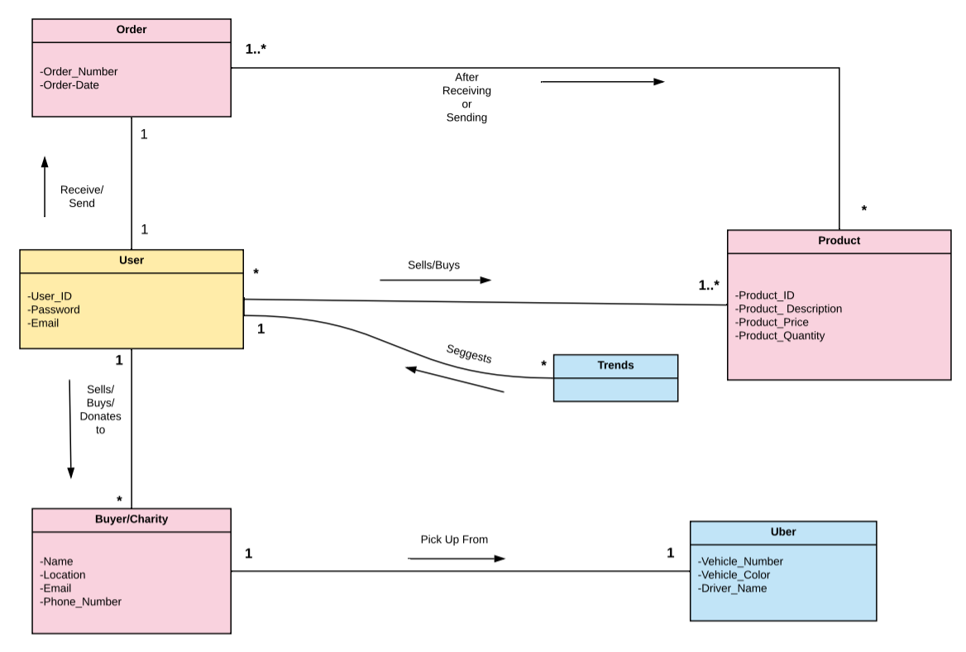

**Use-case Diagram**

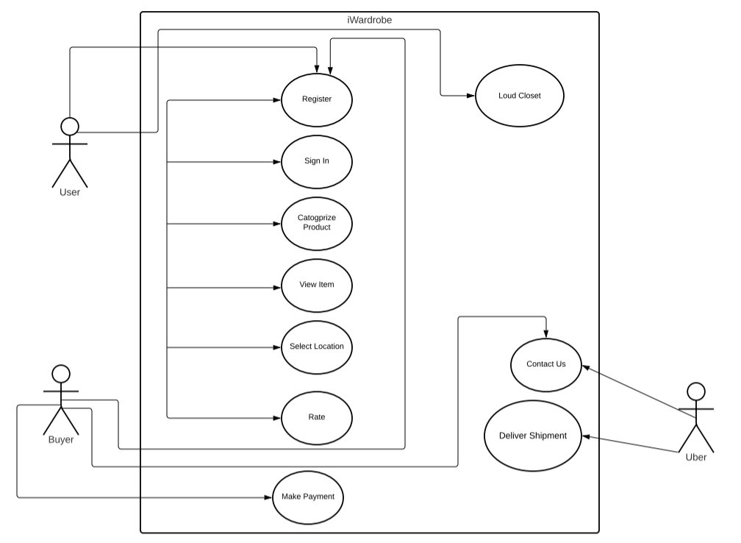

**Use-Case Glossary**

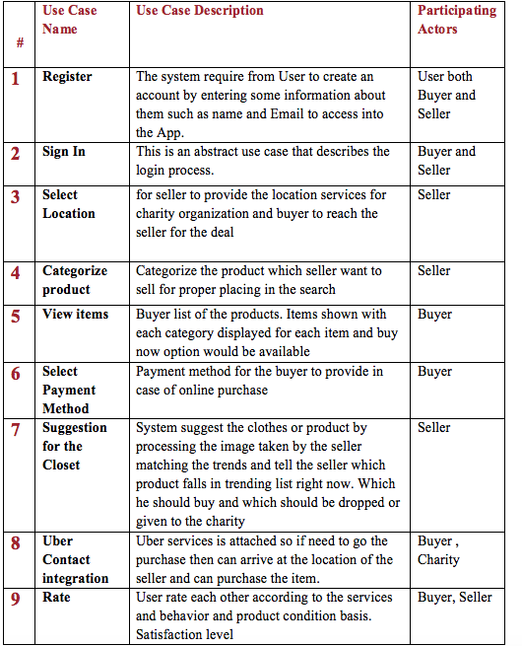

**Use-Case Ranking**

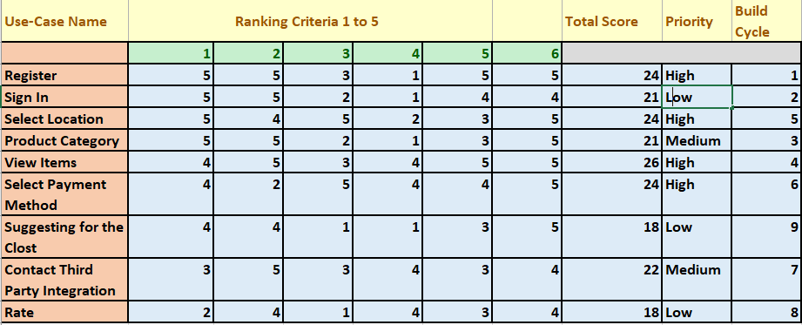

1. Significant impact on the architectural design.
2. Easy to implement but contains significant functionality.
3. Includes risky, time-critical, or complex functions.
4. Involves significant research or new or risky technology.
5. Includes primary business functions.
6. Will increase revenue or decrease costs.

**Use-Case Narrative**

|  |  |
| --- | --- |
| **Use-case Number:** | 1 |
| **Use-case Name:**  **Priority:** | Load my Closet  Low |
| **Use-case short description:** | Take a picture of the item and provide the clear image of the product the user wants to display. Each of the requirements should be defined by the user. |
| **List of Actors** | Seller/User |
| **Use-case precondition:** | Users must be registered and signing in. |
| **Use-case Main Flow:** | **Step1:** User can take the image of the product  **Step2:** User rate and ask for suggestions.  **Step3:** User can take the selection of the product among the matches. |
| **Use-case Exceptional Flow:** | Users can provide the details for the product in the user closet. |
| **Use-case Post Conditions:** | The closet can be categorized into a further list of products of what it contains. |
| **Comments:** | None. |

|  |  |
| --- | --- |
| **Use-case Number:** | 9 |
| **Use-case Name:**  **Priority:** | Contact us  High |
| **Use-case short description:** | Users or buyers select items and contact the third party which is an Uber driver to receive and collect the items from the seller using location services provided by the seller. |
| **List of Actors** | Seller, Buyer, Uber |
| **Use-case precondition:** | Seller must be signed in. |
| **Use-case Main Flow:** | **Step1:** select the list of items  **Step2:** select the buyer  **Step3:** confirm the third party (Uber) about the product and receive the order and the location. |
| **Use-case Exceptional Flow:** | Buyer can cancel the order within 6 hours of the time of the payment. |
| **Use-case Post Conditions:** | Suggest more products related to the categories selected and rate the product received by the buyer. |
| **Comments:** | None. |

|  |  |
| --- | --- |
| **Use-case Number:** | 3 |
| **Use-case Name:**  **Priority:** | Select Location  High |
| **Use-case short description:** | The users select their location to receive the shipment from the seller |
| **List of Actors** | Buyer,Seller |
| **Use-case precondition:** | The buyer must select and share the location with Uber to receive the shipment from the seller. |
| **Use-case Main Flow:** | Step1: select the items  Step2: confirm the payment  Step3: select the location and share with Uber |
| **Use-case Exceptional Flow:** | The buyer can see the state of the order. |
| **Use-case Post Conditions:** | The driver can contact the buyer any time if anything happens to the shipment before it is delivered to the buyer. |
| **Comments:** | None. |

**ERD**

**Class Diagram**

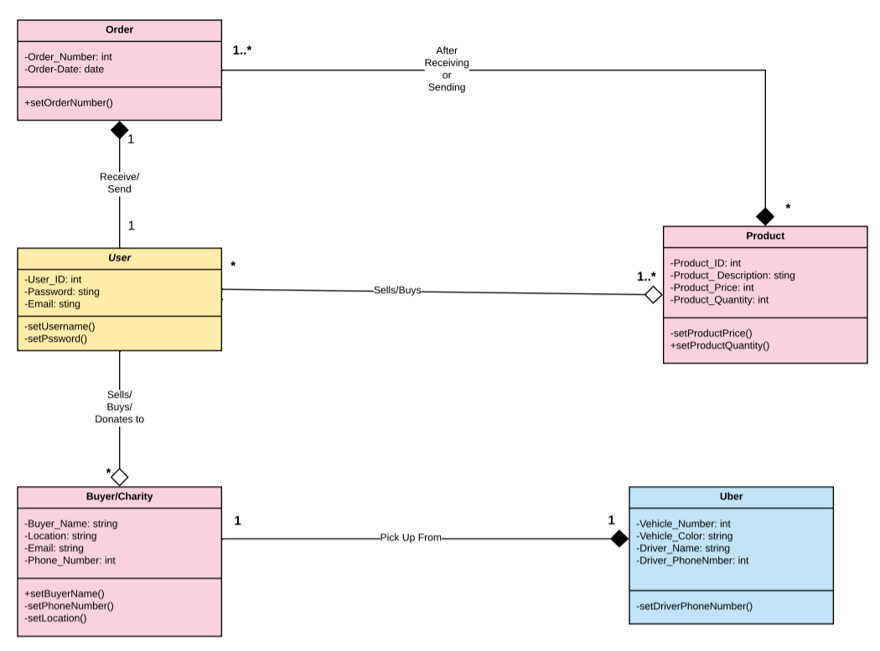

**Interactive Diagram**

**Prototype**

