Training Needs Analysis

Jamie Robinson (08001072)

Otago polytechnic  Year 3 Semester 2 2023

**Training Needs Analysis**

**Objective:**

Teach and convey the basics of report writing and referencing.

**Student Take Away:**

Report template that can be used in the future, knowledge of report structuring and how to reference correctly.

**Equipment Needed:**

* Computer with access to internet/Microsoft Word/Microsoft Power Point
* Projector/Clicker
* Whiteboard
* Handouts (A4 paper)
* Computers students can use during the lesson tasks.

**Topics Covered (Slideshow/Presentation):**

* Report Structure

-Cover page

-Abstract/Executive Summary

-Contents page

-Introduction

-Methods/Results/Discussion/Body

-Conclusion/Recommendations

-References

-Appendices/Appendix (one item)

* Academic Vs. Technical Reports
* Using Images/graphs etc. to convey information.
* Plagiarism
* Referencing (APA7)
* General Advice

-Start early

-Formatting

-Chip away at it

-Proof read the day after writing or have someone else proofread for you

-Decide on topics (as headings) of what you want to cover in the report

-Stick to the material, don’t ramble.

-Relevance/Scope (e.g. images)

-Make use of the marking rubric or other marking guidelines.

-Reference as you go

-Get feedback.

* Questions

**In-class Student Tasks:**

* Create a report template (Individual with guided instructions/steps).
* Practice referencing as a class – look up favorite book/comic etc. and reference a quote from it, share with the class – teacher will write up on the board.
* Take home handout with reference examples.
* Students each ask a question AND/OR tell the class something they learned today.

**Training Need Analysis – Potential Survey Questions:**

**NB. Online questionnaire used – Survey Monkey https://www.surveymonkey.com/r/PGFNYV6**

1. *What are you currently studying? Comment*
2. *Do you plan to undertake further studies? If yes, what course(s)? Comment*
3. *What is your highest academic achievement to date? Comment*
4. *Do you have experience in writing; either technical or academic? Multichoice (Academic, technical, both, neither).*
5. *Have you written a report before? Yes/No*
6. *How would you rate your current writing ability? Multichoice Poor-Excellent*
7. *If you were to be asked to write a report today, would you know where to start? Yes/No/I don’t know.*
8. *Have you used Microsoft Word or a similar word editor before? If so, please give an example. Yes/No/Other (please specify)*
9. *Do you know what referencing is? If so, please explain what referencing style or format you used. Multichoice*
10. *What skills would you be interested in learning? Multichoice (Report structure, Referencing, Both, Neither)*

**Student Responses**

Total Student Responses – 6

Test response – 1

Total Responses – 7

Q1 – All students are currently studying CITEL4

Q2 – Four Students plan to continue to BIT, one said no further studies, one said Game Development

Q3 – Highest Academic Achievement, mostly NCEA 2 or higher, one did automotive engineering

Q4 – Three students had no previous experience in writing, three had either academic or technical writing experience.

Q5 – Four Students had written a report before, two had not.

Q6 – All students said their writing skills were “not good – fair”.

Q7 – Three students believed they new where to start if writing a report, three were not or were not sure.

Q8 – All students had used Microsoft Word before.

Q9 – All students had used APA7/6 referencing before.

Q10 - All students stated that they would like to learn how to reference correctly or write a report or both.

**Changes to Plan**

No drastic changes are being made to the current plan for teaching this lesson based on the responses. Had some students mentioned that they would move on to courses that had academic writing, more time would be spent discussing the differences between academic and technical writing.

**Meeting INTROSH standards**

**Interest**

Ask students if they like writing reports. Hands up for yes, no etc.

(Most will say no…)

Light humor. Question, physical response.

**Title**

Display clearly what we are learning about throughout PowerPoint.

**Objective**

Summary of what we will cover at the beginning & relevant topic titles throughout the PowerPoint to keep objective in sight.

**Need**

Importance being able to communicate ideas clearly and it a structured way, avoid plagiarism etc.

**Scope**

PowerPoint slide outlining our goals & plan for the lesson

**Handouts and references**

Paper handout with referencing examples that they can take home. Template that they can save for future use.

**Revision**

Reflect on what we learnt – Ask each student to either ask a question related to the lesson or comment on something they have learned. No forcing students to speak if they are uncomfortable!

**Student Responses in Full**

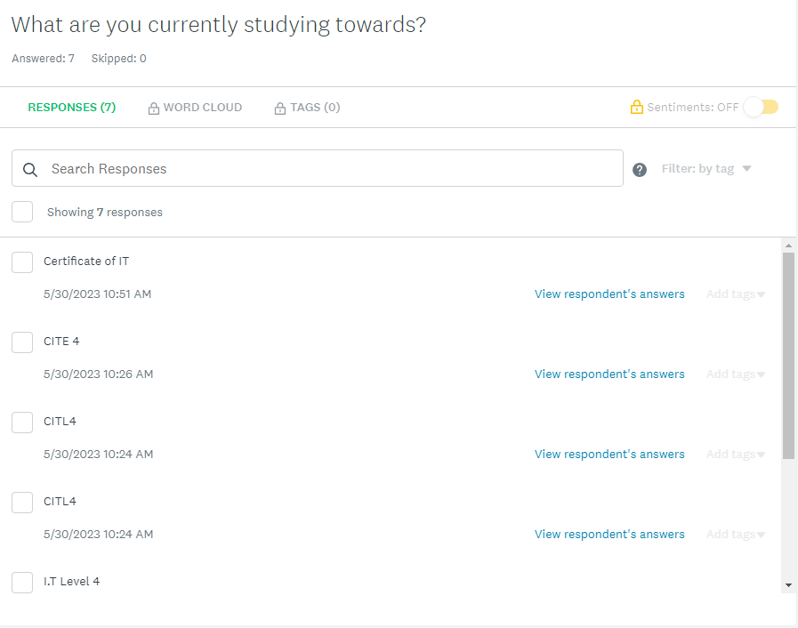

|  |  |  |  |  |  |
| --- | --- | --- | --- | --- | --- |
| TNA RUBRIC | Exemplary | Excellent | Adequate | Insufficient | Poor |
| Questions: suitability and range | Perfectly suited to the exhaustive list of potential topics  Huge range of question types used | Well suited to the thorough list of potential topics  Reasonable range of questions used | Mostly suited to the list of potential topics  Small range of questions types used | Questions are a bit off topic  Basically all the same kind of question | Just one question, or questions are irrelevant |
| Planning and administering | Administered exactly according to plan  External factors are anticipated and efficiently dealt with if they arise | Administered according to plan  External factors are efficiently dealt with if they arise | Administered mostly according to plan  External factors are dealt with if they arise | Not much of a plan or just an attempt to follow the plan  External factors threw things off completely | No plan or plan totally ignored  Unsuccessful administering all together |
| Eliciting responses | Ample, high quality, legitimate responses to be used for efficient planning of a lesson | Plenty of quality responses to be used for planning the lesson | Sufficient responses to be used for planning lesson | Not enough responses to be used to plan lesson objectives | Hardly any attempt to get responses |
| Results analysis | Learner needs can be specifically and indisputably determined from the results set  Objectives are perfect to meet very specific needs | Learner needs can be easily determined from the results set  Objectives are well suited to the needs | Learner needs can be mostly determined from the results set  Objectives mostly suit these needs | An attempt to analyse results and determine some needs  Objectives are vague or not suited to needs | Not much attempt at analysing results, or insufficient results exist  Objectives do not meet needs at all |
| Evaluation | Effectiveness has been thoroughly and thoughtfully evaluated and is totally accurate | Effectiveness has been thoughtfully evaluated and is accurate | Effectiveness has been evaluated and is mostly accurate | An attempt made to evaluate the effectiveness but not very accurate | Totally off the mark evaluation of effectiveness |