Music Genre Classification And Recommendation System
Based on the Audio Features

1st Arvin Jafari Moghadam Fard
Department of Computer Science
University of Milan
Milan, Italy
Arvin.jafarimoghadamfard@studenti.unimi.com

Abstract—Music genre classification is an essential task in music streaming and recommendation systems. This project explores various approaches, from traditional machine learning models like SVM, Random Forest, and XGBoost to deep learning techniques such as Artificial Neural Networks (ANNs) and Convolutional Neural Networks (CNNs), using audio features like MFCCs, Log-Mel Spectrograms, and Chroma Features. Additionally, a music recommendation system was developed using Cosine Similarity and Dynamic Time Warping (DTW) to suggest similar tracks. Results show that XGBoost and ANN models achieved the highest accuracy, while CNNs, despite capturing spectral representations, required further optimizations. This study highlights the potential of deep learning combined with music theory-driven features to improve both classification and recommendation accuracy.
Keywords— Music Genre Classification, Audio Feature Extraction, Machine Learning, Deep Learning, Recommendation System.

Introduction
Automatically identifying music genres is an important challenge in audio pattern recognition, widely used in music streaming services, search engines, and recommendation systems. While early classification methods relied on manually crafted rules and heuristic approaches, advancements in machine learning and deep learning have significantly improved accuracy and automation in genre classification.
This project explores a combination of classical machine learning models (SVM, Random Forest, KNN, Logistic Regression) and artificial neural networks (ANNs) to classify music genres. We extract key features such as MFCCs, Log-Mel Spectrograms, and Spectral Features to capture the essential characteristics of each genre. Different models are evaluated to determine their effectiveness in distinguishing between musical styles based on these features.
To enhance the user experience, we also implement a music recommendation system using Cosine Similarity and Dynamic Time Warping (DTW), allowing for more precise song recommendations based on feature similarities.
The rest of this paper is structured as follows: Section II reviews related work, Section III covers methodology, Section IV presents experimental results, and Section V concludes with key takeaways and future directions.

Related work
In the field of Music Information Retrieval (MIR), automatic music genre classification has garnered significant attention. Early approaches primarily relied on manual feature extraction and traditional machine learning algorithms. For instance, Li et al. (2003) conducted a comparative study evaluating the effectiveness of different feature extraction methods and classification algorithms for music genre classification ijlera.com
.With the advent of deep learning, more sophisticated models have been employed. A study by Haggblade et al. (2011) investigated various machine learning algorithms, including k-nearest neighbor (k-NN), k-means, multi-class SVM, and neural networks, to classify music genres cs229.stanford.edu
. Another research by Taqa et al. (2023) provided a comprehensive survey of music genre classification using audio files, discussing feature extraction, classification methods, and recent developments in the field researchgate.net
.These studies highlight the evolution from traditional machine learning techniques to advanced deep learning models, emphasizing the importance of feature extraction and model selection in achieving high classification accuracy.

Methodology
Our approach to developing the Music Genre Classification and Recommendation System encompasses several key stages:
Dataset Selection and Preprocessing
  - Dataset: We utilized the GTZAN dataset, comprising 1,000 audio tracks each lasting 30 seconds, evenly distributed across 10 genres.
  - Preprocessing: Each audio file was resampled to a consistent sampling rate, converted to mono, and normalized to ensure uniformity.
Feature Extraction
To effectively classify music genres, we extracted various audio features that represent different aspects of the audio signal.

1. Spectral Features
Spectral features describe how the energy of the signal is distributed across different frequencies. These features include:
Fourier Transform (FT): The Short-Time Fourier Transform (STFT) is used to analyze the frequency content of short segments of the audio signal. The STFT of a signal x(t) is given by:
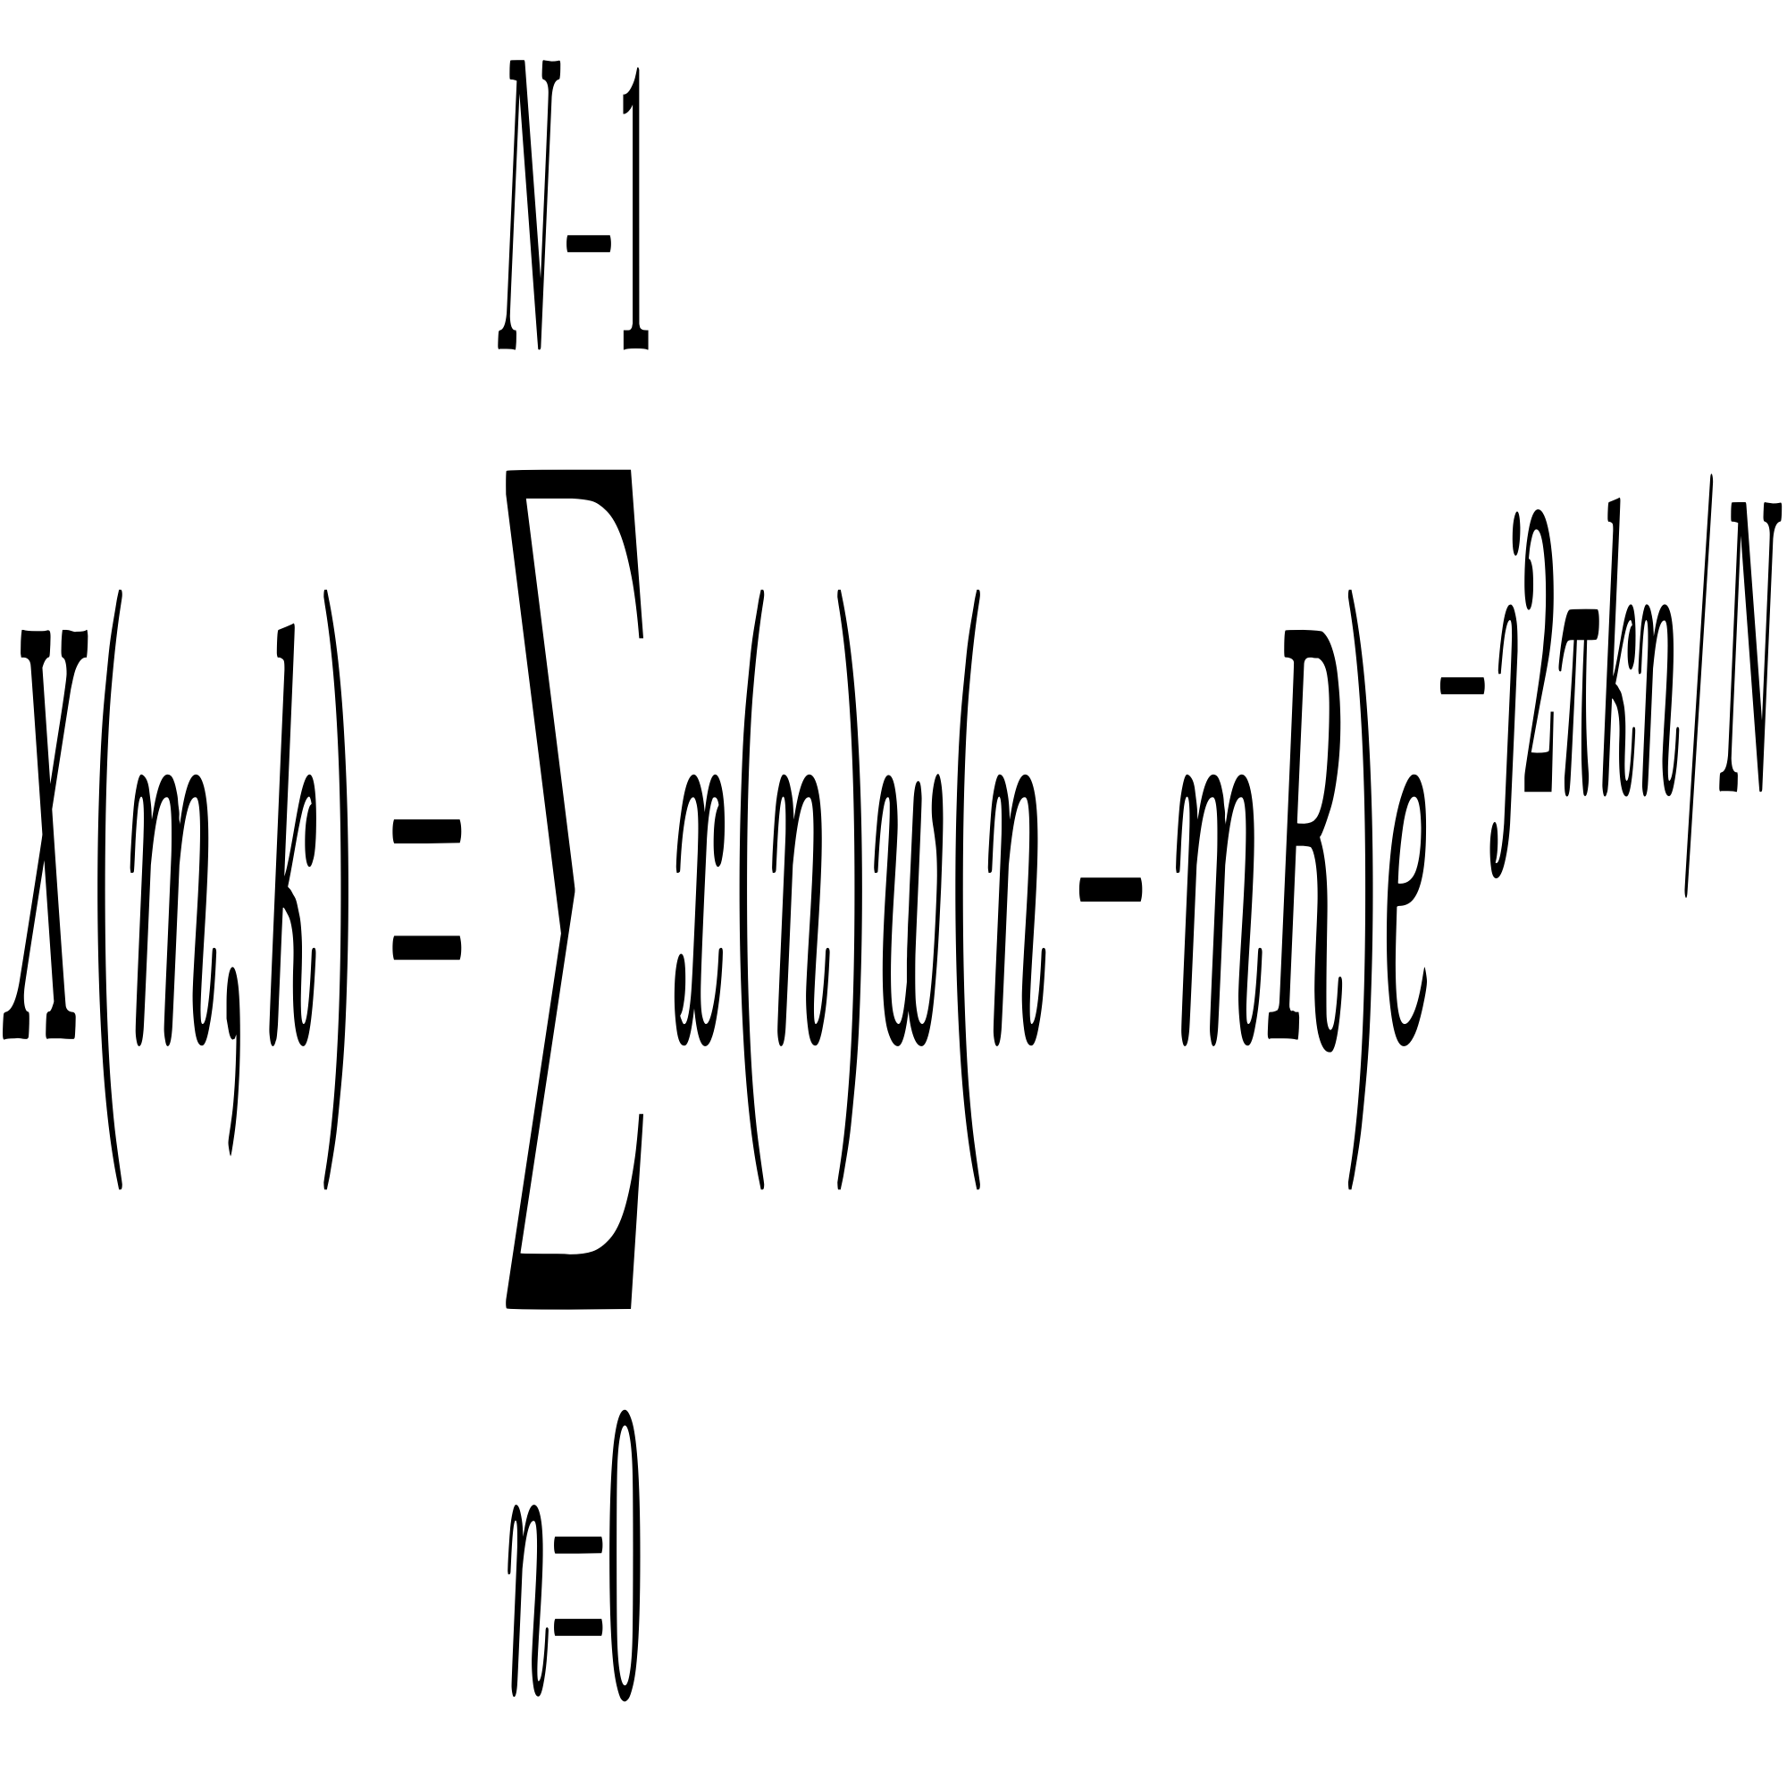
The Fourier Transform provides the foundation for spectrograms, which visually represent frequency variations over time.
Mel-Frequency Cepstral Coefficients (MFCCs):
MFCCs are widely used in speech and audio processing because they model the perceptual characteristics of human hearing. The extraction process involves:
  - Computing the power spectrum using the STFT.
  - Applying a Mel-scale filter bank to approximate human auditory perception.
  - Taking the logarithm of the Mel-spectrogram to compress amplitude variations.
  - Computing the Discrete Cosine Transform (DCT) to decorrelate the features and obtain compact representations.
The formula for MFCCs is:
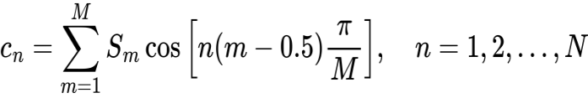
MFCCs capture the timbre of an audio signal, making them particularly useful for genre classification.
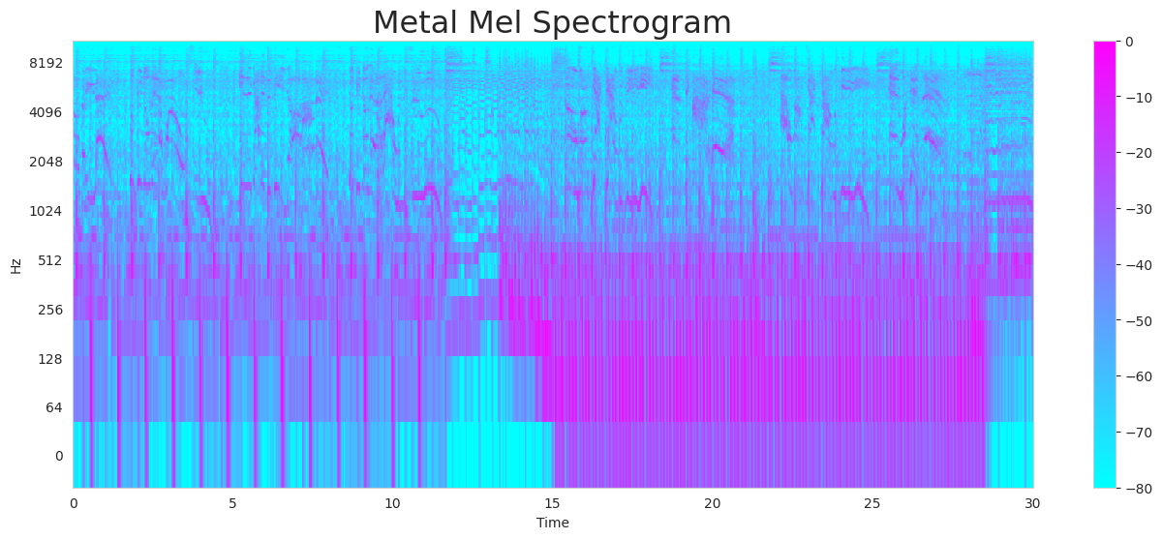
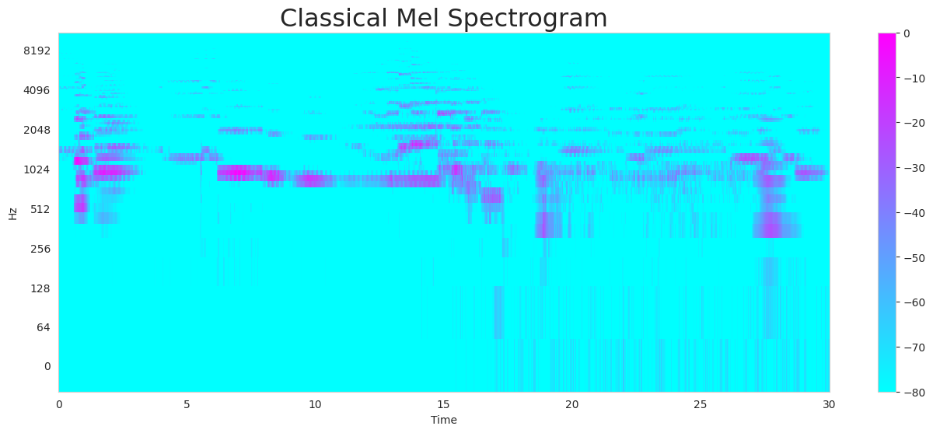
Log-Mel Spectrogram:
The Mel spectrogram represents the audio in a way that aligns with human hearing perception. It is computed using:
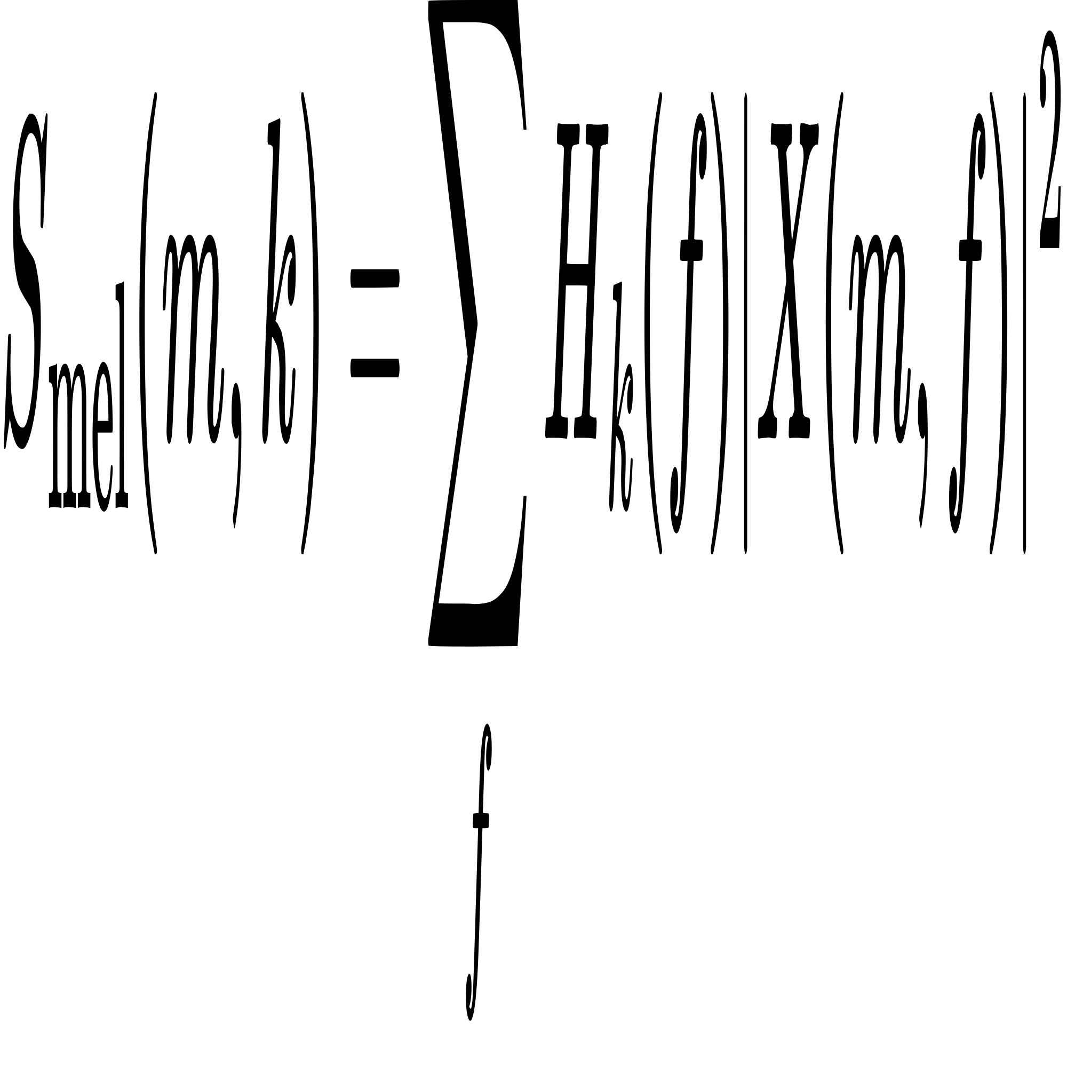Taking the logarithm of 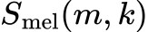 produces the log-Mel spectrogram, which emphasizes perceptually important frequency bands:
where ϵ is a small constant to avoid logarithm of zero.
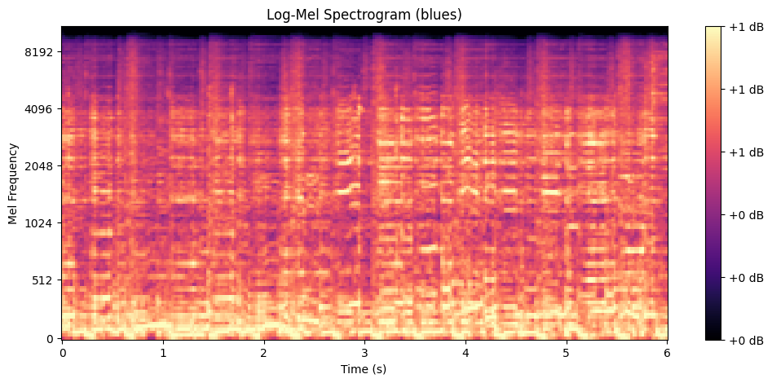
Chroma Features:
Chroma features capture the harmonic and tonal properties of music by mapping the full spectrum into 12 pitch classes (chroma bins) corresponding to the 12 notes in the Western musical scale (C, C#, D, etc.). These features emphasize harmonic progression and chord structures, which are critical for distinguishing between genres like classical, jazz, and blues.
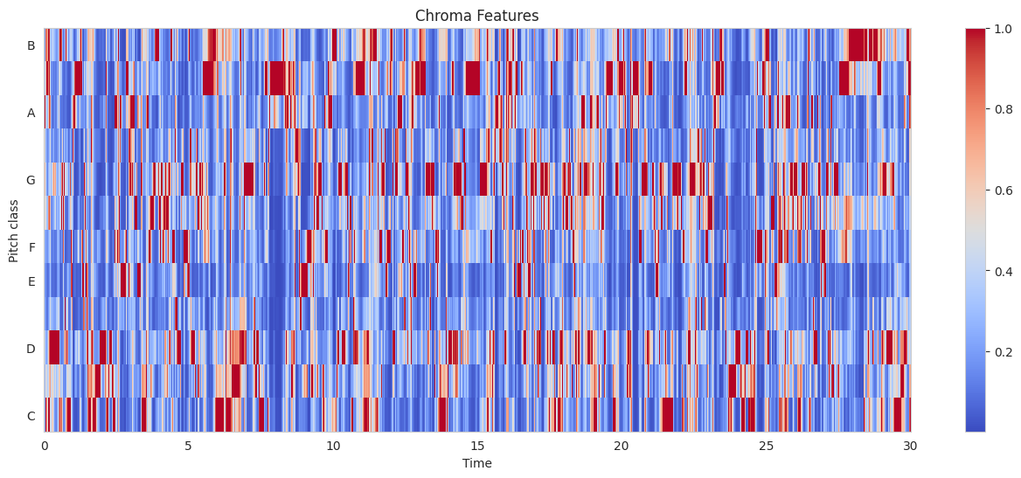

2. Temporal Features
Temporal features capture time-domain variations in the audio signal:
- Zero Crossing Rate (ZCR): Measures how often the signal crosses the zero amplitude axis, indicating noisiness and percussiveness.
- Tempo: The estimated beats per minute (BPM), providing rhythmic information.

3. Harmonic Features
Harmonic features represent the tonal quality of the signal:
- Harmonics-to-Noise Ratio (HNR): Measures the ratio of periodic to non-periodic components, relevant for distinguishing between vocal and instrumental tracks.

Exploratory Data Analysis (EDA)
To understand the dataset's structure:
  - Correlation Analysis: Computed correlation matrices to identify relationships between features.
  - Dimensionality Reduction: Applied Principal Component Analysis (PCA) to visualize data distribution in a 2D space.
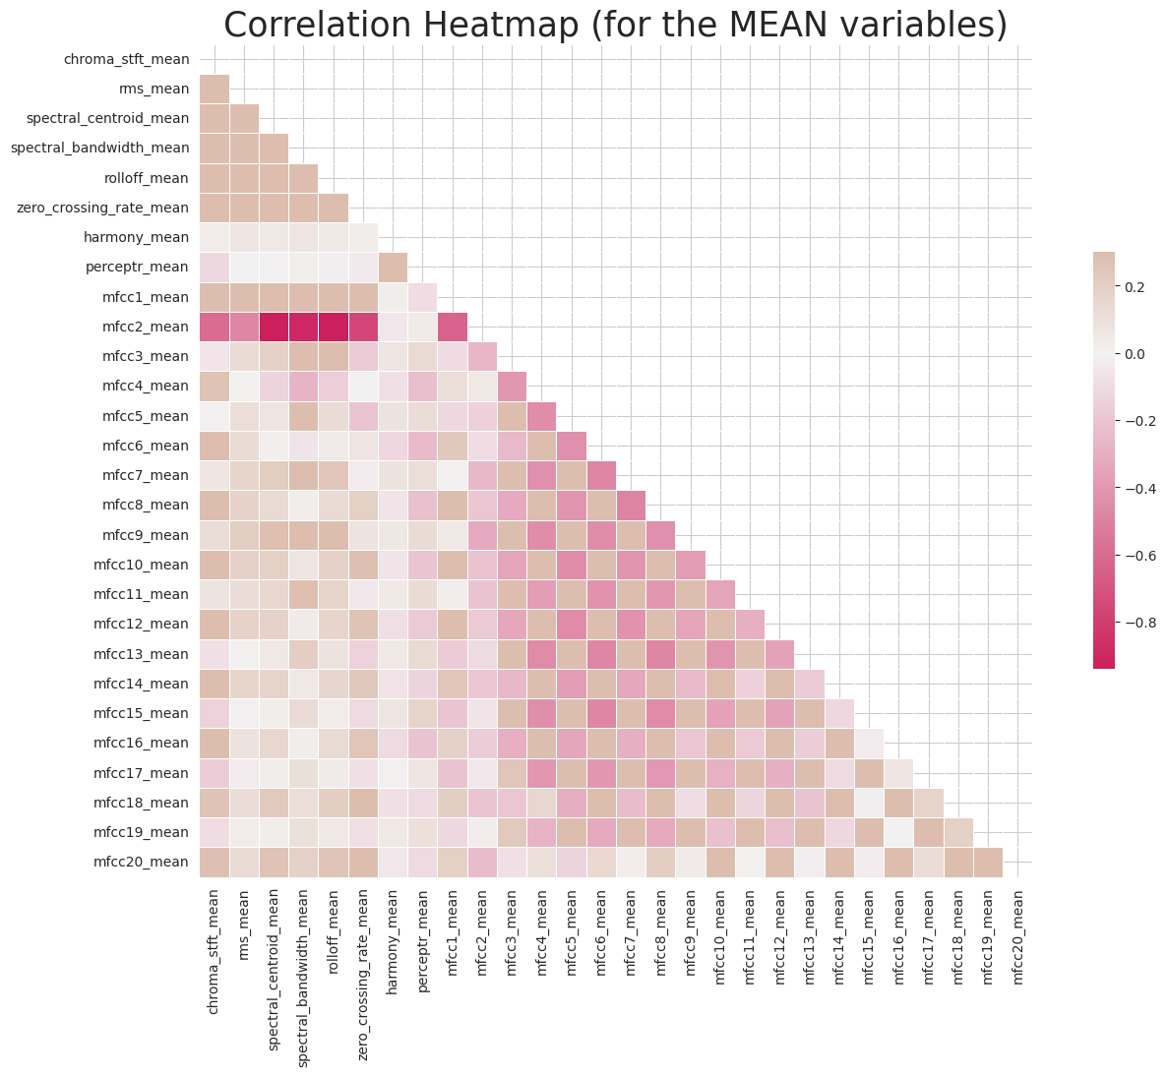
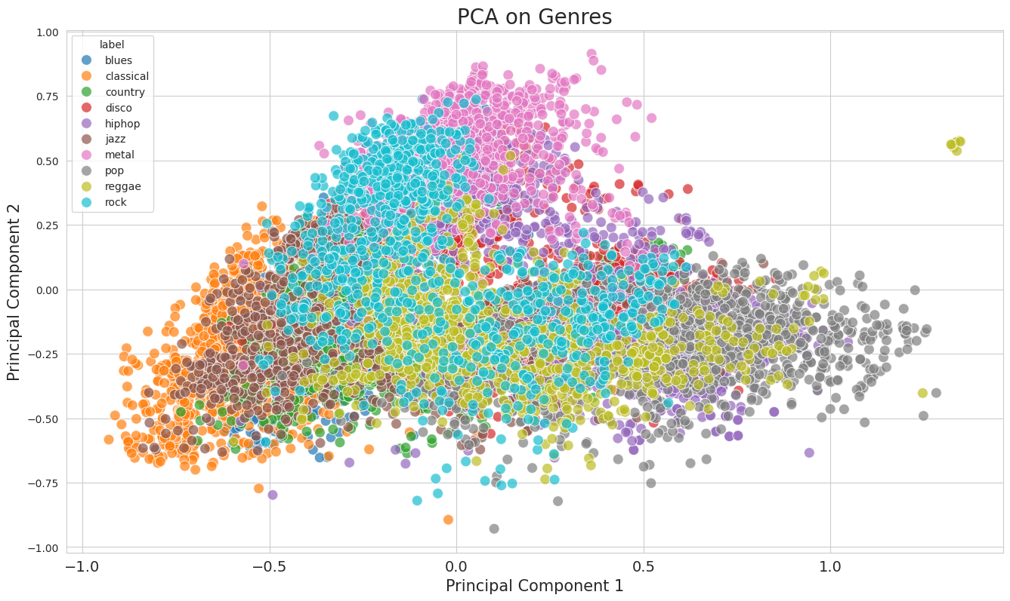
Model Development
We implemented both traditional machine learning classifiers and deep learning models:
  - Classical Machine Learning Models: Evaluated algorithms such as Naive Bayes, k-Nearest Neighbors (k-NN), Decision Trees, Random Forests, Support Vector Machines (SVM), Logistic Regression, and Extreme Gradient Boosting (XGBoost).
  - Artificial Neural Networks (ANN): Designed a feedforward neural network with multiple hidden layers.
  - Convolutional Neural Networks (CNN): Developed a CNN model utilizing log-mel spectrograms as input to capture spatial hierarchies in the data.
Evaluation Metrics
Models were assessed using:
  - Accuracy: The proportion of correctly classified instances.
  - Confusion Matrix: To visualize the performance across different genres.
  - Cross-Validation: Employed k-fold cross-validation to ensure model robustness.
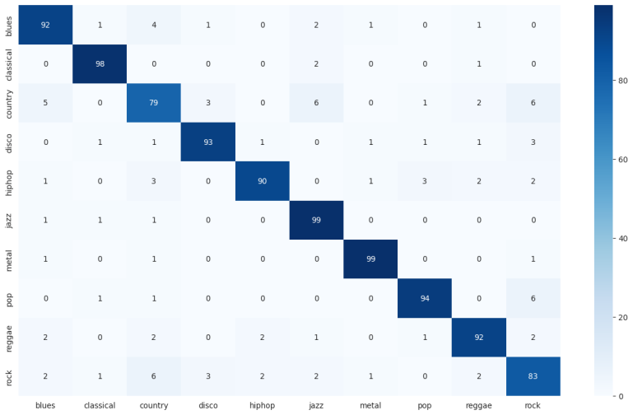
Confusion Matrix for the Cross Gradient Booster
Recommendation System
Implemented a recommendation system leveraging Dynamic Time Warping (DTW):
  - DTW Implementation: Calculated similarity scores between tracks to recommend songs with similar audio features.
  - Integration: Combined the DTW-based recommender with the genre classifier to enhance user experience.
By systematically following these steps, we developed a robust system capable of accurately classifying music genres and providing personalized recommendations based on audio features.

results
In this section, we present the outcomes of our Music Genre Classification and Recommendation System. We evaluated various machine learning models and neural network architectures using the GTZAN dataset, focusing on their accuracy in genre classification.
A. Classical Machine Learning Models
We applied several classical machine learning algorithms to the extracted audio features from the GTZAN dataset. The accuracy scores for each model are as follows:
Model | Accuracy
Naive Bayes | 0.506
Stochastic Gradient Descent | 0.686
K-nearest Neighbors (KNN) | 0.806
Decision Trees | 0.640
Random Forest | 0.812
Support Vetor Machine (SVM) | 0.842
Logistic Regression | 0.742
Extream Gradient Boosting (XGboost) | 0.902
XGBoost (Random Forest) | 0.740

B. Artificial Neural Network (ANN) Model
We developed an ANN model using the extracted features, achieving a maximum validation accuracy of 0.922. This indicates the model's strong capability in capturing complex patterns within the audio data.
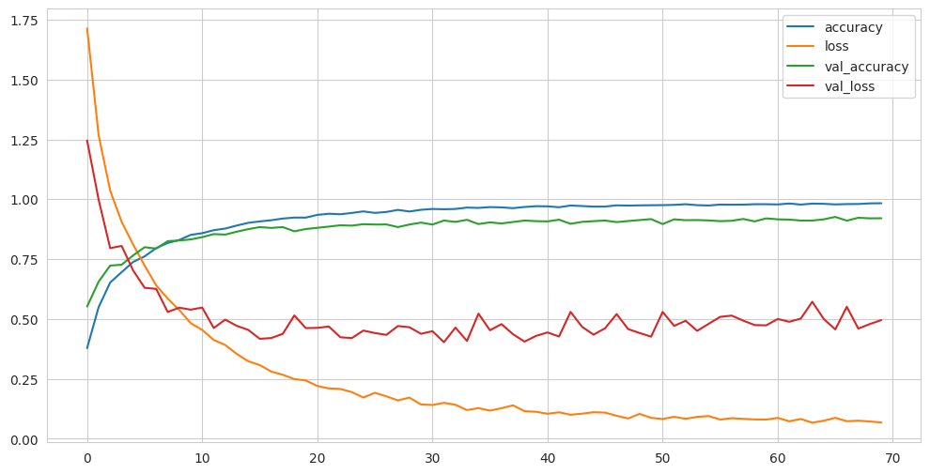
C. Convolutional Neural Network (CNN) Model
Utilizing log-mel spectrograms as input, we trained a CNN model. The model achieved a validation accuracy of 0.726 and a test accuracy of 0.71, suggesting that while effective, there is room for improvement in feature representation or model architecture.
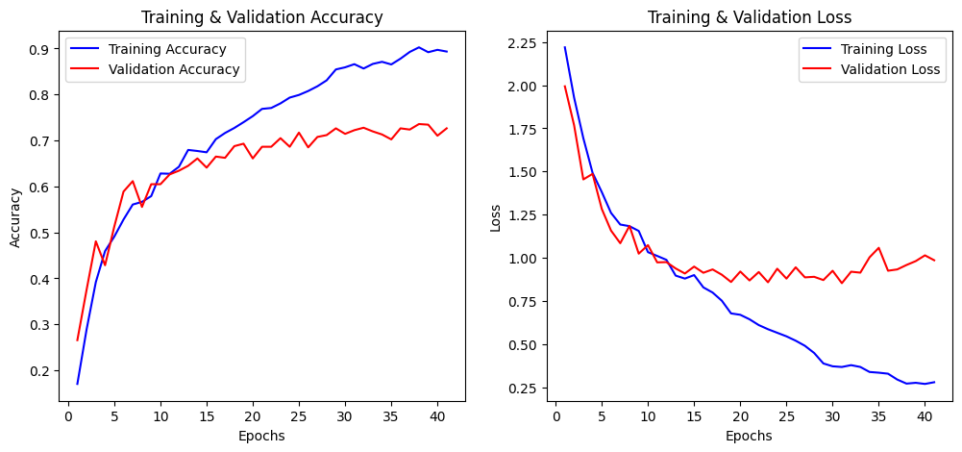

Discussion
The results demonstrate that advanced machine learning models, particularly XGBoost and ANN, outperform traditional algorithms in music genre classification tasks. The high accuracy of the ANN model underscores the importance of capturing non-linear relationships in audio features.
The CNN model, despite being a powerful tool for image-related tasks, showed moderate performance in this context. This could be attributed to the complexity of audio data or the need for more sophisticated architectures tailored to audio signal processing.
For the recommendation system, we implemented a function based on Dynamic Time Warping (DTW) to measure similarity between audio tracks. DTW effectively handles temporal variations, making it suitable for matching tracks with differing lengths or tempos.

Future Work
To further enhance the system’s performance, future research could explore the integration of Recurrent Neural Networks (RNNs) with Convolutional Neural Networks (CNNs) to better capture both spatial and temporal patterns in music signals. While CNNs excel at extracting hierarchical features from spectrograms, they lack the ability to model long-term dependencies in audio sequences. RNN-based architectures such as Long Short-Term Memory (LSTM) networks or Bidirectional GRUs could help analyze how musical elements evolve over time, improving classification accuracy, especially for genres with strong rhythmic and harmonic progressions. Additionally, Transformer models, which have proven highly effective in sequential data tasks, could be investigated to capture global dependencies in music data.
Another promising direction is incorporating music theory-driven feature extraction. Current models rely primarily on statistical and spectral features, but musical scales, note intervals, and harmonic structures play a fundamental role in defining a genre’s identity. Scales, which are organized sequences of notes within an octave, serve as the foundation of melodies and harmonies in music. Different genres favor specific scales; for instance, blues often incorporates the pentatonic scale, while classical and jazz compositions frequently utilize diatonic or modal scales. Extracting scale-based frequency distributions and interval patterns could provide genre-specific insights, as certain note relationships define the harmonic "color" of a musical style.
Furthermore, the interaction between notes in the frequency domain can reveal important genre characteristics. Harmonic relationships, chord structures, and overtone distributions influence the tonal quality of a piece. By analyzing how fundamental frequencies and their harmonics interact within a given scale, a model could better distinguish between genres that share similar rhythmic or timbral features but differ in harmonic complexity. Additionally, studying note transitions and interval distributions over time could improve the recognition of musical phrasing and stylistic motifs, which are often unique to each genre.
Beyond classification, these music theory-based features could also contribute to music generation tools. A deep learning model trained with scale-aware features, note transitions, and frequency relationships could generate genre-specific compositions that respect harmonic and structural conventions. This approach could be highly valuable for AI-assisted composition, intelligent music recommendation, and personalized content creation.
Additionally, incorporating user feedback mechanisms into the recommendation system could enhance its adaptability, allowing it to refine suggestions based on listening behavior and preferences in real-time. This would enable a more dynamic and personalized music experience.
Overall, future research could benefit from combining deep learning advancements (RNNs, Transformers), music theory-based features, and real-time user adaptation, creating more intelligent and musically aware genre classification and recommendation systems. This could have significant implications for music streaming services, AI-assisted music composition, and audio content creation tools.

Conclusion

In this study, we explored a comprehensive approach to music genre classification and recommendation using a combination of classical machine learning models, artificial neural networks (ANNs), convolutional neural networks (CNNs), and dynamic time warping (DTW)-based recommendation techniques. The GTZAN dataset was used to extract meaningful audio features, including MFCCs, spectral features, chroma features, and mel spectrograms, to train multiple classifiers.
Our results demonstrate that ensemble methods such as XGBoost and deep learning approaches, particularly ANN, achieved the highest classification accuracy. While traditional machine learning models like SVM and Random Forest performed well, the ANN model surpassed them, reaching a maximum validation accuracy of 92.2%.
The CNN model trained on log-mel spectrograms, however, did not perform as well as expected, achieving a validation accuracy of 72.6% and test accuracy of 71%. This suggests that while CNNs are effective for image-like representations of audio, additional optimizations such as more complex architectures, improved preprocessing techniques, or hybrid models incorporating temporal dependencies (e.g., CNN-RNN combinations) may be needed to enhance their effectiveness in genre classification tasks.
Additionally, we developed a music recommendation system that utilizes Dynamic Time Warping (DTW) and Cosine Similarity to suggest songs with similar audio characteristics. The DTW approach proved effective in handling variations in tempo and musical structure, allowing for more flexible and robust similarity detection compared to conventional distance metrics.
This research highlights the potential of deep learning and content-based recommendation techniques in music information retrieval. Our findings suggest that combining spectral, harmonic, and temporal features can significantly enhance genre classification accuracy and improve the quality of music recommendations.
Moving forward, the integration of Recurrent Neural Networks (RNNs) with CNNs could further improve temporal modeling of audio signals, while incorporating music theory-driven features such as scale distributions, note intervals, and harmonic relationships may refine classification and open new possibilities for AI-driven music generation.
Overall, this study contributes to the field of audio pattern recognition by presenting a hybrid approach to music classification and recommendation. The methodologies explored in this work can be further extended and applied to real-world applications such as music streaming services, AI-assisted composition, and personalized content generation, enhancing the way music is categorized and recommended in modern digital platforms.

References

Dataset and Repositories

- [1] G. Tzanetakis and P. Cook, "GTZAN: A Large-Scale Dataset for Music Genre Classification," Available: https://www.kaggle.com/datasets/carlthome/gtzan-dataset-music-genre-classification.
- [2] GitHub Repository on Audio Feature Extraction, Available: https://github.com/librosa/librosa.

Music Feature Extraction & Audio Processing

- [3] P. Mermelstein, "Distance measures for speech recognition, psychological and instrumental," Pattern Recognition and Artificial Intelligence, vol. 116, no. 3, pp. 374-388, 1976.
- [4] S. Davis and P. Mermelstein, "Comparison of parametric representations for monosyllabic word recognition in continuously spoken sentences," IEEE Transactions on Acoustics, Speech, and Signal Processing, vol. 28, no. 4, pp. 357–366, 1980.
- [5] A. V. Oppenheim and R. W. Schafer, Discrete-Time Signal Processing, 3rd ed. Upper Saddle River, NJ, USA: Prentice-Hall, 2009.

Machine Learning for Music Classification

- [6] Y. Bengio, A. Courville, and P. Vincent, "Representation Learning: A Review and New Perspectives," IEEE Transactions on Pattern Analysis and Machine Intelligence, vol. 35, no. 8, pp. 1798-1828, Aug. 2013.
- [7] J. Pons, T. Lidy, and X. Serra, "Experimenting with Musically Motivated Convolutional Neural Networks," in 2017 International Joint Conference on Neural Networks (IJCNN), Anchorage, AK, USA, 2017, pp. 34-41.

Dynamic Time Warping (DTW)

- [8] H. Sakoe and S. Chiba, "Dynamic programming algorithm optimization for spoken word recognition," IEEE Transactions on Acoustics, Speech, and Signal Processing, vol. 26, no. 1, pp. 43-49, Feb. 1978.

Music Theory & Computational Music Analysis

- [9] D. Temperley, Music and Probability, Cambridge, MA, USA: MIT Press, 2007.
- [10] E. Gómez, "Tonal Description of Music Audio Signals," EURASIP Journal on Advances in Signal Processing, vol. 2006, 2006.

