INFORME ANALITICA DE DATOS TPAD-1

TPAD-1

12/2/2021

#INSTALAMOS LAS LIBRERIAS A UTILIZAR

install.packages("hexbin")

## Installing package into '/home/rstudio-user/R/x86_64-pc-linux-gnu-library/4.0'  
## (as 'lib' is unspecified)

install.packages("readr")

## Installing package into '/home/rstudio-user/R/x86_64-pc-linux-gnu-library/4.0'  
## (as 'lib' is unspecified)

install.packages("ggplot2")

## Installing package into '/home/rstudio-user/R/x86_64-pc-linux-gnu-library/4.0'  
## (as 'lib' is unspecified)

install.packages("dplyr")

## Installing package into '/home/rstudio-user/R/x86_64-pc-linux-gnu-library/4.0'  
## (as 'lib' is unspecified)

install.packages("scatterplot3d",dependencies=T)

## Installing package into '/home/rstudio-user/R/x86_64-pc-linux-gnu-library/4.0'  
## (as 'lib' is unspecified)

install.packages("tidyverse")

## Installing package into '/home/rstudio-user/R/x86_64-pc-linux-gnu-library/4.0'  
## (as 'lib' is unspecified)

#CARGAMOS LAS LIBRERIAS QUE VAMOS A UTILIZAR

library(readr)  
library(dplyr)

##   
## Attaching package: 'dplyr'

## The following objects are masked from 'package:stats':  
##   
## filter, lag

## The following objects are masked from 'package:base':  
##   
## intersect, setdiff, setequal, union

library(ggplot2)  
library(hexbin)  
library(scatterplot3d)  
library(tidyverse)

## ── Attaching packages ─────────────────────────────────────── tidyverse 1.3.0 ──

## ✓ tibble 3.0.6 ✓ stringr 1.4.0  
## ✓ tidyr 1.1.2 ✓ forcats 0.5.1  
## ✓ purrr 0.3.4

## ── Conflicts ────────────────────────────────────────── tidyverse_conflicts() ──  
## x dplyr::filter() masks stats::filter()  
## x dplyr::lag() masks stats::lag()

#OBTENEMOS EL ENLACE DE LA CARPETA EN LA QUE ESTAMOS TRABAJANDO

getwd()

## [1] "/cloud/project/R-MARKDOWN"

#BUSCAMOS LA RUTA DEL DATAFRAME

cafe_df<-read.csv("/cloud/project/R-MARKDOWN/cafesito/produccion.csv", header = TRUE, sep=",", dec=".")

#NOS INDICA EL TIPO O CLASE DE LA VARIABLE RENDIMIENTO

class(cafe_df$Rendimiento..ha.ton.)

## [1] "numeric"

#A CONTINUACION PODEMOS IDENTIFICAR LA ESTRUCTURA DEL DATAFRAME

str(cafe_df)

## 'data.frame': 266 obs. of 8 variables:  
## $ Anio : int 2007 2007 2007 2007 2007 2007 2007 2007 2007 2007 ...  
## $ Departamento : chr "ANTIOQUIA" "BOLIVAR" "BOYACA" "CALDAS" ...  
## $ Producto : chr "CAFE" "CAFE" "CAFE" "CAFE" ...  
## $ Area..ha. : chr "112,343.60" "502" "11,374.50" "78,393.65" ...  
## $ Produccion..ton. : chr "120,500.80" "446" "9,683.10" "92,815.00" ...  
## $ Rendimiento..ha.ton. : num 1.07 0.89 0.85 1.18 0.93 0.79 0.96 0.57 0.71 0.78 ...  
## $ Produccion.Nacional..ton.: num 14.54 0.05 1.17 11.2 0.26 ...  
## $ Area.Nacional..ha. : num 14.66 0.07 1.48 10.23 0.3 ...

#CONOCER LA DIMENSION DEL DATAFRAME

dim(cafe_df)

## [1] 266 8

#PODEMOS VER LA INFORMACION RESUMIDA DEL DATAFRAME DE LAS VARIABLES CUANTITATIVAS Y VALORES ESTADISTICOS

summary(cafe_df)

## Anio Departamento Producto Area..ha.   
## Min. :2007 Length:266 Length:266 Length:266   
## 1st Qu.:2010 Class :character Class :character Class :character   
## Median :2012 Mode :character Mode :character Mode :character   
## Mean :2012   
## 3rd Qu.:2015   
## Max. :2018   
## Produccion..ton. Rendimiento..ha.ton. Produccion.Nacional..ton.  
## Length:266 Min. :0.0000 Min. : 0.0000   
## Class :character 1st Qu.:0.7500 1st Qu.: 0.3525   
## Mode :character Median :0.9400 Median : 2.7200   
## Mean :0.9364 Mean : 4.5113   
## 3rd Qu.:1.1200 3rd Qu.: 7.1475   
## Max. :2.0000 Max. :18.6700   
## Area.Nacional..ha.  
## Min. : 0.000   
## 1st Qu.: 0.390   
## Median : 3.120   
## Mean : 4.511   
## 3rd Qu.: 6.875   
## Max. :16.430

#INFORMACION CUANTITATIVA DEL DATAFRAME USANDO VARIAS VARIABLES

tapply(cafe_df$Rendimiento..ha.ton., cafe_df$Anio, summary)

## $`2007`  
## Min. 1st Qu. Median Mean 3rd Qu. Max.   
## 0.4500 0.7900 0.9000 0.9505 1.1525 1.5300   
##   
## $`2008`  
## Min. 1st Qu. Median Mean 3rd Qu. Max.   
## 0.4500 0.7775 0.9050 0.9827 1.2000 1.7900   
##   
## $`2009`  
## Min. 1st Qu. Median Mean 3rd Qu. Max.   
## 0.3000 0.7600 0.9300 0.8814 1.1125 1.2100   
##   
## $`2010`  
## Min. 1st Qu. Median Mean 3rd Qu. Max.   
## 0.0000 0.7050 0.9600 0.9061 1.1250 1.5200   
##   
## $`2011`  
## Min. 1st Qu. Median Mean 3rd Qu. Max.   
## 0.4700 0.6100 0.9000 0.8543 1.0550 1.2000   
##   
## $`2012`  
## Min. 1st Qu. Median Mean 3rd Qu. Max.   
## 0.0000 0.7450 0.8300 0.8587 0.9150 2.0000   
##   
## $`2013`  
## Min. 1st Qu. Median Mean 3rd Qu. Max.   
## 0.6000 0.6000 0.7550 0.7595 0.8800 0.9900   
##   
## $`2014`  
## Min. 1st Qu. Median Mean 3rd Qu. Max.   
## 0.6400 0.6500 0.8150 0.8223 0.9500 1.0600   
##   
## $`2015`  
## Min. 1st Qu. Median Mean 3rd Qu. Max.   
## 0.770 0.935 1.065 1.025 1.107 1.150   
##   
## $`2016`  
## Min. 1st Qu. Median Mean 3rd Qu. Max.   
## 0.790 0.960 1.120 1.064 1.150 1.190   
##   
## $`2017`  
## Min. 1st Qu. Median Mean 3rd Qu. Max.   
## 0.660 0.845 1.090 1.068 1.290 1.500   
##   
## $`2018`  
## Min. 1st Qu. Median Mean 3rd Qu. Max.   
## 0.6200 0.8575 1.1200 1.0795 1.3125 1.5200

#ALGUNOS VALORES ESTADISTICOS

sum(cafe_df$Rendimiento..ha.ton.)

## [1] 249.09

prod(cafe_df$Area.Nacional..ha.)

## [1] 0

var(cafe_df$Rendimiento..ha.ton.)

## [1] 0.07135814

length(cafe_df$Area.Nacional..ha.)

## [1] 266

mean(cafe_df$Rendimiento..ha.ton.)

## [1] 0.9364286

max(cafe_df$Rendimiento..ha.ton.)

## [1] 2

min(cafe_df$Rendimiento..ha.ton.)

## [1] 0

sd(cafe_df$Rendimiento..ha.ton.)

## [1] 0.2671294

#RESTAR EL VALOR MAXIMO Y EL VALOR MINIMO DE LA VARIABLE RENDIMIENTO

max(cafe_df$Rendimiento..ha.ton.)-min(cafe_df$Rendimiento..ha.ton.)

## [1] 2

#NOMBRE DE LAS VARIABLES DEL DATAFRAME

names(cafe_df)

## [1] "Anio" "Departamento"   
## [3] "Producto" "Area..ha."   
## [5] "Produccion..ton." "Rendimiento..ha.ton."   
## [7] "Produccion.Nacional..ton." "Area.Nacional..ha."

colnames(cafe_df)

## [1] "Anio" "Departamento"   
## [3] "Producto" "Area..ha."   
## [5] "Produccion..ton." "Rendimiento..ha.ton."   
## [7] "Produccion.Nacional..ton." "Area.Nacional..ha."

#VER LAS PRIMERAS Y ULTIMAS 6 FILAS DEL DATAFRAME

head(cafe_df)

## Anio Departamento Producto Area..ha. Produccion..ton. Rendimiento..ha.ton.  
## 1 2007 ANTIOQUIA CAFE 112,343.60 120,500.80 1.07  
## 2 2007 BOLIVAR CAFE 502 446 0.89  
## 3 2007 BOYACA CAFE 11,374.50 9,683.10 0.85  
## 4 2007 CALDAS CAFE 78,393.65 92,815.00 1.18  
## 5 2007 CAQUETA CAFE 2,295.00 2,134.00 0.93  
## 6 2007 CASANARE CAFE 2,605.00 2,048.40 0.79  
## Produccion.Nacional..ton. Area.Nacional..ha.  
## 1 14.54 14.66  
## 2 0.05 0.07  
## 3 1.17 1.48  
## 4 11.20 10.23  
## 5 0.26 0.30  
## 6 0.25 0.34

tail(cafe_df)

## Anio Departamento Producto Area..ha. Produccion..ton.  
## 261 2018 PUTUMAYO CAFE 209.93 289.5  
## 262 2018 QUINDIO CAFE 16,374.73 17,739.03  
## 263 2018 RISARALDA CAFE 35,874.73 45,918.75  
## 264 2018 SANTANDER CAFE 42,269.07 55,918.71  
## 265 2018 TOLIMA CAFE 97,304.04 97,451.31  
## 266 2018 VALLE DEL CAUCA CAFE 48,305.31 49,667.88  
## Rendimiento..ha.ton. Produccion.Nacional..ton. Area.Nacional..ha.  
## 261 1.38 0.03 0.03  
## 262 1.08 2.07 2.21  
## 263 1.28 5.37 4.83  
## 264 1.32 6.53 5.69  
## 265 1.00 11.39 13.11  
## 266 1.03 5.80 6.51

#INSPECCIONAR DE FORMA DETALLADA EN EL DATAFRAME SELECCIONANDO SUS COLUMNAS Y FILAS

cafe_df[3]

## Producto  
## 1 CAFE  
## 2 CAFE  
## 3 CAFE  
## 4 CAFE  
## 5 CAFE  
## 6 CAFE  
## 7 CAFE  
## 8 CAFE  
## 9 CAFE  
## 10 CAFE  
## 11 CAFE  
## 12 CAFE  
## 13 CAFE  
## 14 CAFE  
## 15 CAFE  
## 16 CAFE  
## 17 CAFE  
## 18 CAFE  
## 19 CAFE  
## 20 CAFE  
## 21 CAFE  
## 22 CAFE  
## 23 CAFE  
## 24 CAFE  
## 25 CAFE  
## 26 CAFE  
## 27 CAFE  
## 28 CAFE  
## 29 CAFE  
## 30 CAFE  
## 31 CAFE  
## 32 CAFE  
## 33 CAFE  
## 34 CAFE  
## 35 CAFE  
## 36 CAFE  
## 37 CAFE  
## 38 CAFE  
## 39 CAFE  
## 40 CAFE  
## 41 CAFE  
## 42 CAFE  
## 43 CAFE  
## 44 CAFE  
## 45 CAFE  
## 46 CAFE  
## 47 CAFE  
## 48 CAFE  
## 49 CAFE  
## 50 CAFE  
## 51 CAFE  
## 52 CAFE  
## 53 CAFE  
## 54 CAFE  
## 55 CAFE  
## 56 CAFE  
## 57 CAFE  
## 58 CAFE  
## 59 CAFE  
## 60 CAFE  
## 61 CAFE  
## 62 CAFE  
## 63 CAFE  
## 64 CAFE  
## 65 CAFE  
## 66 CAFE  
## 67 CAFE  
## 68 CAFE  
## 69 CAFE  
## 70 CAFE  
## 71 CAFE  
## 72 CAFE  
## 73 CAFE  
## 74 CAFE  
## 75 CAFE  
## 76 CAFE  
## 77 CAFE  
## 78 CAFE  
## 79 CAFE  
## 80 CAFE  
## 81 CAFE  
## 82 CAFE  
## 83 CAFE  
## 84 CAFE  
## 85 CAFE  
## 86 CAFE  
## 87 CAFE  
## 88 CAFE  
## 89 CAFE  
## 90 CAFE  
## 91 CAFE  
## 92 CAFE  
## 93 CAFE  
## 94 CAFE  
## 95 CAFE  
## 96 CAFE  
## 97 CAFE  
## 98 CAFE  
## 99 CAFE  
## 100 CAFE  
## 101 CAFE  
## 102 CAFE  
## 103 CAFE  
## 104 CAFE  
## 105 CAFE  
## 106 CAFE  
## 107 CAFE  
## 108 CAFE  
## 109 CAFE  
## 110 CAFE  
## 111 CAFE  
## 112 CAFE  
## 113 CAFE  
## 114 CAFE  
## 115 CAFE  
## 116 CAFE  
## 117 CAFE  
## 118 CAFE  
## 119 CAFE  
## 120 CAFE  
## 121 CAFE  
## 122 CAFE  
## 123 CAFE  
## 124 CAFE  
## 125 CAFE  
## 126 CAFE  
## 127 CAFE  
## 128 CAFE  
## 129 CAFE  
## 130 CAFE  
## 131 CAFE  
## 132 CAFE  
## 133 CAFE  
## 134 CAFE  
## 135 CAFE  
## 136 CAFE  
## 137 CAFE  
## 138 CAFE  
## 139 CAFE  
## 140 CAFE  
## 141 CAFE  
## 142 CAFE  
## 143 CAFE  
## 144 CAFE  
## 145 CAFE  
## 146 CAFE  
## 147 CAFE  
## 148 CAFE  
## 149 CAFE  
## 150 CAFE  
## 151 CAFE  
## 152 CAFE  
## 153 CAFE  
## 154 CAFE  
## 155 CAFE  
## 156 CAFE  
## 157 CAFE  
## 158 CAFE  
## 159 CAFE  
## 160 CAFE  
## 161 CAFE  
## 162 CAFE  
## 163 CAFE  
## 164 CAFE  
## 165 CAFE  
## 166 CAFE  
## 167 CAFE  
## 168 CAFE  
## 169 CAFE  
## 170 CAFE  
## 171 CAFE  
## 172 CAFE  
## 173 CAFE  
## 174 CAFE  
## 175 CAFE  
## 176 CAFE  
## 177 CAFE  
## 178 CAFE  
## 179 CAFE  
## 180 CAFE  
## 181 CAFE  
## 182 CAFE  
## 183 CAFE  
## 184 CAFE  
## 185 CAFE  
## 186 CAFE  
## 187 CAFE  
## 188 CAFE  
## 189 CAFE  
## 190 CAFE  
## 191 CAFE  
## 192 CAFE  
## 193 CAFE  
## 194 CAFE  
## 195 CAFE  
## 196 CAFE  
## 197 CAFE  
## 198 CAFE  
## 199 CAFE  
## 200 CAFE  
## 201 CAFE  
## 202 CAFE  
## 203 CAFE  
## 204 CAFE  
## 205 CAFE  
## 206 CAFE  
## 207 CAFE  
## 208 CAFE  
## 209 CAFE  
## 210 CAFE  
## 211 CAFE  
## 212 CAFE  
## 213 CAFE  
## 214 CAFE  
## 215 CAFE  
## 216 CAFE  
## 217 CAFE  
## 218 CAFE  
## 219 CAFE  
## 220 CAFE  
## 221 CAFE  
## 222 CAFE  
## 223 CAFE  
## 224 CAFE  
## 225 CAFE  
## 226 CAFE  
## 227 CAFE  
## 228 CAFE  
## 229 CAFE  
## 230 CAFE  
## 231 CAFE  
## 232 CAFE  
## 233 CAFE  
## 234 CAFE  
## 235 CAFE  
## 236 CAFE  
## 237 CAFE  
## 238 CAFE  
## 239 CAFE  
## 240 CAFE  
## 241 CAFE  
## 242 CAFE  
## 243 CAFE  
## 244 CAFE  
## 245 CAFE  
## 246 CAFE  
## 247 CAFE  
## 248 CAFE  
## 249 CAFE  
## 250 CAFE  
## 251 CAFE  
## 252 CAFE  
## 253 CAFE  
## 254 CAFE  
## 255 CAFE  
## 256 CAFE  
## 257 CAFE  
## 258 CAFE  
## 259 CAFE  
## 260 CAFE  
## 261 CAFE  
## 262 CAFE  
## 263 CAFE  
## 264 CAFE  
## 265 CAFE  
## 266 CAFE

cafe_df[,4]

## [1] "112,343.60" "502" "11,374.50" "78,393.65" "2,295.00"   
## [6] "2,605.00" "53,471.00" "23,172.00" "290" "43,017.30"   
## [11] "89,661.56" "4,785.00" "17,506.00" "2,048.00" "24,458.50"   
## [16] "30,171.84" "35" "19,904.00" "47,689.25" "34,406.67"   
## [21] "91,679.10" "76,667.80" "114,694.00" "572" "10,778.50"   
## [26] "74,897.00" "2,735.00" "2,149.00" "56,208.00" "23,198.00"   
## [31] "90" "43,633.35" "89,131.20" "4,553.00" "17,521.00"   
## [36] "2,146.00" "25,582.00" "30,171.84" "31" "19,571.00"   
## [41] "47,227.00" "34,169.37" "86,829.20" "72,419.00" "112,420.20"  
## [46] "770" "10,672.50" "73,083.00" "2,332.00" "1,904.00"   
## [51] "57,860.00" "23,420.00" "70" "43,475.84" "86,726.78"   
## [56] "4,488.00" "17,036.00" "2,216.00" "26,467.20" "33,552.58"   
## [61] "23" "19,052.00" "45,428.00" "37,985.90" "88,667.00"   
## [66] "67,001.30" "111,602.71" "0" "850" "9,427.00"   
## [71] "72,240.58" "2,536.00" "2,198.00" "55,162.00" "22,489.50"   
## [76] "157.5" "44,264.16" "87,139.53" "4,207.00" "17,000.00"   
## [81] "2,326.00" "23,504.05" "30,731.96" "24" "18,159.00"   
## [86] "47,308.00" "39,000.64" "84,658.70" "69,332.10" "106,419.57"  
## [91] "10" "850" "8,441.74" "66,331.61" "2,810.00"   
## [96] "2,081.50" "54,246.42" "22,350.00" "157.5" "37,478.87"   
## [101] "78,792.21" "4,100.00" "16,577.00" "2,578.00" "24,263.80"   
## [106] "21,520.45" "40" "20,139.30" "44,733.64" "37,282.04"   
## [111] "93,145.35" "68,038.40" "112,221.14" "870" "6,698.20"   
## [116] "54,871.88" "2,882.50" "2,322.00" "56,825.00" "22,911.00"   
## [121] "70" "37,175.06" "0" "79,809.34" "5,143.00"   
## [126] "17,686.00" "2,783.00" "27,806.40" "19,339.31" "42"   
## [131] "21,109.83" "45,588.03" "33,947.15" "90,904.48" "69,456.71"   
## [136] "109,755.50" "659.04" "9,289.05" "60,264.29" "2,905.84"   
## [141] "2,232.94" "74,105.64" "25,106.39" "125.01" "36,189.18"   
## [146] "118,200.88" "5,750.70" "17,016.72" "2,483.43" "32,136.51"   
## [151] "25,332.45" "24.27" "21,203.03" "39,615.60" "38,613.68"   
## [156] "97,308.81" "53,481.02" "110,115.86" "936.34" "9,834.39"   
## [161] "59,757.18" "3,074.92" "2,599.43" "77,068.46" "26,138.58"   
## [166] "136.88" "33,623.54" "128,273.15" "6,078.64" "18,533.11"   
## [171] "2,739.71" "33,608.32" "23,724.20" "101.16" "21,462.81"   
## [176] "40,154.46" "40,733.20" "100,832.91" "56,035.94" "109,649.61"  
## [181] "1,065.07" "10,461.85" "58,376.40" "3,410.56" "2,752.31"   
## [186] "77,405.83" "25,948.50" "137.47" "34,101.49" "130,452.40"  
## [191] "5,631.53" "17,996.31" "2,922.21" "33,490.93" "22,940.64"   
## [196] "128.65" "21,491.21" "41,732.03" "42,679.11" "103,368.73"  
## [201] "54,938.79" "105,666.60" "1,065.97" "10,181.80" "56,022.04"   
## [206] "3,392.22" "2,671.04" "78,421.95" "25,530.59" "134.96"   
## [211] "33,214.17" "126,052.15" "5,531.20" "17,745.80" "2,924.89"   
## [216] "32,750.16" "21,520.64" "20,041.70" "40,472.26" "41,387.79"   
## [221] "100,328.77" "52,648.25" "99,311.53" "1,137.42" "9,598.33"   
## [226] "51,854.59" "3,408.69" "2,436.63" "80,289.56" "25,158.80"   
## [231] "125.67" "30,894.16" "122,575.76" "5,340.80" "18,129.50"   
## [236] "2,926.85" "33,639.55" "21,409.77" "209.29" "17,699.67"   
## [241] "37,334.16" "42,327.26" "96,018.89" "51,470.86" "98,038.15"   
## [246] "1,182.13" "9,653.45" "50,762.22" "3,485.24" "2,360.55"   
## [251] "82,085.54" "23,915.45" "140.33" "29,085.24" "122,002.46"  
## [256] "4,810.97" "17,414.32" "2,761.01" "33,465.54" "20,873.04"   
## [261] "209.93" "16,374.73" "35,874.73" "42,269.07" "97,304.04"   
## [266] "48,305.31"

cafe_df[,2]

## [1] "ANTIOQUIA" "BOLIVAR" "BOYACA"   
## [4] "CALDAS" "CAQUETA" "CASANARE"   
## [7] "CAUCA" "CESAR" "CHOCO"   
## [10] "CUNDINAMARCA" "HUILA" "LA GUAJIRA"   
## [13] "MAGDALENA" "META" "NARIÑO"   
## [16] "NORTE DE SANTANDER" "PUTUMAYO" "QUINDIO"   
## [19] "RISARALDA" "SANTANDER" "TOLIMA"   
## [22] "VALLE DEL CAUCA" "ANTIOQUIA" "BOLIVAR"   
## [25] "BOYACA" "CALDAS" "CAQUETA"   
## [28] "CASANARE" "CAUCA" "CESAR"   
## [31] "CHOCO" "CUNDINAMARCA" "HUILA"   
## [34] "LA GUAJIRA" "MAGDALENA" "META"   
## [37] "NARIÑO" "NORTE DE SANTANDER" "PUTUMAYO"   
## [40] "QUINDIO" "RISARALDA" "SANTANDER"   
## [43] "TOLIMA" "VALLE DEL CAUCA" "ANTIOQUIA"   
## [46] "BOLIVAR" "BOYACA" "CALDAS"   
## [49] "CAQUETA" "CASANARE" "CAUCA"   
## [52] "CESAR" "CHOCO" "CUNDINAMARCA"   
## [55] "HUILA" "LA GUAJIRA" "MAGDALENA"   
## [58] "META" "NARIÑO" "NORTE DE SANTANDER"  
## [61] "PUTUMAYO" "QUINDIO" "RISARALDA"   
## [64] "SANTANDER" "TOLIMA" "VALLE DEL CAUCA"   
## [67] "ANTIOQUIA" "ARAUCA" "BOLIVAR"   
## [70] "BOYACA" "CALDAS" "CAQUETA"   
## [73] "CASANARE" "CAUCA" "CESAR"   
## [76] "CHOCO" "CUNDINAMARCA" "HUILA"   
## [79] "LA GUAJIRA" "MAGDALENA" "META"   
## [82] "NARIÑO" "NORTE DE SANTANDER" "PUTUMAYO"   
## [85] "QUINDIO" "RISARALDA" "SANTANDER"   
## [88] "TOLIMA" "VALLE DEL CAUCA" "ANTIOQUIA"   
## [91] "ARAUCA" "BOLIVAR" "BOYACA"   
## [94] "CALDAS" "CAQUETA" "CASANARE"   
## [97] "CAUCA" "CESAR" "CHOCO"   
## [100] "CUNDINAMARCA" "HUILA" "LA GUAJIRA"   
## [103] "MAGDALENA" "META" "NARIÑO"   
## [106] "NORTE DE SANTANDER" "PUTUMAYO" "QUINDIO"   
## [109] "RISARALDA" "SANTANDER" "TOLIMA"   
## [112] "VALLE DEL CAUCA" "ANTIOQUIA" "BOLIVAR"   
## [115] "BOYACA" "CALDAS" "CAQUETA"   
## [118] "CASANARE" "CAUCA" "CESAR"   
## [121] "CHOCO" "CUNDINAMARCA" "GUAVIARE"   
## [124] "HUILA" "LA GUAJIRA" "MAGDALENA"   
## [127] "META" "NARIÑO" "NORTE DE SANTANDER"  
## [130] "PUTUMAYO" "QUINDIO" "RISARALDA"   
## [133] "SANTANDER" "TOLIMA" "VALLE DEL CAUCA"   
## [136] "ANTIOQUIA" "BOLIVAR" "BOYACA"   
## [139] "CALDAS" "CAQUETA" "CASANARE"   
## [142] "CAUCA" "CESAR" "CHOCO"   
## [145] "CUNDINAMARCA" "HUILA" "LA GUAJIRA"   
## [148] "MAGDALENA" "META" "NARIÑO"   
## [151] "NORTE DE SANTANDER" "PUTUMAYO" "QUINDIO"   
## [154] "RISARALDA" "SANTANDER" "TOLIMA"   
## [157] "VALLE DEL CAUCA" "ANTIOQUIA" "BOLIVAR"   
## [160] "BOYACA" "CALDAS" "CAQUETA"   
## [163] "CASANARE" "CAUCA" "CESAR"   
## [166] "CHOCO" "CUNDINAMARCA" "HUILA"   
## [169] "LA GUAJIRA" "MAGDALENA" "META"   
## [172] "NARIÑO" "NORTE DE SANTANDER" "PUTUMAYO"   
## [175] "QUINDIO" "RISARALDA" "SANTANDER"   
## [178] "TOLIMA" "VALLE DEL CAUCA" "ANTIOQUIA"   
## [181] "BOLIVAR" "BOYACA" "CALDAS"   
## [184] "CAQUETA" "CASANARE" "CAUCA"   
## [187] "CESAR" "CHOCO" "CUNDINAMARCA"   
## [190] "HUILA" "LA GUAJIRA" "MAGDALENA"   
## [193] "META" "NARIÑO" "NORTE DE SANTANDER"  
## [196] "PUTUMAYO" "QUINDIO" "RISARALDA"   
## [199] "SANTANDER" "TOLIMA" "VALLE DEL CAUCA"   
## [202] "ANTIOQUIA" "BOLIVAR" "BOYACA"   
## [205] "CALDAS" "CAQUETA" "CASANARE"   
## [208] "CAUCA" "CESAR" "CHOCO"   
## [211] "CUNDINAMARCA" "HUILA" "LA GUAJIRA"   
## [214] "MAGDALENA" "META" "NARIÑO"   
## [217] "NORTE DE SANTANDER" "QUINDIO" "RISARALDA"   
## [220] "SANTANDER" "TOLIMA" "VALLE DEL CAUCA"   
## [223] "ANTIOQUIA" "BOLIVAR" "BOYACA"   
## [226] "CALDAS" "CAQUETA" "CASANARE"   
## [229] "CAUCA" "CESAR" "CHOCO"   
## [232] "CUNDINAMARCA" "HUILA" "LA GUAJIRA"   
## [235] "MAGDALENA" "META" "NARIÑO"   
## [238] "NORTE DE SANTANDER" "PUTUMAYO" "QUINDIO"   
## [241] "RISARALDA" "SANTANDER" "TOLIMA"   
## [244] "VALLE DEL CAUCA" "ANTIOQUIA" "BOLIVAR"   
## [247] "BOYACA" "CALDAS" "CAQUETA"   
## [250] "CASANARE" "CAUCA" "CESAR"   
## [253] "CHOCO" "CUNDINAMARCA" "HUILA"   
## [256] "LA GUAJIRA" "MAGDALENA" "META"   
## [259] "NARIÑO" "NORTE DE SANTANDER" "PUTUMAYO"   
## [262] "QUINDIO" "RISARALDA" "SANTANDER"   
## [265] "TOLIMA" "VALLE DEL CAUCA"

cafe_df[2,]

## Anio Departamento Producto Area..ha. Produccion..ton. Rendimiento..ha.ton.  
## 2 2007 BOLIVAR CAFE 502 446 0.89  
## Produccion.Nacional..ton. Area.Nacional..ha.  
## 2 0.05 0.07

cafe_df[100,]

## Anio Departamento Producto Area..ha. Produccion..ton. Rendimiento..ha.ton.  
## 100 2011 CUNDINAMARCA CAFE 37,478.87 32,780.35 0.87  
## Produccion.Nacional..ton. Area.Nacional..ha.  
## 100 5.12 5.26

#CON LA FUNCION TABLE LISTAMOS LAS FILAS DE LA VARIABLE SELECCIONADA

table(cafe_df$Produccion..ton.)

##   
## 0 1,089.74 1,128.32 1,338.56 1,388.13 1,617.20 1,629.25   
## 2 1 1 1 1 1 1   
## 1,650.41 1,656.96 1,672.60 1,688.60 1,718.25 1,747.51 1,933.00   
## 1 1 1 1 1 1 1   
## 1,950.84 10,200.84 10,221.69 10,826.24 101,201.88 102,147.00 102,403.24   
## 1 1 1 1 1 1 1   
## 103,703.00 104,336.56 104,609.42 105,563.88 105,976.19 105.93 11,035.85   
## 1 1 1 1 1 1 1   
## 11,937.90 111,452.91 112,322.38 113,505.20 115,267.98 115,874.98 119,970.68   
## 1 1 1 1 1 1 1   
## 12 12,012.98 12,214.54 12,332.00 12,770.00 120,365.77 120,500.80   
## 1 1 1 1 1 1 1   
## 121,253.38 124.67 125.42 129,052.51 13,276.08 13,278.50 13,301.60   
## 1 1 1 1 1 1 1   
## 13,412.80 13,593.24 13,593.25 13,600.00 13,841.45 131,316.47 133,787.95   
## 1 1 1 1 1 1 1   
## 135,971.20 136,161.86 14,005.00 14,017.00 14,096.05 14,943.62 140   
## 1 1 1 1 1 1 1   
## 140,398.62 141,898.91 145,154.42 145,168.10 15,050.27 15,108.55 15,185.79   
## 1 1 1 1 1 1 1   
## 158.2 158.85 16,628.14 16,691.31 16,935.63 16.87 160.62   
## 1 1 1 1 1 1 1   
## 17,031.09 17,739.03 18,030.13 18,792.05 181.42 19,590.10 19,994.35   
## 1 1 1 1 1 1 1   
## 2,023.50 2,048.40 2,079.70 2,133.10 2,134.00 2,188.92 2,221.90   
## 1 1 1 1 1 1 1   
## 2,328.90 2,332.00 2,340.40 2,393.00 2,446.38 2,469.00 2,503.81   
## 1 1 1 1 1 1 1   
## 2,528.40 2,533.75 2,564.86 2,626.73 2,638.88 2,902.50 2,958.70   
## 1 1 1 1 1 1 1   
## 2,990.91 20,267.64 20,599.27 20,814.11 205.9 21,065.00 21,985.00   
## 1 1 1 1 1 1 1   
## 22,089.82 22,111.65 22,240.81 22,518.42 22,649.03 23,271.89 23,409.44   
## 1 1 1 1 1 1 1   
## 23,471.69 23,669.00 23,791.30 24,073.95 24,594.10 24,694.56 24,993.74   
## 1 1 1 1 1 1 1   
## 25,118.55 25,426.00 26,311.61 26.7 27,094.16 27,487.71 28,077.94   
## 1 1 1 2 1 1 1   
## 28,606.96 282.18 289.5 29,016.75 29,469.52 292.6 3,206.35   
## 1 1 1 1 1 1 1   
## 3,322.42 3,434.30 3,447.31 3,516.80 3,749.27 3,861.63 3,877.62   
## 1 1 1 1 1 1 1   
## 3,923.80 30,227.02 30,786.41 31,165.15 31,262.50 31,413.34 31,770.05   
## 1 1 1 1 1 1 1   
## 32,321.56 32,580.24 32,780.35 33,729.14 33,943.39 34 34,512.79   
## 1 1 1 1 1 1 1   
## 35,004.18 35,679.42 35.6 36,607.56 36,989.43 37,020.90 37,118.07   
## 1 1 1 1 1 1 1   
## 37,214.80 39,073.92 395.07 4,013.11 4,317.50 4,387.19 4,981.59   
## 1 1 1 1 1 1 1   
## 41,645.39 42,719.53 42,948.40 446 45,113.00 45,918.75 45.8   
## 1 1 1 1 1 1 1   
## 46,779.71 47,215.69 47,221.00 47,304.16 47,357.02 47,512.36 48,073.00   
## 1 1 1 1 1 1 1   
## 48.4 49,042.31 49,667.88 49,799.28 5,108.33 5,280.40 5,591.05   
## 1 1 1 1 1 1 1   
## 5,643.39 50,588.14 51,348.00 51,687.80 510 53,288.42 53,648.00   
## 1 1 1 1 2 1 1   
## 54,115.96 54,908.68 55,918.71 56,303.92 57,067.08 57,583.56 58,634.19   
## 1 1 1 1 1 1 1   
## 6,364.41 60,079.00 606.93 61,190.55 62,711.08 62,869.38 63,365.76   
## 1 1 1 1 1 1 1   
## 65,475.63 65,666.43 652.5 66,661.14 67,231.37 68 68,668.20   
## 1 1 1 1 1 1 1   
## 68,670.96 69,496.65 69,618.24 7,083.07 7,638.99 7,780.34 711   
## 1 1 1 1 1 1 1   
## 72,091.00 72,842.55 734.91 748.97 76.04 77,215.36 78,254.77   
## 1 1 1 1 1 1 1   
## 78,805.87 78.75 8,567.97 81,668.22 83,626.44 85,027.49 85,150.66   
## 1 1 1 1 1 1 1   
## 85,212.64 86,453.62 86,884.00 87,642.49 88,633.10 9,501.54 9,547.30   
## 1 1 1 1 1 1 1   
## 9,583.80 9,683.10 91,621.30 92,815.00 94,230.20 94,556.71 95,957.90   
## 1 1 1 1 1 1 1   
## 97,451.31 97,922.49 98   
## 1 1 2

table(cafe_df$Rendimiento..ha.ton.)

##   
## 0 0.3 0.38 0.45 0.47 0.49 0.51 0.52 0.55 0.57 0.59 0.6 0.62 0.63 0.64 0.65   
## 2 1 1 2 1 1 1 1 1 4 2 10 7 1 1 7   
## 0.66 0.67 0.69 0.7 0.71 0.72 0.74 0.75 0.76 0.77 0.78 0.79 0.8 0.81 0.82 0.83   
## 5 2 5 1 2 2 2 6 2 4 2 5 8 3 4 1   
## 0.84 0.85 0.86 0.87 0.88 0.89 0.9 0.91 0.92 0.93 0.94 0.95 0.96 0.97 0.98 0.99   
## 1 7 4 2 2 6 2 5 2 3 3 2 5 5 3 5   
## 1 1.01 1.02 1.03 1.04 1.05 1.06 1.07 1.08 1.09 1.1 1.11 1.12 1.13 1.14 1.15   
## 5 2 2 2 2 4 5 3 5 5 5 4 5 3 4 9   
## 1.16 1.17 1.18 1.19 1.2 1.21 1.22 1.23 1.24 1.25 1.26 1.27 1.28 1.29 1.3 1.32   
## 3 3 2 4 2 2 2 1 2 1 1 1 2 1 2 2   
## 1.33 1.35 1.37 1.38 1.4 1.41 1.44 1.45 1.47 1.5 1.52 1.53 1.79 2   
## 1 2 1 1 1 1 1 1 1 1 2 1 1 1

#PODEMOS VER LA UTILIDAD E INFORMACION DE LA FUNCION

help (subset)

#CON LA FUNCION SUBSET PODEMOS SELECCIONAR POR VARIABLES EN NUESTRO DATAFRAME

subset(cafe_df, subset = Departamento == 'HUILA')

## Anio Departamento Producto Area..ha. Produccion..ton. Rendimiento..ha.ton.  
## 11 2007 HUILA CAFE 89,661.56 129,052.51 1.44  
## 33 2008 HUILA CAFE 89,131.20 131,316.47 1.47  
## 55 2009 HUILA CAFE 86,726.78 104,609.42 1.21  
## 78 2010 HUILA CAFE 87,139.53 104,336.56 1.20  
## 101 2011 HUILA CAFE 78,792.21 85,150.66 1.08  
## 124 2012 HUILA CAFE 79,809.34 85,212.64 1.07  
## 146 2013 HUILA CAFE 118,200.88 115,874.98 0.98  
## 168 2014 HUILA CAFE 128,273.15 135,971.20 1.06  
## 190 2015 HUILA CAFE 130,452.40 145,168.10 1.11  
## 212 2016 HUILA CAFE 126,052.15 145,154.42 1.15  
## 233 2017 HUILA CAFE 122,575.76 133,787.95 1.09  
## 255 2018 HUILA CAFE 122,002.46 136,161.86 1.12  
## Produccion.Nacional..ton. Area.Nacional..ha.  
## 11 15.57 11.70  
## 33 15.85 11.75  
## 55 14.76 11.49  
## 78 13.39 11.71  
## 101 13.30 11.06  
## 124 13.60 11.23  
## 146 17.77 15.31  
## 168 18.67 16.12  
## 190 17.07 16.28  
## 212 17.00 16.21  
## 233 15.71 16.27  
## 255 15.91 16.43

subset(cafe_df, subset = Departamento == 'META')

## Anio Departamento Producto Area..ha. Produccion..ton. Rendimiento..ha.ton.  
## 14 2007 META CAFE 2,048.00 1,617.20 0.79  
## 36 2008 META CAFE 2,146.00 1,656.96 0.77  
## 58 2009 META CAFE 2,216.00 1,672.60 0.75  
## 81 2010 META CAFE 2,326.00 2,221.90 0.96  
## 104 2011 META CAFE 2,578.00 2,533.75 0.98  
## 127 2012 META CAFE 2,783.00 2,133.10 0.77  
## 149 2013 META CAFE 2,483.43 1,650.41 0.66  
## 171 2014 META CAFE 2,739.71 1,950.84 0.71  
## 193 2015 META CAFE 2,922.21 3,206.35 1.10  
## 215 2016 META CAFE 2,924.89 3,322.42 1.14  
## 236 2017 META CAFE 2,926.85 4,013.11 1.37  
## 258 2018 META CAFE 2,761.01 3,877.62 1.40  
## Produccion.Nacional..ton. Area.Nacional..ha.  
## 14 0.20 0.27  
## 36 0.20 0.28  
## 58 0.24 0.29  
## 81 0.29 0.31  
## 104 0.40 0.36  
## 127 0.34 0.39  
## 149 0.25 0.32  
## 171 0.27 0.34  
## 193 0.38 0.36  
## 215 0.39 0.38  
## 236 0.47 0.39  
## 258 0.45 0.37

subset(cafe_df, subset = Anio == '2009')

## Anio Departamento Producto Area..ha. Produccion..ton.  
## 45 2009 ANTIOQUIA CAFE 112,420.20 103,703.00  
## 46 2009 BOLIVAR CAFE 770 292.6  
## 47 2009 BOYACA CAFE 10,672.50 8,567.97  
## 48 2009 CALDAS CAFE 73,083.00 81,668.22  
## 49 2009 CAQUETA CAFE 2,332.00 2,332.00  
## 50 2009 CASANARE CAFE 1,904.00 2,079.70  
## 51 2009 CAUCA CAFE 57,860.00 47,221.00  
## 52 2009 CESAR CAFE 23,420.00 12,770.00  
## 53 2009 CHOCO CAFE 70 78.75  
## 54 2009 CUNDINAMARCA CAFE 43,475.84 37,118.07  
## 55 2009 HUILA CAFE 86,726.78 104,609.42  
## 56 2009 LA GUAJIRA CAFE 4,488.00 2,340.40  
## 57 2009 MAGDALENA CAFE 17,036.00 13,412.80  
## 58 2009 META CAFE 2,216.00 1,672.60  
## 59 2009 NARIÑO CAFE 26,467.20 27,487.71  
## 60 2009 NORTE DE SANTANDER CAFE 33,552.58 10,221.69  
## 61 2009 PUTUMAYO CAFE 23 26.7  
## 62 2009 QUINDIO CAFE 19,052.00 21,985.00  
## 63 2009 RISARALDA CAFE 45,428.00 53,648.00  
## 64 2009 SANTANDER CAFE 37,985.90 26,311.61  
## 65 2009 TOLIMA CAFE 88,667.00 88,633.10  
## 66 2009 VALLE DEL CAUCA CAFE 67,001.30 62,711.08  
## Rendimiento..ha.ton. Produccion.Nacional..ton. Area.Nacional..ha.  
## 45 0.92 14.63 14.90  
## 46 0.38 0.04 0.10  
## 47 0.80 1.21 1.41  
## 48 1.12 11.52 9.68  
## 49 1.00 0.33 0.31  
## 50 1.09 0.29 0.25  
## 51 0.82 6.66 7.67  
## 52 0.55 1.80 3.10  
## 53 1.13 0.01 0.01  
## 54 0.85 5.24 5.76  
## 55 1.21 14.76 11.49  
## 56 0.52 0.33 0.59  
## 57 0.79 1.89 2.26  
## 58 0.75 0.24 0.29  
## 59 1.04 3.88 3.51  
## 60 0.30 1.44 4.45  
## 61 1.16 0.00 0.00  
## 62 1.15 3.10 2.52  
## 63 1.18 7.57 6.02  
## 64 0.69 3.71 5.03  
## 65 1.00 12.50 11.75  
## 66 0.94 8.85 8.88

subset(cafe_df, subset = Anio == '2012')

## Anio Departamento Producto Area..ha. Produccion..ton.  
## 113 2012 ANTIOQUIA CAFE 112,221.14 91,621.30  
## 114 2012 BOLIVAR CAFE 870 652.5  
## 115 2012 BOYACA CAFE 6,698.20 4,981.59  
## 116 2012 CALDAS CAFE 54,871.88 54,115.96  
## 117 2012 CAQUETA CAFE 2,882.50 2,446.38  
## 118 2012 CASANARE CAFE 2,322.00 1,718.25  
## 119 2012 CAUCA CAFE 56,825.00 50,588.14  
## 120 2012 CESAR CAFE 22,911.00 19,994.35  
## 121 2012 CHOCO CAFE 70 140  
## 122 2012 CUNDINAMARCA CAFE 37,175.06 30,786.41  
## 123 2012 GUAVIARE CAFE 0 0  
## 124 2012 HUILA CAFE 79,809.34 85,212.64  
## 125 2012 LA GUAJIRA CAFE 5,143.00 3,434.30  
## 126 2012 MAGDALENA CAFE 17,686.00 14,096.05  
## 127 2012 META CAFE 2,783.00 2,133.10  
## 128 2012 NARIÑO CAFE 27,806.40 28,077.94  
## 129 2012 NORTE DE SANTANDER CAFE 19,339.31 12,214.54  
## 130 2012 PUTUMAYO CAFE 42 48.4  
## 131 2012 QUINDIO CAFE 21,109.83 18,030.13  
## 132 2012 RISARALDA CAFE 45,588.03 36,989.43  
## 133 2012 SANTANDER CAFE 33,947.15 23,271.89  
## 134 2012 TOLIMA CAFE 90,904.48 85,027.49  
## 135 2012 VALLE DEL CAUCA CAFE 69,456.71 61,190.55  
## Rendimiento..ha.ton. Produccion.Nacional..ton. Area.Nacional..ha.  
## 113 0.82 14.62 15.80  
## 114 0.75 0.10 0.12  
## 115 0.74 0.79 0.94  
## 116 0.99 8.63 7.72  
## 117 0.85 0.39 0.41  
## 118 0.74 0.27 0.33  
## 119 0.89 8.07 8.00  
## 120 0.87 3.19 3.22  
## 121 2.00 0.02 0.01  
## 122 0.83 4.91 5.23  
## 123 0.00 0.00 0.00  
## 124 1.07 13.60 11.23  
## 125 0.67 0.55 0.72  
## 126 0.80 2.25 2.49  
## 127 0.77 0.34 0.39  
## 128 1.01 4.48 3.91  
## 129 0.63 1.95 2.72  
## 130 1.15 0.01 0.01  
## 131 0.85 2.88 2.97  
## 132 0.81 5.90 6.42  
## 133 0.69 3.71 4.78  
## 134 0.94 13.57 12.80  
## 135 0.88 9.76 9.78

subset(cafe_df, subset=Anio == '2009',   
 select=c('Rendimiento..ha.ton.', 'Produccion.Nacional..ton.'))

## Rendimiento..ha.ton. Produccion.Nacional..ton.  
## 45 0.92 14.63  
## 46 0.38 0.04  
## 47 0.80 1.21  
## 48 1.12 11.52  
## 49 1.00 0.33  
## 50 1.09 0.29  
## 51 0.82 6.66  
## 52 0.55 1.80  
## 53 1.13 0.01  
## 54 0.85 5.24  
## 55 1.21 14.76  
## 56 0.52 0.33  
## 57 0.79 1.89  
## 58 0.75 0.24  
## 59 1.04 3.88  
## 60 0.30 1.44  
## 61 1.16 0.00  
## 62 1.15 3.10  
## 63 1.18 7.57  
## 64 0.69 3.71  
## 65 1.00 12.50  
## 66 0.94 8.85

subset(cafe_df, subset=Departamento == 'CUNDINAMARCA',   
 select=c('Rendimiento..ha.ton.', 'Produccion.Nacional..ton.'))

## Rendimiento..ha.ton. Produccion.Nacional..ton.  
## 10 0.78 4.07  
## 32 1.79 9.44  
## 54 0.85 5.24  
## 77 0.84 4.78  
## 100 0.87 5.12  
## 122 0.83 4.91  
## 145 0.69 3.83  
## 167 0.75 3.45  
## 189 0.91 3.66  
## 211 0.95 3.68  
## 232 1.10 3.99  
## 254 1.12 3.81

subset(cafe_df, subset=Departamento == 'CUNDINAMARCA' & Anio <= '2012',   
 select=c( 'Produccion.Nacional..ton.', 'Area.Nacional..ha.', 'Rendimiento..ha.ton.'))

## Produccion.Nacional..ton. Area.Nacional..ha. Rendimiento..ha.ton.  
## 10 4.07 5.61 0.78  
## 32 9.44 5.75 1.79  
## 54 5.24 5.76 0.85  
## 77 4.78 5.95 0.84  
## 100 5.12 5.26 0.87  
## 122 4.91 5.23 0.83

#PONEMOS LA INSTRUCCION EN UNA VARIABLE Y LO GRAFICAMOS

Grupo_Antioquia<-subset(cafe_df, subset=Departamento == 'ANTIOQUIA' & Anio <= '2012',   
 select=c( 'Produccion.Nacional..ton.', 'Area.Nacional..ha.', 'Rendimiento..ha.ton.'))  
Grupo_Antioquia

## Produccion.Nacional..ton. Area.Nacional..ha. Rendimiento..ha.ton.  
## 1 14.54 14.66 1.07  
## 23 13.70 15.13 0.99  
## 45 14.63 14.90 0.92  
## 67 15.56 14.99 1.09  
## 90 18.00 14.94 1.08  
## 113 14.62 15.80 0.82

plot(Grupo_Antioquia)

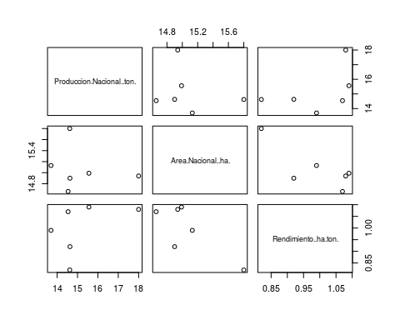

#PODEMOS VER SI EXISTEN DATOS NULOS EN EL DATAFRAME

is.na(cafe_df)

## Anio Departamento Producto Area..ha. Produccion..ton.  
## [1,] FALSE FALSE FALSE FALSE FALSE  
## [2,] FALSE FALSE FALSE FALSE FALSE  
## [3,] FALSE FALSE FALSE FALSE FALSE  
## [4,] FALSE FALSE FALSE FALSE FALSE  
## [5,] FALSE FALSE FALSE FALSE FALSE  
## [6,] FALSE FALSE FALSE FALSE FALSE  
## [7,] FALSE FALSE FALSE FALSE FALSE  
## [8,] FALSE FALSE FALSE FALSE FALSE  
## [9,] FALSE FALSE FALSE FALSE FALSE  
## [10,] FALSE FALSE FALSE FALSE FALSE  
## [11,] FALSE FALSE FALSE FALSE FALSE  
## [12,] FALSE FALSE FALSE FALSE FALSE  
## [13,] FALSE FALSE FALSE FALSE FALSE  
## [14,] FALSE FALSE FALSE FALSE FALSE  
## [15,] FALSE FALSE FALSE FALSE FALSE  
## [16,] FALSE FALSE FALSE FALSE FALSE  
## [17,] FALSE FALSE FALSE FALSE FALSE  
## [18,] FALSE FALSE FALSE FALSE FALSE  
## [19,] FALSE FALSE FALSE FALSE FALSE  
## [20,] FALSE FALSE FALSE FALSE FALSE  
## [21,] FALSE FALSE FALSE FALSE FALSE  
## [22,] FALSE FALSE FALSE FALSE FALSE  
## [23,] FALSE FALSE FALSE FALSE FALSE  
## [24,] FALSE FALSE FALSE FALSE FALSE  
## [25,] FALSE FALSE FALSE FALSE FALSE  
## [26,] FALSE FALSE FALSE FALSE FALSE  
## [27,] FALSE FALSE FALSE FALSE FALSE  
## [28,] FALSE FALSE FALSE FALSE FALSE  
## [29,] FALSE FALSE FALSE FALSE FALSE  
## [30,] FALSE FALSE FALSE FALSE FALSE  
## [31,] FALSE FALSE FALSE FALSE FALSE  
## [32,] FALSE FALSE FALSE FALSE FALSE  
## [33,] FALSE FALSE FALSE FALSE FALSE  
## [34,] FALSE FALSE FALSE FALSE FALSE  
## [35,] FALSE FALSE FALSE FALSE FALSE  
## [36,] FALSE FALSE FALSE FALSE FALSE  
## [37,] FALSE FALSE FALSE FALSE FALSE  
## [38,] FALSE FALSE FALSE FALSE FALSE  
## [39,] FALSE FALSE FALSE FALSE FALSE  
## [40,] FALSE FALSE FALSE FALSE FALSE  
## [41,] FALSE FALSE FALSE FALSE FALSE  
## [42,] FALSE FALSE FALSE FALSE FALSE  
## [43,] FALSE FALSE FALSE FALSE FALSE  
## [44,] FALSE FALSE FALSE FALSE FALSE  
## [45,] FALSE FALSE FALSE FALSE FALSE  
## [46,] FALSE FALSE FALSE FALSE FALSE  
## [47,] FALSE FALSE FALSE FALSE FALSE  
## [48,] FALSE FALSE FALSE FALSE FALSE  
## [49,] FALSE FALSE FALSE FALSE FALSE  
## [50,] FALSE FALSE FALSE FALSE FALSE  
## [51,] FALSE FALSE FALSE FALSE FALSE  
## [52,] FALSE FALSE FALSE FALSE FALSE  
## [53,] FALSE FALSE FALSE FALSE FALSE  
## [54,] FALSE FALSE FALSE FALSE FALSE  
## [55,] FALSE FALSE FALSE FALSE FALSE  
## [56,] FALSE FALSE FALSE FALSE FALSE  
## [57,] FALSE FALSE FALSE FALSE FALSE  
## [58,] FALSE FALSE FALSE FALSE FALSE  
## [59,] FALSE FALSE FALSE FALSE FALSE  
## [60,] FALSE FALSE FALSE FALSE FALSE  
## [61,] FALSE FALSE FALSE FALSE FALSE  
## [62,] FALSE FALSE FALSE FALSE FALSE  
## [63,] FALSE FALSE FALSE FALSE FALSE  
## [64,] FALSE FALSE FALSE FALSE FALSE  
## [65,] FALSE FALSE FALSE FALSE FALSE  
## [66,] FALSE FALSE FALSE FALSE FALSE  
## [67,] FALSE FALSE FALSE FALSE FALSE  
## [68,] FALSE FALSE FALSE FALSE FALSE  
## [69,] FALSE FALSE FALSE FALSE FALSE  
## [70,] FALSE FALSE FALSE FALSE FALSE  
## [71,] FALSE FALSE FALSE FALSE FALSE  
## [72,] FALSE FALSE FALSE FALSE FALSE  
## [73,] FALSE FALSE FALSE FALSE FALSE  
## [74,] FALSE FALSE FALSE FALSE FALSE  
## [75,] FALSE FALSE FALSE FALSE FALSE  
## [76,] FALSE FALSE FALSE FALSE FALSE  
## [77,] FALSE FALSE FALSE FALSE FALSE  
## [78,] FALSE FALSE FALSE FALSE FALSE  
## [79,] FALSE FALSE FALSE FALSE FALSE  
## [80,] FALSE FALSE FALSE FALSE FALSE  
## [81,] FALSE FALSE FALSE FALSE FALSE  
## [82,] FALSE FALSE FALSE FALSE FALSE  
## [83,] FALSE FALSE FALSE FALSE FALSE  
## [84,] FALSE FALSE FALSE FALSE FALSE  
## [85,] FALSE FALSE FALSE FALSE FALSE  
## [86,] FALSE FALSE FALSE FALSE FALSE  
## [87,] FALSE FALSE FALSE FALSE FALSE  
## [88,] FALSE FALSE FALSE FALSE FALSE  
## [89,] FALSE FALSE FALSE FALSE FALSE  
## [90,] FALSE FALSE FALSE FALSE FALSE  
## [91,] FALSE FALSE FALSE FALSE FALSE  
## [92,] FALSE FALSE FALSE FALSE FALSE  
## [93,] FALSE FALSE FALSE FALSE FALSE  
## [94,] FALSE FALSE FALSE FALSE FALSE  
## [95,] FALSE FALSE FALSE FALSE FALSE  
## [96,] FALSE FALSE FALSE FALSE FALSE  
## [97,] FALSE FALSE FALSE FALSE FALSE  
## [98,] FALSE FALSE FALSE FALSE FALSE  
## [99,] FALSE FALSE FALSE FALSE FALSE  
## [100,] FALSE FALSE FALSE FALSE FALSE  
## [101,] FALSE FALSE FALSE FALSE FALSE  
## [102,] FALSE FALSE FALSE FALSE FALSE  
## [103,] FALSE FALSE FALSE FALSE FALSE  
## [104,] FALSE FALSE FALSE FALSE FALSE  
## [105,] FALSE FALSE FALSE FALSE FALSE  
## [106,] FALSE FALSE FALSE FALSE FALSE  
## [107,] FALSE FALSE FALSE FALSE FALSE  
## [108,] FALSE FALSE FALSE FALSE FALSE  
## [109,] FALSE FALSE FALSE FALSE FALSE  
## [110,] FALSE FALSE FALSE FALSE FALSE  
## [111,] FALSE FALSE FALSE FALSE FALSE  
## [112,] FALSE FALSE FALSE FALSE FALSE  
## [113,] FALSE FALSE FALSE FALSE FALSE  
## [114,] FALSE FALSE FALSE FALSE FALSE  
## [115,] FALSE FALSE FALSE FALSE FALSE  
## [116,] FALSE FALSE FALSE FALSE FALSE  
## [117,] FALSE FALSE FALSE FALSE FALSE  
## [118,] FALSE FALSE FALSE FALSE FALSE  
## [119,] FALSE FALSE FALSE FALSE FALSE  
## [120,] FALSE FALSE FALSE FALSE FALSE  
## [121,] FALSE FALSE FALSE FALSE FALSE  
## [122,] FALSE FALSE FALSE FALSE FALSE  
## [123,] FALSE FALSE FALSE FALSE FALSE  
## [124,] FALSE FALSE FALSE FALSE FALSE  
## [125,] FALSE FALSE FALSE FALSE FALSE  
## [126,] FALSE FALSE FALSE FALSE FALSE  
## [127,] FALSE FALSE FALSE FALSE FALSE  
## [128,] FALSE FALSE FALSE FALSE FALSE  
## [129,] FALSE FALSE FALSE FALSE FALSE  
## [130,] FALSE FALSE FALSE FALSE FALSE  
## [131,] FALSE FALSE FALSE FALSE FALSE  
## [132,] FALSE FALSE FALSE FALSE FALSE  
## [133,] FALSE FALSE FALSE FALSE FALSE  
## [134,] FALSE FALSE FALSE FALSE FALSE  
## [135,] FALSE FALSE FALSE FALSE FALSE  
## [136,] FALSE FALSE FALSE FALSE FALSE  
## [137,] FALSE FALSE FALSE FALSE FALSE  
## [138,] FALSE FALSE FALSE FALSE FALSE  
## [139,] FALSE FALSE FALSE FALSE FALSE  
## [140,] FALSE FALSE FALSE FALSE FALSE  
## [141,] FALSE FALSE FALSE FALSE FALSE  
## [142,] FALSE FALSE FALSE FALSE FALSE  
## [143,] FALSE FALSE FALSE FALSE FALSE  
## [144,] FALSE FALSE FALSE FALSE FALSE  
## [145,] FALSE FALSE FALSE FALSE FALSE  
## [146,] FALSE FALSE FALSE FALSE FALSE  
## [147,] FALSE FALSE FALSE FALSE FALSE  
## [148,] FALSE FALSE FALSE FALSE FALSE  
## [149,] FALSE FALSE FALSE FALSE FALSE  
## [150,] FALSE FALSE FALSE FALSE FALSE  
## [151,] FALSE FALSE FALSE FALSE FALSE  
## [152,] FALSE FALSE FALSE FALSE FALSE  
## [153,] FALSE FALSE FALSE FALSE FALSE  
## [154,] FALSE FALSE FALSE FALSE FALSE  
## [155,] FALSE FALSE FALSE FALSE FALSE  
## [156,] FALSE FALSE FALSE FALSE FALSE  
## [157,] FALSE FALSE FALSE FALSE FALSE  
## [158,] FALSE FALSE FALSE FALSE FALSE  
## [159,] FALSE FALSE FALSE FALSE FALSE  
## [160,] FALSE FALSE FALSE FALSE FALSE  
## [161,] FALSE FALSE FALSE FALSE FALSE  
## [162,] FALSE FALSE FALSE FALSE FALSE  
## [163,] FALSE FALSE FALSE FALSE FALSE  
## [164,] FALSE FALSE FALSE FALSE FALSE  
## [165,] FALSE FALSE FALSE FALSE FALSE  
## [166,] FALSE FALSE FALSE FALSE FALSE  
## [167,] FALSE FALSE FALSE FALSE FALSE  
## [168,] FALSE FALSE FALSE FALSE FALSE  
## [169,] FALSE FALSE FALSE FALSE FALSE  
## [170,] FALSE FALSE FALSE FALSE FALSE  
## [171,] FALSE FALSE FALSE FALSE FALSE  
## [172,] FALSE FALSE FALSE FALSE FALSE  
## [173,] FALSE FALSE FALSE FALSE FALSE  
## [174,] FALSE FALSE FALSE FALSE FALSE  
## [175,] FALSE FALSE FALSE FALSE FALSE  
## [176,] FALSE FALSE FALSE FALSE FALSE  
## [177,] FALSE FALSE FALSE FALSE FALSE  
## [178,] FALSE FALSE FALSE FALSE FALSE  
## [179,] FALSE FALSE FALSE FALSE FALSE  
## [180,] FALSE FALSE FALSE FALSE FALSE  
## [181,] FALSE FALSE FALSE FALSE FALSE  
## [182,] FALSE FALSE FALSE FALSE FALSE  
## [183,] FALSE FALSE FALSE FALSE FALSE  
## [184,] FALSE FALSE FALSE FALSE FALSE  
## [185,] FALSE FALSE FALSE FALSE FALSE  
## [186,] FALSE FALSE FALSE FALSE FALSE  
## [187,] FALSE FALSE FALSE FALSE FALSE  
## [188,] FALSE FALSE FALSE FALSE FALSE  
## [189,] FALSE FALSE FALSE FALSE FALSE  
## [190,] FALSE FALSE FALSE FALSE FALSE  
## [191,] FALSE FALSE FALSE FALSE FALSE  
## [192,] FALSE FALSE FALSE FALSE FALSE  
## [193,] FALSE FALSE FALSE FALSE FALSE  
## [194,] FALSE FALSE FALSE FALSE FALSE  
## [195,] FALSE FALSE FALSE FALSE FALSE  
## [196,] FALSE FALSE FALSE FALSE FALSE  
## [197,] FALSE FALSE FALSE FALSE FALSE  
## [198,] FALSE FALSE FALSE FALSE FALSE  
## [199,] FALSE FALSE FALSE FALSE FALSE  
## [200,] FALSE FALSE FALSE FALSE FALSE  
## [201,] FALSE FALSE FALSE FALSE FALSE  
## [202,] FALSE FALSE FALSE FALSE FALSE  
## [203,] FALSE FALSE FALSE FALSE FALSE  
## [204,] FALSE FALSE FALSE FALSE FALSE  
## [205,] FALSE FALSE FALSE FALSE FALSE  
## [206,] FALSE FALSE FALSE FALSE FALSE  
## [207,] FALSE FALSE FALSE FALSE FALSE  
## [208,] FALSE FALSE FALSE FALSE FALSE  
## [209,] FALSE FALSE FALSE FALSE FALSE  
## [210,] FALSE FALSE FALSE FALSE FALSE  
## [211,] FALSE FALSE FALSE FALSE FALSE  
## [212,] FALSE FALSE FALSE FALSE FALSE  
## [213,] FALSE FALSE FALSE FALSE FALSE  
## [214,] FALSE FALSE FALSE FALSE FALSE  
## [215,] FALSE FALSE FALSE FALSE FALSE  
## [216,] FALSE FALSE FALSE FALSE FALSE  
## [217,] FALSE FALSE FALSE FALSE FALSE  
## [218,] FALSE FALSE FALSE FALSE FALSE  
## [219,] FALSE FALSE FALSE FALSE FALSE  
## [220,] FALSE FALSE FALSE FALSE FALSE  
## [221,] FALSE FALSE FALSE FALSE FALSE  
## [222,] FALSE FALSE FALSE FALSE FALSE  
## [223,] FALSE FALSE FALSE FALSE FALSE  
## [224,] FALSE FALSE FALSE FALSE FALSE  
## [225,] FALSE FALSE FALSE FALSE FALSE  
## [226,] FALSE FALSE FALSE FALSE FALSE  
## [227,] FALSE FALSE FALSE FALSE FALSE  
## [228,] FALSE FALSE FALSE FALSE FALSE  
## [229,] FALSE FALSE FALSE FALSE FALSE  
## [230,] FALSE FALSE FALSE FALSE FALSE  
## [231,] FALSE FALSE FALSE FALSE FALSE  
## [232,] FALSE FALSE FALSE FALSE FALSE  
## [233,] FALSE FALSE FALSE FALSE FALSE  
## [234,] FALSE FALSE FALSE FALSE FALSE  
## [235,] FALSE FALSE FALSE FALSE FALSE  
## [236,] FALSE FALSE FALSE FALSE FALSE  
## [237,] FALSE FALSE FALSE FALSE FALSE  
## [238,] FALSE FALSE FALSE FALSE FALSE  
## [239,] FALSE FALSE FALSE FALSE FALSE  
## [240,] FALSE FALSE FALSE FALSE FALSE  
## [241,] FALSE FALSE FALSE FALSE FALSE  
## [242,] FALSE FALSE FALSE FALSE FALSE  
## [243,] FALSE FALSE FALSE FALSE FALSE  
## [244,] FALSE FALSE FALSE FALSE FALSE  
## [245,] FALSE FALSE FALSE FALSE FALSE  
## [246,] FALSE FALSE FALSE FALSE FALSE  
## [247,] FALSE FALSE FALSE FALSE FALSE  
## [248,] FALSE FALSE FALSE FALSE FALSE  
## [249,] FALSE FALSE FALSE FALSE FALSE  
## [250,] FALSE FALSE FALSE FALSE FALSE  
## [251,] FALSE FALSE FALSE FALSE FALSE  
## [252,] FALSE FALSE FALSE FALSE FALSE  
## [253,] FALSE FALSE FALSE FALSE FALSE  
## [254,] FALSE FALSE FALSE FALSE FALSE  
## [255,] FALSE FALSE FALSE FALSE FALSE  
## [256,] FALSE FALSE FALSE FALSE FALSE  
## [257,] FALSE FALSE FALSE FALSE FALSE  
## [258,] FALSE FALSE FALSE FALSE FALSE  
## [259,] FALSE FALSE FALSE FALSE FALSE  
## [260,] FALSE FALSE FALSE FALSE FALSE  
## [261,] FALSE FALSE FALSE FALSE FALSE  
## [262,] FALSE FALSE FALSE FALSE FALSE  
## [263,] FALSE FALSE FALSE FALSE FALSE  
## [264,] FALSE FALSE FALSE FALSE FALSE  
## [265,] FALSE FALSE FALSE FALSE FALSE  
## [266,] FALSE FALSE FALSE FALSE FALSE  
## Rendimiento..ha.ton. Produccion.Nacional..ton. Area.Nacional..ha.  
## [1,] FALSE FALSE FALSE  
## [2,] FALSE FALSE FALSE  
## [3,] FALSE FALSE FALSE  
## [4,] FALSE FALSE FALSE  
## [5,] FALSE FALSE FALSE  
## [6,] FALSE FALSE FALSE  
## [7,] FALSE FALSE FALSE  
## [8,] FALSE FALSE FALSE  
## [9,] FALSE FALSE FALSE  
## [10,] FALSE FALSE FALSE  
## [11,] FALSE FALSE FALSE  
## [12,] FALSE FALSE FALSE  
## [13,] FALSE FALSE FALSE  
## [14,] FALSE FALSE FALSE  
## [15,] FALSE FALSE FALSE  
## [16,] FALSE FALSE FALSE  
## [17,] FALSE FALSE FALSE  
## [18,] FALSE FALSE FALSE  
## [19,] FALSE FALSE FALSE  
## [20,] FALSE FALSE FALSE  
## [21,] FALSE FALSE FALSE  
## [22,] FALSE FALSE FALSE  
## [23,] FALSE FALSE FALSE  
## [24,] FALSE FALSE FALSE  
## [25,] FALSE FALSE FALSE  
## [26,] FALSE FALSE FALSE  
## [27,] FALSE FALSE FALSE  
## [28,] FALSE FALSE FALSE  
## [29,] FALSE FALSE FALSE  
## [30,] FALSE FALSE FALSE  
## [31,] FALSE FALSE FALSE  
## [32,] FALSE FALSE FALSE  
## [33,] FALSE FALSE FALSE  
## [34,] FALSE FALSE FALSE  
## [35,] FALSE FALSE FALSE  
## [36,] FALSE FALSE FALSE  
## [37,] FALSE FALSE FALSE  
## [38,] FALSE FALSE FALSE  
## [39,] FALSE FALSE FALSE  
## [40,] FALSE FALSE FALSE  
## [41,] FALSE FALSE FALSE  
## [42,] FALSE FALSE FALSE  
## [43,] FALSE FALSE FALSE  
## [44,] FALSE FALSE FALSE  
## [45,] FALSE FALSE FALSE  
## [46,] FALSE FALSE FALSE  
## [47,] FALSE FALSE FALSE  
## [48,] FALSE FALSE FALSE  
## [49,] FALSE FALSE FALSE  
## [50,] FALSE FALSE FALSE  
## [51,] FALSE FALSE FALSE  
## [52,] FALSE FALSE FALSE  
## [53,] FALSE FALSE FALSE  
## [54,] FALSE FALSE FALSE  
## [55,] FALSE FALSE FALSE  
## [56,] FALSE FALSE FALSE  
## [57,] FALSE FALSE FALSE  
## [58,] FALSE FALSE FALSE  
## [59,] FALSE FALSE FALSE  
## [60,] FALSE FALSE FALSE  
## [61,] FALSE FALSE FALSE  
## [62,] FALSE FALSE FALSE  
## [63,] FALSE FALSE FALSE  
## [64,] FALSE FALSE FALSE  
## [65,] FALSE FALSE FALSE  
## [66,] FALSE FALSE FALSE  
## [67,] FALSE FALSE FALSE  
## [68,] FALSE FALSE FALSE  
## [69,] FALSE FALSE FALSE  
## [70,] FALSE FALSE FALSE  
## [71,] FALSE FALSE FALSE  
## [72,] FALSE FALSE FALSE  
## [73,] FALSE FALSE FALSE  
## [74,] FALSE FALSE FALSE  
## [75,] FALSE FALSE FALSE  
## [76,] FALSE FALSE FALSE  
## [77,] FALSE FALSE FALSE  
## [78,] FALSE FALSE FALSE  
## [79,] FALSE FALSE FALSE  
## [80,] FALSE FALSE FALSE  
## [81,] FALSE FALSE FALSE  
## [82,] FALSE FALSE FALSE  
## [83,] FALSE FALSE FALSE  
## [84,] FALSE FALSE FALSE  
## [85,] FALSE FALSE FALSE  
## [86,] FALSE FALSE FALSE  
## [87,] FALSE FALSE FALSE  
## [88,] FALSE FALSE FALSE  
## [89,] FALSE FALSE FALSE  
## [90,] FALSE FALSE FALSE  
## [91,] FALSE FALSE FALSE  
## [92,] FALSE FALSE FALSE  
## [93,] FALSE FALSE FALSE  
## [94,] FALSE FALSE FALSE  
## [95,] FALSE FALSE FALSE  
## [96,] FALSE FALSE FALSE  
## [97,] FALSE FALSE FALSE  
## [98,] FALSE FALSE FALSE  
## [99,] FALSE FALSE FALSE  
## [100,] FALSE FALSE FALSE  
## [101,] FALSE FALSE FALSE  
## [102,] FALSE FALSE FALSE  
## [103,] FALSE FALSE FALSE  
## [104,] FALSE FALSE FALSE  
## [105,] FALSE FALSE FALSE  
## [106,] FALSE FALSE FALSE  
## [107,] FALSE FALSE FALSE  
## [108,] FALSE FALSE FALSE  
## [109,] FALSE FALSE FALSE  
## [110,] FALSE FALSE FALSE  
## [111,] FALSE FALSE FALSE  
## [112,] FALSE FALSE FALSE  
## [113,] FALSE FALSE FALSE  
## [114,] FALSE FALSE FALSE  
## [115,] FALSE FALSE FALSE  
## [116,] FALSE FALSE FALSE  
## [117,] FALSE FALSE FALSE  
## [118,] FALSE FALSE FALSE  
## [119,] FALSE FALSE FALSE  
## [120,] FALSE FALSE FALSE  
## [121,] FALSE FALSE FALSE  
## [122,] FALSE FALSE FALSE  
## [123,] FALSE FALSE FALSE  
## [124,] FALSE FALSE FALSE  
## [125,] FALSE FALSE FALSE  
## [126,] FALSE FALSE FALSE  
## [127,] FALSE FALSE FALSE  
## [128,] FALSE FALSE FALSE  
## [129,] FALSE FALSE FALSE  
## [130,] FALSE FALSE FALSE  
## [131,] FALSE FALSE FALSE  
## [132,] FALSE FALSE FALSE  
## [133,] FALSE FALSE FALSE  
## [134,] FALSE FALSE FALSE  
## [135,] FALSE FALSE FALSE  
## [136,] FALSE FALSE FALSE  
## [137,] FALSE FALSE FALSE  
## [138,] FALSE FALSE FALSE  
## [139,] FALSE FALSE FALSE  
## [140,] FALSE FALSE FALSE  
## [141,] FALSE FALSE FALSE  
## [142,] FALSE FALSE FALSE  
## [143,] FALSE FALSE FALSE  
## [144,] FALSE FALSE FALSE  
## [145,] FALSE FALSE FALSE  
## [146,] FALSE FALSE FALSE  
## [147,] FALSE FALSE FALSE  
## [148,] FALSE FALSE FALSE  
## [149,] FALSE FALSE FALSE  
## [150,] FALSE FALSE FALSE  
## [151,] FALSE FALSE FALSE  
## [152,] FALSE FALSE FALSE  
## [153,] FALSE FALSE FALSE  
## [154,] FALSE FALSE FALSE  
## [155,] FALSE FALSE FALSE  
## [156,] FALSE FALSE FALSE  
## [157,] FALSE FALSE FALSE  
## [158,] FALSE FALSE FALSE  
## [159,] FALSE FALSE FALSE  
## [160,] FALSE FALSE FALSE  
## [161,] FALSE FALSE FALSE  
## [162,] FALSE FALSE FALSE  
## [163,] FALSE FALSE FALSE  
## [164,] FALSE FALSE FALSE  
## [165,] FALSE FALSE FALSE  
## [166,] FALSE FALSE FALSE  
## [167,] FALSE FALSE FALSE  
## [168,] FALSE FALSE FALSE  
## [169,] FALSE FALSE FALSE  
## [170,] FALSE FALSE FALSE  
## [171,] FALSE FALSE FALSE  
## [172,] FALSE FALSE FALSE  
## [173,] FALSE FALSE FALSE  
## [174,] FALSE FALSE FALSE  
## [175,] FALSE FALSE FALSE  
## [176,] FALSE FALSE FALSE  
## [177,] FALSE FALSE FALSE  
## [178,] FALSE FALSE FALSE  
## [179,] FALSE FALSE FALSE  
## [180,] FALSE FALSE FALSE  
## [181,] FALSE FALSE FALSE  
## [182,] FALSE FALSE FALSE  
## [183,] FALSE FALSE FALSE  
## [184,] FALSE FALSE FALSE  
## [185,] FALSE FALSE FALSE  
## [186,] FALSE FALSE FALSE  
## [187,] FALSE FALSE FALSE  
## [188,] FALSE FALSE FALSE  
## [189,] FALSE FALSE FALSE  
## [190,] FALSE FALSE FALSE  
## [191,] FALSE FALSE FALSE  
## [192,] FALSE FALSE FALSE  
## [193,] FALSE FALSE FALSE  
## [194,] FALSE FALSE FALSE  
## [195,] FALSE FALSE FALSE  
## [196,] FALSE FALSE FALSE  
## [197,] FALSE FALSE FALSE  
## [198,] FALSE FALSE FALSE  
## [199,] FALSE FALSE FALSE  
## [200,] FALSE FALSE FALSE  
## [201,] FALSE FALSE FALSE  
## [202,] FALSE FALSE FALSE  
## [203,] FALSE FALSE FALSE  
## [204,] FALSE FALSE FALSE  
## [205,] FALSE FALSE FALSE  
## [206,] FALSE FALSE FALSE  
## [207,] FALSE FALSE FALSE  
## [208,] FALSE FALSE FALSE  
## [209,] FALSE FALSE FALSE  
## [210,] FALSE FALSE FALSE  
## [211,] FALSE FALSE FALSE  
## [212,] FALSE FALSE FALSE  
## [213,] FALSE FALSE FALSE  
## [214,] FALSE FALSE FALSE  
## [215,] FALSE FALSE FALSE  
## [216,] FALSE FALSE FALSE  
## [217,] FALSE FALSE FALSE  
## [218,] FALSE FALSE FALSE  
## [219,] FALSE FALSE FALSE  
## [220,] FALSE FALSE FALSE  
## [221,] FALSE FALSE FALSE  
## [222,] FALSE FALSE FALSE  
## [223,] FALSE FALSE FALSE  
## [224,] FALSE FALSE FALSE  
## [225,] FALSE FALSE FALSE  
## [226,] FALSE FALSE FALSE  
## [227,] FALSE FALSE FALSE  
## [228,] FALSE FALSE FALSE  
## [229,] FALSE FALSE FALSE  
## [230,] FALSE FALSE FALSE  
## [231,] FALSE FALSE FALSE  
## [232,] FALSE FALSE FALSE  
## [233,] FALSE FALSE FALSE  
## [234,] FALSE FALSE FALSE  
## [235,] FALSE FALSE FALSE  
## [236,] FALSE FALSE FALSE  
## [237,] FALSE FALSE FALSE  
## [238,] FALSE FALSE FALSE  
## [239,] FALSE FALSE FALSE  
## [240,] FALSE FALSE FALSE  
## [241,] FALSE FALSE FALSE  
## [242,] FALSE FALSE FALSE  
## [243,] FALSE FALSE FALSE  
## [244,] FALSE FALSE FALSE  
## [245,] FALSE FALSE FALSE  
## [246,] FALSE FALSE FALSE  
## [247,] FALSE FALSE FALSE  
## [248,] FALSE FALSE FALSE  
## [249,] FALSE FALSE FALSE  
## [250,] FALSE FALSE FALSE  
## [251,] FALSE FALSE FALSE  
## [252,] FALSE FALSE FALSE  
## [253,] FALSE FALSE FALSE  
## [254,] FALSE FALSE FALSE  
## [255,] FALSE FALSE FALSE  
## [256,] FALSE FALSE FALSE  
## [257,] FALSE FALSE FALSE  
## [258,] FALSE FALSE FALSE  
## [259,] FALSE FALSE FALSE  
## [260,] FALSE FALSE FALSE  
## [261,] FALSE FALSE FALSE  
## [262,] FALSE FALSE FALSE  
## [263,] FALSE FALSE FALSE  
## [264,] FALSE FALSE FALSE  
## [265,] FALSE FALSE FALSE  
## [266,] FALSE FALSE FALSE

is.na(cafe_df$Area..ha.)

## [1] FALSE FALSE FALSE FALSE FALSE FALSE FALSE FALSE FALSE FALSE FALSE FALSE  
## [13] FALSE FALSE FALSE FALSE FALSE FALSE FALSE FALSE FALSE FALSE FALSE FALSE  
## [25] FALSE FALSE FALSE FALSE FALSE FALSE FALSE FALSE FALSE FALSE FALSE FALSE  
## [37] FALSE FALSE FALSE FALSE FALSE FALSE FALSE FALSE FALSE FALSE FALSE FALSE  
## [49] FALSE FALSE FALSE FALSE FALSE FALSE FALSE FALSE FALSE FALSE FALSE FALSE  
## [61] FALSE FALSE FALSE FALSE FALSE FALSE FALSE FALSE FALSE FALSE FALSE FALSE  
## [73] FALSE FALSE FALSE FALSE FALSE FALSE FALSE FALSE FALSE FALSE FALSE FALSE  
## [85] FALSE FALSE FALSE FALSE FALSE FALSE FALSE FALSE FALSE FALSE FALSE FALSE  
## [97] FALSE FALSE FALSE FALSE FALSE FALSE FALSE FALSE FALSE FALSE FALSE FALSE  
## [109] FALSE FALSE FALSE FALSE FALSE FALSE FALSE FALSE FALSE FALSE FALSE FALSE  
## [121] FALSE FALSE FALSE FALSE FALSE FALSE FALSE FALSE FALSE FALSE FALSE FALSE  
## [133] FALSE FALSE FALSE FALSE FALSE FALSE FALSE FALSE FALSE FALSE FALSE FALSE  
## [145] FALSE FALSE FALSE FALSE FALSE FALSE FALSE FALSE FALSE FALSE FALSE FALSE  
## [157] FALSE FALSE FALSE FALSE FALSE FALSE FALSE FALSE FALSE FALSE FALSE FALSE  
## [169] FALSE FALSE FALSE FALSE FALSE FALSE FALSE FALSE FALSE FALSE FALSE FALSE  
## [181] FALSE FALSE FALSE FALSE FALSE FALSE FALSE FALSE FALSE FALSE FALSE FALSE  
## [193] FALSE FALSE FALSE FALSE FALSE FALSE FALSE FALSE FALSE FALSE FALSE FALSE  
## [205] FALSE FALSE FALSE FALSE FALSE FALSE FALSE FALSE FALSE FALSE FALSE FALSE  
## [217] FALSE FALSE FALSE FALSE FALSE FALSE FALSE FALSE FALSE FALSE FALSE FALSE  
## [229] FALSE FALSE FALSE FALSE FALSE FALSE FALSE FALSE FALSE FALSE FALSE FALSE  
## [241] FALSE FALSE FALSE FALSE FALSE FALSE FALSE FALSE FALSE FALSE FALSE FALSE  
## [253] FALSE FALSE FALSE FALSE FALSE FALSE FALSE FALSE FALSE FALSE FALSE FALSE  
## [265] FALSE FALSE

is.na(cafe_df$Rendimiento..ha.ton.)

## [1] FALSE FALSE FALSE FALSE FALSE FALSE FALSE FALSE FALSE FALSE FALSE FALSE  
## [13] FALSE FALSE FALSE FALSE FALSE FALSE FALSE FALSE FALSE FALSE FALSE FALSE  
## [25] FALSE FALSE FALSE FALSE FALSE FALSE FALSE FALSE FALSE FALSE FALSE FALSE  
## [37] FALSE FALSE FALSE FALSE FALSE FALSE FALSE FALSE FALSE FALSE FALSE FALSE  
## [49] FALSE FALSE FALSE FALSE FALSE FALSE FALSE FALSE FALSE FALSE FALSE FALSE  
## [61] FALSE FALSE FALSE FALSE FALSE FALSE FALSE FALSE FALSE FALSE FALSE FALSE  
## [73] FALSE FALSE FALSE FALSE FALSE FALSE FALSE FALSE FALSE FALSE FALSE FALSE  
## [85] FALSE FALSE FALSE FALSE FALSE FALSE FALSE FALSE FALSE FALSE FALSE FALSE  
## [97] FALSE FALSE FALSE FALSE FALSE FALSE FALSE FALSE FALSE FALSE FALSE FALSE  
## [109] FALSE FALSE FALSE FALSE FALSE FALSE FALSE FALSE FALSE FALSE FALSE FALSE  
## [121] FALSE FALSE FALSE FALSE FALSE FALSE FALSE FALSE FALSE FALSE FALSE FALSE  
## [133] FALSE FALSE FALSE FALSE FALSE FALSE FALSE FALSE FALSE FALSE FALSE FALSE  
## [145] FALSE FALSE FALSE FALSE FALSE FALSE FALSE FALSE FALSE FALSE FALSE FALSE  
## [157] FALSE FALSE FALSE FALSE FALSE FALSE FALSE FALSE FALSE FALSE FALSE FALSE  
## [169] FALSE FALSE FALSE FALSE FALSE FALSE FALSE FALSE FALSE FALSE FALSE FALSE  
## [181] FALSE FALSE FALSE FALSE FALSE FALSE FALSE FALSE FALSE FALSE FALSE FALSE  
## [193] FALSE FALSE FALSE FALSE FALSE FALSE FALSE FALSE FALSE FALSE FALSE FALSE  
## [205] FALSE FALSE FALSE FALSE FALSE FALSE FALSE FALSE FALSE FALSE FALSE FALSE  
## [217] FALSE FALSE FALSE FALSE FALSE FALSE FALSE FALSE FALSE FALSE FALSE FALSE  
## [229] FALSE FALSE FALSE FALSE FALSE FALSE FALSE FALSE FALSE FALSE FALSE FALSE  
## [241] FALSE FALSE FALSE FALSE FALSE FALSE FALSE FALSE FALSE FALSE FALSE FALSE  
## [253] FALSE FALSE FALSE FALSE FALSE FALSE FALSE FALSE FALSE FALSE FALSE FALSE  
## [265] FALSE FALSE

#NOS MUESTRA LA SUMA DE LOS VALORES NULOS EN EL DATAFRAME

rowSums(is.na(cafe_df))

## [1] 0 0 0 0 0 0 0 0 0 0 0 0 0 0 0 0 0 0 0 0 0 0 0 0 0 0 0 0 0 0 0 0 0 0 0 0 0  
## [38] 0 0 0 0 0 0 0 0 0 0 0 0 0 0 0 0 0 0 0 0 0 0 0 0 0 0 0 0 0 0 0 0 0 0 0 0 0  
## [75] 0 0 0 0 0 0 0 0 0 0 0 0 0 0 0 0 0 0 0 0 0 0 0 0 0 0 0 0 0 0 0 0 0 0 0 0 0  
## [112] 0 0 0 0 0 0 0 0 0 0 0 0 0 0 0 0 0 0 0 0 0 0 0 0 0 0 0 0 0 0 0 0 0 0 0 0 0  
## [149] 0 0 0 0 0 0 0 0 0 0 0 0 0 0 0 0 0 0 0 0 0 0 0 0 0 0 0 0 0 0 0 0 0 0 0 0 0  
## [186] 0 0 0 0 0 0 0 0 0 0 0 0 0 0 0 0 0 0 0 0 0 0 0 0 0 0 0 0 0 0 0 0 0 0 0 0 0  
## [223] 0 0 0 0 0 0 0 0 0 0 0 0 0 0 0 0 0 0 0 0 0 0 0 0 0 0 0 0 0 0 0 0 0 0 0 0 0  
## [260] 0 0 0 0 0 0 0

#NOS MUESTRA LA SUMA TOTAL DE TODOS LOS VALORES NULOS

sum(rowSums(is.na(cafe_df)))

## [1] 0

#VISUALIZAMOS HISTOGRAMAS POR VARIABLE

plot(cafe_df$Rendimiento..ha.ton.)

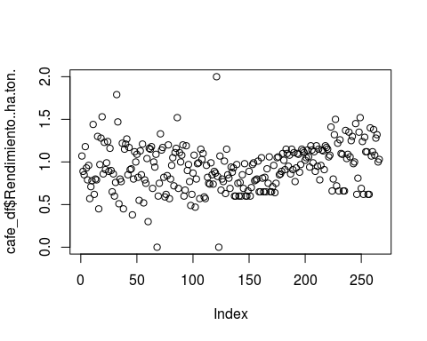

#GRAFICAMOS LA VARIABLE Y SELECCIONAMOS ALGUNOS DETALLES

plot(cafe_df$Rendimiento..ha.ton., main ="Gráfico Dispersion",   
 sub ="CANTIDAD",  
 type ="p", # p indica puntos de dispersion  
 col ="red",  
 xlab ="cantidad",  
 ylab = "Rendimiento (ha/ton)")

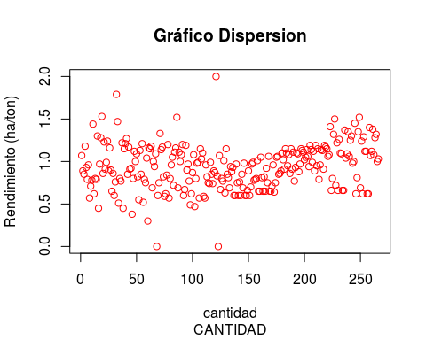

plot(cafe_df$Rendimiento..ha.ton., main ="Gráfico Dispersion",   
 sub ="Indices",  
 type ="b", # b indica lineas uniendo los puntos de dispersion  
 col ="red",  
 xlab ="cantidad",  
 ylab = "Rendimiento (ha/ton)")

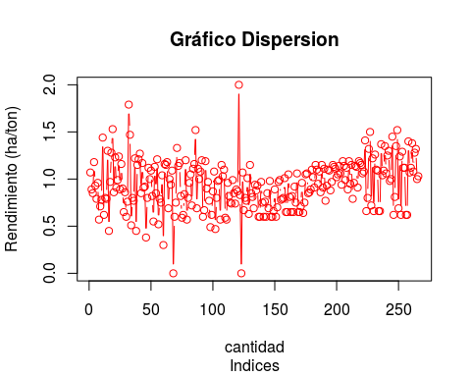

plot(cafe_df$Rendimiento..ha.ton., main ="Gráfico Dispersion",   
 sub ="Indices",  
 type ="o", # b indica lineas sobreindicadas sobre los puntos de dispersion  
 col ="blue",  
 xlab ="cantidad",  
 ylab = "Rendimiento (ha/ton)")

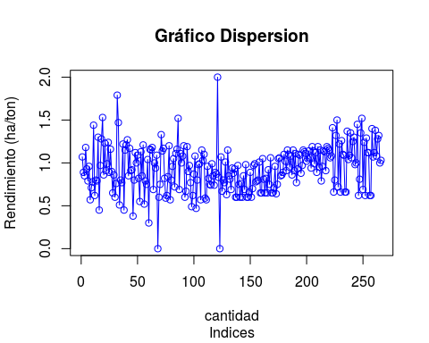

plot(cafe_df$Rendimiento..ha.ton., main ="Gráfico Dispersion",   
 sub ="Indices",  
 type ="h", # b indica lineas tipo histograma sobre los puntos de dispersion  
 col ="blue",  
 xlab ="cantidad",  
 ylab = "Rendimiento (ha/ton)")

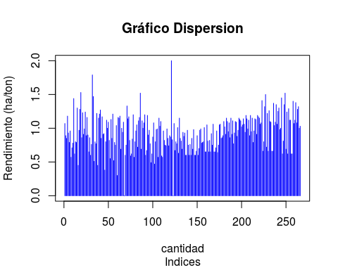

plot(cafe_df$Rendimiento..ha.ton., main ="Gráfico Dispersion",   
 sub ="Indices",  
 type ="s", # s funcion escalera (horizontal a vertical)  
 col ="blue",  
 xlab ="cantidad",  
 ylab = "Rendimiento (ha/ton)")

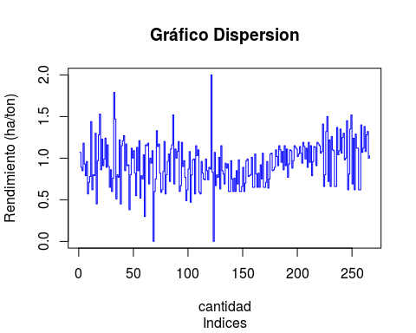

plot(cafe_df$Rendimiento..ha.ton., main ="Gráfico Dispersion",   
 sub ="Indices",  
 type ="l", # l indica lineas   
 col ="blue",  
 xlab ="cantidad",  
 ylab = "Rendimiento (ha/ton)")

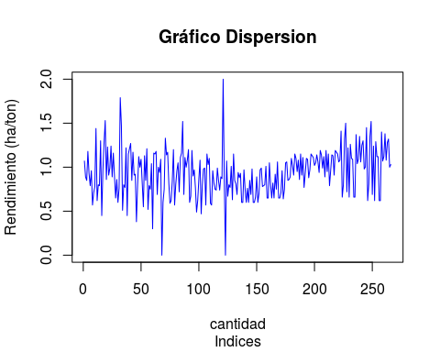

#GRAFICAS POR VARIABLES

plot(x = cafe_df$Area..ha., y = cafe_df$Rendimiento..ha.ton.)

## Warning in xy.coords(x, y, xlabel, ylabel, log): NAs introduced by coercion

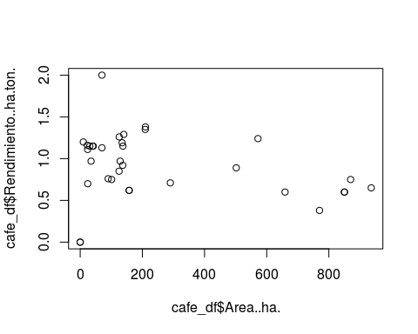

plot(x = cafe_df$Area..ha., y = cafe_df$Area.Nacional..ha.)

## Warning in xy.coords(x, y, xlabel, ylabel, log): NAs introduced by coercion

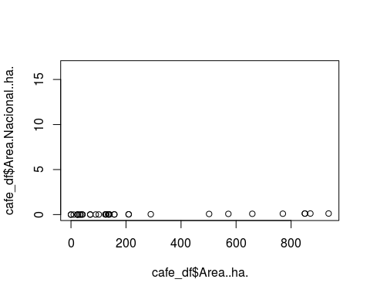

plot(x = cafe_df$Anio, y = cafe_df$Rendimiento..ha.ton.)

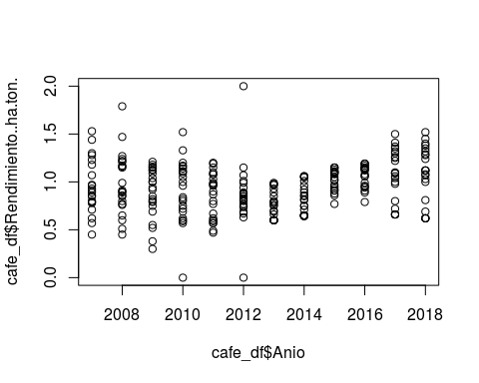

plot(x = cafe_df$Anio, y = cafe_df$Produccion..ton.)

## Warning in xy.coords(x, y, xlabel, ylabel, log): NAs introduced by coercion

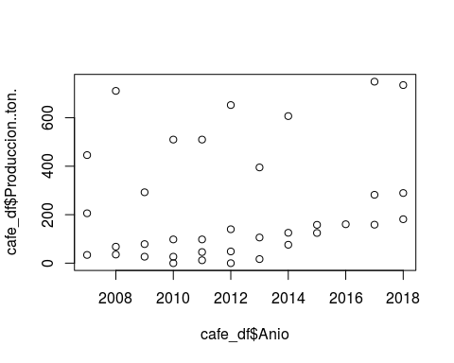

plot(x = cafe_df$Area..ha., y = cafe_df$Produccion.Nacional..ton.)

## Warning in xy.coords(x, y, xlabel, ylabel, log): NAs introduced by coercion

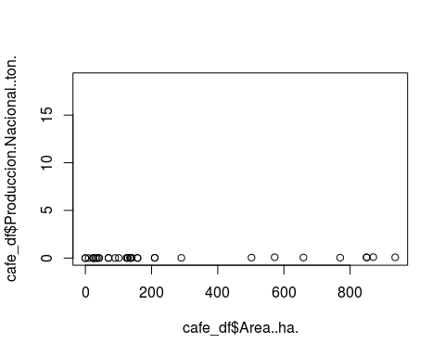

plot(cafe_df$Area..ha.)

## Warning in xy.coords(x, y, xlabel, ylabel, log): NAs introduced by coercion

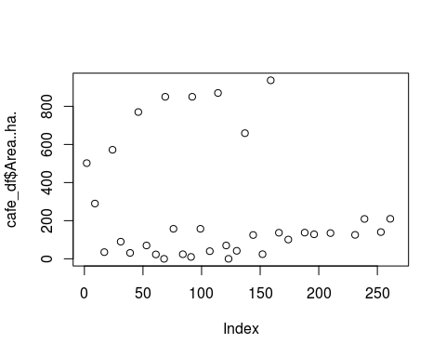

#REPRESENTA LA FRECUENCIA DE LOS DATOS EN UN HISTOGRAMA

hist(cafe_df$Rendimiento..ha.ton., main ="Histograma",   
 sub ="Rendimiento (ha/ton)",  
 col ="red",  
 xlab ="Cantidad (miles) ",  
 ylab = "Frecuencia")

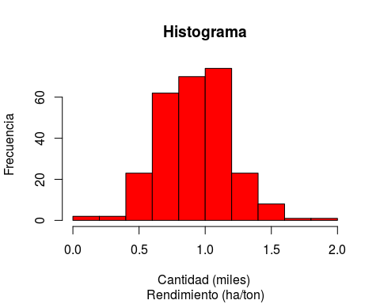

#DIAGRAMA DE BARRAS DE LA COLUMNA RENDIMIENTO

barplot(table(cafe_df$Rendimiento..ha.ton.))

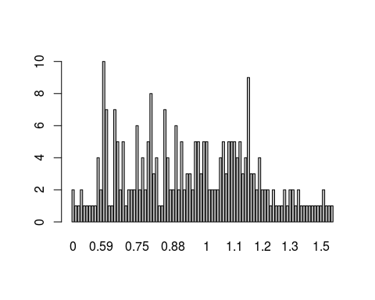

#PARA VER COMO SE DISTRUBUYEN LOS DATOS PODEMOS USAR LA FUNCION DENSITY, LA DENSIDAD ES UNA VERSION SUAVIZASA DEL HISTOGRAMA, NOS PERMITE OBSERVAR SI LOS DATOS SE COMPORTAN COMO UNA DISTRIBUCION NORMAL

plot(density(cafe_df$Rendimiento..ha.ton.), main="Densidad para el Rendimiento (ha/ton)")

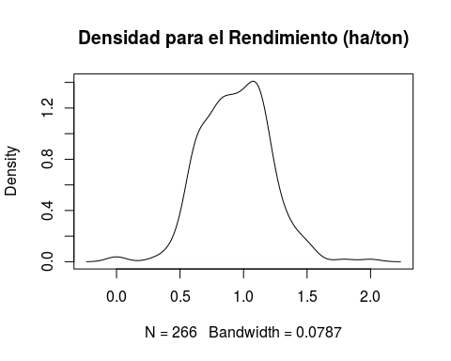

plot(density(cafe_df$Produccion.Nacional..ton.), main="Densidad para la produccion Nacional (ton)")

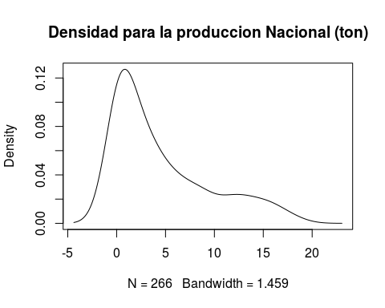

plot(density(cafe_df$Area.Nacional..ha.), main="Densidad para el Area Nacional (ha)")

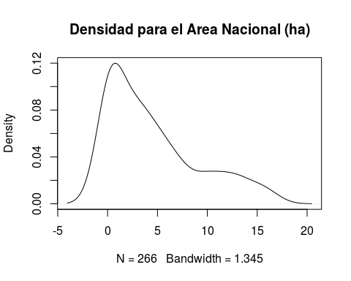

#HACEMOS UN GRAFICO DE PASTEL

pie(table(cafe_df$Departamento[1:10]))

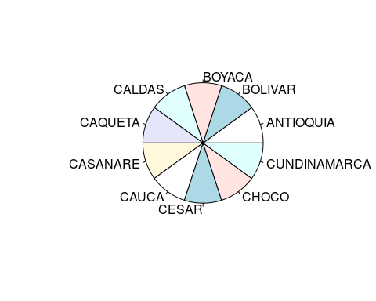

pie(table(cafe_df$Rendimiento..ha.ton.[1:10]))

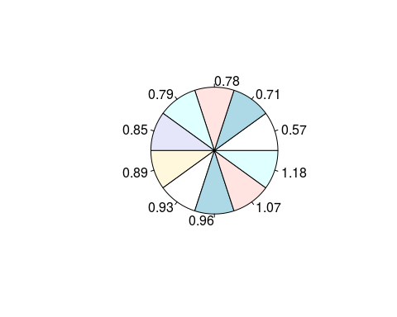

#LOS BOXPLOTS O DIAGRAMAS DE CAJA SE CONTRIBUYEN A PARTIR DE LOS PERCENTILES. #SE CONSTRUYE UN RECTANGULO USANDO ENTRE EL PRIMER Y EL TERCER CUARTIL. #LA ALTURA DEL RECTANGULO ES EL RANGO INTERCUARTIL. #LA MEDIANA ES UNA LINEA QUE DIVIDE EL RECTANGULO- #LOS VALORES MAS EXTREMOS QUE EL LARGO DE LOS BRAZOS SON CONSIDERADOS ATIPICOS #EL BOXPLOT NOS ENTREGA INFORMACION SOBRE LA SIMETRIA DE LA DISTRIBUCION DE LOS DATOS, SI LA MEDIANA NO ESTA EN EL CENTRO DEL RECTANGULO LA DISTRIBUCION NO ES SIMETRICRA. #SON UTILES PARA VER LA PRESENCIA DE VALORES ATIPICOS O OUTLERS

boxplot(cafe_df$Rendimiento..ha.ton.,ylab="Rendimiento (ha/ton)")

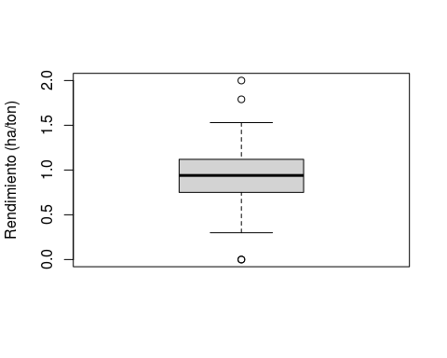

boxplot(cafe_df$Produccion.Nacional..ton.,ylab="Produccion Nacional (ton)")

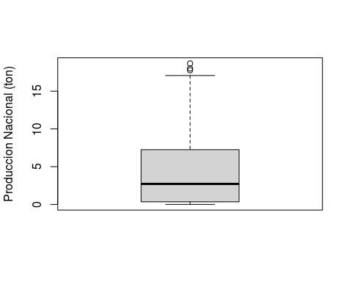

#SELECCIONAR POR RANGOS

boxplot(x=cafe_df$Rendimiento..ha.ton.[1:10],main="Rendimiento (ha/ton)")

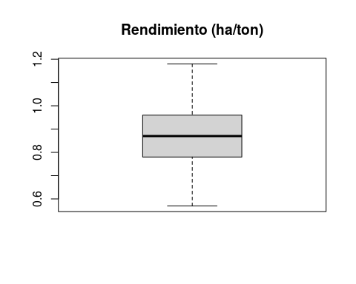

#CON LA FUNCION HEXBIN SE PUEDE MEJORAR LA PRESENTACION Y LECTURA DE LOS GRAFICOS. #SE CREA EL OBJETO BIN CON LA RELACION DE DOS VARIABLES

bin1<-hexbin(cafe_df$Produccion..ton.,cafe_df$Rendimiento..ha.ton., xbins=10)

## Warning in xy.coords(x, y, xl, yl): NAs introduced by coercion

plot(bin1)

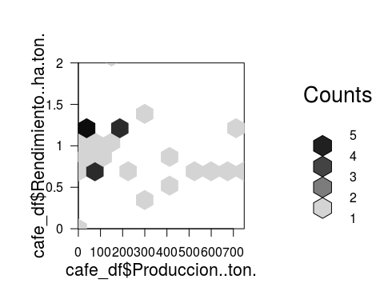

bin2<-hexbin(cafe_df$Area.Nacional..ha.,cafe_df$Rendimiento..ha.ton., xbins=10)  
  
plot(bin2)

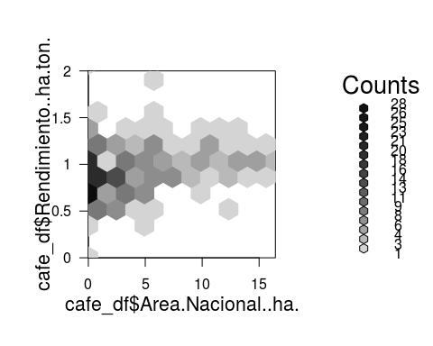

#HALLAMOS LA CORRELACION ENTRE LAS VARIABLES POR CORRELACION DE PEARSON- #INDICAMOS LAS VARIABLES CON VALORES DESCARTANDO LOS VALORES NULOS QUE EXISTAN

cor(cafe_df$Area.Nacional..ha.,cafe_df$Rendimiento..ha.ton., use="complete.obs")

## [1] 0.2806767

#PARA CALCULAR LA MODA SELECCIONANDO LAS VARIABLES EN EL DATAFRAME “cafe_df”

moda=function(var){  
 frec.var<-table(var)  
 valor=which(frec.var==max(frec.var)) #Elemento con el valor  
 names(valor)}  
  
which.max(cafe_df$Rendimiento..ha.ton.)

## [1] 121

#SEGUIMOS ESTUDIANDO EL COMPORTAMIENTO O DISTRIBUCION DE LOS DATOS O LA INFORMACION CON GRAFICOS DE DISPERSION. #GRAFICO DE DISPERSION DEL COMPORTAMIENTO DE LA PRODUCCION VS RENDIMIENTO, PERMITE ENTENDER O DESCUBRIR PATRONES EN LOS DATOS

qplot(Produccion..ton., Rendimiento..ha.ton., data = cafe_df,  
 main ="Grafico de Dispersion",  
 col = "Red",  
 xlab ="Produccion (miles ton)",  
 ylab = "Rendimiento (ha/ton)")

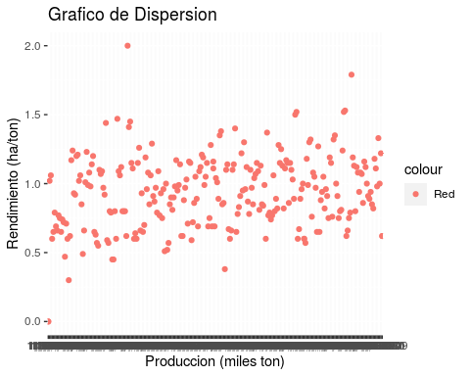

#GRAFICO DE DISPERSION SEL COMPORTAMIENTO DE LA PRODUCCION NACIONAL VS RENDIMIENTO.

qplot(Produccion.Nacional..ton., Rendimiento..ha.ton., data = cafe_df,  
 main ="Grafico de Dispersion",  
 col = "Red",  
 xlab ="Produccion Nacional (miles ton)",  
 ylab = "Rendimiento (ha/ton)")

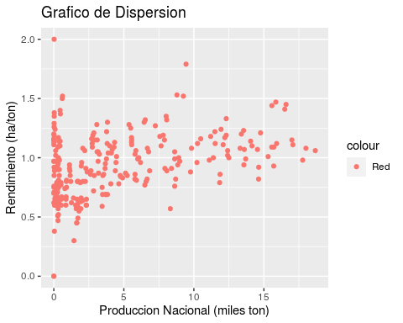

#COEFICIENTE DE CORRELACION DE PEARSON ENTRE LA PRODUCCION NACIONAL Y EL RENDIMIENTO. #HALLAS LA CORRELACION ENTRE LAS VARIABLES POR CORRELACION DE PEARSON #INDICAMOS QUE UTILIZA LAS VARIABLES CON VALORES DESCARTANDO LOS VALORES NULOS QUE EXISTAN

cor(cafe_df$Produccion.Nacional..ton.,cafe_df$Rendimiento..ha.ton., use="complete.obs")

## [1] 0.3855697

#GRAFICO DE DISPERSION DEL COMPORTAMIENTO ENTRE EL AREA NACIONAL VS EL RENDIMIENTO. PERMITE ENTENDER O DESCUBRIR PATRONES EN LOS DATOS

qplot(Area.Nacional..ha., Rendimiento..ha.ton., data = cafe_df,  
 main ="Grafico de Dispersion",  
 col = "Red",  
 xlab ="Area Nacional ha",  
 ylab = "Rendimiento (ha/ton)")

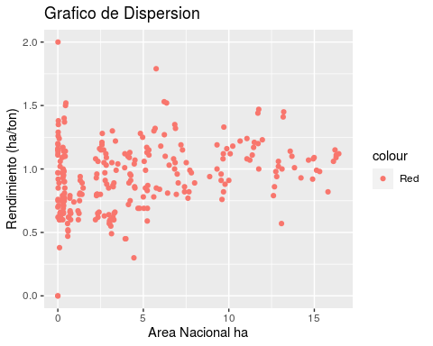

#COEFICIENTE DE CORRELACION DE PEARSON #COEFICIENTE DE CORRELACIÓN ENTRE EL AREA NA-CIONAL Y EL RENDIMIENTO #HALLAR LA CORRELACION ENTRE LAS VARIABLES POR METODO CORRELACION DE PEARSON #INDICAMOS QUE UTILIZA LAS VARIABLES CON VALORES DESCARTANDO LOS VALORES NULOS QUE EXISTAN

cor(cafe_df$Area.Nacional..ha.,cafe_df$Rendimiento..ha.ton., use="complete.obs")

## [1] 0.2806767

qplot(Anio, Rendimiento..ha.ton., data = cafe_df,  
 main ="Grafico de Dispersion",  
 col = "Red",  
 xlab ="Area Nacional ha",  
 ylab = "Rendimiento (ha/ton)")

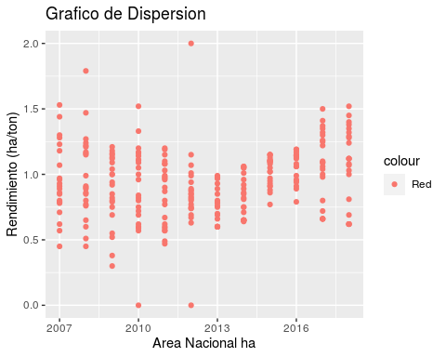

#ESPECIFICAR EL DATAFRAME ES EL PRIMER ARGUMENTO EN LA FUNCIÓN GGPLOT # DENTRO DE AES() ESCRIBIMOS LAS VARIABLES (X,Y) QUE QUEREMOS GRAFICAR # PERMITE ENTENDER O DESCUBRIR PATRONES EN LOS DATOS # SE PUEDE UTILIZAR EL PARAMETRO COLOR PARA REPRESENTAR UNA TERCERA VARIABLE # GRÁFICO DE DISPERSION: AREA NACIONAL VS RENDIMIENTO

ggplot(cafe_df) +   
 geom_point(aes(x = Area.Nacional..ha., y = Rendimiento..ha.ton., color = Anio))

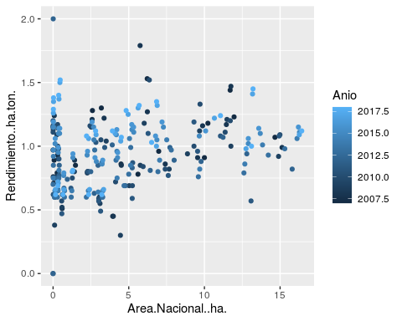

#GRAFICO DE LINEAS: AREA NACIONAL VS RENDIMIENTO

ggplot(cafe_df) +   
 geom_line(aes(x = Area.Nacional..ha., y = Rendimiento..ha.ton., color = Anio))

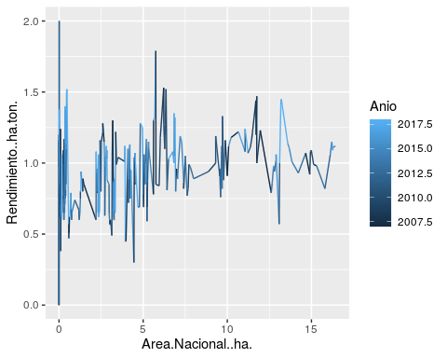

#GRAFICO DE DISPERSION: PRODUCCION NACIONAL VS RENDIMIENTO

ggplot(cafe_df) +   
 geom_point(aes(x = Produccion.Nacional..ton., y = Rendimiento..ha.ton., color = Anio))

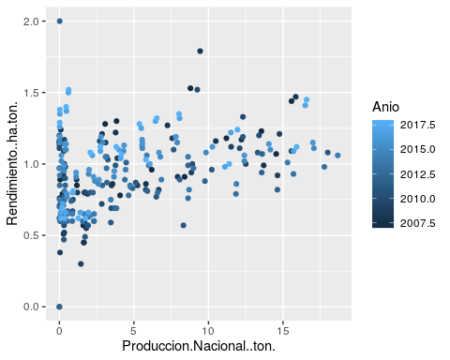

#GRAFICO DE LINEAS: PRODUCCION NACIONAL VS RENDIMIENTO

ggplot(cafe_df) +   
 geom_line(aes(x = Produccion.Nacional..ton., y = Rendimiento..ha.ton., color = Anio))

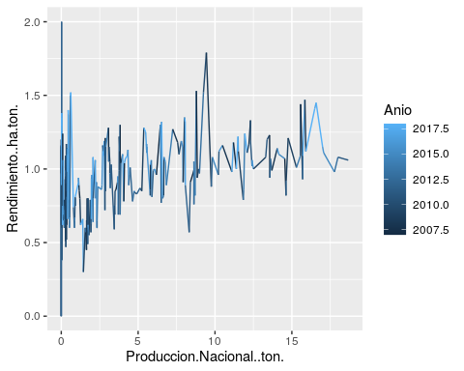

#OTRA FORMA DE GRAFICO DE LINEAS SIN REPRESENTAR LOS AÑOS

data(cafe_df)

## Warning in data(cafe_df): data set 'cafe_df' not found

ggplot(cafe_df, aes(x = Produccion.Nacional..ton., y = Rendimiento..ha.ton., color ="red")) +   
 geom_line()

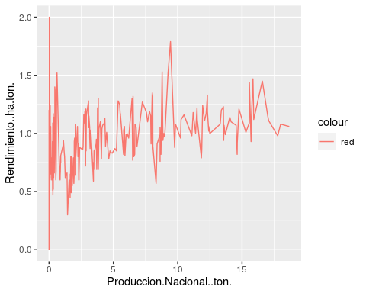

#HISTOGRAMA: AREA NACIONAL

ggplot(cafe_df) +   
 geom_histogram(aes(x = Area.Nacional..ha., color="red"))

## `stat_bin()` using `bins = 30`. Pick better value with `binwidth`.

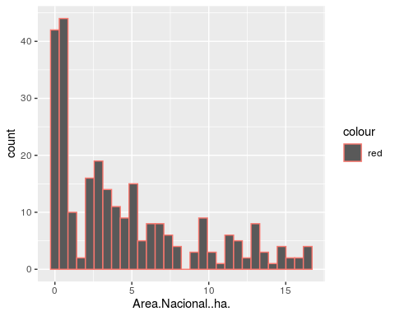

#HISTOGRAMA PRODUCCION NACIONAL

ggplot(cafe_df) +   
 geom_histogram(aes(x = Produccion.Nacional..ton., color="red"))

## `stat_bin()` using `bins = 30`. Pick better value with `binwidth`.

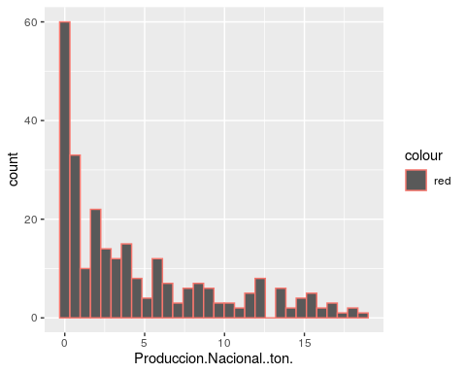

#HISTOGRAMA RENDIMIENTO

ggplot(cafe_df) +   
 geom_histogram(aes(x = Rendimiento..ha.ton., color="red"))

## `stat_bin()` using `bins = 30`. Pick better value with `binwidth`.

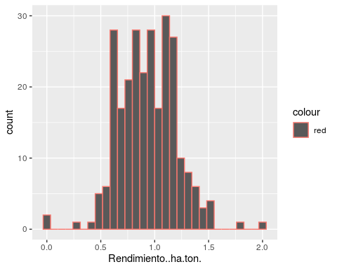

#GRAFICO DE LINEAS: PRODUCCION NACIONAL VS RENDIMIENTO

ggplot(cafe_df) +   
 geom_line(aes(x = Produccion.Nacional..ton., y = Rendimiento..ha.ton., color = Anio))



#GRAFICO DE CAJAS: PRODUCCION NACIONA VS RENDIMIENTO

ggplot(cafe_df) +   
 geom_boxplot(aes(x = Produccion.Nacional..ton., y = Rendimiento..ha.ton., color = Anio))

## Warning: Continuous x aesthetic -- did you forget aes(group=...)?

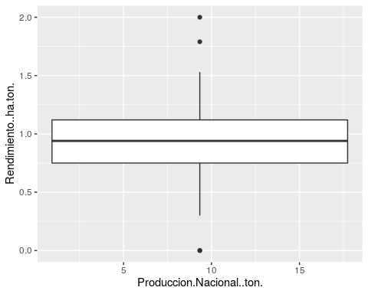

#GRAFICO DE CAJAS: AREA NACIONAS VS RENDIMIENTO

ggplot(cafe_df) +   
 geom_boxplot(aes(x = Area.Nacional..ha., y = Rendimiento..ha.ton., color = Anio))

## Warning: Continuous x aesthetic -- did you forget aes(group=...)?

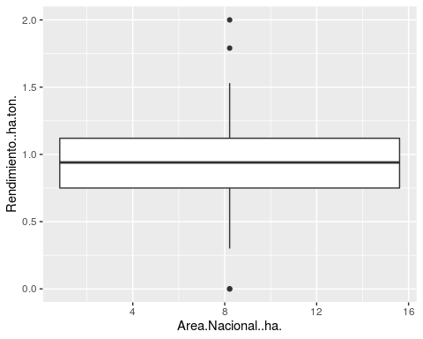

#GRAFICO DE DISPERSION JITTER: AREA NACIONAL VS RENDIMIENTO

ggplot(cafe_df) +   
 geom_jitter(aes(x = Area.Nacional..ha., y = Rendimiento..ha.ton., color = Anio))

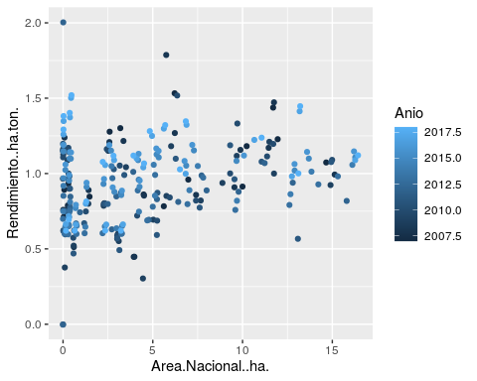

#GRAFICO DE DISPERSION PRODUCCION NACIONAL VS RENDIMIENTO

ggplot(cafe_df) +   
 geom_point(aes(x = Produccion.Nacional..ton., y = Rendimiento..ha.ton., color = Anio))



#GRAFICO DE DISPERCION JITTER: PRODUCCION NACIONAL VS RENDIMIENTO

ggplot(cafe_df) +   
 geom_jitter(aes(x = Produccion.Nacional..ton., y = Rendimiento..ha.ton., color = Anio))

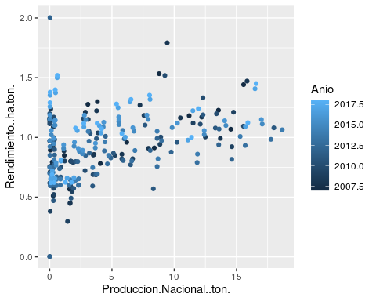

#OTRA FORMA CON GRAFICO DE DISPERSION SIN REPRESENTAR LOS AÑOS

data(cafe_df)

## Warning in data(cafe_df): data set 'cafe_df' not found

ggplot(cafe_df, aes(x = Produccion.Nacional..ton., y = Rendimiento..ha.ton., color ="red")) +   
 geom_point()

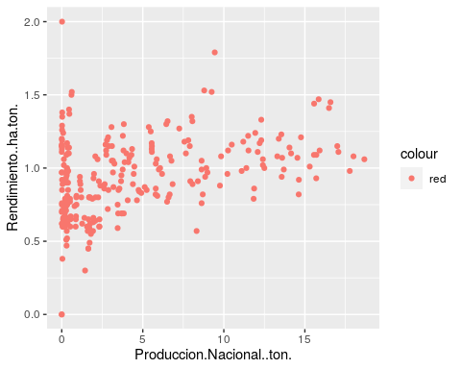

#OTRA FORMA CON GRAFICO DE LINEAS SIN REPRESENTAR LOS AÑOS

data(cafe_df)

## Warning in data(cafe_df): data set 'cafe_df' not found

ggplot(cafe_df, aes(x = Produccion.Nacional..ton., y = Rendimiento..ha.ton., color ="red")) +   
 geom_line()



#COMPARANDO CUANDO TIENE REPRESENTADO LOS AÑOS A CONTINUACION

ggplot(cafe_df, aes(x = Produccion.Nacional..ton., y = Rendimiento..ha.ton., color = Anio)) +   
 geom_line()



#TAMBIEN SE PUEDE REALIZAR DISPERSION EN PANELES POR AÑOS. #PERMITE ENTENDER O DESCUBRIR PATRONES EN LOS DATOS

ggplot(cafe_df, aes(x = Produccion.Nacional..ton., y = Rendimiento..ha.ton.)) +   
 geom_jitter() +  
 facet_grid(.~ Anio)

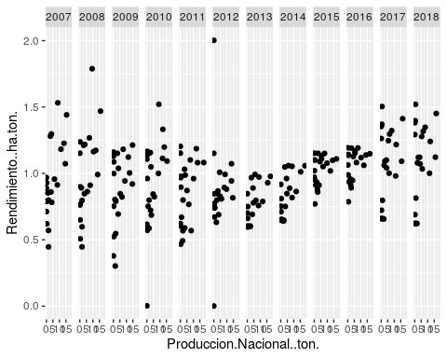

#PANELES SEPARADOS #TAMBIEN SE PUEDE REALIZAR DISPERSION EN PANELES SEPARADOS POR AÑOS

ggplot(cafe_df, aes(x = Produccion.Nacional..ton., y = Rendimiento..ha.ton.)) +   
 geom_point() +  
 facet_wrap(.~ Anio)

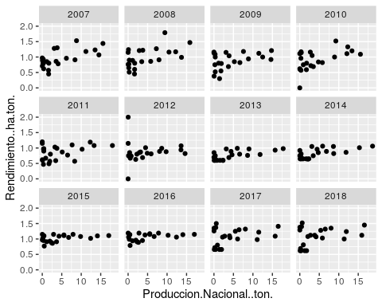

ggplot(cafe_df, aes(x = Area.Nacional..ha., y = Rendimiento..ha.ton.)) +   
 geom_point() +  
 facet_wrap(.~ Anio)

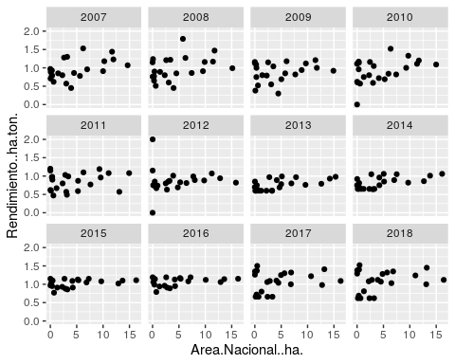

##COMPARANDO EL ANTERIOR CON EL GRAFICO DE DISPERSION SIN AÑOS # OTRA FORMA CON GRAFICO DE DISPERSION SIN REPRESENTAR LOS AÑOS

data(cafe_df)

## Warning in data(cafe_df): data set 'cafe_df' not found

ggplot(cafe_df, aes(x = Produccion.Nacional..ton., y = Rendimiento..ha.ton., color ="red")) +   
 geom_point()



#COMPARAR CON GRAFICO DE DISPERSION PRODUCCION NACIONAL VS RENDIMIENTO CON AÑOS

ggplot(cafe_df) +   
 geom_jitter(aes(x = Produccion.Nacional..ton., y = Rendimiento..ha.ton., color = Anio))

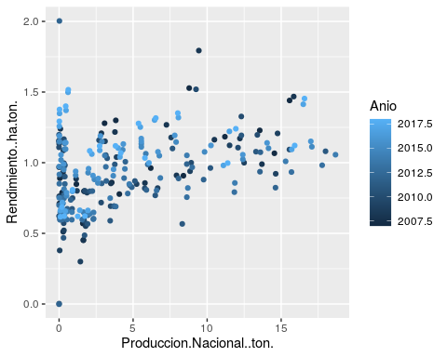

#AHORA SE UTILIZARA UN SUAVIZADOR #LA GRAFICA LINEAL SUAVIZADA

ggplot(cafe_df, aes(x = Area.Nacional..ha., y = Rendimiento..ha.ton.)) +   
 geom_point() +  
 facet_wrap(.~ Anio) +  
 geom_smooth(span = 3)

## `geom_smooth()` using method = 'loess' and formula 'y ~ x'

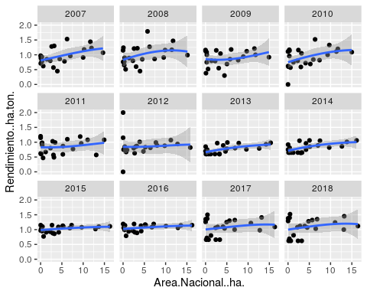

FIN