

**Authors**: Danielle Sledge, Julia Shabow, Viktoriya Tkhoryk,

Laurel Whitten, Robin Khan, Garrett Watkins

**Data Set:** [**https://www.kaggle.com/prateekmaj21/disney-movies**](https://www.kaggle.com/prateekmaj21/disney-movies)

**Cleaning Our Data**

Before we began analyzing our data, we condensed our data down from 579 to 478 rows by removing any empty rows that didn’t have a value for genre, revenue, or the MPAA rating that would output an error in our Jupyter Notebook. We also removed any movies prior to 1990 to help further condense our data. We then split out month, date, and year into separate columns for better filtering and incorporated the “.dt.day_name()” option to create a weekdays column of listed dates to help us solve one of our questions. We removed total gross revenue because it had the revenue without inflation and kept the adjusted gross revenue. We concluded our data filtering by changing our column titles for easier readability and reordered our columns.

**When are most movies released?**

After creating a bar chart of the number of movies released per month and a pie chart of the percentage of the number of movies released by weekday, we found that most movies came out during the month of March (52), and most were released on a Friday (83.26%). We expected the Christmas season and the summer to release the most movies, but the data shows that most movies were released in March before the Easter weekend and November before Thanksgiving. 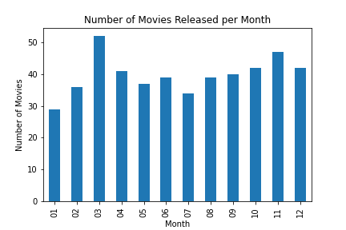

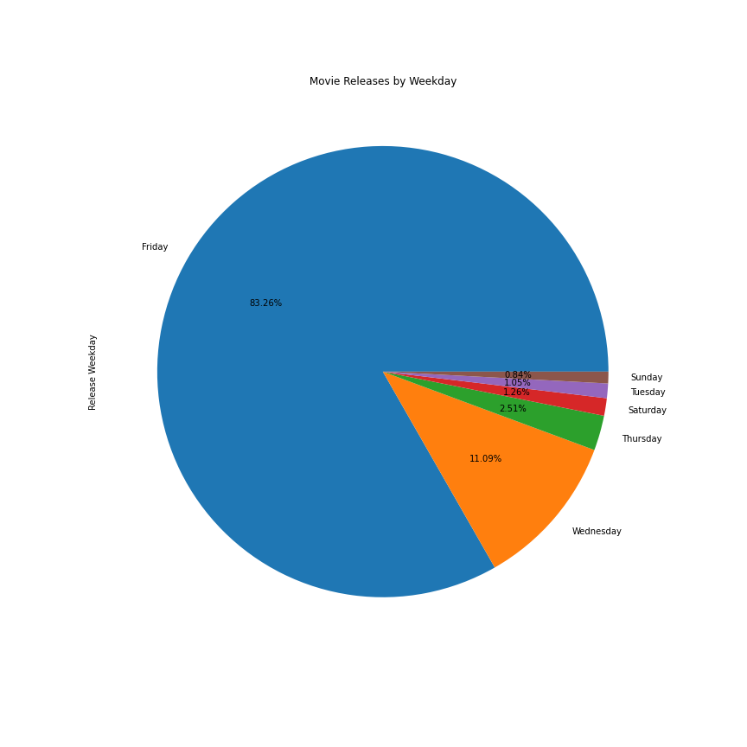

**Which genre had the highest amount of movies?**

We created a pie chart visualizing the number of movies released by genre. After looking at this chart, we can see that Comedy makes up about 31% of all movies, followed by Adventure (23.64%), and Drama (19.46%). The other 52% consists of Action, Thriller/Suspense, Romantic Comedy, Documentary, Musical, Western, Horror, Black Comedy and Concert/Performance. To find this information, we grouped our data by genre and used a count function to find the number of movies released within each. Although Comedy has the highest amount of movies, it has the 7th highest average inflation-adjusted gross revenue compared to all other genres. 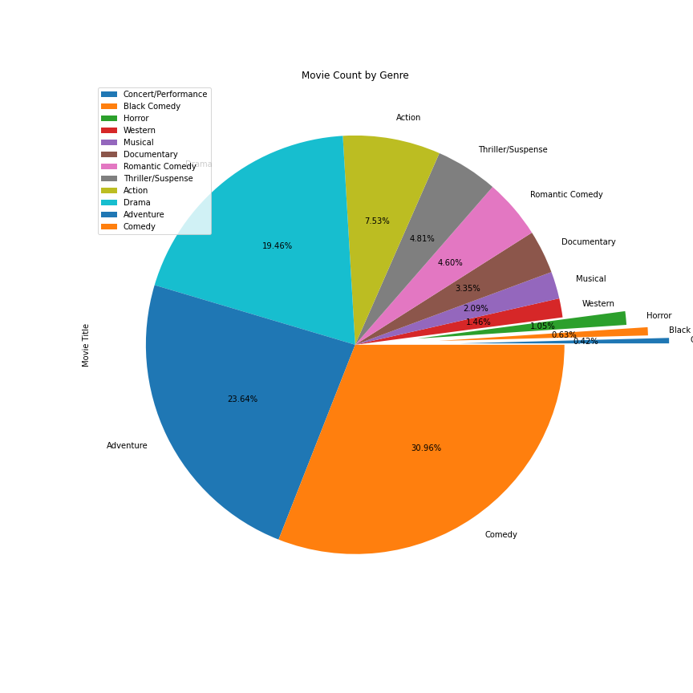

**What years had the highest revenue?**

After grouping our data by release year and finding the sum of revenue, we created a line graph visualizing inflation-adjusted revenue from 1990 to 2016. Disney’s movie revenue has experienced consistent ups and downs throughout the years and seemed to drop in the early 2000’s to early 2010’s, until after 2015. Disney had their highest adjusted gross revenue of all time in 2016. However, Disney released the most movies in 1995 and has had a steady decline of the number of movies released ever since. While 2016 had the highest revenue, there were only 14 movies released, one of the lowest amounts released since 1990.

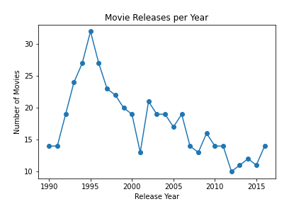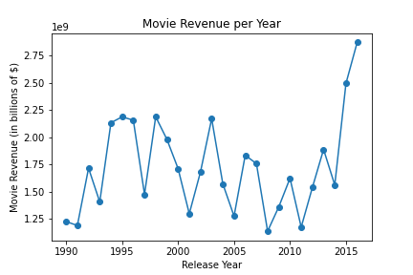

**Challenges**

Due to the number of missing values within the dataset, we had to remove a large portion of movie data which limited our sample. This is why we decided to limit our analysis from 1990 to 2016. We began with six columns but after cleaning we only utilized values from the movie title, release date, genre, and inflation adjusted gross columns. Aside from the missing values that led to some challenges, the nature of this dataset did not support much more scientific forms of analysis. In order to have run regressions or analyze the distribution of the data, it would have required more information, thus creating limitations.