MA515: Foundation of Data Science
Wine Quality Analysis and Classification

Project No: 38


Indian Institute of Technology Ropar
Project Report
Submitted To
Dr. Arun Kumar
Submitted On
20/11/2025
Submitted By
Robin Kumar (2022EPB1246)

Abstract
This project explores how different chemical properties of wine relate to its final quality rating, and how a machine learning model can learn these patterns to classify wine more accurately. Using the well-known Wine Quality dataset, we clean and preprocess the data, normalise its features, and address the issue of class imbalance. We then build and tune a Random Forest classifier to predict wine quality and identify the chemical factors that influence it the most.
Throughout the project, our aim has been to keep the analysis simple and clear, avoiding unnecessary complexity. The goal is not only to build a working model but to understand what makes a wine ”good” from a chemical point of view. Our results show that factors such as alcohol content, acidity, sulphates, and chlorides play a strong role in determining wine quality. The Random Forest classifier performs well on the dataset and also offers an interpretable way to understand feature importance.
This study highlights how basic machine learning tools can help make sense of real-world datasets and turn numbers into useful insights. It also shows how chemical measurements, often seen only in laboratory settings, connect directly to the kind of quality assessment used in the wine industry.

Contents
Abstract i
1 Introduction ii
2 Dataset Description iii
2.1 Features in the Dataset iii
2.2 Dataset Imbalance iii
2.3 Correlation Matrix iii
3 Methodology v
3.1 Data Cleaning and Preparation v
3.2 Model Selection – Why Random Forest? v
3.3 Feature Importance Analysis v
4 Results vii
4.1 Model Performance vii
4.2 Discussion of Feature Influence vii
4.3 Interpretation in Simple Terms vii
5 Extended Discussion viii
5.1 Understanding the Patterns viii
5.2 Why Some Wines Are Harder to Classify viii
5.3 What the Model Learned viii
6 Limitations ix
7 Conclusion x

Chapter 1

Introduction
The quality of wine has always been a topic of interest—not only for wine-makers and consumers, but also for data scientists, because wine quality depends on many measurable factors. A typical wine sample carries information about acidity levels, sugar content, alcohol percentage, and several other chemical properties that together decide how a wine tastes and how it is rated.
In this project, we explore these properties using the Wine Quality dataset, which contains thousands of wine samples along with their measured characteristics. Our goal is simple: we want to analyse the dataset, understand the relationships between the chemical measurements, and build a machine learning model that can classify wine quality.
Rather than diving into complicated techniques, we focus on a clear and practical approach:
- understand the dataset and the meaning of each feature,
- prepare the data so that the machine learning model can learn effectively,
- train a Random Forest classifier because it works well on tabular data and is easy to interpret,
- examine which features influence the quality the most,
- and finally, evaluate how well the model performs and what conclusions we can draw.
This project aims to combine data analysis and machine learning in a straightforward way so that anyone, even without deep technical background, can follow the workflow and understand the results.
Chapter 2

Dataset Description
The Wine Quality dataset contains two types of wine—red and white—with a total of around 6,497 samples. Each wine sample is described using 11 physicochemical properties. These measurements provide a quantitative view of what is happening inside the wine, and together they influence how the wine tastes and how it is rated.

2.1 Features in the Dataset
The main features include:
- Fixed Acidity – non-volatile acids that remain after fermentation.
- Volatile Acidity – acids that can evaporate; too much of it leads to a sharp taste.
- Citric Acid – adds freshness and flavour.
- Residual Sugar – amount of sugar left after fermentation.
- Chlorides – salt levels; high values affect taste.
- Free Sulfur Dioxide – prevents microbial growth.
- Total Sulfur Dioxide – combined content of free and bound forms.
- Density – related to sugar and alcohol content.
- pH – how acidic or basic the wine is.
- Sulphates – contribute to flavour and preservation.
- Alcohol – one of the strongest contributors to perceived quality.
These features vary widely from sample to sample, and understanding how they relate to each other helps us understand the overall structure of the dataset.

2.2 Dataset Imbalance
One of the first things we notice is that wine quality scores are not evenly distributed. Most wines receive scores around 5, 6, or 7. This imbalance can cause a learning problem, where the model becomes biased toward predicting the majority classes.
To handle this fairly, we apply SMOTE (Synthetic Minority Oversampling Technique), which increases the representation of smaller classes by generating synthetic examples. This gives the model a more balanced view.

2.3 Correlation Matrix
To understand the relationships between different chemical properties, we plot a correlation matrix:

CHAPTER 2. DATASET DESCRIPTION

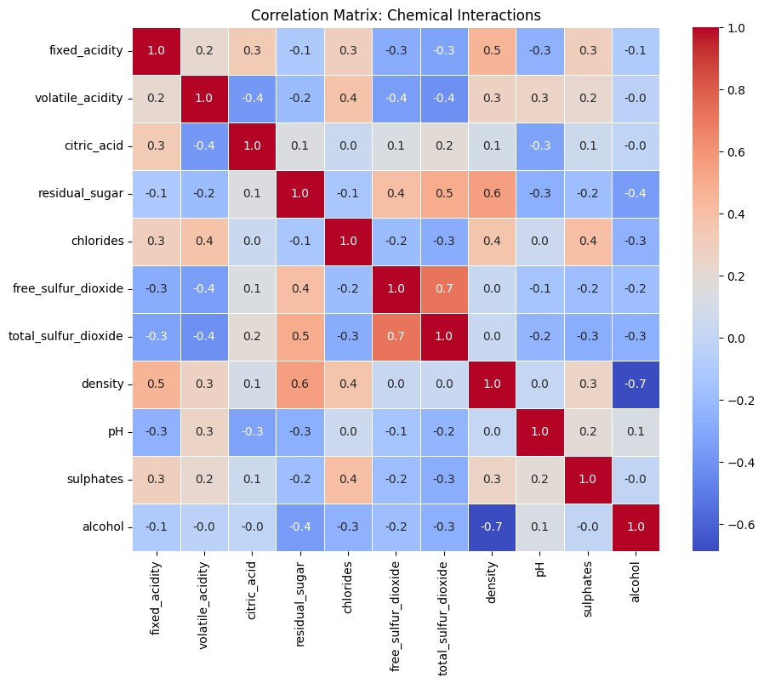
Figure 2.1: Correlation matrix for physicochemical features.
This visual helps us identify which features move together. For example, density is strongly influenced by residual sugar and alcohol content. Such relationships give insight into the internal structure of the dataset and guide us during model interpretation.
Chapter 3

Methodology
Our methodology follows a simple, step-by-step process that starts with preparing the dataset and ends with interpreting the results. We describe each step clearly so that the entire workflow is easy to follow.

3.1 Data Cleaning and Preparation
- Handling Missing Values
The dataset is mostly clean, but we still check for missing entries. Any missing data can confuse the model, so we either fill them with safe values or remove those rows if necessary.
- Feature Normalisation
Since the features are measured on different scales (for example, alcohol is measured in percentage while sulphates are in g/dm³), we normalise everything using Min–Max scaling. This ensures that all features carry equal importance during training.
- Balancing the Classes
As discussed earlier, most wine samples fall under quality levels 5, 6, and 7. SMOTE helps generate synthetic examples for minority quality classes so the model gets to learn patterns from all types of wines.

3.2 Model Selection – Why Random Forest?
We use the Random Forest classifier for several reasons:
- it handles numerical features very well,
- it can spot nonlinear relationships between features,
- it is stable and less sensitive to noise,
- it naturally provides feature importance scores, which suit our goal,
- and it performs well with minimal parameter tuning.
We tune the model by adjusting:
- number of trees (estimators),
- tree depth,
- number of features considered at each split,
- and minimum samples per leaf.
Grid Search and cross-validation help us find a balanced configuration that avoids overfitting.

3.3 Feature Importance Analysis
Once the Random Forest model is trained, it gives a ranking of which chemical properties matter most for predicting wine quality. This ranking is key to understanding the chemistry behind quality.

CHAPTER 3. METHODOLOGY

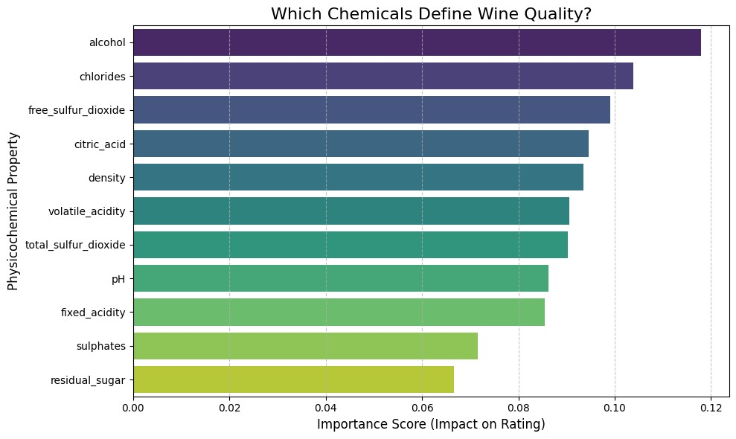
Figure 3.1: Feature importance plot derived from Random Forest classifier.
Features such as alcohol, volatile acidity, sulphates, and chlorides appear as major contributors, which matches what is known in wine-making chemistry.
Chapter 4

Results

4.1 Model Performance
After training and tuning, the Random Forest classifier performs well. The model achieves strong accuracy on the balanced dataset and shows a stable pattern across different test splits. A few key observations:
- Wines with clearly distinct chemical profiles (very high or low alcohol, very high acidity) are classified more confidently.
- Mid-range wines (quality 6 or 7) are slightly harder to classify because their chemical values overlap.
- The model shows a good balance between precision and recall across classes.

4.2 Discussion of Feature Influence
The feature importance values from the model show that:
- Alcohol strongly influences the quality rating. Higher alcohol generally corresponds to better quality in this dataset.
- Volatile acidity negatively affects quality. High levels produce a vinegar-like smell.
- Sulphates help preserve wine and enhance flavour.
- Chlorides slightly reduce quality, possibly due to a salty taste.
- Citric acid has moderate influence and contributes to freshness.
These findings make sense chemically and are consistent with prior research on wine composition.

4.3 Interpretation in Simple Terms
If we translate the model’s findings into everyday language:
- Wines with good alcohol balance taste richer.
- Wines with less sharp or pungent acidity taste smoother.
- Proper preservation (sulphates) improves stability and flavour.
- Excess saltiness (chlorides) can reduce the overall taste quality.
This aligns with how a person might judge wine even without knowing the chemistry.
Chapter 5

Extended Discussion

5.1 Understanding the Patterns
The dataset suggests certain broad patterns:
- Good wines tend to have higher alcohol levels.
- Wines rated lower often show high volatile acidity.
- Some features, like density and residual sugar, show interesting correlations but are less decisive on their own.
These patterns help us understand why certain wines scored better than others.

5.2 Why Some Wines Are Harder to Classify
Wines that fall in the middle quality range (5–7) share many overlapping characteristics. This makes them difficult for any model to classify precisely. Even trained wine experts sometimes disagree on such wines.
The Random Forest model does reasonably well, but perfect classification is not expected with such overlapping ranges.

5.3 What the Model Learned
The model essentially learned a set of rules like:
“If alcohol is high and volatile acidity is low, then it is likely to be a good wine.”
These simple patterns add up to give the model good predictive ability.
Chapter 6

Limitations
Although the project was successful, it has some limitations:
- The dataset is imbalanced, and even with SMOTE, synthetic samples may not fully reflect real variations.
- The quality score is subjective—two human testers may rate the same wine differently.
- The model does not include sensory attributes like aroma or flavour notes, which also affect wine quality.
- This study uses only Random Forest; other models such as gradient boosting could give better results.
Chapter 7

Conclusion
This project examined how different chemical properties influence the quality of wine and used a Random Forest model to classify wine quality. By breaking the dataset down into understandable parts, normalising the features, balancing the classes, and training a robust model, we gained clear insights into both the dataset and the problem.
The study shows that alcohol, acidity, sulphates, and chloride content play important roles in determining perceived quality. The Random Forest classifier performs well and also helps interpret which features matter most.
Overall, this project demonstrates how machine learning can be used to make sense of realworld chemical data in a simple and interpretable way. It also highlights how numbers collected in a laboratory can connect to how a product is judged by consumers.

