LAFAGE Robin
CHOGNOT Gabin

CE312 TP1

Time chart of compteur_8_v1.vhd simulation :
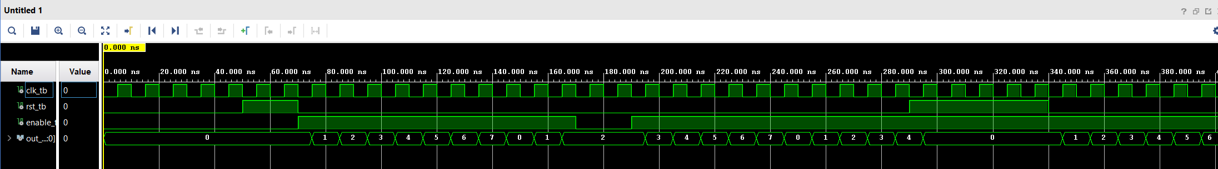

This is a counter, which counts from 0 to 7 at every rising edge when enable equals 1, and reset to 0 after reaching 7 or when reset equals 1.

Questions :

1/ We are only counting from 0 to 7, so we only need 3 bits to do the operation, but we are printing on a 7 segments display, which uses 7 bits. That’s what compteur_8_v2.vhd is used for.
2/ A testbench is a file used to specify different values for the entry signals for different periods of time, to verify if the program output equals to the expected values of the output signals.

3/

