Exercise week1-2

Qing Tian

2017-08-25

knitr::opts_chunk$set(echo = TRUE)

Summary: this exercise practices using R Markdown and basic R commands. It includes two parts: (i) run some simple R commands, (ii) work with specific datasets.

### Test R commands

*variables*

integer:

x <- 1  
y <- 2  
z <- x + y  
print (x)

## [1] 1

print (y)

## [1] 2

print (z)

## [1] 3

strings:

str1 <- "Hello"  
str2 <- "from Qing"  
str = paste (str1, str2)  
print (str)

## [1] "Hello from Qing"

cat(str1,str2)

## Hello from Qing

one-dimenal array:

x <- 0:10  
y <- 2*x  
plot(x,y)

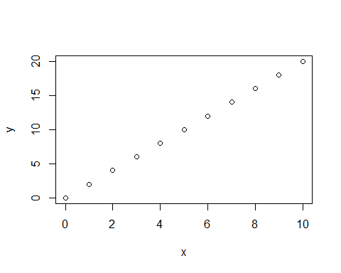

x <- seq(10, 20)  
print (x)

## [1] 10 11 12 13 14 15 16 17 18 19 20

x <- seq(10, 20, 2)  
print (x)

## [1] 10 12 14 16 18 20

y <- rev(x)  
print(y)

## [1] 20 18 16 14 12 10

x <- c(1, 3, 6, 10, 15)  
b <- 2  
y <- 5*x + b  
print(y)

## [1] 7 17 32 52 77

plot(x, y)

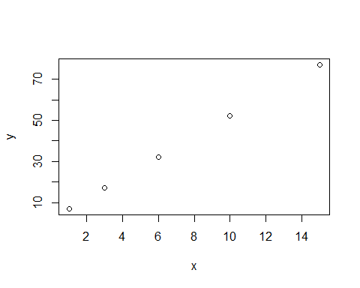

x <- rep(c(2,4,6,8), 3)  
print (x)

## [1] 2 4 6 8 2 4 6 8 2 4 6 8

x <- rep(c(2, 4, 6, 8), each=2)  
print(x)

## [1] 2 2 4 4 6 6 8 8

### Work with specific datasets

**Dataset1: cars**

*Show data*

colnames(cars)

## [1] "speed" "dist"

nrow(cars)

## [1] 50

summary(cars)

## speed dist   
## Min. : 4.0 Min. : 2.00   
## 1st Qu.:12.0 1st Qu.: 26.00   
## Median :15.0 Median : 36.00   
## Mean :15.4 Mean : 42.98   
## 3rd Qu.:19.0 3rd Qu.: 56.00   
## Max. :25.0 Max. :120.00

*Plotting*

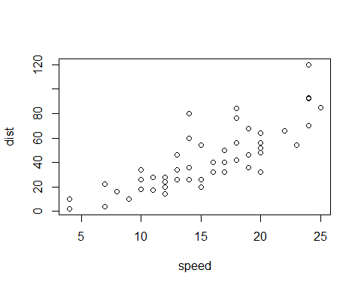

**Dataset2: pressure**

*Data: columns, number of rows, and stats*

## [1] "temperature" "pressure"

## [1] 19

## temperature pressure   
## Min. : 0 Min. : 0.0002   
## 1st Qu.: 90 1st Qu.: 0.1800   
## Median :180 Median : 8.8000   
## Mean :180 Mean :124.3367   
## 3rd Qu.:270 3rd Qu.:126.5000   
## Max. :360 Max. :806.0000

*Relationship*

