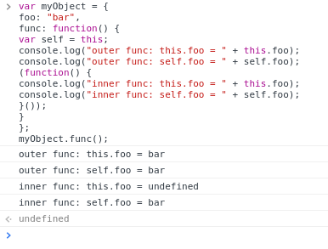
Q2.

Reason for the output of this code snippet:-

line1:- in this it will call the myobject key which is defined earlier. print bar
line2:- in this self variable having value this so it will call myObject ket and print bar
line3:- In this it self executing function and foo is not defined under this scope so print undefined
line4:- In this self.foo and scope of this function is inside the myobject so it will cal foo because in self we will define this and this call foo.

Q 7.
What’s the result of executing this code and why?
function test() {
console.log(a);
console.log(fun());
var a = 1;
function fun() {
return 2;
}
}
test();

Sol.
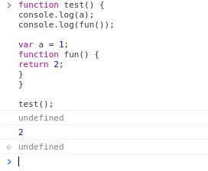

Reason :
Firstly when we performed console.log(a), a was not initialized with any value but was declared automatically as of the hoisting in JavaScript.
Then fun() was called which returned 2 as value and hence, that was used in console.log(fun());

So ,bascally a was never assigned value of 1.

