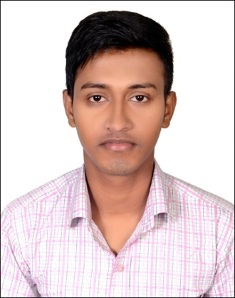**Resume**

**OF**

**ROBIN CHANDRA NATH**

**Diploma Engineer (computer)**

Cell: +8801825292002

Email:robin.nath014@gmail.com

|  |
| --- |
| **Career Objective** |

I would like to take the challenging, creative and progressive opportunity where I can express my skill, ability and ideas, to maintain & utilize human and natural resources to lead the company for the development of nation considering company image.

|  |
| --- |
| **Educational Background** |

* **BSC in Computer Science & Engineering**

• Institution : Port City International University(PCIU)

• Department : CSE

• Result : Waiting for Result

* **Diploma in Engineering**

• Institution : Feni Engineering Institute

• Department : Computer

• Board : Bangladesh Technical Education Board, Dhaka.

• Result : 3.39

* **Secondary School Certificate (S.S.C)**

• Institution : karim ullah High School.

• Group : Science

• Result : 4.19 (In the scale of 5.00)

• Year of passing : 2012

• Board : Comilla

|  |  |  |
| --- | --- | --- |
| **Training** | | |
| **Institute** | **Department** | **Duration** |
| **UNITECH SKILL DEVELOPMENT CENTER**  **(USDC)**  **(RH-Home Center, Green Road, Dhaka 1215)** | **Computer** | **03 Months** |

|  |  |  |  |  |
| --- | --- | --- | --- | --- |
| **Language Proficiency** | | | | |
| **Language** | **Speak** | **Read** | **Write** | **Understand** |
| Bengali | Excellent | Excellent | Excellent | Excellent |
| English | Excellent | Excellent | Excellent | Excellent |

|  |
| --- |
| **IT SKILL** |

* **Operating systems : Windows.**
* **Programs : Microsoft office package (excel, Word etc.), Adobe**

**Photoshop.**

* **Internet : Very good. , Excellent.**
* **Programming site : Webpage Design & Developing**
* **Programming Language** **: HTML, HTML5, CSS, CSS 3, PHP, JAVA SCRIPT.**
* **PC maintenance : Experienced.**

|  |
| --- |
| **Personal Information** |

Name : Robin Chandra Nath

Father's Name : Bhusan Chandra Nath

Mother's Name : Deepali Rani Nath

Date of Birth : 06, Auguest, 1995

Nationality : Bangladeshi (By birth)

Religion : Hindu

Marital Status : Single

Sex : Male

Blood Group : O- (Negative)

Height : 5. 8"

National ID No. : 199530125560000129

Permanent Address : Vill: Ramananda Pur, Post: Matubhuiyan, P.S: Dagonbhuiyan, Dist.: Feni.

Present Address : Do

|  |
| --- |
| **Declaration of Authenticity** |

I do hereby declare that all information presented here are true to my knowledge. If required and where applicable, these documents can be supported by appropriate authentic certificates/papers.

**Date: Robin Nath**