Census: Quantitative Analysis Application
Users’ Manual
Sung Kyu Park, John D. Venable

Department of Cell Biology
The Scripps Research Institute
(Ver. 1.0, Aug. 2007)

Abstract

High-throughput and high-resolution mass spectrometry data from shotgun proteomics necessitates an efficient and automated way to analyze large amounts of quantitative data. The advent of many different types of labeling experiments in addition to the label free ones makes quantitative analyses more challenging than ever. We introduce a software tool called Census that facilitates quantitative analysis of shotgun proteomics data generated from different strategies. Because speed is a necessity for analyzing large amounts of quantitative proteomics data, Census is fast (i.e., typically takes less than 1 hour to analyze thousands of peptide identifications). In addition, the need for manual intervention and validation has been minimized using both a dynamic peak finding algorithm that makes use of database search results to identify peak boundaries and improved measurement quality control. To address poor quality measurements, Census uses robust approaches including weighted peptide measurements, and good statistical filters to eliminate outliers, and minimize the impact of bad measurements. Census also provides a nice graphical user interface to support manual validation and peak definition (if needed) and encourage user interaction with the data.
Introduction

In recent years, global quantification using mass spectrometry has garnered a significant level of interest due to the emergence of fields that rely on large scale profiling of peptides/proteins (proteomics) and small molecules (metabolomics). In the field of proteomics, the identification of large numbers of peptides has become commonplace with the advent of new instrumentation and informatics tools, however, progress with regards to the quantification process has been hampered by the extreme analytical challenges.
Here we present a software called Census to cover variety of quantitative strategies including both labeling (15N, 18O, SILAC, iTRAQ, etc) and labeling experiments. Census is capable of quantification from either MS or MS/MS scans ⁴⁰ and is thus able to process data generated from data-dependant, SRM, or MRM analyses. Other new features incorporated into Census include the ability to use high resolution and high mass accuracy MS data for improved quantification, as well as the ability to perform label free quantitative analyses based on both spectral counting and an LC-MS peak area approach utilizing chromatogram alignment.
Census is composed of two parts: a quantitative analysis module that generates chromatograms from spectra and calculates peptide ion abundances, and a qualitative module that aids in tandem MS spectra visualization. Census has been developed to accommodate isotopic labeling and isotope free analyses as well as quantification from either MS or MS/MS data (Supplementary Fig. 1.). In order to provide this level of flexibility, the program uses a configuration file that can be generated from within the user interface. The configuration file contains all relevant information needed for the quantification process including parameters for chromatogram extraction, peak finding, chromatogram alignment, and amino acid elemental composition information just to name a few.
Requirements

1. Software requirement
Census has been developed in Java and is, therefore, operating system independent. It can be deployed on a personnel Windows desktop using a graphical user interface or onto a high performance server and run from the console making it accessible to multiple users. Census is available from the authors for individual use and evaluation through an Institutional Software Transfer Agreement (see http://fields.scripps.edu/census for details).

2. File format requirement

Census currently supports MS1/MS2 files (McDonald, W.H. et al. Rapid Commun. Mass Spectrom. 18, pp2162-2168 (2004) and mzXML for spectral data. Census also needs to take search identification file, and DTASelect output file and pepXML are currently supported by Census. MS1/MS2 file format can be generated by RawExtractor. Both RawExtractor and DTASelect softwares can be downloaded at http://fields.scripps.edu.

Installation

Census can be installed either on Windows desktop using a graphical user interface or on the Unix operating system such as Linux. Copy distributed files into a folder in your computer and either double click census.bat on GUI mode or run command “java census.jar” with following options.

usage: OptionsTip
-example java -jar census.jar -c /my_folder/census_config.xml -f
folder_name
-i identification file such as DTASelect-filter.txt, pepXML or
census_id.txt
-c confile file name with path
-ch chro xml file
-e export report file
-f path to working directory. Default is current folder.
-g run in GUI mode
-h print help
-x mzXML files instead of MS file format.

Census Parameters

Census supports various quantitative strategies both labeling (¹⁵N, SILAC, iTRAQ, etc)
and labeling free experiments. Census parameter file is XML format and can be either generated through Census GUI or modified manually from parameter template or pre-generated file you already have. The parameter file is consisted of two parts - atom element composition and Census configuration parts.
By double clicking census.bat file (or run census.jar file using –g option on the command line) the main Census interface will appear (Fig 1).

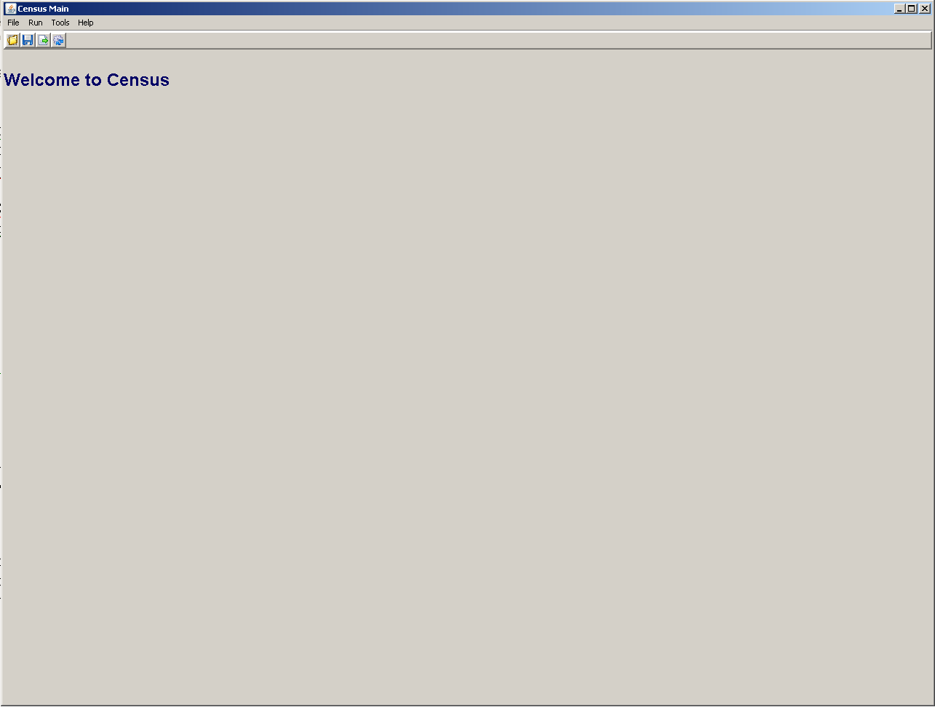
Fig 1. Census main page

From the menu select Run->Configuration, and then select “Isotope Labeling Configuration” from radio buttons. Fig 2 shows Census parameters.

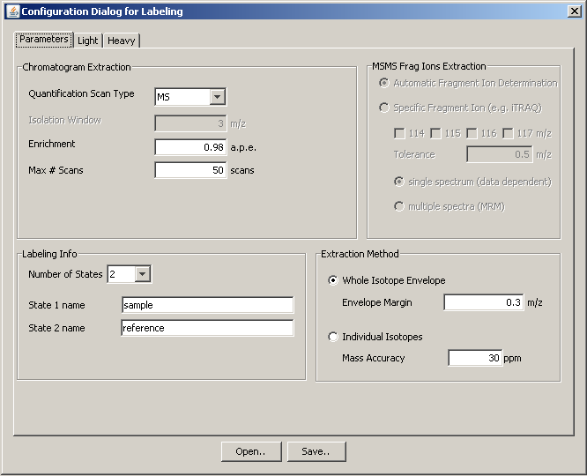Fig 2. Parameters to generate

Select Light or Heavy tab to populate element compositions (Fig 3).
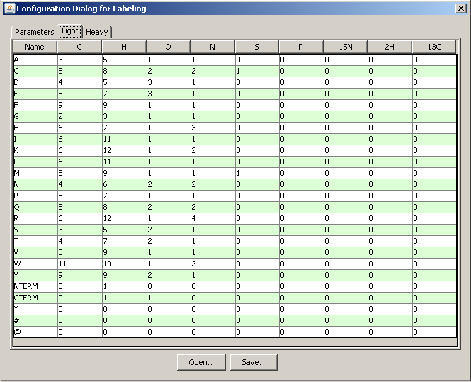
Fig 3. Element Compositions

User can click open button to load existing configuration file. By selecting save button, census_config.xml file will be generated. See appendix A for sample census_config.xml file.

Execution

Select from menu Run->Labeled Data (alternatively you can select non labeled data) and as shown in Fig 4, select corresponding files and click ‘OK’ button. It will start analyzing data. After successful run, census_chro.xml file will be generated. It contains various information of analysis result including re-constructed chromatograms.

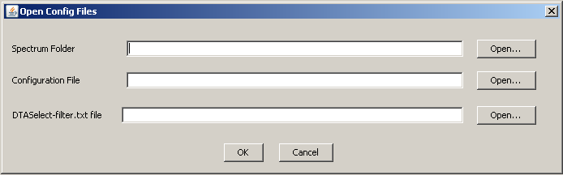
Fig 4 Load and Execute Labeled Experiment

Post Analysis

After successful execution, users can see post analysis page (Fig 5). If users already have census_chro.xml generated and want to run post analysis, open census_chro.xml file by selecting File->Open Chro file from menu.
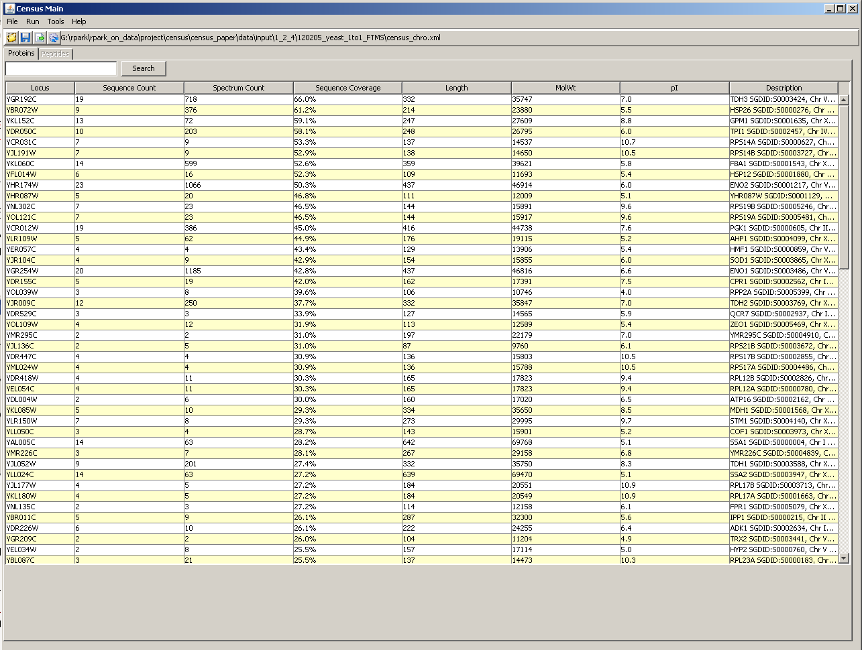
Fig 5. Main page of Post analysis

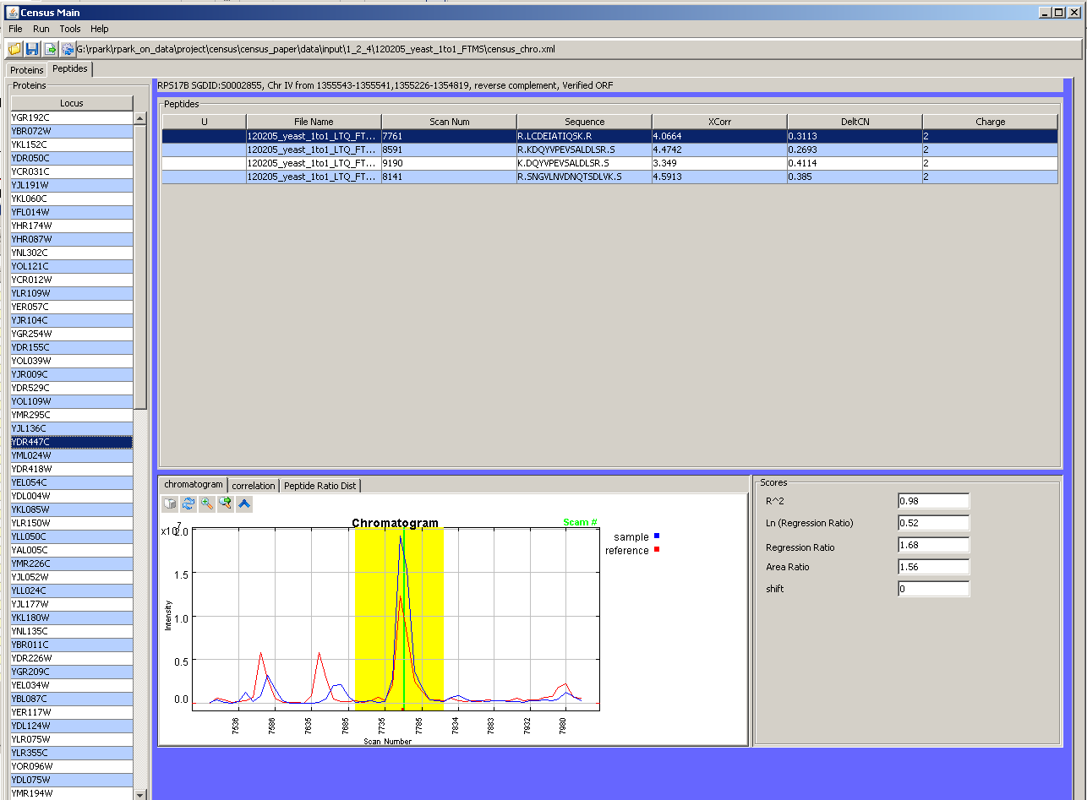
Fig 6. Peptide information of Post Analysis

Generating Report

After quantitative analysis, users can filter out low quality of peptides applying various filtering criteria. Select File->Export Report from menu, and users can see filtering parameters with default values (Fig 7). Users can generate report by clicking Export report.

- Determination Factor : Square of linear regression
- Outlier threshold p-value : p-value to remove outlier peptides from same protein
- Remove peptides with negative R: Linear regression value less than zero to be removed
- Correction Factor: Systemic error to correct peptide ratio. This will be applied to all peptides
- Unique peptide: Select unique or non-unique peptide

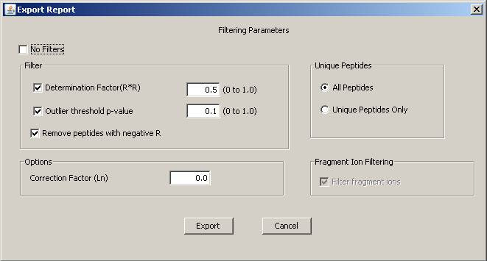
Fig 7. Filtering Parameters for Generating Report

Appendix A

<?xml version="1.0" encoding="UTF-8"?>
<config>
<label_type labeling="true">
<name>sample</name>
<name>reference</name>
</label_type>
<params>
<scan_type>MS</scan_type>
<extract_method>2</extract_method>
<mass_accuracy unit="ppm">30</mass_accuracy>
<enrich>0.98</enrich>
<max_win>50</max_win>
</params>
<element_comp>
<each_sample>
<residue name="A">
<ele_C>3</ele_C>
<ele_H>5</ele_H>
<ele_O>1</ele_O>
<ele_N>1</ele_N>
<ele_S>0</ele_S>
<ele_P>0</ele_P>
<ele_15N>0</ele_15N>
<ele_2H>0</ele_2H>
<ele_13C>0</ele_13C>
</residue>
<residue name="C">
<ele_C>5</ele_C>
<ele_H>8</ele_H>
<ele_O>2</ele_O>
<ele_N>2</ele_N>
<ele_S>1</ele_S>
<ele_P>0</ele_P>
<ele_15N>0</ele_15N>
<ele_2H>0</ele_2H>
<ele_13C>0</ele_13C>
</residue>
<residue name="D">
<ele_C>4</ele_C>
<ele_H>5</ele_H>
<ele_O>3</ele_O>
<ele_N>1</ele_N>
<ele_S>0</ele_S>
<ele_P>0</ele_P>
<ele_15N>0</ele_15N>
<ele_2H>0</ele_2H>
<ele_13C>0</ele_13C>
</residue>
<residue name="E">
<ele_C>5</ele_C>
<ele_H>7</ele_H>
<ele_O>3</ele_O>
<ele_N>1</ele_N>
<ele_S>0</ele_S>
<ele_P>0</ele_P>
<ele_15N>0</ele_15N>
<ele_2H>0</ele_2H>
<ele_13C>0</ele_13C>
</residue>
<residue name="F">
<ele_C>9</ele_C>
<ele_H>9</ele_H>
<ele_O>1</ele_O>
<ele_N>1</ele_N>
<ele_S>0</ele_S>
<ele_P>0</ele_P>
<ele_15N>0</ele_15N>
<ele_2H>0</ele_2H>
<ele_13C>0</ele_13C>
</residue>
<residue name="G">
<ele_C>2</ele_C>
<ele_H>3</ele_H>
<ele_O>1</ele_O>
<ele_N>1</ele_N>
<ele_S>0</ele_S>
<ele_P>0</ele_P>
<ele_15N>0</ele_15N>
<ele_2H>0</ele_2H>
<ele_13C>0</ele_13C>
</residue>
<residue name="H">
<ele_C>6</ele_C>
<ele_H>7</ele_H>
<ele_O>1</ele_O>
<ele_N>3</ele_N>
<ele_S>0</ele_S>
<ele_P>0</ele_P>
<ele_15N>0</ele_15N>
<ele_2H>0</ele_2H>
<ele_13C>0</ele_13C>
</residue>
<residue name="I">
<ele_C>6</ele_C>
<ele_H>11</ele_H>
<ele_O>1</ele_O>
<ele_N>1</ele_N>
<ele_S>0</ele_S>
<ele_P>0</ele_P>
<ele_15N>0</ele_15N>
<ele_2H>0</ele_2H>
<ele_13C>0</ele_13C>
</residue>
<residue name="K">
<ele_C>6</ele_C>
<ele_H>12</ele_H>
<ele_O>1</ele_O>
<ele_N>2</ele_N>
<ele_S>0</ele_S>
<ele_P>0</ele_P>
<ele_15N>0</ele_15N>
<ele_2H>0</ele_2H>
<ele_13C>0</ele_13C>
</residue>
<residue name="L">
<ele_C>6</ele_C>
<ele_H>11</ele_H>
<ele_O>1</ele_O>
<ele_N>1</ele_N>
<ele_S>0</ele_S>
<ele_P>0</ele_P>
<ele_15N>0</ele_15N>
<ele_2H>0</ele_2H>
<ele_13C>0</ele_13C>
</residue>
<residue name="M">
<ele_C>5</ele_C>
<ele_H>9</ele_H>
<ele_O>1</ele_O>
<ele_N>1</ele_N>
<ele_S>1</ele_S>
<ele_P>0</ele_P>
<ele_15N>0</ele_15N>
<ele_2H>0</ele_2H>
<ele_13C>0</ele_13C>
</residue>
<residue name="N">
<ele_C>4</ele_C>
<ele_H>6</ele_H>
<ele_O>2</ele_O>
<ele_N>2</ele_N>
<ele_S>0</ele_S>
<ele_P>0</ele_P>
<ele_15N>0</ele_15N>
<ele_2H>0</ele_2H>
<ele_13C>0</ele_13C>
</residue>
<residue name="P">
<ele_C>5</ele_C>
<ele_H>7</ele_H>
<ele_O>1</ele_O>
<ele_N>1</ele_N>
<ele_S>0</ele_S>
<ele_P>0</ele_P>
<ele_15N>0</ele_15N>
<ele_2H>0</ele_2H>
<ele_13C>0</ele_13C>
</residue>
<residue name="Q">
<ele_C>5</ele_C>
<ele_H>8</ele_H>
<ele_O>2</ele_O>
<ele_N>2</ele_N>
<ele_S>0</ele_S>
<ele_P>0</ele_P>
<ele_15N>0</ele_15N>
<ele_2H>0</ele_2H>
<ele_13C>0</ele_13C>
</residue>
<residue name="R">
<ele_C>6</ele_C>
<ele_H>12</ele_H>
<ele_O>1</ele_O>
<ele_N>4</ele_N>
<ele_S>0</ele_S>
<ele_P>0</ele_P>
<ele_15N>0</ele_15N>
<ele_2H>0</ele_2H>
<ele_13C>0</ele_13C>
</residue>
<residue name="S">
<ele_C>3</ele_C>
<ele_H>5</ele_H>
<ele_O>2</ele_O>
<ele_N>1</ele_N>
<ele_S>0</ele_S>
<ele_P>0</ele_P>
<ele_15N>0</ele_15N>
<ele_2H>0</ele_2H>
<ele_13C>0</ele_13C>
</residue>
<residue name="T">
<ele_C>4</ele_C>
<ele_H>7</ele_H>
<ele_O>2</ele_O>
<ele_N>1</ele_N>
<ele_S>0</ele_S>
<ele_P>0</ele_P>
<ele_15N>0</ele_15N>
<ele_2H>0</ele_2H>
<ele_13C>0</ele_13C>
</residue>
<residue name="V">
<ele_C>5</ele_C>
<ele_H>9</ele_H>
<ele_O>1</ele_O>
<ele_N>1</ele_N>
<ele_S>0</ele_S>
<ele_P>0</ele_P>
<ele_15N>0</ele_15N>
<ele_2H>0</ele_2H>
<ele_13C>0</ele_13C>
</residue>
<residue name="W">
<ele_C>11</ele_C>
<ele_H>10</ele_H>
<ele_O>1</ele_O>
<ele_N>2</ele_N>
<ele_S>0</ele_S>
<ele_P>0</ele_P>
<ele_15N>0</ele_15N>
<ele_2H>0</ele_2H>
<ele_13C>0</ele_13C>
</residue>
<residue name="Y">
<ele_C>9</ele_C>
<ele_H>9</ele_H>
<ele_O>2</ele_O>
<ele_N>1</ele_N>
<ele_S>0</ele_S>
<ele_P>0</ele_P>
<ele_15N>0</ele_15N>
<ele_2H>0</ele_2H>
<ele_13C>0</ele_13C>
</residue>
<residue name="NTERM">
<ele_C>0</ele_C>
<ele_H>1</ele_H>
<ele_O>0</ele_O>
<ele_N>0</ele_N>
<ele_S>0</ele_S>
<ele_P>0</ele_P>
<ele_15N>0</ele_15N>
<ele_2H>0</ele_2H>
<ele_13C>0</ele_13C>
</residue>
<residue name="CTERM">
<ele_C>0</ele_C>
<ele_H>1</ele_H>
<ele_O>1</ele_O>
<ele_N>0</ele_N>
<ele_S>0</ele_S>
<ele_P>0</ele_P>
<ele_15N>0</ele_15N>
<ele_2H>0</ele_2H>
<ele_13C>0</ele_13C>
</residue>
<residue name="*">
<ele_C>0</ele_C>
<ele_H>0</ele_H>
<ele_O>0</ele_O>
<ele_N>0</ele_N>
<ele_S>0</ele_S>
<ele_P>0</ele_P>
<ele_15N>0</ele_15N>
<ele_2H>0</ele_2H>
<ele_13C>0</ele_13C>
</residue>
<residue name="#">
<ele_C>0</ele_C>
<ele_H>0</ele_H>
<ele_O>0</ele_O>
<ele_N>0</ele_N>
<ele_S>0</ele_S>
<ele_P>0</ele_P>
<ele_15N>0</ele_15N>
<ele_2H>0</ele_2H>
<ele_13C>0</ele_13C>
</residue>
<residue name="@">
<ele_C>0</ele_C>
<ele_H>0</ele_H>
<ele_O>0</ele_O>
<ele_N>0</ele_N>
<ele_S>0</ele_S>
<ele_P>0</ele_P>
<ele_15N>0</ele_15N>
<ele_2H>0</ele_2H>
<ele_13C>0</ele_13C>
</residue>
</each_sample>
<each_sample>
<residue name="A">
<ele_C>3</ele_C>
<ele_H>5</ele_H>
<ele_O>1</ele_O>
<ele_N>0</ele_N>
<ele_S>0</ele_S>
<ele_P>0</ele_P>
<ele_15N>1</ele_15N>
<ele_2H>0</ele_2H>
<ele_13C>0</ele_13C>
</residue>
<residue name="C">
<ele_C>5</ele_C>
<ele_H>8</ele_H>
<ele_O>2</ele_O>
<ele_N>1</ele_N>
<ele_S>1</ele_S>
<ele_P>0</ele_P>
<ele_15N>1</ele_15N>
<ele_2H>0</ele_2H>
<ele_13C>0</ele_13C>
</residue>
<residue name="D">
<ele_C>4</ele_C>
<ele_H>5</ele_H>
<ele_O>3</ele_O>
<ele_N>0</ele_N>
<ele_S>0</ele_S>
<ele_P>0</ele_P>
<ele_15N>1</ele_15N>
<ele_2H>0</ele_2H>
<ele_13C>0</ele_13C>
</residue>
<residue name="E">
<ele_C>5</ele_C>
<ele_H>7</ele_H>
<ele_O>3</ele_O>
<ele_N>0</ele_N>
<ele_S>0</ele_S>
<ele_P>0</ele_P>
<ele_15N>1</ele_15N>
<ele_2H>0</ele_2H>
<ele_13C>0</ele_13C>
</residue>
<residue name="F">
<ele_C>9</ele_C>
<ele_H>9</ele_H>
<ele_O>1</ele_O>
<ele_N>0</ele_N>
<ele_S>0</ele_S>
<ele_P>0</ele_P>
<ele_15N>1</ele_15N>
<ele_2H>0</ele_2H>
<ele_13C>0</ele_13C>
</residue>
<residue name="G">
<ele_C>2</ele_C>
<ele_H>3</ele_H>
<ele_O>1</ele_O>
<ele_N>0</ele_N>
<ele_S>0</ele_S>
<ele_P>0</ele_P>
<ele_15N>1</ele_15N>
<ele_2H>0</ele_2H>
<ele_13C>0</ele_13C>
</residue>
<residue name="H">
<ele_C>6</ele_C>
<ele_H>7</ele_H>
<ele_O>1</ele_O>
<ele_N>0</ele_N>
<ele_S>0</ele_S>
<ele_P>0</ele_P>
<ele_15N>3</ele_15N>
<ele_2H>0</ele_2H>
<ele_13C>0</ele_13C>
</residue>
<residue name="I">
<ele_C>6</ele_C>
<ele_H>11</ele_H>
<ele_O>1</ele_O>
<ele_N>0</ele_N>
<ele_S>0</ele_S>
<ele_P>0</ele_P>
<ele_15N>1</ele_15N>
<ele_2H>0</ele_2H>
<ele_13C>0</ele_13C>
</residue>
<residue name="K">
<ele_C>6</ele_C>
<ele_H>12</ele_H>
<ele_O>1</ele_O>
<ele_N>0</ele_N>
<ele_S>0</ele_S>
<ele_P>0</ele_P>
<ele_15N>2</ele_15N>
<ele_2H>0</ele_2H>
<ele_13C>0</ele_13C>
</residue>
<residue name="L">
<ele_C>6</ele_C>
<ele_H>11</ele_H>
<ele_O>1</ele_O>
<ele_N>0</ele_N>
<ele_S>0</ele_S>
<ele_P>0</ele_P>
<ele_15N>1</ele_15N>
<ele_2H>0</ele_2H>
<ele_13C>0</ele_13C>
</residue>
<residue name="M">
<ele_C>5</ele_C>
<ele_H>9</ele_H>
<ele_O>1</ele_O>
<ele_N>0</ele_N>
<ele_S>1</ele_S>
<ele_P>0</ele_P>
<ele_15N>1</ele_15N>
<ele_2H>0</ele_2H>
<ele_13C>0</ele_13C>
</residue>
<residue name="N">
<ele_C>4</ele_C>
<ele_H>6</ele_H>
<ele_O>2</ele_O>
<ele_N>0</ele_N>
<ele_S>0</ele_S>
<ele_P>0</ele_P>
<ele_15N>2</ele_15N>
<ele_2H>0</ele_2H>
<ele_13C>0</ele_13C>
</residue>
<residue name="P">
<ele_C>5</ele_C>
<ele_H>7</ele_H>
<ele_O>1</ele_O>
<ele_N>0</ele_N>
<ele_S>0</ele_S>
<ele_P>0</ele_P>
<ele_15N>1</ele_15N>
<ele_2H>0</ele_2H>
<ele_13C>0</ele_13C>
</residue>
<residue name="Q">
<ele_C>5</ele_C>
<ele_H>8</ele_H>
<ele_O>2</ele_O>
<ele_N>0</ele_N>
<ele_S>0</ele_S>
<ele_P>0</ele_P>
<ele_15N>2</ele_15N>
<ele_2H>0</ele_2H>
<ele_13C>0</ele_13C>
</residue>
<residue name="R">
<ele_C>6</ele_C>
<ele_H>12</ele_H>
<ele_O>1</ele_O>
<ele_N>0</ele_N>
<ele_S>0</ele_S>
<ele_P>0</ele_P>
<ele_15N>4</ele_15N>
<ele_2H>0</ele_2H>
<ele_13C>0</ele_13C>
</residue>
<residue name="S">
<ele_C>3</ele_C>
<ele_H>5</ele_H>
<ele_O>2</ele_O>
<ele_N>0</ele_N>
<ele_S>0</ele_S>
<ele_P>0</ele_P>
<ele_15N>1</ele_15N>
<ele_2H>0</ele_2H>
<ele_13C>0</ele_13C>
</residue>
<residue name="T">
<ele_C>4</ele_C>
<ele_H>7</ele_H>
<ele_O>2</ele_O>
<ele_N>0</ele_N>
<ele_S>0</ele_S>
<ele_P>0</ele_P>
<ele_15N>1</ele_15N>
<ele_2H>0</ele_2H>
<ele_13C>0</ele_13C>
</residue>
<residue name="V">
<ele_C>5</ele_C>
<ele_H>9</ele_H>
<ele_O>1</ele_O>
<ele_N>0</ele_N>
<ele_S>0</ele_S>
<ele_P>0</ele_P>
<ele_15N>1</ele_15N>
<ele_2H>0</ele_2H>
<ele_13C>0</ele_13C>
</residue>
<residue name="W">
<ele_C>11</ele_C>
<ele_H>10</ele_H>
<ele_O>1</ele_O>
<ele_N>0</ele_N>
<ele_S>0</ele_S>
<ele_P>0</ele_P>
<ele_15N>2</ele_15N>
<ele_2H>0</ele_2H>
<ele_13C>0</ele_13C>
</residue>
<residue name="Y">
<ele_C>9</ele_C>
<ele_H>9</ele_H>
<ele_O>2</ele_O>
<ele_N>0</ele_N>
<ele_S>0</ele_S>
<ele_P>0</ele_P>
<ele_15N>1</ele_15N>
<ele_2H>0</ele_2H>
<ele_13C>0</ele_13C>
</residue>
<residue name="NTERM">
<ele_C>0</ele_C>
<ele_H>1</ele_H>
<ele_O>0</ele_O>
<ele_N>0</ele_N>
<ele_S>0</ele_S>
<ele_P>0</ele_P>
<ele_15N>0</ele_15N>
<ele_2H>0</ele_2H>
<ele_13C>0</ele_13C>
</residue>
<residue name="CTERM">
<ele_C>0</ele_C>
<ele_H>1</ele_H>
<ele_O>1</ele_O>
<ele_N>0</ele_N>
<ele_S>0</ele_S>
<ele_P>0</ele_P>
<ele_15N>0</ele_15N>
<ele_2H>0</ele_2H>
<ele_13C>0</ele_13C>
</residue>
<residue name="*">
<ele_C>0</ele_C>
<ele_H>0</ele_H>
<ele_O>0</ele_O>
<ele_N>0</ele_N>
<ele_S>0</ele_S>
<ele_P>0</ele_P>
<ele_15N>0</ele_15N>
<ele_2H>0</ele_2H>
<ele_13C>0</ele_13C>
</residue>
<residue name="#">
<ele_C>0</ele_C>
<ele_H>0</ele_H>
<ele_O>0</ele_O>
<ele_N>0</ele_N>
<ele_S>0</ele_S>
<ele_P>0</ele_P>
<ele_15N>0</ele_15N>
<ele_2H>0</ele_2H>
<ele_13C>0</ele_13C>
</residue>
<residue name="@">
<ele_C>0</ele_C>
<ele_H>0</ele_H>
<ele_O>0</ele_O>
<ele_N>0</ele_N>
<ele_S>0</ele_S>
<ele_P>0</ele_P>
<ele_15N>0</ele_15N>
<ele_2H>0</ele_2H>
<ele_13C>0</ele_13C>
</residue>
</each_sample>
</element_comp>
</config>

