# How to run the code

The project is a maven project. You can just import it into your eclipse as “Existing Maven Project”. After you imported into your eclipse, you need to build the project using command “mvn clean compile” or using Eclipse to build it. After you build it, you can go to “App.java” under package “com.barclaycard.us.action” and run it. I have created some sample data under “SampleData” folder. If you run the code directly, you will see result as below

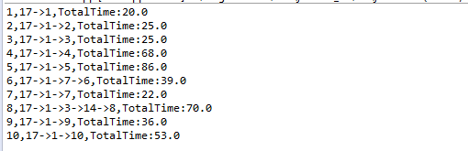

Each line is the result for the conveyor info for a bag. It is separated by comma. The 1st number is bag id, the 2nd is the path, it show you the shortest path of how the bag being transferred from source gate to the destination gate, the 3rd one is the shortest time it used. Following is the graph which help you to understand the result

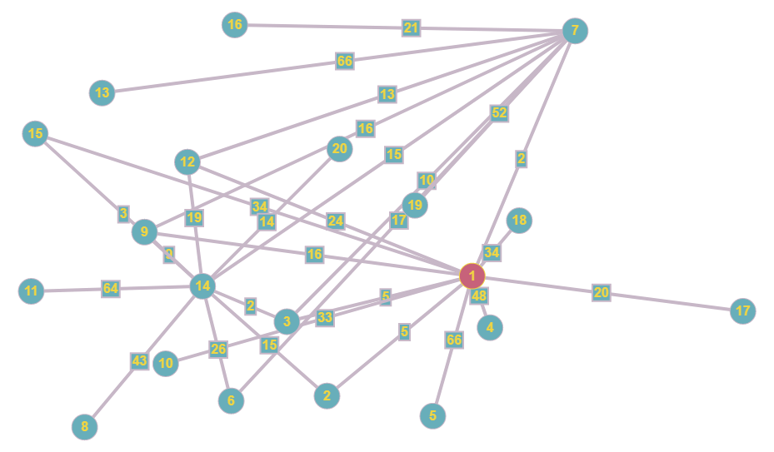

# How to mock data

If you want to mock your own data, you need to change the data in file “bags.text” and “departures.txt” under “SampleData” folder. You can add entries and remove entries in the above 2 file. As “id” in bag table is the primary key, if you add more than 2 entries with the same id, one will override the other. The same rule apply on departure table. If you want to change the transfer time between gates, you need to change the 3rd column in file “conveyor.properties”. There are 5 files. Each of them can be treated as a table. Here is the schema for the 5 files/tables

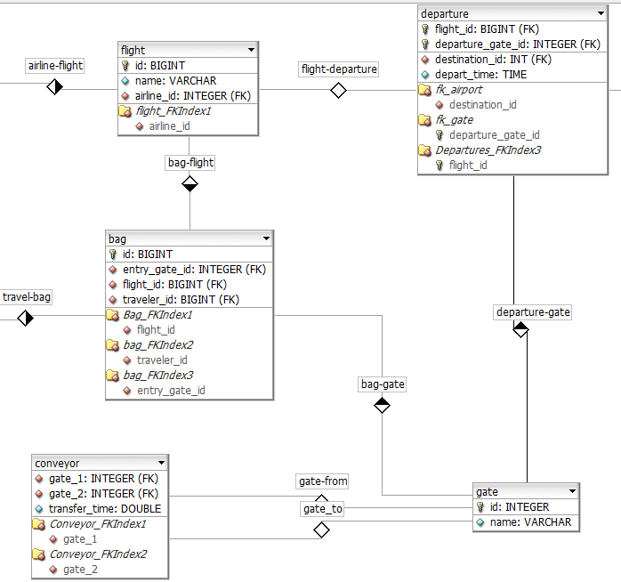

# Unit Test Report

I have generated a test report under “target\site”, you can open the file “surefire-report.html” to review the test report. The unit test code is under “src/test/java”. There are several new features I want to add, due to time limitation, I don’t write unit test for some of the class. All the cores functions are covered by the unit test. If you want to generate the report by yourself, you can use command “mvn surefire-report:report”. You can also right click the root package of the test cases, and click “run as Junit test”. It can generate a report too, but with different format of using maven command.

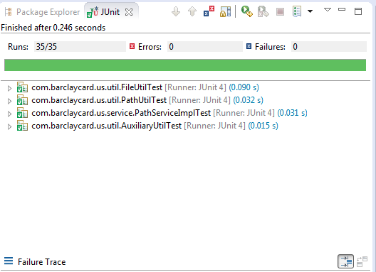

# The Architecture and Design

The project can be designed as a micro service which provides conveyor info for the other systems. The result can be json/xml format. Here is the table design

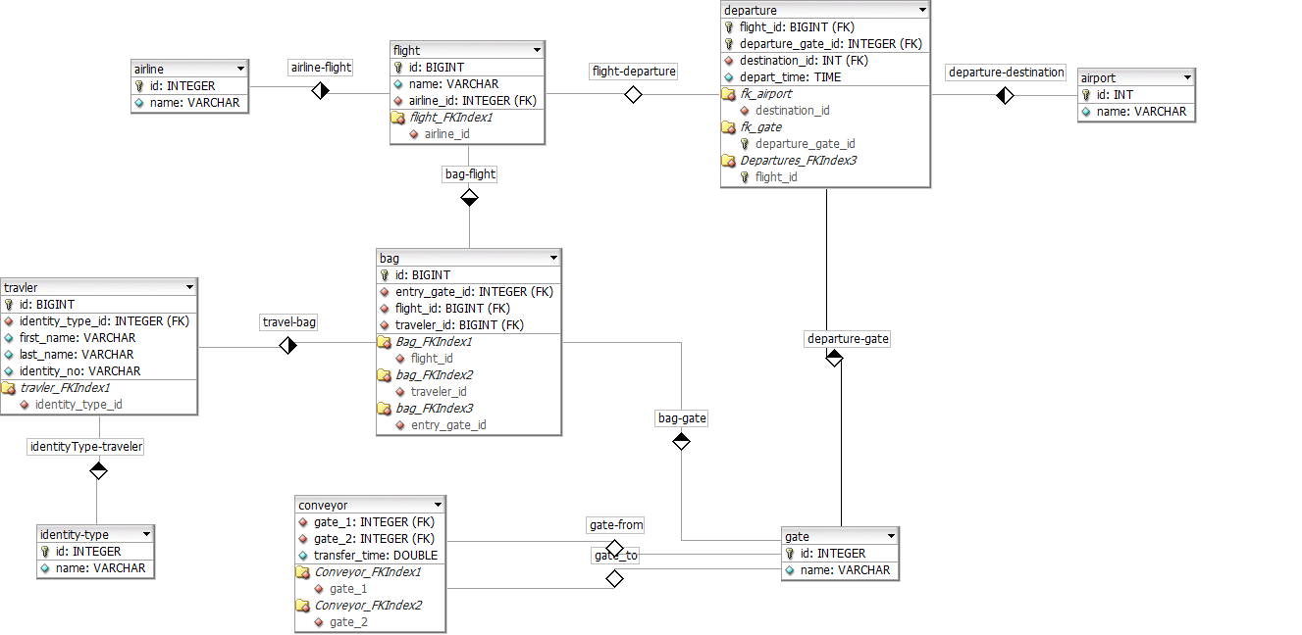

Each table has a java class related. In my code, the pojo classes are under package “com.barclaycard.us.model”. There can be an ORM layer between the pojo class and the database layer. There are a few ORM framework options, such Hibernate, MyBatis and etc. I am using files to simulate database/tables and using java collection to simulate ORM. FileUtil.java is used to read records from file, and AuxiliaryUtil.java is used translate the data from files into pojo classes. After the transformation, PathUtil.java is used to calculate the shortest path. I am using an optimized version of Dijkstra's algorithm. The time complexity is ElogV(E is the edges, V is vertex).

A service layer is used to provide service. To be more specific, they are under package “com.barclaycard.us.service”.

***Notes: Although I am using integer to represent the vertex, it can be represented by text too. The only thing which is to translate the id to name(text) when output the result and translate the name(text) to number when reading files. I have provided such function in service package.***

# Graph for Test Case

Here is the graph for “ServiceTest” case

