**Git Project**

**Preparation**

If you are not familiar with the concept of git please read the following article:

<https://en.wikipedia.org/wiki/Git>

**How to install git**

**Practice**

Please complete all the exercises created in the following page:

<https://learngitbranching.js.org/>

Please complete the exercises in the order that page suggest as shown below

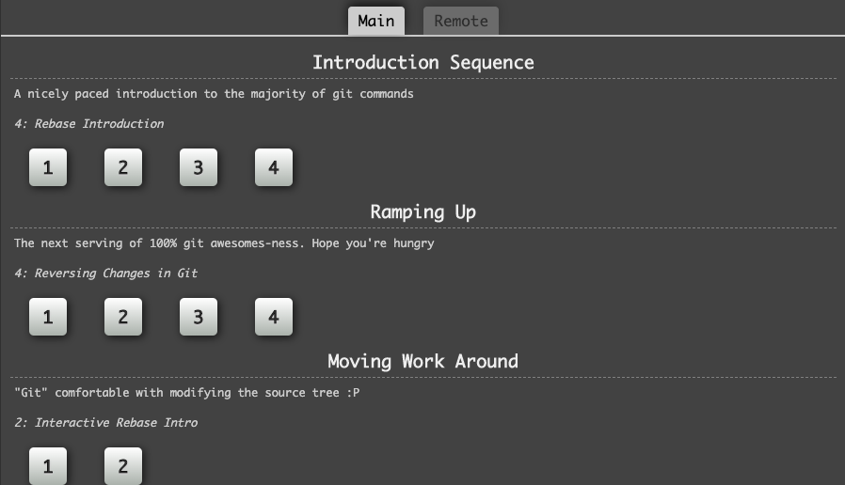

First complete the exercises in the Main tab and afterwards complete the ones in the Remote tab.

If you have any doubt please reach out to your mentor so that you can clarify all the questions you have. On the other hand you can reach out to [sebpache1@publicisgroupe.net](mailto:sebpache1@publicisgroupe.net)

**Project**

Once you have completed the exercises in the page above. As part of this exercise evaluation you will need to create a repository that has the following criteria:

* Have a master, development and release branch.
* Have merge commit
* Have rebased commits
* Have conflict resolution commits.

**Steps**

**In order to evaluate the commits, push and merges**

1. Create an empty repository and initialize it(This will by itself create the master branch).
2. Create the development branch and push it to a remote(have an active github account for this).
3. Create at least one feature branch.
4. Commit twice to the feature branch and push it.
5. Merge the commit branch into the develop branch and the push it.

**In order to evaluate the rebase of the branches**

1. Create a brand new feature branch
2. Commit to the newly created branch.
3. Commit three times to the feature and push it.
4. Rebase the Develop branch into the master branch.
5. Tag the master branch with a tag name 1.0.0.