Adapter Pattern



Now, the current code interface is not compatible with the new vendor’s interface.

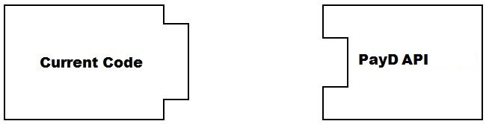
An Adapter to rescue

