Logo:

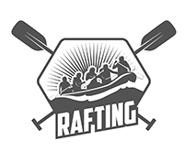

primary-color: #49516f;

secondary-color: #6279b8;

accent1-color: #8ea4d2;

accent2-color: #496f5d;

heading-font: Boldonse

text-font: Gidole

URL Color Palette: <https://coolors.co/8ea4d2-6279b8-49516f-496f5d-4c9f70>