Site Name
Rexburg Chamber of Commerce

Site Purpose

The website will act as a hub connecting Rexburg’s businesses, residents, and visitors. It highlights local events, showcases area businesses, and encourages residents to shop locally. Through these efforts, it supports economic growth and fosters a strong, connected community.

Target Market
Local business owners and residents throughout Rexburg and its neighboring communities.

Site Goals
- Familiarize new students with local businesses.
- Promote local business events to encourage shopping and restaurants.
- Attract new businesses and encourage economic development in the community.
- Improve city engagement by providing information on where to connect with other members of the community.

User Personas
- New Students: Lexi is a new student at BYU-Idaho. She would like to know what businesses are in town, especially for her new apartment, where she can go to eat, especially within walking distance from her new apartment.
- Small Business Owners: Heather just opened a new bakery in town selling soup and sourdough bread. She wants to help grow her business.
- City Officials: Jed works for Rexburg City and is looking for a place to promote city events to encourage community and belonging in Rexburg.

Scenarios
- A new resident is settling into the area and wants to learn what local services are available. They visit the Chamber’s website to browse a business directory and find grocery stores, furniture shops, and other essential resources nearby.
- A college student looking for dining options visits the Chamber website to explore local restaurants and cafes. They use filters to find places within walking distance and check for student discounts or community recommendations.
- A small business owner recently opened a shop and wants to promote their products to the community. They visit the Chamber’s website to learn how to list their business, post updates, and connect with potential customers.
- A business owner seeking networking opportunities visits the Chamber website to learn about upcoming workshops, member luncheons, and business growth resources. They look for information on how to register or become a Chamber member.
- A community member interested in local events visits the Chamber website to check the community calendar. They browse upcoming festivals, markets, and city activities, and register to attend events that interest them.
- A city representative planning a community event visits the Chamber website to submit event details for inclusion on the events calendar. They want to ensure the event reaches both residents and local businesses.
- A visitor considering relocating to the area explores the Chamber’s website to learn about the local business climate, employment opportunities, and quality of life before making a decision to move.
- A local organization wanting to collaborate with small businesses uses the Chamber’s business directory to identify potential partners for sponsorships, city initiatives, and community projects.

SEO Plan
- Use relevant meta tags in the website
- Verify the site on Google's Business Profile
- Create profiles on Facebook and Instagram to promote the Chamber’s website and it’s sponsored events

Design Brief
- Primary Color # 11224E
- Secondary Color# F87B1B
- Accent Color 1: # CBD99B
- Accent Color 2: EEEEEE
- Font Family 1: Fredericka the Great
- Font Family 2: Inria Serif

Site Map
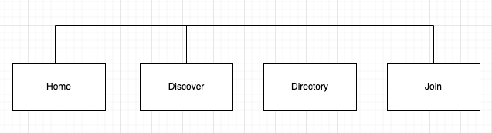
Wireframes
