Ejb3Unit - Out-of-Container EJB 3.0 Testing

Daniel Wiese, Fabian Bauschulte

Table of contents

Ejb3Unit - Out-of-Container EJB 3.0 Testing 1
Preface 1
Approach 1
Configuration 2
Entity-Bean test: 2
First simple example 2
Parameterisation of entity instance generation 4
Writing own Generator 6
Testing entity beans with relations 8
Testing beans with OneToMany relations 8
Mocked session bean test 9
Using mock controlls 10
Object Equality 10
Object Identity 10
String Contains a Substring 11
Anything 11
Combining Constraints 11
And - Logical Conjunction 11
Or - Logical Disjunction 12
Specifying return types 12
Session bean test: 12
JBoss Service classes 13

Preface

The Ejb3Unit project will automate Entity and Session bean testing outside the container for the EJB 3.0 specification. Ejb3Unit can execute automated standalone JUnit test for all EJB 3.0 standard conform J2EE projects.

Approach
EJb3Unit can be configured for an in memory database (default setting) or for a user defined target database (never use production databases). Ejb3Unit provides three different test categories:

- Entity bean test: Fully automated test. Entity bens are randomly generated and written / read against the database (or in memory db). Equals and HashCode methods are checked automatically. Nullable fields are tested.

- Mocked session bean test: A session bean class is created and for all Ejb3 dependency injection field’s mock objects are injected. This test allows testing of an Session bean in isolation.

- Session bean test: The tested session bean and all referenced session beans are created (annotated with @EJB for dependency injection). Also DataSource and SessionContext are injected. The in memory database is initialized with predefined data using comma separated value files. Each .csv file represents data for one table (using the mapping definitions form the corresponding entity bean). This test is an integration test.

Configuration
Ejb3Unit use a single configuration file named ejb3unit.properties. This file has to be present in your class path. All necessary configuration is done here (like the database driver, connection, etc.) . This is an example for the in memory database:

### The ejb3unit configuration file ###
ejb3unit.inMemoryTest=true
ejb3unit.show_sql=false

This is an example of a user defined database:

### The ejb3unit configuration file ###
ejb3unit.connection.url=jdbc:protokoll:db://host:port/shema
ejb3unit.connection.driver_class=my.jdbc.Driver
ejb3unit.connection.username=ejb3unit
ejb3unit.connection.password=ejb3unit
ejb3unit.dialect=org.hibernate.dialect.SQLServerDialect
ejb3unit.show_sql=true

## values are create-drop, create, update ##
ejb3unit.shema.update=create

Entity-Bean test:

With EJB3Unit you can create and test entity beans outside the container.
EJB3Unit will automate your entity bean testing. Ejb3Unit will generate random (or customized) entity beans for you and test the read write access against your database. During this test possible data truncations, wrong declared nullable fields or other possible schema errors will be checked. Furthermore EJB3Unit will check your equals and hashCode implementations for your Entity beans.

First simple example

How to write a simple Entity bean test?

We assume that a Book bean is an entity bean

@Entity
@Table(name = "AUTOR")
public class Author implements Serializable{

@Id(generate = GeneratorType.NONE)
private int id;

private String name;

@Column(name="creation_timestamp", nullable=false)
private Date created;
}

If we want to write a JUnit test for this entity bean we write the following piece of code:

public class Author Test
extends BaseEntityTest<Author> {

/**
* Constructor.
*/
public StockWKNBoTest() {
super(Author.class);
}
}

That’s it! It’s not that much code for y complete entity bean JUnit test!

But what will happen behind the facade? Ejb3Unit will start to analyse the meta data information of the entity bean. This means: What are the persistent fields, what the primary key fields, which fields are transient and so on?

Using all this Meta-Information’s Ejb3Unit is able to generate random instances of the Author bean.

Now Ejb3Unit will make very useful tests automatically for you. The current Ejb3Unit Implementation will:

- Check if <n> randomly generated instances can be written to the database (this is only possible if the database schema is correct). The random bean generation consider following variations:
  - Try to write ban instances with max. length fields (e.g. a string with the length 255 chars - if the max length definition of this field is 255 characters)
  - Try to write null values to nullable fields.
- Check if <n> randomly generated instances can be read from the database. The read operation will:
  - Check if the read entity bean instance is equals to the generated instance (based on the persistent fields)
  - Check if the equals() implementation is correct. This mends that two entity beans representing the same database row are equal. And two beans representing different rows in the database are never equal.
  - Check if the hashCode() implementation is correct. This means that two beans which are equal must have the same hashCode. And <n> different beans should have a hashCode variation

Parameterisation of entity instance generation
In the previous test we generated only random entity beans instances. No we will show how the automatic generation of entity beans can be parameterized.

In the default case, every persistent field of an entity bean will be filled with random data. This default behaviour can be overwritten by using an own Generator implementation.

Imagine you would like to test the following entity bean:

@Entity
@Table(name = "ARTICLE")
public class Article implements Serializable{

@Id (generate = GeneratorType.TABLE)
@Column (name = "id")
private int id;

private String title;

private int autorId;
}

We will assume that the autorId is a foreign key field to the Authors table (and we will ignore the fact, that such a realization of the entity bean is “strange” because we would normally use a relation to Author)

Now we would like to crate an entity bean test which will generate random data for the persistent fields id and title but the field autorId should have always the value 1 (because we know than in our database an Author with the primary key 1 exists).

To parameterize such an Ejb3Unit Test we need two things:
- A generator class for the field autorId which generates always “1” as value
- A Ejb3Unit entity test, using this generator

The generic generator interface is very simple:

public interface Generator<T> {
T getValue();
}

The getValue() method generates a value for a distinct type T for a specified field. The Introspector class contains information about the Meta data of the bean.

Every concrete generator must contain Meta data information (Java 5 annotations) describing for which case the generator should be used. For example we could use following annotation:

@GeneratorType(
className = Integer.class,
field = "autorId",
fieldType = FieldType.ALL_TYPES)

To describe that this generator should be used for all fields named “autorId” of type Integer.

With this knowledge we are now able to develop our custom generator:

@GeneratorType(className = Integer.class, field = "autorId", fieldType = FieldType.ALL_TYPES)
public class ConstantIntegerGenerator implements Generator<Integer> {

private final int constant;

public ConstantIntegerGenerator(int constant) {
this.constant = constant;
}

public Integer getValue() {
return this.constant;
}
}

That’s it. Now we have to register our custom generator to our Ejb3Unit entity test:

public class ArticleTest extends BaseEntityTest<Article> {

private static final Generator[] SPECIAL_GENERATORS = {
new ConstantIntegerGenerator(1) };

public ArticleTest () {
super(Article.class, SPECIAL_GENERATORS);
}
}

That’s it. Now all generated Articles will have the autorId=1 value and the bean can be persisted in the database.

But how Ejb3Unit knows which generator should be used for a concrete persistent field?

The answer is: Ejb3Unit use a well defined hierarchy of generators. Always the generator with the highest specialization will be used.

In our example the ConstantIntegerGenerator has a higher specialization as the build in RandomIntegerGenerator! This is the reason why our implementation is used.

The hierarchy is a follows:

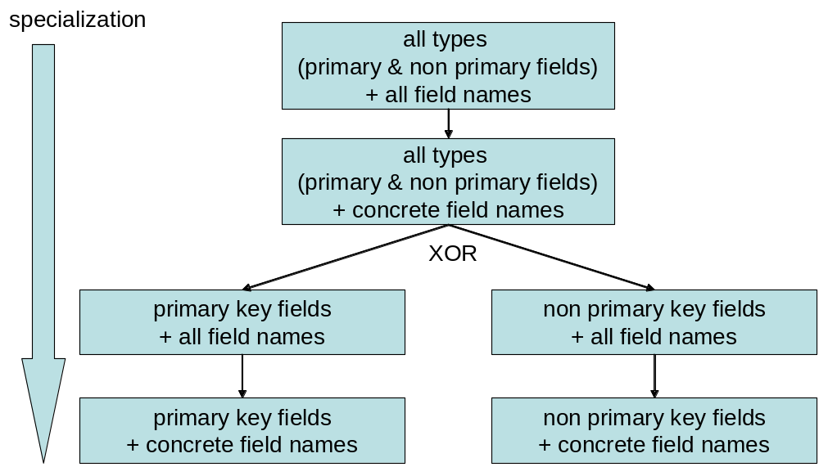

As you see a linear hierarchy definition is used. Every concrete generator has a clear hierarchy level.

Writing own Generator
As explained before, every generator must implement the generator Interface

The generic generator interface is very simple:

public interface Generator<T> {
T getValue();
}

If a generator needs different kinds of references, for the generation of the next value, annotations for dependency injection can be used.

Following annotations for dependency injection are possible inside the generator class:

- @ ForInstance: If a generator need a reference to the entity bean instance where this generator is used for
- @ ForProperty: If a generator need a reference to the property of a entity bean instance where this generator is used for
- @ UsedIntrospector: If a generator need a reference to the introspector associated with the entity bean, where this generator is used for

Sometimes a generator need to prepare some things before a JunitTest is executedt and cleanup later his stuff when the JUnit test is completed. For this Ejb3Unit provides two annotations for life cycle methods:

- @PrepareGenerator: Every method with this annotation gets called before the JUnit test is executed
- @CleanupGenerator: Every method with this annotation gets called after the JUnit test is executed

Example: The following snippet demonstrated the usage of such Annotation:

@PrepareGenerator
public void preCreate() {

if (emf==null){
this.initEntityManagerFactory();
}
}

The next code snippet shows a custom generator for Date generation.

@GeneratorType(className = Date.class, fieldType = FieldType.ALL_TYPES)
public class RandomDateGenerator extends BaseUniqueValueGenerator<Date>
implements Generator<Date> {

@ForProperty private Property forProperty;
@UsedIntrospector private Introspector introspector;

public Date getValue() {
return this.getUniqueValueForEachPkField(forProperty,
introspector);
}

@Override
protected Date generateCadidate() {
return BaseRandomDataGenerator.getValueDate();
}

}

Testing entity beans with relations
In many cases the entity beans which are intended to test have relations. Possible relations are OneToMany, ManyToOne and OneToOne.

With Ejb3Unit it’s possible to Test this beans AND the relations (in a non transitive way!).

Testing beans with OneToMany relations
The first thing you have to write is a generator which generates <n> bans for the Collection filed (representing the n side)

In this example we ere going to create a Order. Typically a Order has relation to <n> LineItems. The LineItems are represented by the property “lineItems” which is of type Collection.

As the first step we must create a (inner) Class –a Generator, called MyLineItemCreator.

@GeneratorType(className = Collection.class,field="lineItems")
class MyLineItemCreator extends
BeanCollectionGenerator<LineItem> {

private MyLineItemCreator() {
super(LineItem.class, 10);
}
}

We simple inherit form the BeanCollectionGenerator. In the constructor we have to pass the amount of line items generated for each Order.

Now we can create an EntityTest and add this generator to this entity test:

public class OrderTest extends BaseEntityTest<Order> {

private static final Generator[] SPECIAL_GENERATORS = {
new MyLineItemCreator() };

public OrderTest() {
super(Order.class, SPECIAL_GENERATORS);
}
}

That’s it! This test will always create Orders with 10 LineItem´s. Every LineItem will have an automatic back association to the Order (and vice versa)

Mocked session bean test
EJB3Unit is able to inject to annotated fields (using EJB 3 (JSR 220) annotations), mock objects. The MockedSessionBeanTest can be used to automate the dependency injection and execute easily test with mocked dependencies. The basic test can be configured by extending the MockedSessionBeanTest class. The next example shows ho to test a session bean class called MyOtherSessionBean:

public class MyOtherSessionBeanTest extends
MockedSessionBeanTest<MyOtherSessionBean> {

/**
* Constructor.
*/
public MyOtherSessionBeanTest() {
super(MyOtherSessionBean.class);
}

public void test_executeOperation() {
…
}
}

In the test method test_executeOperation() we can specify which operation on which JMock objects will be executed. We can specify this e.g.:

public void test_executeOperation() {
MyOtherSessionBean toTest = this.getBeanToTest();
final Mock mySessionBean =
this.getMockControl("mySessionBean");

mySessionBean.expects(once()).method("getDs").
will(returnValue(ds));

//call the expected operation
toTest.executeOperation();

With the method getMockControl(“propertyName”) we can retrieve the Mock control object for every property in the session bean.

Using mock controlls

Object Equality

The most commonly used constraint is eq, which specifies that the received argument must be equal to a given value. The code below, for example, specifies that the method "m" must be called with one argument of value 1.

mock.expects(once()).method("m").with( eq(1) );

The eq constraint uses the equals method of the expected value to compare the expected and actual values for equality. Null values are checked beforehand, so it is safe to specify eq(null) or apply the constraint to a null actual value. The eq constraint is overridden for all primitive types; primitive values are boxed into objects that are then compared using the equals method. Arrays are treated as a special case: two arrays are considered equal by eq if they are the same size and all their elements are considered equal by eq.
Numeric Equality with Error Margin

An overloaded version of the eq constraint specifies floating point values as equal to another value with some margin of error to account for rounding error. The following code specifies that the method "m" will be called with one argument of value 1 plus or minus 0.002.

mock.expects(once()).method("m").with( eq(1, 0.002) );

Object Identity

The same constraint specifies that the actual value of the argument must be the same object as the expected value. This is a tighter constraint than eq, but is usually what you want for arguments that pass references to behavioural objects. The following code specifies that method "m" will be called with one argument that refers to the same object as expected.

Object expected = new Object();

mock.expects(once()).method("m").with( same(expected) );

As a rule of thumb, use eq for value objects and same for behavioural objects.
Instance of a Type

The isA constraint specifies that the actual argument must be an instance of the given type. The following code specifies that method "m" must be called with an argument that is an ActionEvent.

mock.expects(once()).method("m").with( isA(ActionEvent.class) );

String Contains a Substring

The stringContains constraint specifies that the expected argument must be a string that contains the given substring. The following code specifies that method "m" must be called with an argument that is a string containing the text "hello".

mock.expects(once()).method("m").with( stringContains("hello") );

The stringContains constraint is especially useful for testing string contents but isolating tests from the exact details of punctuation and formatting. For example, the code above would accept any of the following argument values: "hello world"; "hello, world"; "hello!"; and so on.
Null or Not Null

The constraints NULL and NOT_NULL are specify that an argument is null or is not null, respectively. These are constants, not methods. The following code specifies that method "m" must be called with two arguments, the first must be null and the second must not be null.

mock.expects(once()).method("m").with( NULL, NOT_NULL );

Anything

The ANYTHING constraint specifies that any value is allowed. This is useful for ignoring arguments that are not germane to the scenario being tested. Judicious use of the ANYTHING constraint can ensure that your tests are flexible and do not require constant maintenance when tested code changes. The following code specifies that the method "m" must be called with two arguments, the first of which is equal to 1 and the second of which is ignored in this test.

mock.expects(once()).method("m").with( eq(1), ANYTHING );

Combining Constraints

Constraints can be composed to create a tighter or looser specification. Composite constraints are themselves constraints and can therefore be further composed.
Not — Logical Negation

The not constraint specifies that the actual argument must not meet a given constraint. The following code specifies that the method "m" must be called with an argument that is not equal to 1.

mock.expects(once()).method("m").with( not(eq(1)) );

And - Logical Conjunction

The and constraint specifies that the actual argument must meet both of two constraints given as arguments. The following code specifies that the method "m" must be called with a string that contains the text "hello" and the text "world".

mock.expects(once()).method("m").with( and(stringContains("hello"),
stringContains("world")) );

Or - Logical Disjunction

The or constraint specifies that the actual argument must meet either of two constraints given as arguments. The following code specifies that the method "m" must be called with a string that contains the text "hello" or the text "howdy".

mock.expects(once()).method("m").with( or(stringContains("hello"),
stringContains("howdy")) );

Specifying return types
You can specify a single return type for one call

mySessionBean.expects(once()).method("getMethod").will(returnValue(10));

Or multiple different return types for multiple calls.

mock.expects(atLeastOnce()).method(m).with(...)
.will( onConsecutiveCalls(
returnValue(10),
returnValue(20),
throwException(new IOException("end of stream")) ) );

Session bean test:

With EJB3Unit you can create and test session beans outside the container. EJB3Unit will support EJB 3 dependency injection, life cycle methods (with annotations) and other EJB 3 features for statefull and stateless session beans.

Currently following dependeny injection Attributes are supported:
- @EJB → dependency injection of other Staeless/Staefull session beans. The Session bean implementation is discovered automatically at runtime
- @Resource→dependency injection is supported for following resources:
  - DataSource : A data source implementation is Injected (conform to the Ejb3Unit) settings
- @PersistenceContext→ EntityManager: A full function implementation of the EJB 3.0 EntityManager is injected automatically

public class SaleAccessServiceTest extends
BaseSessionBeanTest<SaleAccessService> {

private static final Class[] USED_ENTITY_BEANS = { SaleBo.class };

public SaleAccessServiceTest() {
super(SaleAccessService.class, USED_ENTITY_BEANS);
}

/**
* Testmethod.
*/
public void testLoadImpossibleData() {
SaleAccessService toTest = this.getBeanToTest();
}
}

JBoss Service classes

With EJB3Unit you can create and test JBoss service classes outside the container. EJB3Unit will support EJB 3 dependency injection, life cycle methods (with annotations) and other EJB 3 features for JBoss service classes.

public class SaleWindowCacheTest extends BaseJbossServiceTest<SaleWindowCache> {

private static final Class[] USED_ENTITY_BEANS = { SaleBo.class };

/**
* Create the test case.
*/
public SaleWindowCacheTest() {
super(SaleWindowCache.class, USED_ENTITY_BEANS);
}
}

