Question 1.
Imagine a publishing company that markets both book and audiocassette versions of its
works. Create a class publication that stores the title (a string) and price (type float )of a
publication. From this class derive two classes: book, which adds a page count (type
int ), and tape, which adds a playing time in minutes (type float ). Each of these three
classes should have a getdata() function to get its data from the user at the keyboard,
and a putdata() function to display its data.
Write a main() program to test the book and tape classes by creating instances of them,
asking the user to fill in data with getdata() , and then displaying the data with putdata().

SOLUTION:
#include<iostream>
#include<string>
using namespace std;
class Publication
{
private:
string title;
float price;
public:
void getData()
{
cout<<"\nEnter Title: ";
cin>>title;
cout<<"Enter Price: $";
cin>>price;
}

void putData()
{ cout<<"\nTitle: "<<title<<"\nPrice: "<<price; }
};
class Book : public Publication
{
private:
int pages;
public:
void getData()
{ Publication::getData(); cout<<"Enter Pages: "; cin>>pages; }

void putData()
{ Publication::putData(); cout<<"\nPages: "<<pages; }
};
class Tape : public Publication
{
private:
float minutes;
public:
void getData()
{ Publication::getData(); cout<<"Enter Minutes: "; cin>>minutes; }

void putData()
{ Publication::putData(); cout<<"\nMinutes: "<<minutes; }
};

int main()
{
Book b; Tape t;
b.getData();
t.getData();

cout<<"\a"<<endl; // ’\a'produces the beep sound
b.putData();
cout<<endl;
t.putData();
cout<<endl;

return 0;
}

Output :

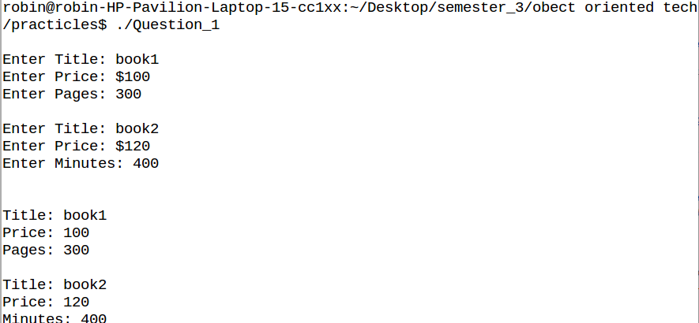

Question 2:
Write a class representing bank accounts. The class should have the following data
members : Customer Name, Account Number, Type of Account (Savings/Current etc),
Account Balance. The class should allow basic operations like creating a new account,
deposit an amount, withdraw money after checking the balance, display account details.
SOLUTION:
#include<iostream>
#include<stdio.h>
#include<string.h>

using namespace std;

class bank
{
int acno;
char nm[100], acctype[100];
float bal;
public:
bank(int acc_no, char *name, char *acc_type, float balance) //Parameterized Constructor
{
acno=acc_no;
strcpy(nm, name);
strcpy(acctype, acc_type);
bal=balance;
}
void deposit();
void withdraw();
void display();
};
void bank::deposit() //depositing an amount
{
int damt1;
cout<<"\n Enter Deposit Amount = ";
cin>>damt1;
bal+=damt1;
}
void bank::withdraw() //withdrawing an amount
{
int wamt1;
cout<<"\n Enter Withdraw Amount = ";
cin>>wamt1;
if(wamt1>bal)
cout<<"\n Cannot Withdraw Amount";
bal-=wamt1;
}
void bank::display() //displaying the details
{
cout<<"\n ----------------------";
cout<<"\n Accout No. : "<<acno;
cout<<"\n Name : "<<nm;
cout<<"\n Account Type : "<<acctype;
cout<<"\n Balance : "<<bal<<endl;
}
int main()
{
int acc_no;
char name[100], acc_type[100];
float balance;
cout<<"\n Enter Details: \n";
cout<<"-----------------------";
cout<<"\n Accout No. ";
cin>>acc_no;
cout<<"\n Name : ";
cin>>name;
cout<<"\n Account Type : ";
cin>>acc_type;
cout<<"\n Balance : ";
cin>>balance;

bank b1(acc_no, name, acc_type, balance); //object is created
b1.deposit(); //
b1.withdraw(); // calling member functions
b1.display(); //
return 0;
}
Output:
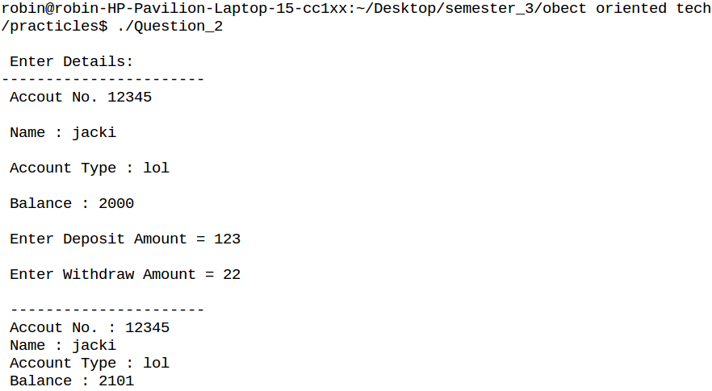

Question 3:
( CarbonFootprint Abstract Class: Polymorphism) Using an abstract class with only pure
virtual functions, you can specify similar behaviour for possibly disparate classes.
Governments and companies worldwide are becoming increasingly concerned with
carbon footprints (annual releases of carbon dioxide into the atmosphere) from buildings
burning various types of fuels for heat, vehicles burning fuels for power, and the like.
Many scientists blame these greenhouse gases for the phenomenon called global
warming. Create three small classes unrelated by inheritance—classes Building, Car
and Bicycle . Give each class some unique appropriate attributes and behaviours that
it does not have in common with other classes. Write an abstract class CarbonFootprint
with only a pure virtual getCarbonFootprint method. Have each of your classes inherit
from that abstract class and implement the getCarbonFootprint method to calculate an
appropriate carbon footprint for that class (check out a few websites that explain how to
calculate carbon footprints). Write an application that creates objects of each of the three
classes, places pointers to those objects in a vector of CarbonFootprint pointers, then
iterates through the vector, polymorphically invoking each object’s getCarbonFootprint
method. For each object, print some identifying information and the object’s carbon
footprint.
SOLUTION:
#include <iostream>
#include <vector>
using namespace std;

class CarbonFootPrint //abstract class
{
public:
virtual void getCarbonFootPrint()=0; //a pure virtual function
//A virtual function is “made pure” by the “pseudo initializer” = 0;
//virtual ~CarbonFootPrint();//virtual destructor
//it is iportant for an abstract class to have a virtual destructor
};

class Building : public CarbonFootPrint
{
public:
Building(double e, int m); //constructor
Building()=default;
~Building()=default; //destructor set to default
void setElectric();
virtual void getCarbonFootPrint() override;

private:
double electric{0};
int months{12};
};

Building::Building(double e, int m): electric{e},months{m} {}//constructor

void Building::setElectric()
{
cout << "Enter your monthly electric in KWH: " << endl;
cin >> electric;
}

void Building::getCarbonFootPrint()
{
cout << "The carbon footprint for this house is " << endl;
cout<<(electric * months)<<endl;
}

class Car : public CarbonFootPrint
{
public:
Car(double =0, double=0); //constructor
~Car()=default; //destructor
void setYearlyMiles();
void setAverageMPG();
virtual void getCarbonFootPrint()override;

private:
double yearlyMiles{0}, averageMPG{0};
int co2 = 9;
};

//class implementation
Car::Car(double ym, double mpg):yearlyMiles{ym},averageMPG{mpg}{}

void Car::setYearlyMiles()
{
cout << "Enter in your yearly miles: " << endl;
cin >> yearlyMiles;
}

void Car::setAverageMPG()
{
cout << "Enter in your average miles per gallon: " << endl;
cin >> averageMPG;
}

void Car::getCarbonFootPrint()
{
cout << "The carbon footprint for this car is " << endl;
cout<<((yearlyMiles * averageMPG) * co2)<<endl;
}

class Bicycle : public CarbonFootPrint
{
public:
Bicycle(double, int); //constructor
Bicycle()=default;
~Bicycle()=default; //destructor
void setMiles();
virtual void getCarbonFootPrint();

private:
int calories{34};
double miles{0};
};

//class implementation
Bicycle::Bicycle(double m, int c):miles{m},calories{c}{}

void Bicycle::setMiles()
{
cout << "Enter in number of miles: " << endl;
cin >> miles;
}

void Bicycle::getCarbonFootPrint()
{
cout << "The carbon footprint for this bicycle is " << endl;
cout<<miles * calories<<endl;
}

int count=0;
int main()
{
CarbonFootPrint* list[20];
int answer, i;

cout << "Welcome to the Carbon Footprint Calculator!\n" << endl;

do
{
cout << "Main Menu\n" << endl;
cout << "1: Set house info.\n" << endl;
cout << "2: Set car info.\n" << endl;
cout << "3: Set bicycle info.\n" << endl;
cout << "4: Get carbon footprint for all items set.\n" << endl;
cin >> answer;

switch (answer)
{
case 1:
{
cout << "\n" << endl;
Building *anotherBuilding;
anotherBuilding = new Building;
anotherBuilding->setElectric();
cout << "\n" << endl;
list[count]=anotherBuilding;
count++;
break;
}

case 2:
{
cout << "\n" << endl;
Car *anotherCar;
anotherCar = new Car;
anotherCar->setYearlyMiles();
anotherCar->setAverageMPG();
cout << "\n" << endl;
list[count]=anotherCar;
count++;
break;
}

case 3:
{
cout << "\n" << endl;
Bicycle *anotherbike;
anotherbike = new Bicycle;
anotherbike->setMiles();
cout << "\n" << endl;
list[count]=anotherbike;
count++;
break;
}

case 4:
{
for(int i=0;i<count;i++)
{
list[i]->getCarbonFootPrint();
}
//have it iterate through the vector and print out each carbon footprint.
break;
}

default:
{
cout << answer << " is not a valid option" << endl;

break;
}
}
}
while (answer != 4);
return 0;
}
Output:
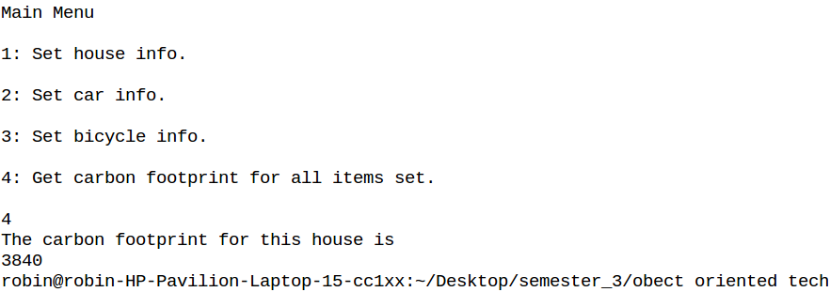

Question 7:
Write a Program to find Maximum out of Two Numbers using friend function.
Here one number is a member of one class and the other number is a member of some
other class.
SOLUTION:
#include<iostream>
using namespace std;
class Number2;
class Number1
{
int num;
public:
void setnum(int i)
{
num = i;
}
int getnum()
{return num;}
friend void largest(Number1 , Number2);
};
class Number2
{
int num;
public:
void setnum(int i)
{
num = i;
}
int getnum()
{return num;}
friend void largest(Number1 , Number2);
};
void largest(Number1 n1,Number2 n2)
{
if(n1.num>n2.num)
cout<<"Number 1 is largest"<<n1.num<<endl;
else if(n2.num>n1.num)
cout<<"Number 2 is largest:"<<n2.num<<endl;
else
cout<<"Numbers are equal";
}
int main()
{
Number1 n1;
Number2 n2;
n1.setnum(2);
n2.setnum(4);
largest(n1,n2);
return 0;
}
Output:
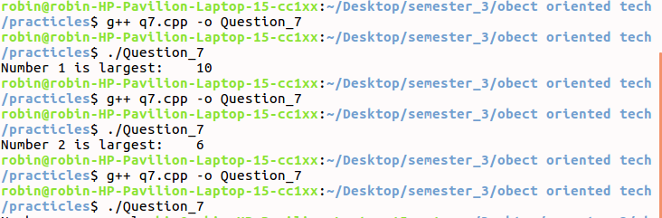

Question 8:
Write a Program to swap private data members of classes named as class_1, class_2
using friend function.
SOLUTION
#include<iostream>
using namespace std;
class Number2;
class Number1
{
int num;
public:
void setnum(int i)
{
num = i;
}
int getnum()
{return num;}
friend void swap(Number1 &, Number2 &);
};
class Number2
{
int num;
public:
void setnum(int i)
{
num = i;
}
int getnum()
{return num;}
friend void swap(Number1 &, Number2 &);
};
void swap(Number1 &n1,Number2 &n2)
{
int temp;
temp = n1.num;
n1.num = n2.num;
n2.num = temp;
}
int main()
{
Number1 n1;
Number1 n2;
n1.setnum(3);
n2.setnum(5);
cout<<"before swap\n";
cout<<"N1: "<<n1.getnum();
cout<<"\nN2: "<<n2.getnum();
swap(n1,n2);
cout<<"\nafter swap\n";
cout<<"N1: "<<n1.getnum();
cout<<"\nN2: "<<n2.getnum()<<endl;
}
Output:
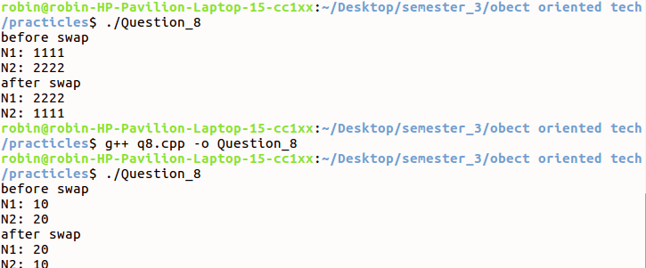

Question 9:
Write a Program to design a class to represent a matrix. The class should have the
functionality to insert and retrieve the elements of the matrix. Define constructors to
allocate memory dynamically for the dimensions supplied.
SOLUTION
#include<iostream>
using namespace std;
class Matrix
{
int **p;
int n,m;
public:
Matrix(int r,int c)
{
n=r;
m=c;
p = new int*[n];
for(int i=0;i<n;i++)
p[i] = new int[m];
}
void setmat()
{
cout<<"Enter te elements for the matrix: ";
for(int i=0;i<n;i++)
for(int j=0;j<m;j++)
cin>>p[i][j];
}
void showmat()
{
cout<<"\nMatrix is:\n";
for(int i=0;i<n;i++)
{
cout<<endl;
for(int j=0;j<m;j++)
cout<<p[i][j];
}
}
};
int main()
{
Matrix m(3,3);
m.setmat();
m.showmat();
return 0;
}
Output:
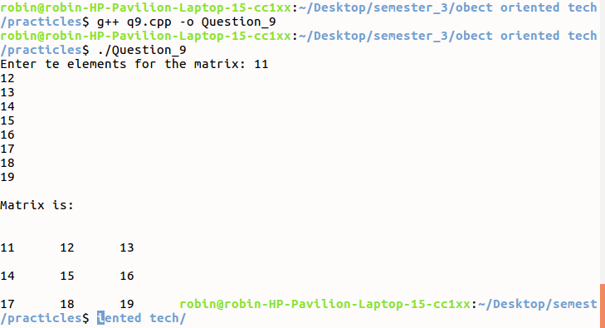

Question 10:
Write a Program which creates & uses an array of the object of a class. ( for eg.
implementing the list of students of a class having details such as Name, Age, marks
etc..).
SOLUTION
#include<iostream>
#include<iomanip>
using namespace std;
class Student
{
int roll,age;
string name;
float marks;
public:
Student()
{
roll = age = 0;
marks = 0.0f;
name = " ";
}
void set(int rn,int ag,string nm,float mk)
{
roll = rn;
age =ag;
name = nm;
marks = mk;
}
void put()
{
cout<<"ROLL No: "<<left<<setw(20)<<roll<<endl;
cout<<"NAME : "<<left<<setw(20)<<name<<endl;
cout<<"AGE : "<<left<<setw(20)<<age<<endl;
cout<<"MARKS : "<<left<<setw(20)<<marks<<endl;
}
};
int main()
{
int i,n,r,a;
string nm;
float mk;
cout<<"Ente the no. of student details wanna enter: ";
cin>>n;
const int num =n;
Student s[num];
for(i=0;i<n;i++)
{
cout<<"Enter the Roll no : ";
cin>>r;
cout<<"Enter the name: ";
cin>>nm;
cout<<"Enter the age: ";
cin>>a;
cout<<"Enter the marks: ";
cin>>mk;
s[i].set(r,a,nm,mk);
}
for(i=0;i<n;i++)
{
s[i].put();
cout<<endl;
}
}
Output:
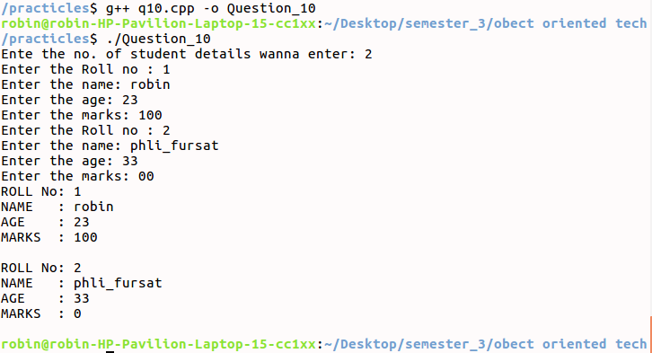

Question 11:
Write a class with a simple integer as a class member and a member function that
returns that value. There should be two overloaded constructors one which takes an
integer as an argument and the other taking a “char *” as an argument. (Note: Can use
atoi function to convert “char *” to int.)
SOLUTION

#include<iostream>
using namespace std;
class Integer
{
int i;
public:
Integer()
{
i=0;
}
Integer(int n)
{
i=n;
}
Integer(char *ch)
{
i = atoi(ch);
}
void show()
{
cout<<"i = "<<i<<endl;
}
};
int main()
{
Integer i1;
Integer i2(10);
char ch[10];
cout<<"Enter the no: ";
fgets(ch,9,stdin);
Integer i3(ch);
i1.show();
i2.show();
i3.show();
return 0;
}
Output:
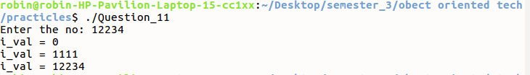

Question 12:
Overload the ‘ + ’ operator to add two Rational Numbers.
SOLUTION
#include<iostream>
using namespace std;
class Rational
{
int n,d;
public:
void set(int a,int b)
{
n=a;
d=b;
}
void put() const
{
cout<<"Sum:";
cout<<n<<"/"<<d;
}
friend Rational operator+(Rational ,Rational);
};
Rational operator+(Rational u1,Rational u2)
{
Rational r;
r.n=u1.n*u2.d+u2.n*u1.d;
r.d=u1.d*u2.d;
return r;
}
int main()
{
int a,b;
Rational r1,r2,r3;
cout<<"Enter the 1st rationals numerator and denominator: ";
cin>>a>>b;
r1.set(a,b);
cout<<"Enter the 2nd rationals numerator and denominator: ";
cin>>a>>b;
r2.set(a,b);
r3 = r1 + r2;
r3.put();
return 0;
}
Output:
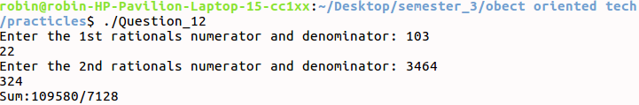

Question 13
Overload the ‘ * ’ operator to multiply two matrices.
SOLUTION
#include<iostream>
using namespace std;
class Matrix
{
int arr[3][3];
public:
void set()
{
for(int i=0;i<3;i++)
for(int j=0;j<3;j++)
cin>>arr[i][j];
}
void show()
{
for(int i=0;i<3;i++)
{
cout<<endl;
for(int j=0;j<3;j++)
cout<<arr[i][j]<<" ";
}
}
Matrix operator*(Matrix m)
{
Matrix r;
for(int i=0;i<3;i++)
{
for(int j=0;j<3;j++)
{
r.arr[i][j]=0;
for(int k=0;k<3;k++)
{
r.arr[i][j]+=arr[i][k]*m.arr[k][j];
}
}
}
return r;
}
};
int main()
{
Matrix m1,m2,m3;
cout<<"Enter the matrix 1:\n";
m1.set();
cout<<"\nEnter the mateix 2:\n";
m2.set();
m3 = m1 * m2;
m3.show();
return 0;
}
Output:
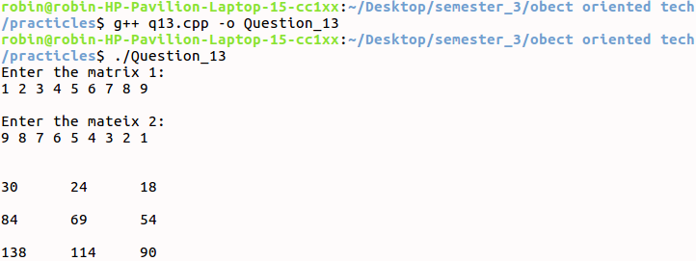

Question 14:
Design a Point class with coordinates x and y representing a point on the plane (use
constructors and overload << and >> operators). Design a Polar class which represent
class using polar coordinates radius(r) and angle(a). Write a program which takes input
data for a Point object and perform type conversion so as to convert the Point data into
Polar data.
Use the following formulas where required:
x = r * cos(a); y = r * sin(a);
a = atan(y/x); r = sqrt(x*x + y*y);
SOLUTION:
#include<iostream>
using namespace std;
class Point
{
int x,y;
public:
Point()
{
x=0;
y=0;
}
Point(int a,int b)
{
x=a;
y=b;
}
int getx()
{return x;}
int gety()
{return y;}
friend istream & operator >>(istream &in,Point &p);
friend ostream & operator <<(ostream &out,const Point &p);
};
istream & operator >>(istream &in,Point &p)
{
cout<<"Enter X and Y coordinate: ";
in >> p.x >> p.y ;
return in;
}
ostream & operator <<(ostream &out,const Point &p)
{
out<<"("<< p.x <<","<< p.y <<")"<<endl;
return out;
}
class Polar
{
int r,a;
public:
Polar()
{
r=0;
a=0;
}
Polar(int ab,int bb)
{
r=ab;
a=bb;
}
Polar(Point p)
{
r = p.getx();
a = p.gety();
}
void show()
{
cout<<"("<<r<<","<<a<<")"<<endl;
}
};
int main()
{
Point p;
cin >> p;
cout << p;
Polar p1(p);
Polar p2;
p1.show();
p2.show();

}
Output :
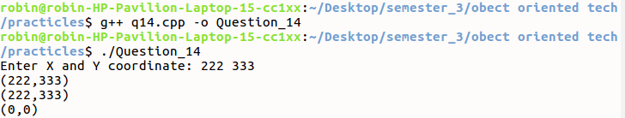

Question 15:
Define an Employee class with class members as ID, name and salary. Define a member
function “greater” which takes one parameter (object of class Employee) as a function
argument. The function should compare the salary of two Employees and return the
object whose salary is greater. Achieve the above using “this” pointer.
SOLUTION
#include<iostream>
using namespace std;
class Employee
{
int eid;
string name;
float salary;
public:
Employee(int eid,string name,float salary)
{
this->eid = eid;
this->name = name;
this->salary = salary;
}
int greater(Employee);
};
int Employee::greater(Employee e)
{
if(this->salary>e.salary)
return 1;
else
return 2;
}
int main()
{
Employee e1(1,"yash",50000.0f);
Employee e2(2,"Abhishek",60000.0f);
if(1==e1.greater(e2))
cout<<"Employee 1 has greater salary"<<endl;
else if(2 == e1.greater(e2))
cout<<"Employee 2 has greater salary"<<endl;
return 0;
}
Output:
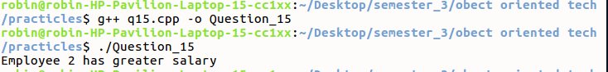

Question 17:
Write a program to copy the contents of one file to another.
SOLUTION
#include<iostream>
#include<fstream>
using namespace std;
int main()
{
string line;
int len;
ofstream fout;
fout.open("source.txt");
cout<<"Enter data fr source file (0 to terminate) : \n";
while(fout)
{
getline(cin,line);
if(line == "0")
break;
fout<<line<<endl;
}
fout.close();
fout.open("destination.txt");
ifstream fin;
fin.open("source.txt");
while(fout && fin)
{
getline(fin,line);
fout<<line<<endl;
}
fin.close();
fout.close();
}
Output:
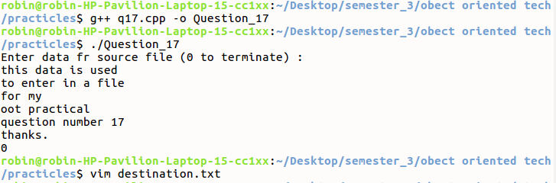

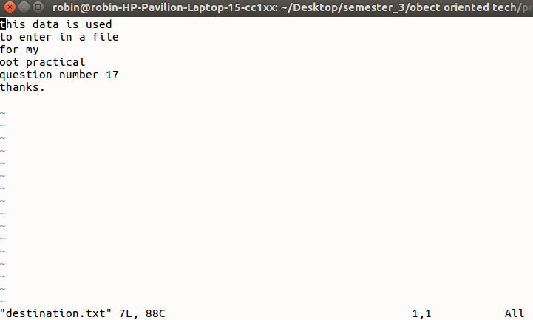

Question 18:
Write a program to maintain an elementary database of employees using files
SOLUTION
#include<iostream>
#include<fstream>
#include<iomanip>
using namespace std;
ofstream fout;
class Employee
{
string name;
int eid;
float salary;
public:
void get()
{
cout<<"Enter the name: ";
cin>>name;
cout<<"Enter the Id : ";
cin>>eid;
cout<<"Enter the salary: ";
cin>>salary;
fout<<setw(10)<<eid<<setw(20)<<name<<" " <<setw(10)<<salary<<endl;
}
};
int main()
{
Employee e;
int ch=1;
fout.open("database.txt");
fout<<"Employee Id Employee Name Employee Salary"<<endl;
while(ch==1)
{
e.get();
cout<<"Want to enter more(1-yes ,0-no): ";
cin>>ch;
}
fout.close();
return 0;
}
Output:
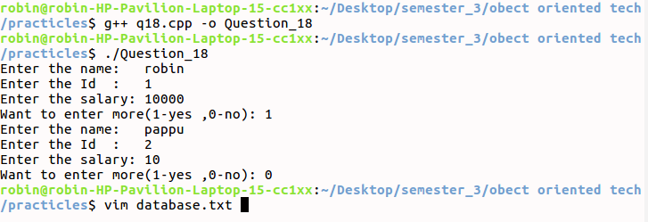
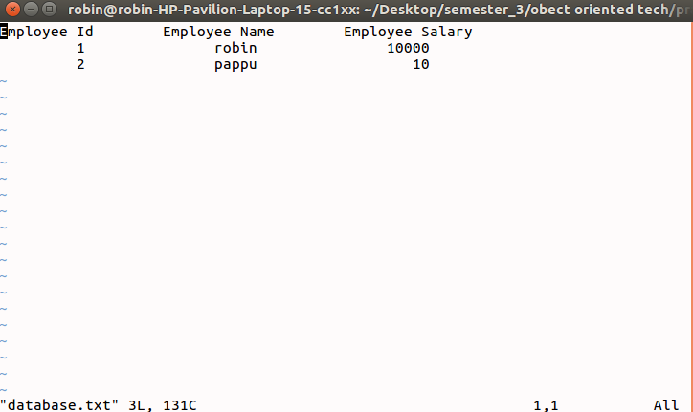

Question 19:
Accept 3 file names as command-line arguments. The first 2 are input files in which first
file has to be created as a float file and the second file has to be created as a string file.
Merge the contents of these 2 files into the 3 rd file. It should be one integer from the first
file followed by one line from the second file. Display the merged file.

SOLUTION
#include <iostream>
#include<fstream>
using namespace std;

int main(int argc, char** argv)
{
if(argc<4)
return 0;
ifstream fp1,fp2;
ofstream fout;
int x;
string line;
fp1.open(argv[1]);
fp2.open(argv[2]);
fout.open(argv[3]);
if(!fp1 || !fp2 || !fout)
{
cout<<"File not open";
return 0;
}
while(fp1>>x && getline(fp2,line))
{
fout<<line<<" - "<<x<<endl;
}
fp1.close();
fp2.close();
fout.close();
return 0;
}
Output:
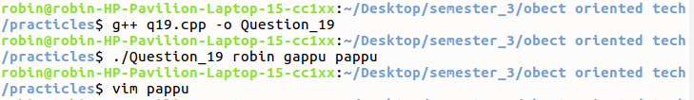
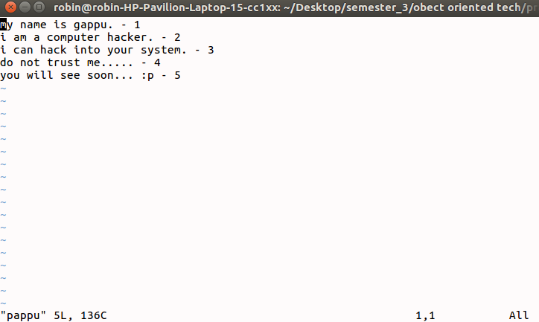

Question 20:
Design a user-defined manipulator to display the output for float values as
10 column width
Right-Justified
Two-digit precision
Filling unused space with ‘*’
Trailing zeros are shown
Show sign for positive values
SOLUTION
#include<iostream>
#include<iomanip>
using namespace std;
void justify(float f)
{
cout<<setw(10)<<f;
}
void precise(float f)
{
cout<<setw(10)<<setprecision(2)<<f;
}
void unused(float f)
{
cout<<setfill('*');
cout<<setw(10)<<f;
}
void zeros(float f)
{
cout<<f<<setfill('0')<<setw(10);
}
void positive(float f)
{
if(f>0)
cout<<setw(10)<<"+"<<f;
else if(f<0)
cout<<setw(10)<<"-"<<f;
else
cout<<setw(10)<<f;
}

int main()
{
int ch;
float f;
do
{

cout<<"\n1)Right justify\n2)two digit precision\n3)Filling unused space with *\n4)Trailing zeros are shown\n5)Show sign for positive values\n6)Exit\n>";
cin>>ch;
if(ch ==6)
return 0;
cout<<"Enter the float value to display: ";
cin>>f;
switch(ch)
{
case 1:{
justify(f);
break;
}
case 2:{
precise(f);
break;
}
case 3:{
unused(f);
break;
}
case 4:{
zeros(f);
break;
}
case 5:{
positive(f);
break;
}
default:{
cout<<"Wrong choice!!!!";
break;
}
}
}while(ch<=5);
}
Output:
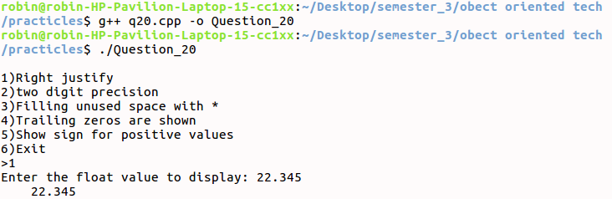

Question 21:
Passing by reference is also an effective way to allow a function to return more than one
value. Write a program that returns the previous and next power of two of the parameter
passed using the concept of pass by reference.
SOLUTION
#include<iostream>
#include<math.h>
using namespace std;
int find(int &next)
{
int prev;
prev = sqrt(next);
next *= next;
return prev;
}
int main()
{
int num,next,prev;
cout<<"Enter the number: ";
cin>>num;
next = num;
prev = find (next);
cout<<num<< "Previous power is "<<prev<<" and next power is "<<next<<endl;
return 0;
}
Output:
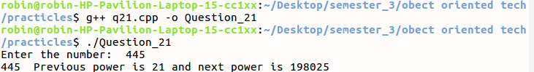

Question 22:
Write a program to sort a list of numbers using call by reference. Smallest number
should be output first.
SOLUTION
#include<iostream>
using namespace std;
void sort(int *arr,int n)
{
int i,j,swap,temp;
for(i=0;i<n;i++)
{
swap =0;
for(j=0;j<n-i-1;j++)
{
if(arr[j]>arr[j+1])
{
temp=arr[j];
arr[j]=arr[j+1];
arr[j+1]=temp;
swap++;
}
}
if(swap == 0)
break;
}
}
int main()
{
int arr[10],i,n;
cout<<"Enter the no. of elements: ";
cin>>n;
cout<<"Enter the arr element: ";
for(i=0;i<n;i++)
cin>>arr[i];
sort(arr,n);
cout<<"Array after sort is: ";
for(i=0;i<n;i++)
cout<<arr[i]<<" ";
}
Output:
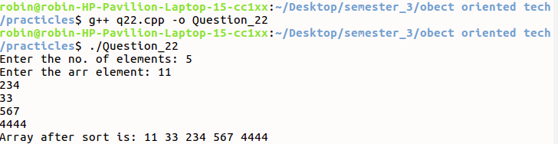

Question 23:
Write a program in C++ that instantiates a function template that implements a binary
search of a sorted array of objects.
SOLUTION
#include<iostream>
using namespace std;
template <class t>
int binarysearch(t arr[],int count,t num)
{
int first = 0;
int last = count-1;
int middle = (first+last)/2;
while (first <= last)
{
if(arr[middle] < num)
{
first = middle + 1;

}
else if(arr[middle] == num)
{
cout<<num<<" found in the array at the location "<<middle+1<<"\n";
break;
}
else
{
last = middle - 1;
}
middle = (first + last)/2;
}
if(first > last)
{
cout<<num<<" not found in the array";
}
}
int main()
{
int i,n,arri[10],numi;
float arrf[10],numf;
cout<<"Enter the number os element : ";
cin>>n;
cout<<"Enter the Integer Array elements(sorted): ";
for(i=0;i<n;i++)
{
cin>>arri[i];
}
cout<<"Enter the Element want to search : ";
cin>>numi;
binarysearch(arri,n,numi);
cout<<"Enter the Float Array elements(sorted): ";
for(i=0;i<n;i++)
{
cin>>arr[i];
}
cout<<"Enter the Element want to search : ";
cin>>numf;
binarysearch(arrf,n,numf);
return 0;
}
Output:
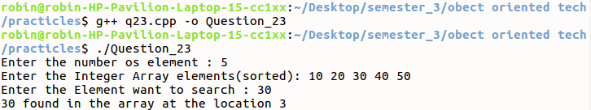

Question 24:
Write a function to reverse the elements of an array. The function should be a template
which can operate on any type of data. Invoke
the reverse function for arrays with
different data types from main()
SOLUTION
#include<iostream>
using namespace std;
template <class t>
t* reverse (t arr[],int n)
{
int j=0;
const int size = n;
t rev[size];
for(int i = size-1;i>= 0;i--)
{
rev[j] = arr[i];
j++;
}
for(int i=0;i<n;i++)
arr[i] = rev[i];
return arr;
}
int main()
{
int i,arri[10],n,*pi;
float arrf[10],*pf;
cout<<"Enter the number of element: ";
cin>>n;
cout<<"Enter the Integer Arry Element: ";
for(i=0;i<n;i++)
{
cin>>arri[i];
}
pi= reverse(arri,n);
for(i=0;i<n;i++)
cout<<pi[i]<<" ";
cout<<"\nEnter the Float Arry Element: ";
for(i=0;i<n;i++)
{
cin>>arrf[i];
}
pf= reverse(arrf,n);
for(i=0;i<n;i++)
cout<<pf[i]<<" ";
cout<<endl;
return 0;
}
Output:
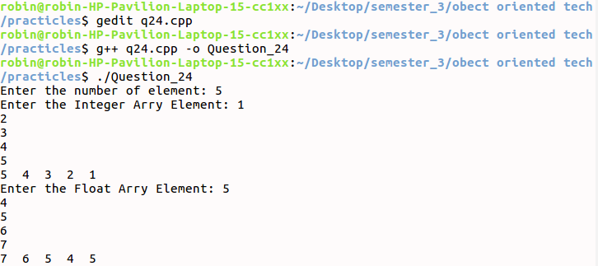

Question 25:
Create a class Stack storing stack of integers. Use exception handling to deal with
situation of overflow and underflow
#include<iostream>
using namespace std;
class Stack
{
int stack[5];
int top;
public:
Stack()
{
top = 0;
}
int push(int i)
{
if(top == 5)
return 0;
else
{
stack[top++]=i;
return 1;
}
}
int pop()
{
if(top<0)
return -1;
else
{
int t = stack[top];
top=top-1;
return t;
}
}
void display()
{
int i;
for(i=0;i<top;i++)
cout<<" "<<stack[i];
}
};
int main()
{
Stack s;
int num,r;
cout<<"\nEnter the items to Push ";
do
{
cout<<"> ";
cin>>num;
try
{
r=s.push(num);
if(r==0)
throw "Overflow\n";
else
cout<<" PUSHED";
}
catch(const char *excp)
{
cout<<excp<<endl;
}
cout<<"\nWanna push more element: ";
cin>>r;
}while(r==1);
s.display();
cout<<"\nWant to Pop items";
cin>>r;
while(r==1)
{
try
{
r=s.pop();
if(r==-1)
throw "Underflow\n";
else
cout<<r<<" POPED";
}
catch(const char *excp)
{
cout<<excp<<endl;
}
cout<<"\nWnna pop more: ";
cin>>r;
}
s.display();
}
Output:
