HOW TO IMPORT PROJECT LOMBOK

step 1: open web browser and search 'maven repository' >click on the first link

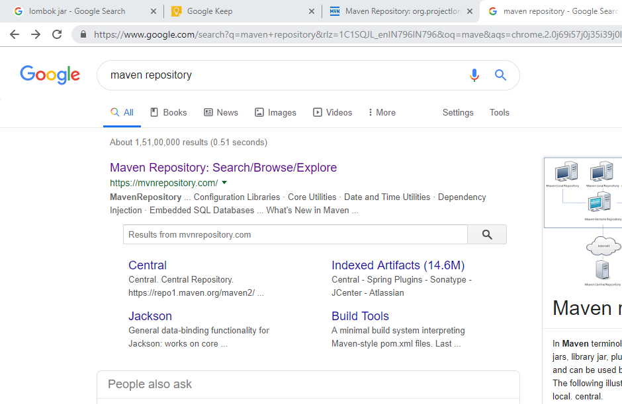

step2: search ' project lombok' and click on > project lombok

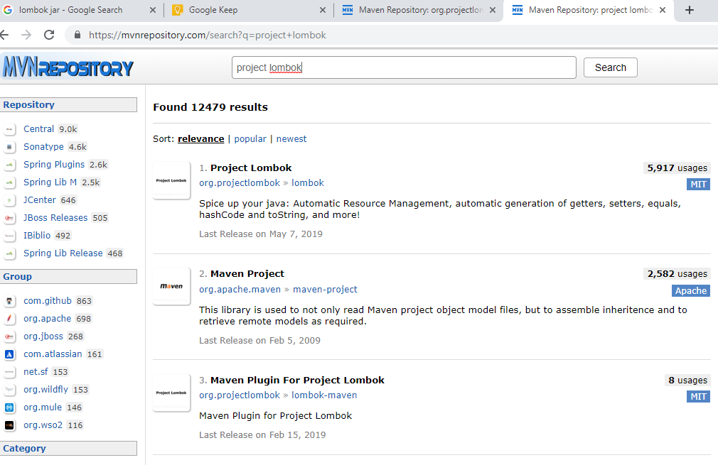

step 3: click on > 1.18.8

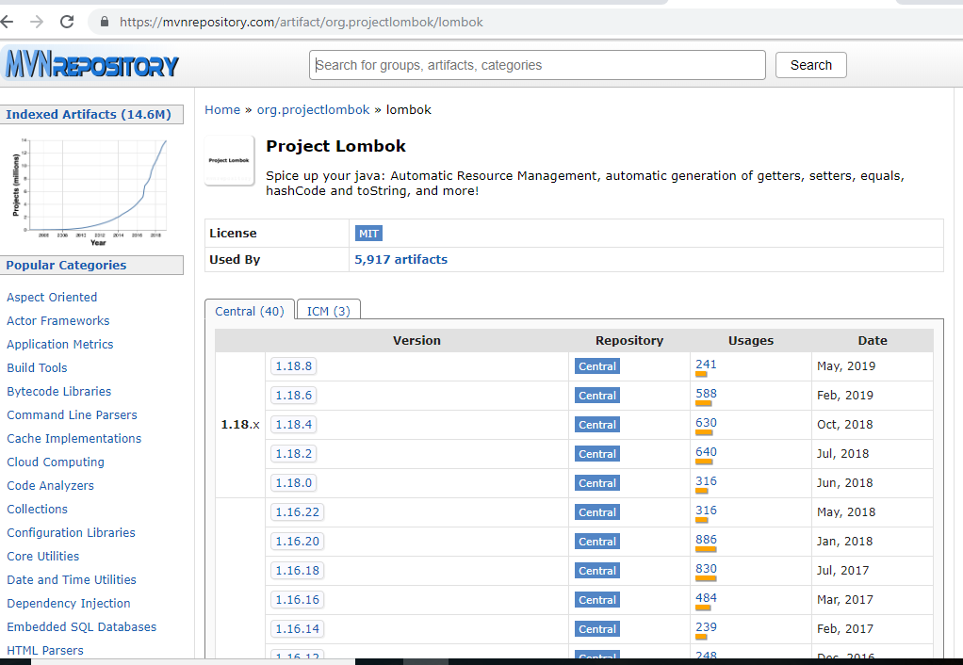

step 4:click on > jar file and download

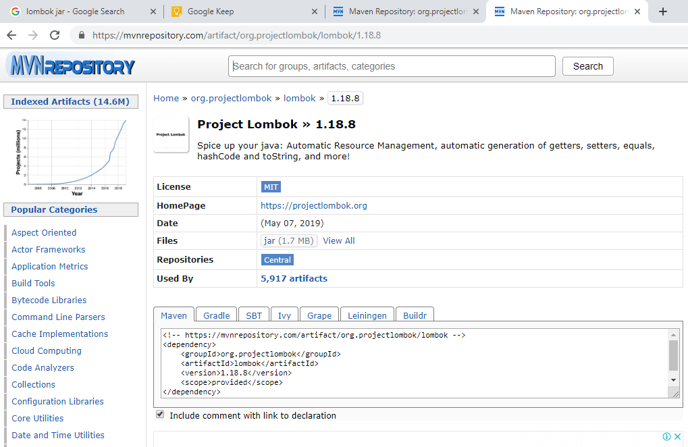

**: Next how to import the lombok to your package**

steps 5: go to eclipse > right click on your project >build path>add external files >select the lombok file >apply >close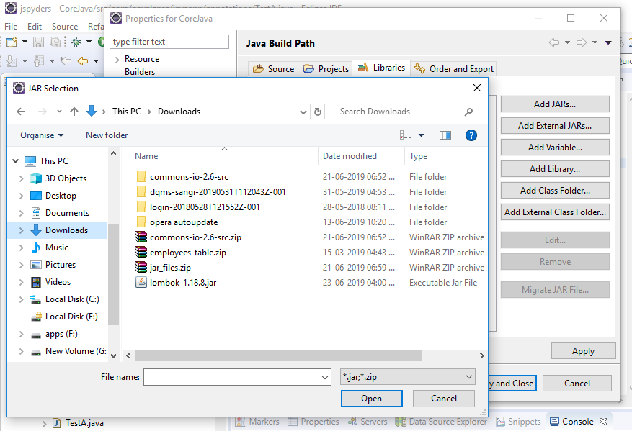

step 6 : right click on Lombok jar file in eclipse >select >run as >java application

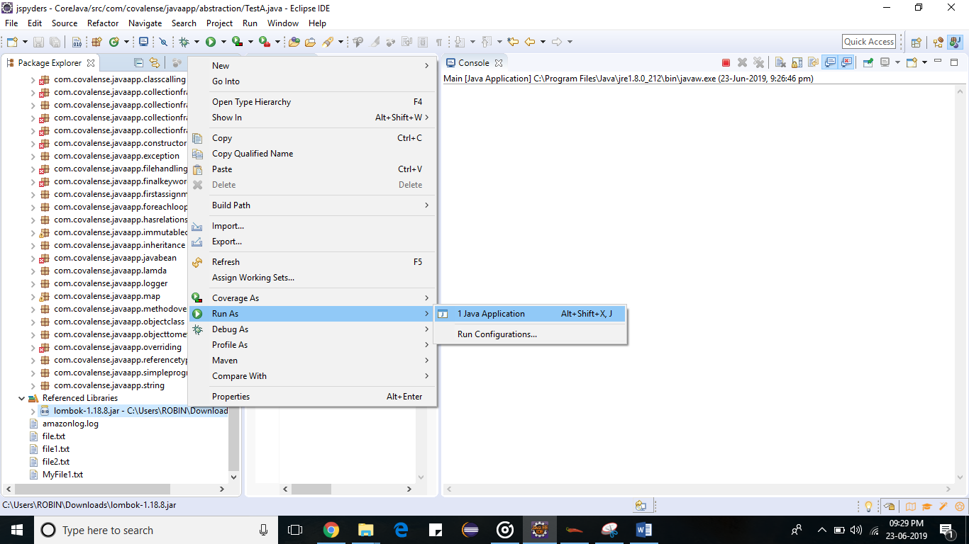

Step 7: click on > install

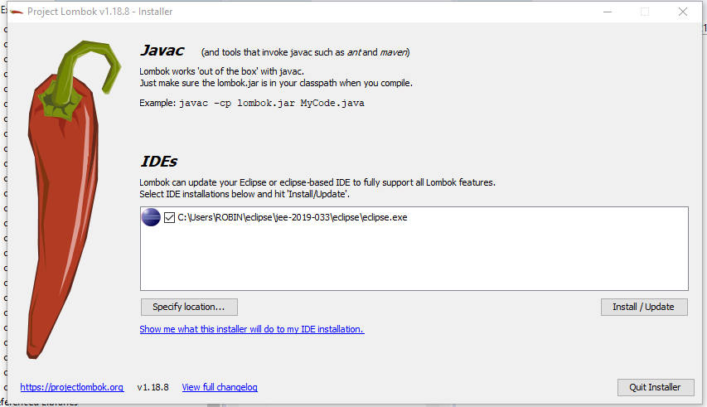

Step 8: finished the installation,now you can use Lombok features

