Composer Setup:

Download composer from getcomposer.org and install. while installing choose the php.exe file latest version which you have already installed.

open Git base and check the version

>composer -V

>composer global update

composer.json file not found.

Took the composer.json file and pasted into D:\Users\DMuruge1\AppData\Roaming\Composer.

>composer global install

This will install some dependencies.

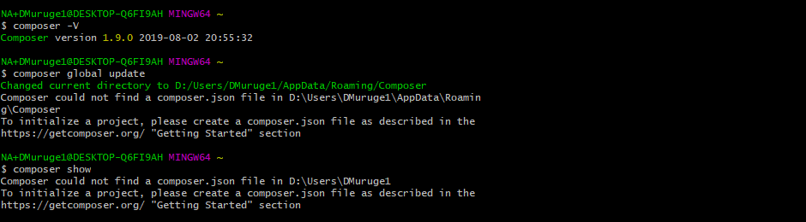

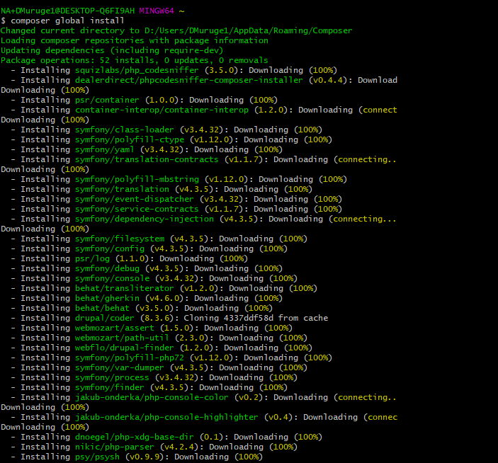

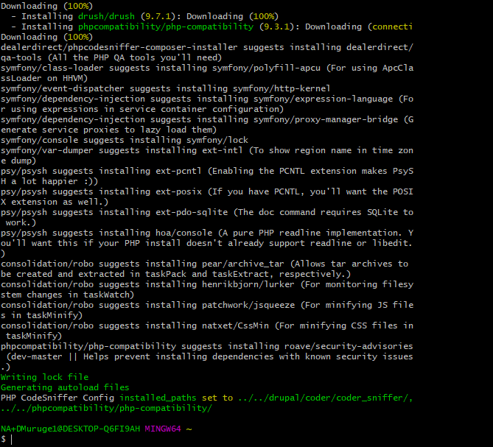

Composer Installation done.

Install Drupal with composer:

Go to <https://github.com/drupal-composer/drupal-project>

Run the command in GIT terminal: composer create-project drupal-composer/drupal-project:8.x-dev some-dir --no-interaction

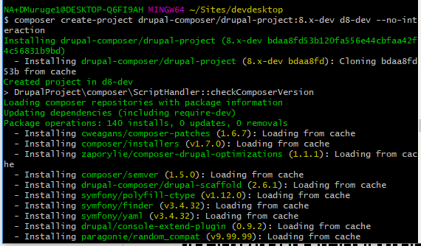

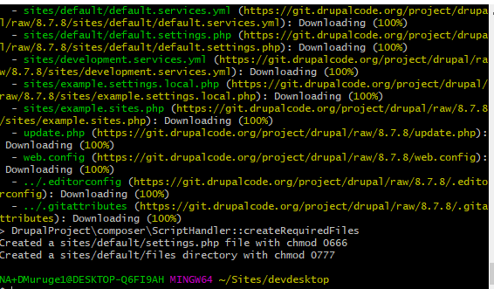

Drupal core is downloaded to the specified path.

Open Dev desktop.

Import local Drupal site.

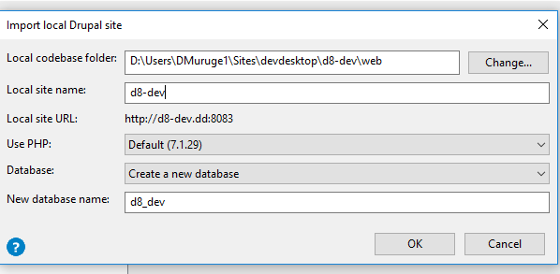

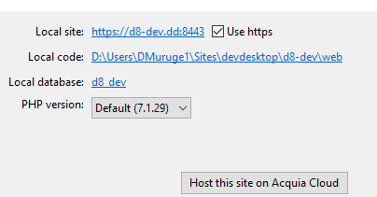

Go to the Site. This will show you the Installation wizard. Install D8.

Install module using composer:

Run: composer require drupal/devel.

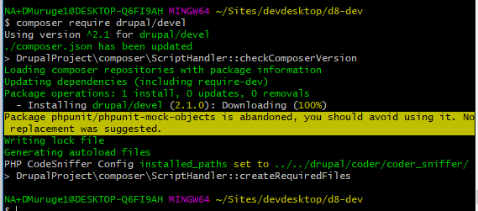

Module Installed with the needed dependencies.

Acquia Dev Desktop setup:

Install Acquia Dev Desktop.

Drush will also be installed along with ADD.

Create an account with <https://accounts.acquia.com/sign-in>

Get the Environment access from Admin.

Go to Acquia Dev Desktop.

Add Acquia cloud sites.

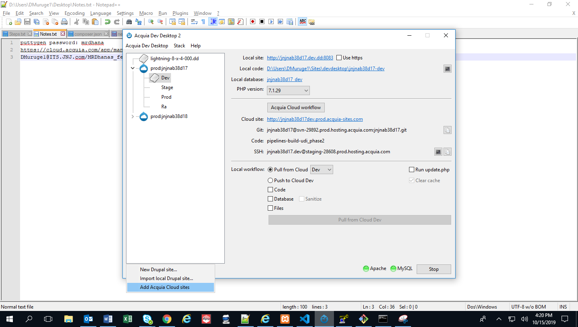

Generate SSH Key and add this to Acquia cloud.

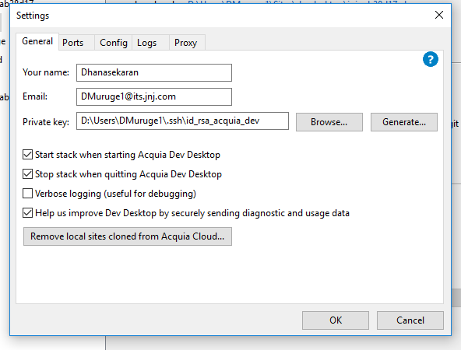

Click Ok.

All the Environments will be added to the ADD as below.

Click on ‘Clone this site locally and use it in Dev Desktop’.

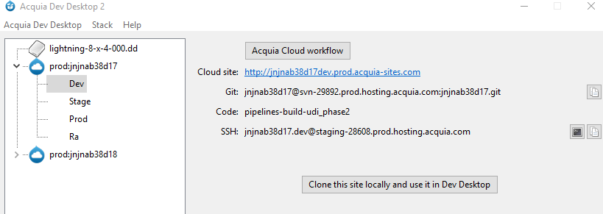

The entire files and database will be downloaded.

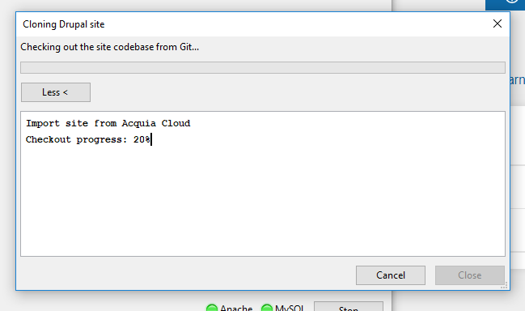

Local setup will happen automatically.

ADD setup is ready to work.

Deployment Flow:

Commit your changes to the branch.

You can commit your changes either from GIT bash or from ADD.

Go to pipelines.

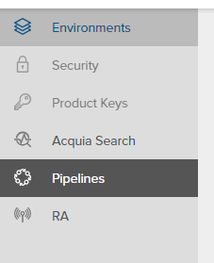

Click Start Job.



Select the branch to deploy files.

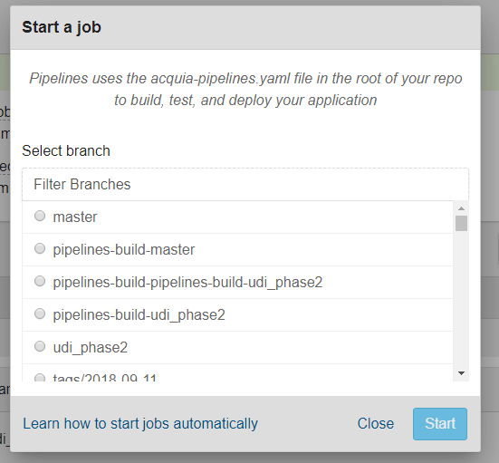

Click Start.

You have added a job, and this will run at the backend.

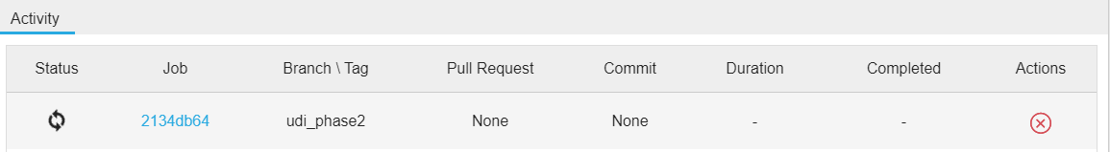

Task can be checked in the list.

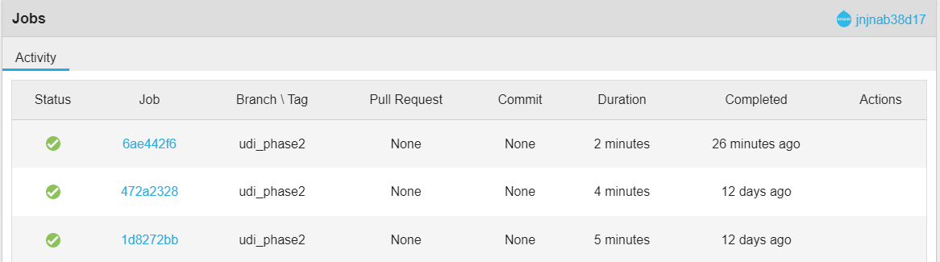

Deployment to the Dev Environment is done.

Connect SSH to Dev Environment:

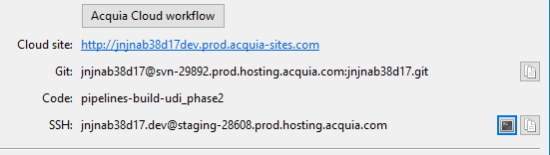

Navigate to the Project folder.



Run the command drush cr.

Cache cleared in Dev site.

Deploy code from Dev to Stage Environments:

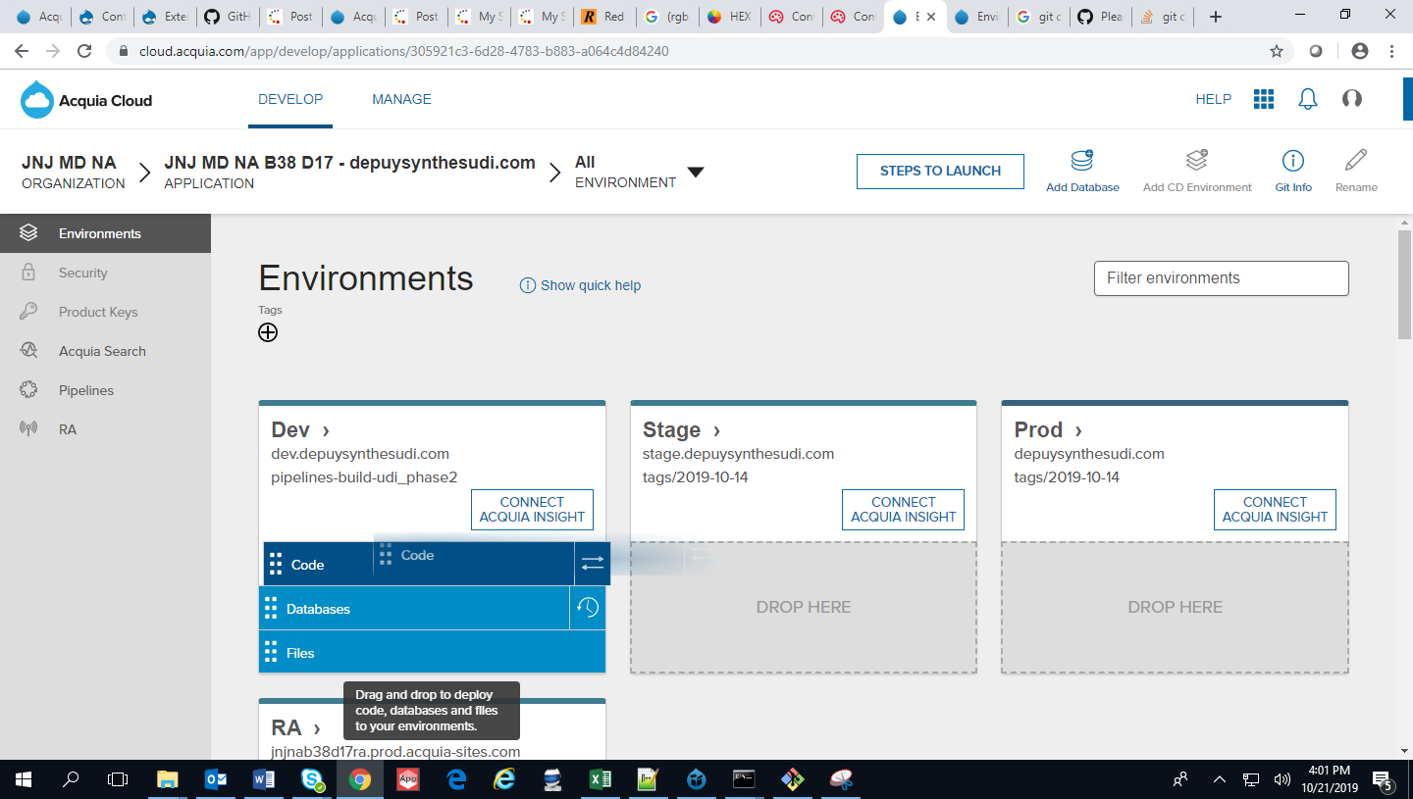

Click on “Code” and drag and drop to Stage.

This will add new Job at the backend and automatically deploy all the updates from Dev to Stage.

Same way we can deploy files from Stage to PROD.

Database also deployed in same way.

Git clone failed Issue:

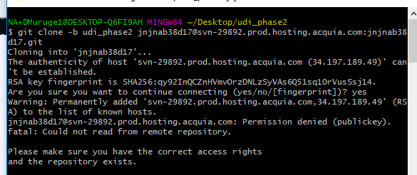

Navigate to the D:\Users\DMuruge1\.ssh path and move all the existing ssh keys to the new folder.

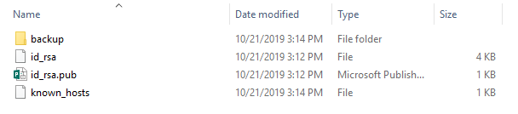

Keep only Id_rsa and id_rsa_pub files.

Scheduled Jobs:

