**Creating Custom Themes in Drupal 8**

### Info.yml file:

1. In Drupal 8, we use .info.yml format. It's a format used by Symphony PHP framework
2. The YAML file comprises a key and a value pair, which are separated by a colon.
3. Mandatory fields: name, type, description, core.
4. Define Region
5. Define libraries: Include CSS and Js files

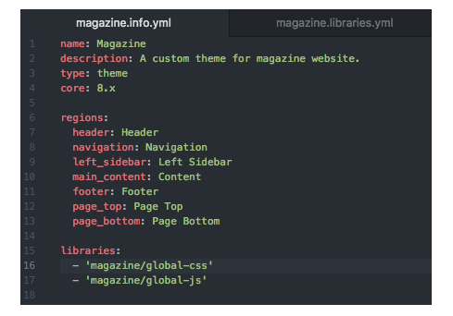

### Libraries.yml file:

Include our cascading style sheets (CSS) and javascript file (js).

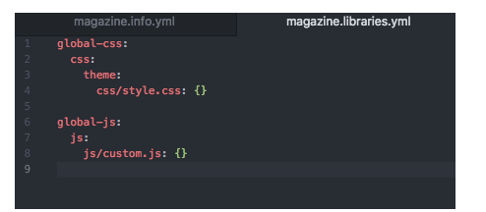

### Twig Debugging:

1. Go to Sites > Default
2. Copy paste default.services.yml and rename it to services.yml
3. Debug: false
4. Simply change false to true and save the file.

<!-- BEGIN OUTPUT from ‘themes/custom/magazine/templates/page.html.twig →

Your code will be here.

<!-- END OUTPUT from ‘themes/custom/magazine/templates/page.html.twig →

page.html.twig:

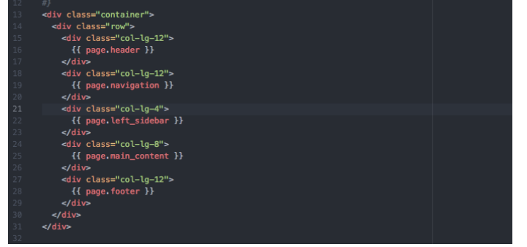

Theming:

<https://opensenselabs.com/blog/tech/creating-custom-themes-drupal-8-part-1>

All about Theming:

<https://www.drupal.org/docs/8/theming>

Comparison of PHP Template and Twig theming paradigms:

<https://www.drupal.org/docs/8/theming/twig/comparison-of-phptemplate-and-twig-theming-paradigms>