How To: Display a banner on your Capital application window

版本 1

创建于: 2013-1-2 上午7:38 作者 [Nuri](http://communities.mentor.com/mgcx/people/Nuri) - 最后修改:  2013-1-2 下午2:31 作者 [Nuri](http://communities.mentor.com/mgcx/people/Nuri)

Introduction

Several command line options are available when launching any Capital or VeSys 2.0 application.  These options can be used to define which clientprops.xml file to use and for displaying a banner on the application window.  You can use these command line options to create a shortcut for running Capital in a different environment (e.g. “production server” vs. “development server”).

Details

The following options are available.

|  |  |  |
| --- | --- | --- |
| Argument | Options | Description |
| nosplash | true/false | Supress the splash screen |
| logname | name | The log files created will use this as the   username component |
| username | username | username |
| password | password | password |
| clientprops | path to configration file | relative to CAPITAL_HOME |
| adaptorconfigfile | absolute path to adaptor configuration file | used instead of  %capital_home%\adaptors\adaptors.xml |
| pluginfolder | absolute path to plugin folder | used instead of %capital_home%\plugins |
| title | title | Title |
| -Xmx<value> | Value | Start-up memory. |

For example:

C:\MentorGraphics\Capital\bin\CaitalLaunch.exe –clientprops=production_clientprops.xml “-title=PRODUCTION SERVER”

*Click to enlarge*

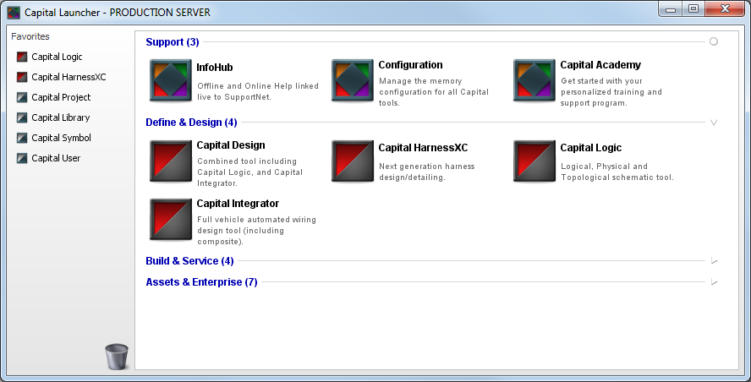

Launching any application from Capital Launcher will inherit the same command line options. E.g. Capital Logic.

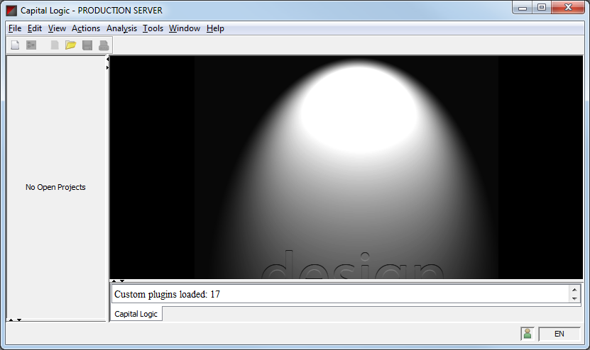

Step1：Create two XML files...

clientprops_serverA.xml (this has the correct port number for server A)

clientprops_serverB.xml (this has the correct port number for server B)

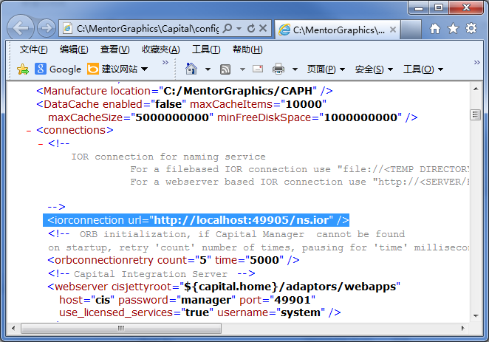

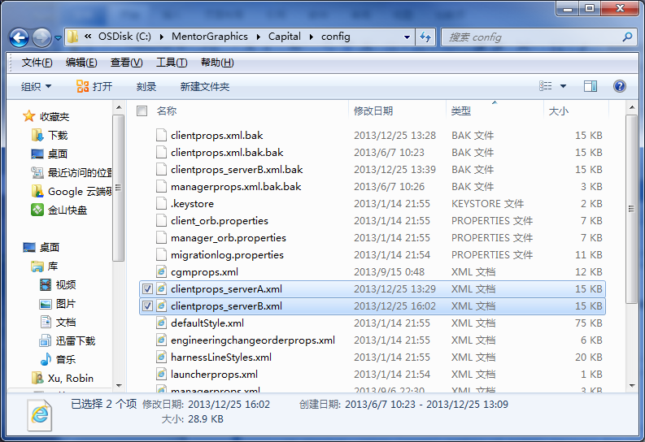

Create two shortcuts for Capital Launcher (this is a Windows shortcut).

C:\MentorGraphics\Capital\bin\CapitalLauncher.exe -clientprops=\config\clientprops_serverA.xml -title=SERVER_A

C:\MentorGraphics\Capital\bin\CapitalLauncher.exe -clientprops=\config\clientprops_serverB.xml -title=SERVER_B

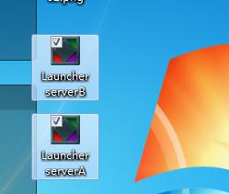

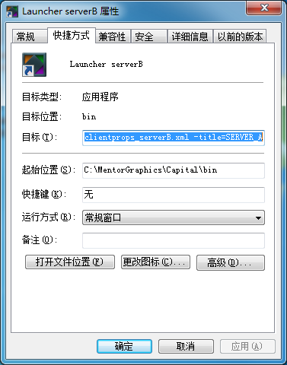

Step2：把“C:\MentorGraphics\Capital\bin\CapitalLauncher.exe -clientprops=\config\clientprops_serverA.xml -title=SERVER_A”填入到上方高亮显示的目标属性中