Ein Bild, das Text enthält.

**New Usability Concept for Modelling Wizard**

(TINF21C, SWE)

**Project:** Modelling Wizard Improvements

**Customer:** Markus Rentschler

Christian Holder

**Team:** Project Manager – Robin Ziegler ([inf21100@lehre.dhbw-stuttgart.de](mailto:inf21100@lehre.dhbw-stuttgart.de))

Developer – Nils Hoffmann ([inf21194@lehre.dhbw-stuttgart.de](mailto:inf21194@lehre.dhbw-stuttgart.de))

Test Manager – Michael Grote ([inf21111@lehre.dhbw-stuttgart.de](mailto:inf21111@lehre.dhbw-stuttgart.de))

System Architect – Fabian Kreuzer ([inf21106@lehre.dhbw-stuttgart.de](mailto:inf21106@lehre.dhbw-stuttgart.de))

Tech. Documentation – Dana Frey ([inf21099@lehre.dhbw-stuttgart.de](mailto:inf21099@lehre.dhbw-stuttgart.de))

Product Manager – Maximilian Trumpp ([inf21123@lehre.dhbw-stuttgart.de](mailto:inf21123@lehre.dhbw-stuttgart.de))

Graphical Designer – Sophie Kirschner ([inf21083@lehre.dhbw-stuttgart.de](mailto:inf21083@lehre.dhbw-stuttgart.de))

**Change History**

|  |  |  |  |
| --- | --- | --- | --- |
| **Version** | **Date** | **Author** | **Comment** |
| 0.1 | 18.03.2023 | Sophie Kirschner | Initial Setup |
| 0.2 | 19.03.2023 | Nils Hoffmann | Revision |
| 0.3 | 21.03.2023 | Sophie Kirschner | Sketch integration |
| 0.4 | 30.03.2023 | Sophie Kirschner | Improvements |
| 0.5 | 03.04.2023 | Sophie Kirschner | Improvements |
| 1.0 | 20.04.2023 | Sophie Kirschner | Add new elements |

Table of Contents

1. Introduction 5

2. Guideline DIN EN ISO 9241-110 6

3. Navigation Bar 8

3.1 File Menu 8

3.1.1 Issue 1: “Save and Close File” 8

3.1.2 Issue 2: “Open” and „Import” 8

3.1.3 Issue 3: “Load Library” 8

3.2 Options Menu 9

3.2.1 Issue: mode indicator 9

3.3 Help menu 9

3.3.1 Issue: “About” 9

3.4 Issue: Input fields 9

4. Starting View 10

4.1 Add Start Dialog 10

4.2 Add Presentation of Filename 10

4.3 Add New File Dialog 10

5. Generic Data 11

5.1 Issue 1: Button to expand “Attributes” sheet 11

5.2 Issue 2: “Role Class Library” 12

5.3 Issue 3: “Interface Class Library” 12

5.4 Issue 4: Usage of libraries 12

5.5 Issue 5: first column in “Generic Information” table 12

5.6 Issue 6: selected table entry below the table 12

5.7 Issue 7: “Attributes” sheet in advanced mode 12

5.8 Additional changes: 13

6. Interfaces 14

6.1 Issue 1: additional button to expand “Attributes” sheet 14

6.2 Issue 2: “Interface Class Library” 14

6.3 Issue 3: “Role Class Library” 14

6.4 Issue 4: usage of libraries 14

6.5 Issue 5: first column in “Interfaces” table 14

6.6 Issue 6: selected table entry below the table 15

6.7 Issue 7: “Attributes” sheet in advanced mode 15

6.8 Additional changes: 15

7. Attachments 16

7.1 Issue 1: “Role Class Library” and “Interface Class Library” 16

7.2 Issue 2: form for adding attachments 16

7.3 Issue 3: first column in table 17

7.4 Additional changes: 17

8. General Issues 18

8.1 Issue 1: dark mode and individual sizing 18

8.2 Issue 2: color theme 18

8.3 Issue 3: old look and feel 18

8.4 Additional changes: 18

9. Sources 19

1. Introduction

The new usability concept is based on the already performed GUI (Graphical User Interface) analysis. It can be viewed with the following link:

<https://github.com/users/robinziegler/projects/1?pane=issue&itemId=13232065>

In the solution described below, the problems found there are fixed, thus ensuring better usability as well as user experience.

The solution must comply with the applicable guidelines. In this project, we base ourselves on the DIN EN ISO 9241 Guidelines with a special focus on part 110 - "Principles of dialog design". In the following, we will take a closer look at this guideline.

Another important guideline for ensuring usability is the regulation for creating barrier-free information technology. We do not consider the implementation of this to be relevant in the context of the project with regard to the user profile. The purpose of the ordinance is to enable and ensure a comprehensive and fundamentally unrestricted barrier-free design of modern information and communication technology. The implementation is carried out, among other things, with the help of videos with sign language [1]. This is not necessary in the project because, for example, no acoustic signals are sent.

In the individual chapters, the known issues from the analysis are mentioned with the targeted solutions. In order to visualize the new concept, additional design sketches are included, on the basis of which a prototype of the GUI can be made afterwards.

1. Guideline DIN EN ISO 9241-110

In the following, we will take a closer look at the DIN EN ISO 9241 standard. It "describes quality guidelines for ensuring the ergonomics of interactive systems." [2]

The standard is divided into 17 sections, of which Section 110- Principles of Dialog Design is particularly authoritative.

The following is a summary of these principles:

**Task appropriateness**

A system should support the user in completing his task by basing the functionalities on the characteristic properties of the task rather than on the technology used to complete it. Unnecessary commands, for example, should be hidden and related commands should be grouped together. [3]

**Self-descriptiveness**

In a dialog, it should be obvious to the user at all times where he is, what actions can be taken and how they will be executed. The user should also be informed about changes in the state and expected inputs. For example, it makes sense to provide the required input format or to display meaningful error messages instead of simple error codes. [3]

**Conformity to expectations**

A dialog should conform to all foreseeable user concerns and generally accepted conventions from the context of use. This includes common keyboard shortcuts for e.g. copy and paste, as well as the use of commonly known abbreviations. [3]

**Controllability**

The user should be able to start the program sequence, as well as to influence direction and speed, until the desired goal is reached. Important functions for this are the saving of incomplete processing steps, the possibility of undoing certain steps and the call of old states. [3]

**Individualizability**

A system is individualizable when users can change the presentation of information to suit their individual abilities and needs, e.g. by using a zoom function. [3]

**Conduciveness to learning**

A dialog should support and guide the user in learning how to use the interactive system. For example, there should be a short explanation for each working step. [3]

**Error tolerance**

The intended work result should be achieved with either no or minimal correction effort on the part of the user, despite recognizably flawed input. Error tolerance can be achieved by the following means: Error detection and prevention (damage control) e.g., by suggesting corrected input or pointing out any problems; error correction, or error management, to deal with errors that do occur. [3]

1. Navigation Bar

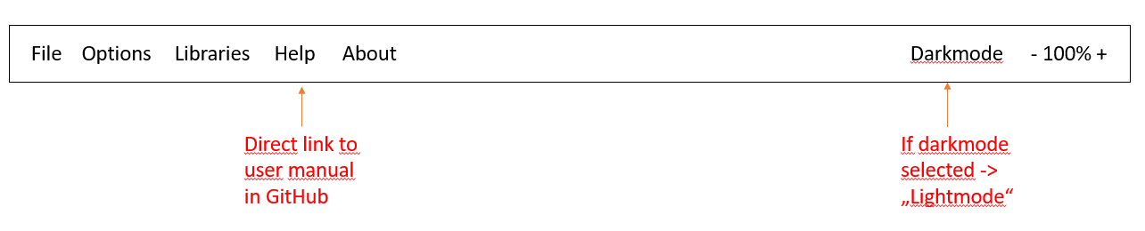

Picture 1: Navigation bar overview

## 3.1 File Menu

### 3.1.1 Issue 1: “Save and Close File”

The “Save and Close File” option is unnecessarily redundant in the menu since the options “Save” and “Exit” already exist.

**Solution**: Remove the option

### 3.1.2 Issue 2: “Open” and „Import”

The options “Open” and “Import” provide the same feature.

**Solution**: Merge into a single function.

### 3.1.3 Issue 3: “Load Library”

The “Load Library” option fits better in “Libraries” menu than in the “File” menu.

Ein Bild, das Text enthält.
**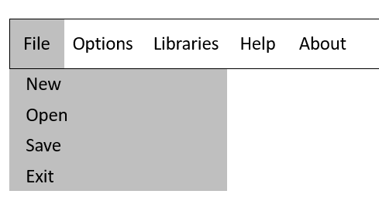Solution**: Move to the “Libraries” menu.

Picture 2: Navigation bar „File“ menu

Picture 3 Navigation bar „Libraries“ menu

## 3.2 Options Menu

### 3.2.1 Issue: mode indicator

There is no indicator, which mode/file is currently active. The self- descriptiveness is not given.

**Solution**: Display of all possible modes, the currently active ones grayed out including an indicator (dot, checkmark or "active" written out in the line).

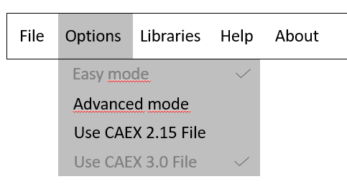

Picture 4: Navigation bar „Options“ menu

## 3.3 Help menu

### 3.3.1 Issue: “About”

The “About” option doesn’t suit the term “Help”. This issue is optional since “About” is in most applications found under this tab.

**Solution**: “Help”: Direct Link to the Manual, “About”: Transfer to a separate menu point in the navigation bar (please see at picture 1: Navigation bar overview).

## 3.4 Issue: Input fields

Unnecessary function in navigation bar; confusing for user.

**Solution**: Remove the function (please see at picture 1: Navigation bar overview).

1. Starting View

## 4.1 Add Start Dialog

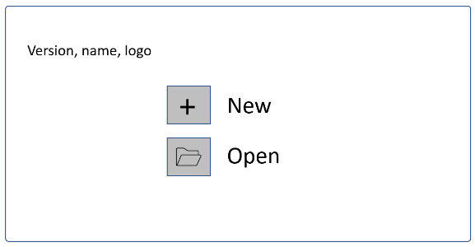Add a dialog that is called when the Modelling Wizard is started. In this dialog, the user selects whether to open an existing project or to create a new one.

Picture 5: Start Dialog

## 4.2 Add Presentation of Filename

To ensure "self-descriptiveness", the user should always be able to see which file is currently opened. For this purpose, the file name is displayed at the top of the application.

## 4.3 Add New File Dialog

Ein Bild, das Tisch enthält.
Ein Bild, das Diagramm enthält.
If the user creates a new file, it is necessary that both "Device Name" as well as "Manufacturer" are entered. To minimize errors, both entries are queried directly during creation. The file name is then generated from these two entries.

Picture 7: New File Dialog filled

Picture 6: New File Dialog

1. Generic Data

*Ein Bild, das Tisch enthält.
*

Picture 8: Generic Data tab overview

*Ein Bild, das Tisch enthält.
*

Picture 9: Generic Data „Add Role Class Library“ button clicked -> Library selection menu

## 5.1 Issue 1: Button to expand “Attributes” sheet

User has to click on additional button to expand prefilled “Attributes” sheet.

**Solution**: Remove the separate button. On clicking the table row, directly open the prefilled “Attributes” sheet.

## 5.2 Issue 2: “Role Class Library”

Display of “Role Class Library” unnecessary for basic usage.

**Solution**: Implement the menu as a pop-up dialog which opens when clicking “add Role Class Library” button.

## 5.3 Issue 3: “Interface Class Library”

Display of “Interface Class Library” unnecessary for “General Data” tab, because it provides no purpose at this position.

**Solution**: Remove the menu.

## 5.4 Issue 4: Usage of libraries

No explanation on the usage of libraries for unexperienced users.

**Solution**: Remove the drag-and-drop system and replace it with a combination of checkboxes and an “Add” button, enabling the selection of multiple libraries at once.

## 5.5 Issue 5: first column in “Generic Information” table

No real purpose of first column in “Generic Information” table.

**Solution**: Remove the column.

## 5.6 Issue 6: selected table entry below the table

Display of selected table entry below the table unnecessary .

**Solution**: Remove it.

## 5.7 Issue 7: “Attributes” sheet in advanced mode

“DataType” unrestricted editing through the user can cause problems.

**Solution**: Dropdown selection menu to limit the User-Input.

## 5.8 Additional changes:

* Move the delete button of the added libraries to the individual table rows
* Rename the attribute “Product Code” to “Device Name”

1. Interfaces

Because the “Interfaces” tab is quite similar to the “Generic Data” tab, please see the previous sketch.

## 6.1 Issue 1: additional button to expand “Attributes” sheet

User has to click on additional button to expand prefilled “Attributes” sheet.

**Solution**: Remove the separate button; on clicking the table row, directly open the prefilled “Attributes” sheet.

## 6.2 Issue 2: “Interface Class Library”

Display of “Interface Class Library” unnecessary for basic usage.

**Solution**: Implement the menu as a pop-up dialog which opens when clicking “add Role Class Library” button.

## 6.3 Issue 3: “Role Class Library”

Display of “Role Class Library” unnecessary for “Interfaces” tab, because it provides no purpose at this position.

**Solution**: Remove the menu.

## 6.4 Issue 4: usage of libraries

No explanation on the usage of libraries for unexperienced users.

**Solution**: Remove the drag-and-drop system and replace it with a combination of checkboxes and an “Add” button, enabling the selection of multiple libraries at once.

## 6.5 Issue 5: first column in “Interfaces” table

No real purpose of first column in “Interfaces” table.

**Solution**: Remove the column.

## 6.6 Issue 6: selected table entry below the table

Display of selected table entry below the table unnecessary.

**Solution**: Remove it.

## 6.7 Issue 7: “Attributes” sheet in advanced mode

“DataType” unrestricted editing through the user can cause problems.

**Solution**: Dropdown selection menu to limit the User-Input.

## 6.8 Additional changes:

* Move the delete button of the added libraries to the individual table rows

1. Attachments

Ein Bild, das Text enthält.

Picture 10: Attachments tab overview

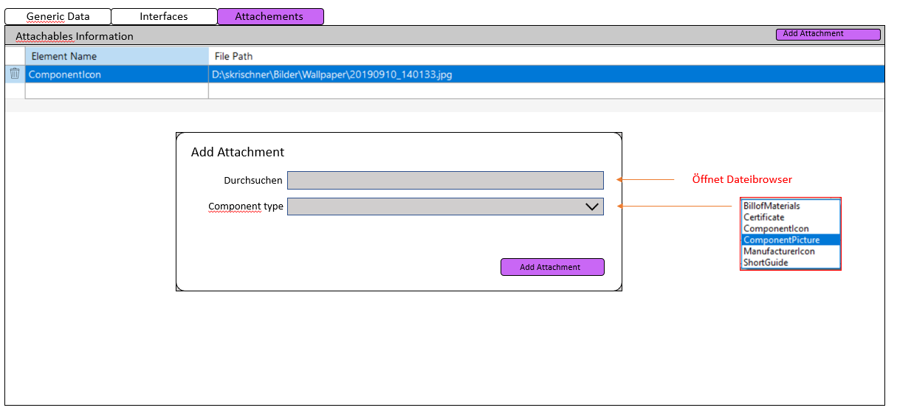

Picture 11: Attachments „Add Attachment” button clicked -> Attachment Selection menu

## 7.1 Issue 1: “Role Class Library” and “Interface Class Library”

Display of “Role Class Library” and “Interface Class Library” unnecessary for “Attachments” tab, because it provides no purpose at this position.

**Solution**: Remove the menus.

## 7.2 Issue 2: form for adding attachments

The form for adding attachments is not user-friendly. To activate the form, the add button must be pressed, which is not communicated.

**Solution**: Only show the input form when the “add“ button is pressed. After successfully adding an attachment, hide the form again.

## 7.3 Issue 3: first column in table

No real purpose of first column in table.

**Solution**: Remove the column.

## 7.4 Additional changes:

* Move the delete button of the added libraries to the individual table rows

1. General Issues

## 8.1 Issue 1: dark mode and individual sizing

No dark mode and individual sizing option (no customizability).

**Solution**: Optional dark mode and sizing function in navigation bar.

## 8.2 Issue 2: color theme

Unattractive color theme and no clear marking of which tab you are in (Generic Data, Interfaces or Attachments).

**Solution**: Colored mark of currently used tab.

## 8.3 Issue 3: old look and feel

Generally old look and feel.

**Solution**: Usage of WinUI3 for designing the new GUI.

## 8.4 Additional changes:

* Show an information tag when hovering over different areas with the cursor to ease the usage.

1. Sources

[1] <https://www.gesetze-im-internet.de/bitv_2_0/BJNR184300011.html> (Last opened 27.04.2023, 15:23)

[2] <https://www.handbuch-usability.de/grundlagen/normen-und-standards/iso-9241/> (Last opened 27.04.2023, 15:35)

[3] Sarodnick, F./Brau, H.: Methoden der Usability Evaluation, Wissenschaftliche Grundlagen und praktische Anwendung, 2. Auflage, Bern 2011