Ein Bild, das Text enthält.

**Usability analysis of previous team**

(TINF21C, SWE)

**Project:** Modelling Wizard Improvements

**Customer:** Markus Rentschler

Christian Holder

**Team:** Project Manager – Robin Ziegler ([inf21100@lehre.dhbw-stuttgart.de](mailto:inf21100@lehre.dhbw-stuttgart.de))

Developer – Nils Hoffmann ([inf21194@lehre.dhbw-stuttgart.de](mailto:inf21194@lehre.dhbw-stuttgart.de))

Test Manager – Michael Grote ([inf21111@lehre.dhbw-stuttgart.de](mailto:inf21111@lehre.dhbw-stuttgart.de))

System Architect – Fabian Kreuzer ([inf21106@lehre.dhbw-stuttgart.de](mailto:inf21106@lehre.dhbw-stuttgart.de))

Tech. Documentation – Dana Frey ([inf21099@lehre.dhbw-stuttgart.de](mailto:inf21099@lehre.dhbw-stuttgart.de))

Product Manager – Maximilian Trumpp ([inf21123@lehre.dhbw-stuttgart.de](mailto:inf21123@lehre.dhbw-stuttgart.de))

Graphical Designer – Sophie Kirschner ([inf21083@lehre.dhbw-stuttgart.de](mailto:inf21083@lehre.dhbw-stuttgart.de))

**Change History**

|  |  |  |  |
| --- | --- | --- | --- |
| **Version** | **Date** | **Author** | **Comment** |
| 0.1 | 16.03.2023 | Sophie Kirschner | Initial Setup |
| 1.0 | 04.05.2023 | Sophie Kirschner | Improvements |

Table of Contents

1. Introduction 3

2. Navigation Bar 4

2.1 File Menu 4

2.2 Options Menu 4

2.3 Input Fields 4

2.4 Help Menu 5

3. Generic Data 6

4. Interfaces 8

5. Attachments 9

6. General Issues 10

1. Introduction

The analysis was based on the DIN EN ISO 9241 guidelines with a special focus on part 110 – “Grundsätze der Dialoggestaltung”. In this, there are seven principles that play a key role in ensuring usability: Task appropriateness, self-descriptiveness, conformity to expectations, controllability, individualizability, conduciveness to learning, error tolerance.

This usability analysis was created by using the methods of “Thinking Aloud” and a question sheet. The sheets are available at: <https://github.com/users/robinziegler/projects/1?pane=issue&itemId=13232065>

The issues with the previous Software are summarized in the following.

1. Navigation Bar

## 2.1 File Menu

Ein Bild, das Text enthält.

Picture 1: File Menu

Issue 1: “Save and Close File” unnecessarily redundant

Issue 2: “Open” and „Import” provide the same feature

Issue 3: “Load Library” fits better in “Libraries” menu

## 2.2 Options Menu

Ein Bild, das Text enthält.

Picture 2: Options Menu

Issue: No indicator, which mode/file is currently active (no self-descriptiveness)

## 2.3 Input Fields



Picture 3: Input fields in navigation bar

Issue: Unnecessary function in navigation bar, confusing for user

## 2.4 Help Menu

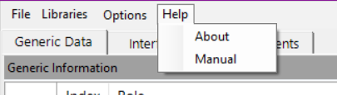

Picture 4: Help Menu

Issue: “About” doesn’t suit the term “Help”

1. Generic Data

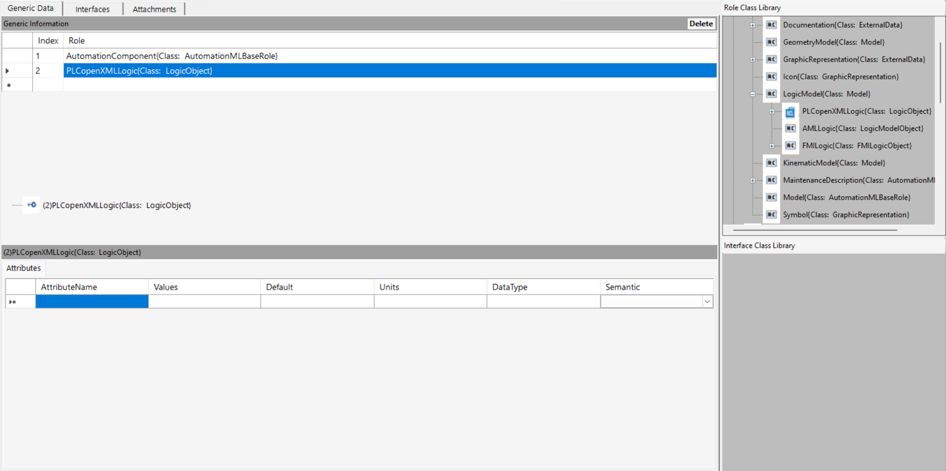

Picture 5: Generic Data Overview

Issue 1: User has to click on additional button to expand prefilled “Attributes” sheet

Issue 2: Display of “Role Class Library” unnecessary for basic usage

Issue 3: Display of “Interface Class Library” unnecessary for “General Data” tab, because it provides no purpose at this position

Issue 4: No explanation on the usage of libraries for unexperienced users (adding a library to the table with the drag and drop system is unexplained and difficult to utilize; no self-descriptiveness and learning facilitation)

Issue 5: No purpose of first column in “Generic Information” table

Ein Bild, das Tisch enthält.
Issue 6: Display of selected table entry below the table unnecessary (redundant)

Picture 6: Generic Data Attributes in advanced mode

Issue 7: “Attributes” sheet in advanced mode: “DataType” unrestricted editing through the user can cause problems (no preventive error tolerance)

1. Interfaces

Ein Bild, das Text enthält.

Picture 7: Interfaces Overview

Issue 1: User has to click on additional button to expand prefilled “Attributes” sheet

Issue 2: Display of “Interface Class Library” unnecessary for basic usage

Issue 3: Display of “Role Class Library” unnecessary for “Interfaces” tab, because it provides no purpose at this position

Issue 4: No explanation on the usage of libraries for unexperienced users (adding a library to the table with the drag and drop system is unexplained and difficult to utilize; no self-descriptiveness and learning facilitation)

Issue 5: No purpose of first column in “Interfaces” table

Issue 6: Display of selected table entry below the table unnecessary (redundancy)

Issue 7: “Attributes” sheet in advanced mode: “DataType” unrestricted editing through the user can cause problems (no preventive error tolerance)

1. Attachments

Ein Bild, das Text enthält.

Picture : Attachments Overview

Issue 1: Display of “Role Class Library” and “Interface Class Library” unnecessary for “Attachments” tab, because it provides no purpose at this position

Issue 2: The form for adding attachments is not user-friendly. To activate the form, the add button must be pressed, which is not communicated

Issue 3: No purpose of first column in table

1. General Issues

Issue 1: No dark mode and individual sizing option (no individualizability)

Issue 2: Unattractive color theme and no clear marking of which tab you are in (Generic Data, Interfaces or Attachments)

Issue 3: Generally old look and feel