Ein Bild, das Text enthält.

**Project Manual**

(TINF21C, SWE)

**Project:** Modelling Wizard Improvements

**Customer:** Markus Rentschler

Christian Holder

**Team:** Project Manager – Robin Ziegler ([inf21100@lehre.dhbw-stuttgart.de](mailto:inf21100@lehre.dhbw-stuttgart.de))

Developer – Nils Hoffmann ([inf21194@lehre.dhbw-stuttgart.de](mailto:inf21194@lehre.dhbw-stuttgart.de))

Test Manager – Michael Grote ([inf21111@lehre.dhbw-stuttgart.de](mailto:inf21111@lehre.dhbw-stuttgart.de))

Graphical Designer - Sophie Kirschner ([inf21083@lehre.dhbw-stuttgart.de](mailto:inf21083@lehre.dhbw-stuttgart.de))

System Architect – Fabian Kreuzer ([inf21106@lehre.dhbw-stuttgart.de](mailto:inf21106@lehre.dhbw-stuttgart.de))

Tech. Documentation – Dana Frey ([inf21099@lehre.dhbw-stuttgart.de](mailto:inf21099@lehre.dhbw-stuttgart.de))

Product Manager – Maximilian Trumpp ([inf21123@lehre.dhbw-stuttgart.de](mailto:inf21123@lehre.dhbw-stuttgart.de))

**Change History**

|  |  |  |  |
| --- | --- | --- | --- |
| **Version** | **Date** | **Author** | **Comment** |
| 0.1 | 22.09.2022 | Michael Grote | Preliminary Setup |
| 1.0 | 06.10.2022 | Michael Grote | Edit Content |
| 1.1 | 16.05.2023 | Michael Grote | Update Content |

Table of Contents

1. Project Assignment 1

2. Project Context 2

3. Project Organization 3

4. Work Breakdown Structure (PSP) 4

5. Milestones 5

6. Lists of tasks and responsible person 6

7. Gant-Chart 8

8. Risks 9

9. Changes during the project 10

# Project Assignment

|  |  |
| --- | --- |
| Project Assignment | |
| Project Objective (Output)  The aim of the project is to analyze the usability of the existing Windows stand-alone application “Modelling Wizard”. From this, a usability concept for the GUI is to be developed. In addition, the existing functions are to be tested. Furthermore, the existing source code is to be refactored. | |
| Project Benefit (Outcome)  The user-friendliness is to be improved by adjustments to the GUI. Thus, the user should later be able to use the software more intuitively. In addition, already known errors should be eliminated. By refactoring the existing source code, maintainability should be improved. This also results in the preservation of adaptability for the future. | |
| Customer:  M. Rentschler; C. Holder | Project leader:  Robin Ziegler |
| Team members:   * Robin Ziegler * Maximilian Trumpp * Michael Grote * Fabian Kreuzer * Dana Frey * Nils Hoffmann * Sophie Kirschner | Previous developer team:   * Linus Eickhoff * Florian Kellermann * Lukas Ernst * Florian Kaiser * Malte Horst * Rajkumar Pulaparthi |
| Main tasks:   * Documentation * Analysis * Design * Development * Tests | Milestones:   * Analysis phase * Design phase * Coding * Test phase * Presentation |
| Project start event:  Introductory lecture with project assignment | Project start date:  09.September 2022 |
| Project end event:  Presentation of the Results | Project end date:  19.May 2023 |

# Project Context

|  |
| --- |
| Initial situation and problem description |
| The current implementation has minor bugs and still needs a more detailed bug analysis. In addition, the user interface has several buttons with similar functions. This affects the usability. In addition, some menus should be moved from "Simple Mode" to "Advanced Mode" to make it easier to use in Simple Mode. Furthermore, a proper user manual for the software is missing. |

|  |  |
| --- | --- |
| Temporal Project Context | |
| Pre-project phase | Post-project phase |
| * The stand-alone application has already been developed by another team. The GUI has some small bugs, and the user-friendliness can be increased even further | * The existing GUI should be redesigned. The existing code should be refactored. The user manual should be extended to show all functionalities of the application. |

|  |  |  |  |
| --- | --- | --- | --- |
| Stakeholder Analysis | | | |
| Stakeholder | Potential / Chance | Conflict / Risks | Actions |
| Customer | Satisfaction with the new implementation. | Requests for changes during the project. | Regular communication between supplier and client. |
| Supplier | Development of a solution that meets the requirements. | Misjudgment of effort, time pressure, miscommunication | Fixed intermediate dates, regular meetings, uniform code standards |
| User | Benefit of the application, increase in efficiency, intuitive usability | Lack of understanding of the application, incorrect operations | Creation of a usability concept and testing of catching errors |

# Project Organization

|  |  |  |
| --- | --- | --- |
| Project Organization | | |
| Position | Description | Name |
| Customer | * Defines the project framework * Sets out the customer requirements | Rentschler, Markus /  Holder, Christian |
| Project leader | * Control of the distribution of tasks * Coordination of the members * Allocation of resources | Robin Ziegler |
| Project team | Product Manger  Test Manager  System Architect  Tech. Documentation  Developer  Graphical Designer | Maximilian Trumpp  Michael Grote  Fabian Kreuzer  Dana Frey  Nils Hoffmann  Sophie Kirschner |

# Work Breakdown Structure (PSP)

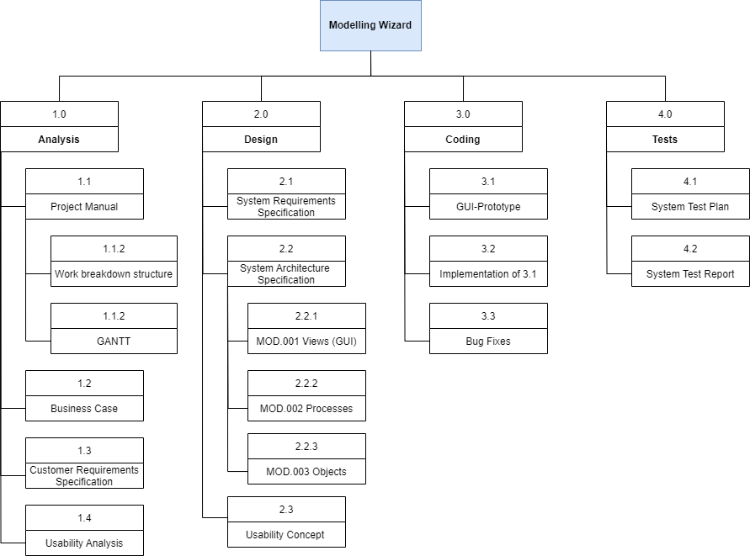

# Milestones

|  |  |  |  |
| --- | --- | --- | --- |
| WP-Code | Milestone  Name | Plan Date | Responsible Person |
| 1.0 | Analysis |  |  |
| 1.1 | Project Manual | 06.10.2022 | Michael Grote |
| 1.1.1 | Work breakdown  structure | 06.10.2022 | Michael Grote |
| 1.1.2 | GANTT | 06.10.2022 | Michael Grote |
| 1.2 | Business Case | 10.10.2022 | Robin Ziegler |
| 1.3 | Customer Requirements  Specification | 06.10.2022 | Maximilian Trumpp |
| 1.4 | Usability Analysis | 15.03.2023 | Sophie Kirschner |
| 2.0 | Design |  |  |
| 2.1 | System Requirements  Specification | 20.10.2022 | Dana Frey |
| 2.2 | System Architecture  Specification | 30.10.2022 | Fabian Kreuzer |
| 2.2.1 | MOD.001 Views (GUI) | 12.05.2023 | Fabian Kreuzer |
| 2.2.2 | MOD.002 Processes | 12.05.2023 | Fabian Kreuzer |
| 2.2.3 | MOD.003 Objects | 12.05.2023 | Fabian Kreuzer |
| 2.3 | Usability Concept | 19.03.2023 | Sophie Kirschner |
| 3.0 | Coding |  |  |
| 3.1 | GUI-Prototype | 26.03.2023 | Sophie Kirschner |
| 3.2 | Implementation of 3.1 | 12.05.2023 | Maximilian Trumpp |
| 3.3 | Bug Fixes | 18.05.2023 | Fabian Kreuzer |
| 4.0 | Tests |  |  |
| 4.1 | System Test Plan | 01.05.2023 | Michael Grote |
| 4.2 | System Test Report | 18.05.2023 | Robin Ziegler |

# Lists of tasks and responsible person

|  |  |  |
| --- | --- | --- |
| Activities and Responsibility | | |
| Person | Category | Tasks |
| **Robin Ziegler**  *Position:* Project Leader  *GitHub-Name:* robinziegler | Documentation,  Organization | * Business Case * Organization of GitHub * Contact person to the Customer * Software Test Report |
| **Maximilian Trumpp**  *Position:* Product Manager  *GitHub-Name:* maximiliantrumpp | Documentation | * Customer Requirements Specification * Contact person to the Customer |
| Development | * Implementation of the new GUI * Backend Implementation |
| **Michael Grote**  *Position:* Test Manager  *GitHub-Name:* michi3214 | Documentation | * Project Manual * Software Test Plan |
| Development | * Implementation of the new GUI |
| **Fabian Kreuzer**  *Position:* System Architect  *GitHub-Name:* Fabiankreuzer | Documentation | * System Architecture Specification |
| Development | * Implementation of the new GUI * Backend Implementation |
| **Dana Frey**  *Position:* Tech. Documentation  *GitHub-Name:* DanaFrey | Documentation | * System Requirements Specification * Meeting Minutes |
| Development | * Implementation of the new GUI |
| **Nils Hoffmann**  *Position:* Developer  *GitHub-Name:* HoffmannNils | Documentation | * User Manual |
| Development | * Implementation of the new GUI |
| **Sophie Kirschner**  Position: Graphical Designer  GitHub-Name:  sophiekirschner | Documentation | * Usability Analysis * Usability Concept |

# Gant-Chart

The original GANT-Chart could be found in GitHub (see <https://github.com/robinziegler/TINF21C_Team4_Modelling_Wizard_Improvements/tree/master/PROJECT/PM>).

First part of the project:

Ein Bild, das Text, Screenshot, Zahl, Diagramm enthält.

Second part of the project:

Ein Bild, das Text, Screenshot, Zahl, Reihe enthält.

# Risks

* ***Financial Risk:***

Due to delays in development or unforeseen bugs, the development effort could increase. The higher development effort would increase personal costs.

***Actions:***

By distributing development tasks among different team members, some processes can be performed more efficiently.

* ***Planning Risk:***

Time schedules might have been planned too tightly.

***Actions:***

For unexpected development efforts, a team member should act as a floater. In addition, certain buffers should be built into the schedules.

* ***Technical Risk:***

Since development has already been started by a previous team, our team needs to get familiar with the existing code first. The programming language C# is only known to a limited extent in our team.

***Actions:***

A good familiarization with the existing project and the used programming language is necessary. In this context it is useful to get used to the existing documentation.

* ***Legal Risk:***

Due to the use of software from other developers, attention to possible legal conditions is necessary.

***Actions:***

When using components from other developers, attention must be paid to possible licenses and plagiarism must be avoided as much as possible.

* ***Personal Risk:***

Significant problems could arise due to possible staff absences. The spontaneous loss of a team member would compromise the scheduled completion.

***Actions:***

By distributing development among multiple team members, the impact of a team member leaving can be better hedged.

# Changes during the project

After analyzing the existing application, it was decided to discard the application and make a new implementation. This was to reduce the development effort. This also allowed the use of a new framework, which simplified the implementation of a more modern GUI.

In addition, there was a personnel change during the project. Sophie Kirschner joined the team.