

**System Requirements Specification**

(TINF21C, SWE)

**Project:** Modelling Wizard Improvements

**Customer:** Markus Rentschler

Christian Holder

**Team:** Project Manager – Robin Ziegler ([inf21100@lehre.dhbw-stuttgart.de](mailto:inf21100@lehre.dhbw-stuttgart.de))

Developer – Nils Hoffmann ([inf21194@lehre.dhbw-stuttgart.de](mailto:inf21194@lehre.dhbw-stuttgart.de))

Test Manager – Michael Grote ([inf21111@lehre.dhbw-stuttgart.de](mailto:inf21111@lehre.dhbw-stuttgart.de))

System Architect – Fabian Kreuzer ([inf21106@lehre.dhbw-stuttgart.de](mailto:inf21106@lehre.dhbw-stuttgart.de))

Tech. Documentation – Dana Frey ([inf21099@lehre.dhbw-stuttgart.de](mailto:inf21099@lehre.dhbw-stuttgart.de))

Product Manager – Maximilian Trumpp ([inf21123@lehre.dhbw-stuttgart.de](mailto:inf21123@lehre.dhbw-stuttgart.de))

Usability Analyist – Sophie Kirschner (0.6[inf21083@lehre.dhbw-stuttgart.de](mailto:inf21083@lehre.dhbw-stuttgart.de))

**Change History**

|  |  |  |  |
| --- | --- | --- | --- |
| **Version** | **Date** | **Author** | **Comment** |
| 0.1 | 07.10.2022 | Dana Frey | created |
| 0.2 | 14.10.2022 | Dana Frey | Added ‘Introduction’ and ‘Use Cases’ |
| 0.3 | 17.10.2022 | Dana Frey | Added ‚Features‘ |
| 0.4 | 19.10.2022 | Dana Frey | reworks |
| 0.5 | 20.10.2022 | Dana Frey | Added ‚Enhancements‘ and did reworks |
| 0.6 | 10.05.2023 | Dana Frey | Updates for each chapter |
| 1.0 | 12.05.2023 | Dana Frey | Updates for the final version |

Table of Contents

1. Introduction 5

1.1 Product Environment 6

2. Use Cases 6

2.1 <UC.001> Create new device 6

2.2 <UC.002> Save device 7

2.3 <UC.003> Create interface from existing library 8

2.4 <UC.004> View device data 9

2.5 <UC.005> Add attachments to device 10

2.6 <UC.006> Add system unit classes to device 11

2.7 <UC.007> Add role class to device 12

2.8 <UC.008> Add library to device 13

3. Functional Features 14

3.1.1 <LF11> Import 14

3.1.2 <LF12> File validation 14

3.1.3 <LF13> Error handling 14

3.1.4 <LF14> Unsaved changes 15

3.1.5 <LF15> Edit device 15

3.1.6 <LF16> Create device 15

3.1.7 <LF17> Export device 15

4. Non-functional Features 15

4.1.1 <NF11> GUI 15

4.1.2 <NF12> Display device in a readable way 19

4.1.3 <NF13> Easy Mode 19

4.1.4 <NF14> Expert Mode 19

4.1.5 <NF15> Portable 19

4.1.6 <NF16> Performance 19

4.1.7 <NF17> Compatibility 19

5. Bug fixes 20

5.1 <BUG10> Data Models 20

5.2 <BUG20> Open Saved Files 20

5.3 <BUG30> Delete without Confirmation 20

5.4 <BUG40> Deleted Interface 20

5.5 <BUG50> List View for Attributes 20

5.6 <BUG60> Separate Menu Bar 20

5.7 <BUG70> Visual Displacement 20

5.8 <BUG80> Text Colours removed 21

5.9 <BUG90> Theme changes Dialog 21

5.10 <BUG100> Wrong Colouring 21

5.11 <BUG110> Semantic 21

5.12 <BUG120> Content Dialog size 21

5.13 <BUG130> Visual Feedback 21

5.14 <BUG140> Crash while Edit 21

5.15 <BUG150> Attribute Highlight 21

5.16 <BUG160> Library Visualization 22

5.17 <BUG170> Local Storage 22

5.18 <BUG180> Wrong Text 22

5.19 <BUG190> Window Refactoring 22

5.20 <BUG200> Dialog Cancel 22

5.21 <BUG210> Change Filename 22

5.22 <BUG220> Data Grid size 22

5.23 <BUG230> Update Status 22

6. Enhancements 23

6.1 <ENH10 > Data Models 23

6.2 <ENH20 > Device Name 23

6.3 <ENH30 > Easy Mode 23

6.4 <ENH40 > Error Handling 23

6.5 <ENH50 > Remove Input Fields 23

6.6 <ENH60 > Save Buttons 24

6.7 <ENH70 > Open and Import 24

6.8 <ENH80> Load Library Repositioning 24

6.9 <ENH90> Mode Indicator 24

6.10 <ENH100> Remove About 24

6.11 <ENH110> Attributes Button 24

6.12 <ENH120> Remove Interface Class Library 24

6.13 <ENH130> Remove Column 24

6.14 <ENH140> Remove Table Display 25

6.15 <ENH150> Edit Data Types 25

6.16 <ENH160> Delete Option 25

6.17 <ENH170> Remove Textfields 25

6.18 <ENH180> Information Texts 25

6.19 <ENH190> Dialog 25

6.20 <ENH200> Adding Interfaces 25

6.21 <ENH210> Add Table 25

6.22 <ENH220> AML Files 26

6.23 <ENH230> Attachments 26

6.24 <ENH240> Dark Light Mode 26

6.25 <ENH250> Title Bar 26

6.26 <ENH260> Update Tables 26

6.27 <ENH270> Replace List View 26

6.28 <ENH280> About Dialog 26

6.29 <ENH290> Filename 26

6.30 <ENH300> Unsaved Changes 27

6.31 <ENH310> Value Validation 27

6.32 <ENH320> Start Dialog 27

6.33 <ENH330> Add Role Class 27

6.34 <ENH340> Visual Loading 27

6.35 <ENH350> Save Options 27

6.36 <ENH360> Automatic Expansion 27

6.37 <ENH370> NavBar Icons 27

6.38 <ENH380> Back Arrow 28

7. References 28

8. Glossary 28

# 1. Introduction

Our project deals with the already existing program called „Modelling Wizard“. The program can create a device model in a graphical user interface (GUI). It is possible to add device interfaces (such as physical ports) or file attachments to the created device model. If the user already owns descriptive files, those files can be used to create a device model as well. The current version of the Modelling Wizard is capable of handling AMLX, AML, EDZ, IODD and GSD import.

The goal of our project is to create a more user-friendly version of the Modelling Wizard which includes an improved version of the GUI as well as fixing bugs and refactoring the code by the team beforehand.

## 1.1 Product Environment

AutomationML (AML) is the short form of Automation MarkUp Language and is used to describe parts of automation plants as objects. These objects can consist of multiple other objects and can be part of a larger assembly of objects. That way AML can be used to describe a single screw or an entire robot with the necessary level of detail. AML makes use of various standards to describe the following plant components:

1. CAEX (Computer Aided Engineering Exchange) to describe attributes of objects and their relations in a hierarchical structure. This is called a system topology. In this respect, CAEX forms the overarching integration framework of AutomationML.
2. COLLADA to describe the geometry and 3D Models of an object
3. COLLADA also integrates motion planning. It describes the connections and relations of moveable objects, which is called Kinematics.
4. PLCopen XML describes the logic. Internal behavior and states if objects, action-sequences and I/O connections are implemented via this format. An IODD (IO Device Description) file describes the sensor and actuator of a plant or component. It also contains information on identify, parameters, process data, communication and more. It is written in XML-format, same as AML, which ensures a conversion.

# 2. Use Cases

Our project doesn't include new added Use Cases and focuses more on the improvement of the given project. Therefore, the following Use Cases have been taken over by the previous team to still be able to visualize the current program’s Use Cases.

## 2.1 <UC.001> Create new device

|  |  |
| --- | --- |
| Use Case's Objective: | User wants to create a device |
| System Boundary: | The application itself |
| Precondition: | The user needs to have the minimal required data for the device on hand. The program needs to be installed on the user’s system and opened. |
| Postcondition on success: | The entered data is displayed completely and correctly |
| Involved Users: | Every end-user of the application |
| Triggering Event: | When the user opens the application and uses the 'New' function to create a new device |

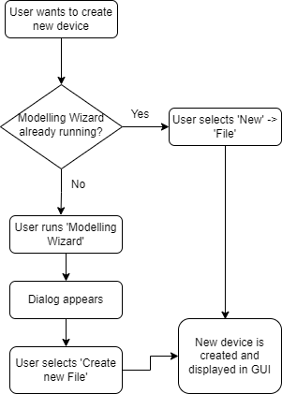

## 2.2 <UC.002> Save device

|  |  |
| --- | --- |
| Use Case's Objective: | User wants to save a device by using the ‘Save’ function |
| System Boundary: | The application itself |
| Precondition: | The user created a device |
| Postcondition on success: | The user created or loaded at least one device successfully |
| Involved Users: | Every end-user of the application |
| Triggering Event: | When the user has an opened device, which the user wants to save |

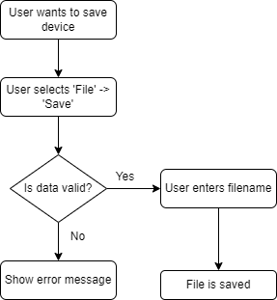

## 2.3 <UC.003> Create interface from existing library

|  |  |
| --- | --- |
| Use Case's Objective: | User wants to create a device interface by adding an interface from one of the existing libraries |
| System Boundary: | The application itself |
| Precondition: | The user needs to have the minimal required data for the device or interface to be added. |
| Postcondition on success: | The user has successfully added an interface to his device |
| Involved Users: | Every end-user of the application |
| Triggering Event: | When the user wants to add a device interface |

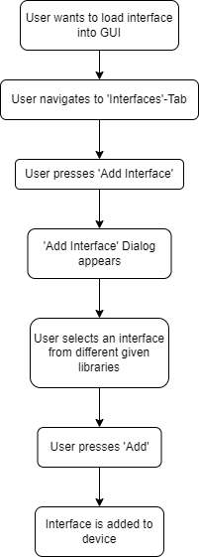

## 2.4 <UC.004> View device data

|  |  |
| --- | --- |
| Use Case's Objective: | After at least one device was successfully created, the device data should be visible and editable on the user interface |
| System Boundary: | The application itself |
| Precondition: | The user created or loaded a device |
| Postcondition on success: | The user created or loaded at least one device successfully and its data is visible on the screen |
| Involved Users: | Every end-user of the application |
| Triggering Event: | When the user wants to view device data |

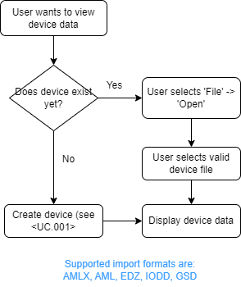

## 2.5 <UC.005> Add attachments to device

|  |  |
| --- | --- |
| Use Case's Objective: | It is possible to add an attachment to the object, such as a manufacturer's icon |
| System Boundary: | The application itself |
| Precondition: | The user created or loaded a device |
| Postcondition on success: | The user has successfully added an attachment to his device |
| Involved Users: | Every end-user of the application |
| Triggering Event: | When the user has the need to edit device data and add attachments such as icons. |

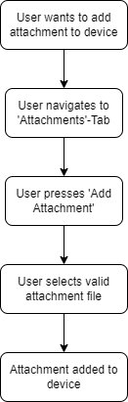

## 2.6 <UC.006> Add system unit classes to device

|  |  |
| --- | --- |
| Use Case's Objective: | User wants to add a system unit class to existing device |
| System Boundary: | The application itself |
| Precondition: | The user created or loaded a device |
| Postcondition on success: | The user has successfully added a system unit class to his device |
| Involved Users: | Every end-user of the application |
| Triggering Event: | When the user has the need to add a system unit class to his device |

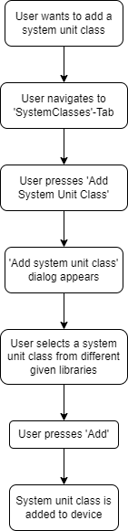

## 2.7 <UC.007> Add role class to device

|  |  |
| --- | --- |
| Use Case's Objective: | User wants to add a role class to existing device |
| System Boundary: | The application itself |
| Precondition: | The user created or loaded a device |
| Postcondition on success: | The user has successfully added a role class to his device |
| Involved Users: | Every end-user of the application |
| Triggering Event: | When the user has the need to add a role class to his device |

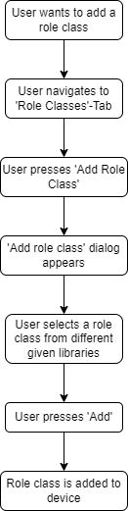

## 2.8 <UC.008> Add individual library

|  |  |
| --- | --- |
| Use Case's Objective: | User wants to add an individual library to application |
| System Boundary: | The application itself |
| Precondition: | The user created or loaded a device |
| Postcondition on success: | The user has successfully added an individual library to application |
| Involved Users: | Every end-user of the application |
| Triggering Event: | When the user has the need to add an own library |

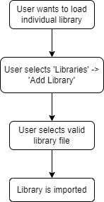

# 3. Functional Features

## 3.1.1 <LF11> Import

The application should be able to import a file by the absolute path to the file. This import supports files of the file types AMLX, AML, EDZ, IODD and GSD.

## 3.1.2 <LF12> File validation

The system shall be able to detect wrongly formatted imported files and throw an error to the user.

## 3.1.3 <LF13> Error handling

The system shall be able to handle errors (unexpected shut down, wrongly formatted files, ...) and throw an error to the user. If an error appears to be in a specific part of the program, the cursor should be pointed to that exact location.

## 3.1.4 <LF14> Edit device

When the attributes of a loaded device are displayed to the user, the user should be able to edit every attribute he wants to change.

## 3.1.5 <LF15> Create device

When the application is started, the user should be able to create a new and empty device model.

## 3.1.6 <LF16> Export device

When the user has edited a device, he should be able to save the device to a file.

## 3.1.7 <LF17> Easy Mode

When the user wants to hide additional attribute information -visible in the "System Classes"-Tab-, he can press the 'Easy Mode'-button. 'Easy mode' is the default mode.

## 3.1.8 <LF18> Expert Mode

When the user wants to display additional attribute information -which was not visible in the "System Classes"-Tab before-, he can press the 'Expert Mode'-button.

# 4. Non-functional Features

## 4.1.1 <NF11> GUI

The system should display a graphical user interface after startup of the standalone application. The user will interact with this GUI for every other functionality of the application. The first prototype includes the changes in the existing UI and is shown in the Usability Concept (https://github.com/robinziegler/TINF21C_Team4_Modelling_Wizard_Improvements/wiki/New-Usability-Concept). The final prototype is a complete redesign of the old interface.

**Old GUI from the previous Modelling Wizard team (in easy mode):**

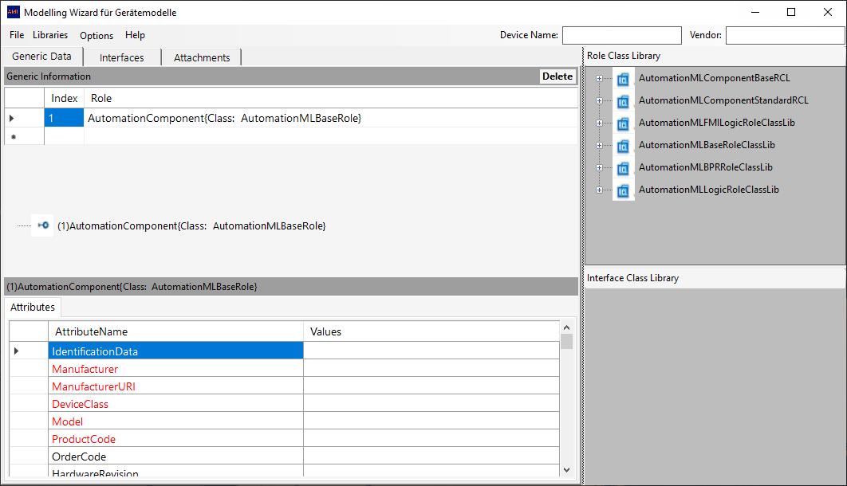

**Old GUI from the previous Modelling Wizard team (in "advanced" mode = expert mode):**

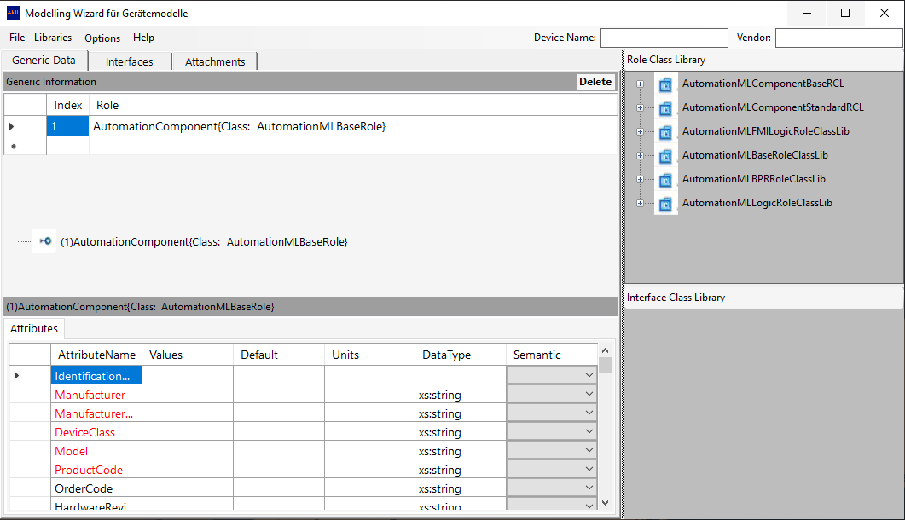

**Final GUI version (in easy mode):**

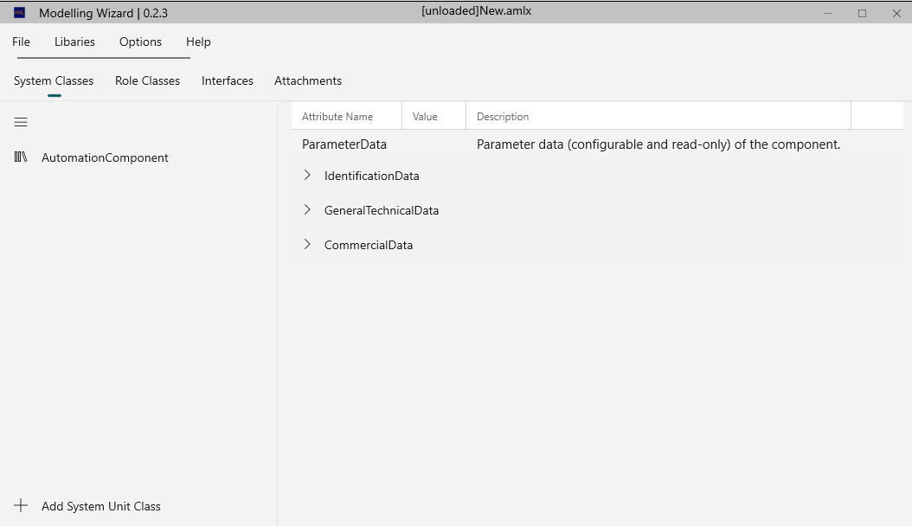

**Final GUI version (in expert mode):**

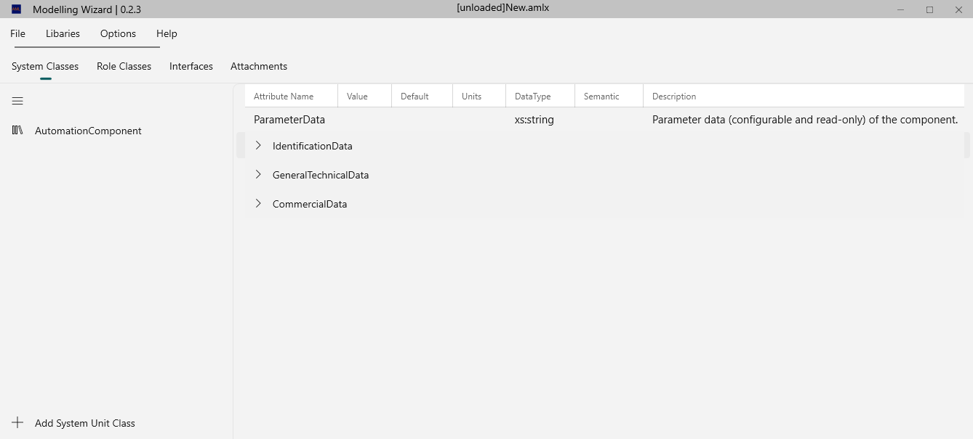

The graphical user interface should be user friendly. There should not be an overwhelming amount of information, button areas should easily be clickable, there should be no unnecessary buttons, etc..

When a device is loaded or created the attributes of the element should be displayed directly and easily readable for the user.

## 4.1.2 <NF12> Portable

The program should be runnable without any installation.

## 4.1.3 <NF13> Performance

The application should respond instantly after a user's action.

## 4.1.4 <NF14> Compatibility

The application should be executable on every current system such as Windows 10 or higher. Furthermore, the application is only executable on the Windows platform.

# 5. Bug fixes

## 5.1 <BUG10> Data Models

<https://github.com/robinziegler/TINF21C_Team4_Modelling_Wizard_Improvements/issues/12>

## 5.2 <BUG20> Open Saved Files

<https://github.com/robinziegler/TINF21C_Team4_Modelling_Wizard_Improvements/issues/5>

## 5.3 <BUG30> Delete without Confirmation

<https://github.com/robinziegler/TINF21C_Team4_Modelling_Wizard_Improvements/issues/27>

## 5.4 <BUG40> Deleted Interface

<https://github.com/robinziegler/TINF21C_Team4_Modelling_Wizard_Improvements/issues/28>

## 5.5 <BUG50> List View for Attributes

<https://github.com/robinziegler/TINF21C_Team4_Modelling_Wizard_Improvements/issues/75>

## 5.6 <BUG60> Separate Menu Bar

<https://github.com/robinziegler/TINF21C_Team4_Modelling_Wizard_Improvements/issues/72>

## 5.7 <BUG70> Visual Displacement

<https://github.com/robinziegler/TINF21C_Team4_Modelling_Wizard_Improvements/issues/71>

## 5.8 <BUG80> Text Colours removed

<https://github.com/robinziegler/TINF21C_Team4_Modelling_Wizard_Improvements/issues/68>

## 5.9 <BUG90> Theme changes Dialog

<https://github.com/robinziegler/TINF21C_Team4_Modelling_Wizard_Improvements/issues/66>

## 5.10 <BUG100> Wrong Colouring

<https://github.com/robinziegler/TINF21C_Team4_Modelling_Wizard_Improvements/issues/62>

## 5.11 <BUG110> Semantic

<https://github.com/robinziegler/TINF21C_Team4_Modelling_Wizard_Improvements/issues/60>

## 5.12 <BUG120> Content Dialog size

<https://github.com/robinziegler/TINF21C_Team4_Modelling_Wizard_Improvements/issues/52>

## 5.13 <BUG130> Visual Feedback

<https://github.com/robinziegler/TINF21C_Team4_Modelling_Wizard_Improvements/issues/134>

## 5.14 <BUG140> Crash while Edit

<https://github.com/robinziegler/TINF21C_Team4_Modelling_Wizard_Improvements/issues/130>

## 5.15 <BUG150> Attribute Highlight

<https://github.com/robinziegler/TINF21C_Team4_Modelling_Wizard_Improvements/issues/115>

## 5.16 <BUG160> Library Visualization

<https://github.com/robinziegler/TINF21C_Team4_Modelling_Wizard_Improvements/issues/114>

## 5.17 <BUG170> Local Storage

<https://github.com/robinziegler/TINF21C_Team4_Modelling_Wizard_Improvements/issues/97>

## 5.18 <BUG180> Wrong Text

<https://github.com/robinziegler/TINF21C_Team4_Modelling_Wizard_Improvements/issues/82>

## 5.19 <BUG190> Window Refactoring

<https://github.com/robinziegler/TINF21C_Team4_Modelling_Wizard_Improvements/issues/132>

## 5.20 <BUG200> Dialog Cancel

<https://github.com/robinziegler/TINF21C_Team4_Modelling_Wizard_Improvements/issues/133>

## 5.21 <BUG210> Change Filename

<https://github.com/robinziegler/TINF21C_Team4_Modelling_Wizard_Improvements/issues/135>

## 5.22 <BUG220> Data Grid size

<https://github.com/robinziegler/TINF21C_Team4_Modelling_Wizard_Improvements/issues/136>

## 5.23 <BUG230> Update Status

<https://github.com/robinziegler/TINF21C_Team4_Modelling_Wizard_Improvements/issues/137>

## 5.24 <BUG240> Add Role Class

<https://github.com/robinziegler/TINF21C_Team4_Modelling_Wizard_Improvements/issues/85>

# 6. Enhancements

## 6.1 <ENH10 > Data Models

<https://github.com/robinziegler/TINF21C_Team4_Modelling_Wizard_Improvements/issues/13>

## 6.2 <ENH20 > Device Name

<https://github.com/robinziegler/TINF21C_Team4_Modelling_Wizard_Improvements/issues/11>

## 6.3 <ENH30 > Easy Mode

<https://github.com/robinziegler/TINF21C_Team4_Modelling_Wizard_Improvements/issues/10>

## 6.4 <ENH40 > Error Handling

<https://github.com/robinziegler/TINF21C_Team4_Modelling_Wizard_Improvements/issues/9>

## 6.5 <ENH50 > Remove Input Fields

<https://github.com/robinziegler/TINF21C_Team4_Modelling_Wizard_Improvements/issues/>8

## 6.6 <ENH60 > Save Buttons

<https://github.com/robinziegler/TINF21C_Team4_Modelling_Wizard_Improvements/issues/7>

## 6.7 <ENH70 > Open and Import

<https://github.com/robinziegler/TINF21C_Team4_Modelling_Wizard_Improvements/issues/6>

## 6.8 <ENH80> Load Library Repositioning

<https://github.com/robinziegler/TINF21C_Team4_Modelling_Wizard_Improvements/issues/40>

## 6.9 <ENH90> Mode Indicator

<https://github.com/robinziegler/TINF21C_Team4_Modelling_Wizard_Improvements/issues/41>

## 6.10 <ENH100> Remove About

<https://github.com/robinziegler/TINF21C_Team4_Modelling_Wizard_Improvements/issues/42>

## 6.11 <ENH110> Attributes Button

<https://github.com/robinziegler/TINF21C_Team4_Modelling_Wizard_Improvements/issues/43>

## 6.12 <ENH120> Remove Interface Class Library

<https://github.com/robinziegler/TINF21C_Team4_Modelling_Wizard_Improvements/issues/44>

## 6.13 <ENH130> Remove Column

https://github.com/robinziegler/TINF21C_Team4_Modelling_Wizard_Improvements/issues/45

## 6.14 <ENH140> Remove Table Display

<https://github.com/robinziegler/TINF21C_Team4_Modelling_Wizard_Improvements/issues/46>

## 6.15 <ENH150> Edit Data Types

<https://github.com/robinziegler/TINF21C_Team4_Modelling_Wizard_Improvements/issues/47>

## 6.16 <ENH160> Delete Option

<https://github.com/robinziegler/TINF21C_Team4_Modelling_Wizard_Improvements/issues/48>

## 6.17 <ENH170> Remove Textfields

<https://github.com/robinziegler/TINF21C_Team4_Modelling_Wizard_Improvements/issues/49>

## 6.18 <ENH180> Information Texts

<https://github.com/robinziegler/TINF21C_Team4_Modelling_Wizard_Improvements/issues/50>

## 6.19 <ENH190> Dialog

<https://github.com/robinziegler/TINF21C_Team4_Modelling_Wizard_Improvements/issues/51>

## 6.20 <ENH200> Adding Interfaces

<https://github.com/robinziegler/TINF21C_Team4_Modelling_Wizard_Improvements/issues/53>

## 6.21 <ENH210> Add Table

<https://github.com/robinziegler/TINF21C_Team4_Modelling_Wizard_Improvements/issues/54>

## 6.22 <ENH220> AML Files

<https://github.com/robinziegler/TINF21C_Team4_Modelling_Wizard_Improvements/issues/57>

## 6.23 <ENH230> Attachments

<https://github.com/robinziegler/TINF21C_Team4_Modelling_Wizard_Improvements/issues/58>

## 6.24 <ENH240> Dark Light Mode

<https://github.com/robinziegler/TINF21C_Team4_Modelling_Wizard_Improvements/issues/61>

## 6.25 <ENH250> Title Bar

<https://github.com/robinziegler/TINF21C_Team4_Modelling_Wizard_Improvements/issues/63>

## 6.26 <ENH260> Update Tables

<https://github.com/robinziegler/TINF21C_Team4_Modelling_Wizard_Improvements/issues/64>

## 6.27 <ENH270> Replace List View

<https://github.com/robinziegler/TINF21C_Team4_Modelling_Wizard_Improvements/issues/70>

## 6.28 <ENH280> About Dialog

<https://github.com/robinziegler/TINF21C_Team4_Modelling_Wizard_Improvements/issues/73>

## 6.29 <ENH290> Filename

<https://github.com/robinziegler/TINF21C_Team4_Modelling_Wizard_Improvements/issues/76>

## 6.30 <ENH300> Unsaved Changes

<https://github.com/robinziegler/TINF21C_Team4_Modelling_Wizard_Improvements/issues/77>

## 6.31 <ENH310> Value Validation

<https://github.com/robinziegler/TINF21C_Team4_Modelling_Wizard_Improvements/issues/78>

## 6.32 <ENH320> Start Dialog

<https://github.com/robinziegler/TINF21C_Team4_Modelling_Wizard_Improvements/issues/79>

## 6.33 <ENH330> Visual Loading

<https://github.com/robinziegler/TINF21C_Team4_Modelling_Wizard_Improvements/issues/88>

## 6.34 <ENH340> Save Options

<https://github.com/robinziegler/TINF21C_Team4_Modelling_Wizard_Improvements/issues/89>

## 6.35 <ENH350> Automatic Expansion

<https://github.com/robinziegler/TINF21C_Team4_Modelling_Wizard_Improvements/issues/112>

## 6.36 <ENH360> NavBar Icons

<https://github.com/robinziegler/TINF21C_Team4_Modelling_Wizard_Improvements/issues/113>

## 6.37 <ENH370> Back Arrow

<https://github.com/robinziegler/TINF21C_Team4_Modelling_Wizard_Improvements/issues/116>

# 7. References

[1] <https://github.com/H4CK3R-01/TINF20C_ModellingWizard_Devices/wiki/1.-Software-Requirements--Specification#UC3>

[2] Software Engineering lessons by Markus Rentschler and Christian Holder

# 8. Glossary

|  |  |
| --- | --- |
| AML | Automation Markup Language is an open standard data format for storing and exchanging plant planning data |
| AMLX | AML Package |
| CAEX | Computer-Aided Engineering Exchange |
| EDZ | EPLAN Electric P8 Data Archive Zipped File |
| GSD | General Station Description |
| GUI | Graphical User Interface |
| IODD | Input/Output Device Description |