The problem and promise of scale in multilayer networks

Alec L. Robitaille1, Quinn M.R. Webber2, Julie W. Turner1, Eric Vander Wal1,2

1Department of Biology, Memorial University of Newfoundland, Canada; 2Cognitive and Behavioural Ecology Interdisciplinary Program, Memorial University of Newfoundland

# Abstract

Scale remains a seminal concept in ecology. Spatial scale, for instance, has become a central consideration in the way we understand landscape ecology and animal space use. Meanwhile, social processes can also scale from fine-scale interactions to co-occurrence to overlapping home ranges. Multilayer networks promise the integration of monolayer animal social networks with the complexity and importance of animal space use and movement in heterogeneous landscapes. Despite the complex interplay between social networks and how animals use space, there remains an important biological and methodological gap in our understanding of an animal’s perception of scale, e.g., grain and extent. But scale can affect multilayer network dynamics and how we build and interpret them. Here we discuss the role of scale in the context of multilayer networks and provide a case study of caribou (*Rangifer tarandus*) to illustrate the role of social, spatial, and temporal scale on multilayer processes. We also present perspectives on future development and application of scale in multilayer networks with respect to habitat selection and space use, individual fitness and phenotypes, and movement ecology and collective movement. Effective integration of social and spatial processes, including biologically meaningful scales, within the context of animal social networks is an emerging area of research; our contribution uniquely incorporates perspectives on how the social environment and spatial processes are linked across scales in a multilayer framework. Based on social network and behavioural ecology theory as well as our case study, we demonstrate potential for interconnectedness among individual animals, their social environment, and the landscapes they occupy.

## Keywords

Landscape ecology, Movement ecology, Social network analysis, Space use

# Introduction

Our inference regarding the ecological processes underlying ecological patterns are directly linked to the scale at which they are observed (Levin 1992; Allen and Hoekstra 2015). Animals are influenced across scales, through processes such as species-specific as trophic interactions and resource availability (Legendre 1993; Chave 2013) and global climate and productivity (Field et al. 2009). Multiscale ecology has been integrated into species distribution modelling (Elith and Leathwick 2009), habitat selection (Mayor et al. 2007), and food webs (Sugihara, Schoenly, and Trombla 1989). Meanwhile, in the context of animal behaviour, certain behaviours are scale dependent, for example, acoustic communication in birds occurs over variable spatial scales (Luther 2009). We posit that animal behaviour and, more specifically, the social environment that animals experience must also be scale-dependent.

Sociality exists across both temporal and spatial scales (Whitehead 2008). For example, grooming requires close spatial proximity between conspecifics and occurs over brief time periods (e.g. Carter et al. 2015), whereas social association represents shared space use by members of the same social group (Figure 1, Franks et al. 2010). Further, for social interactions or associations to occur individuals must share space, and thus have overlapping home ranges. In the context of the social environment, home range overlap is a relatively coarse scale of sociality across which individuals share space over coarser spatial and temporal scales (e.g. Piza-Roca et al. 2018). Although the social environment clearly scales spatially and temporally, it remains unclear whether coarser scales of sociality, including social association and home range overlap, vary predictably with social interaction (Castles et al. 2014; Farine 2015). Thus, we define social scale as the type of social relationship observed that can be explicitly defined and measured (Farine et al. 2015).

Animal social network analysis is a well-developed tool used to measure the relationships of individuals and organization of social systems (Krause et al. 2009; Wey et al. 2008; Croft et al. 2008). Social network analysis provides insight into the structure of social communities and social network properties, which can influence population dynamics and evolutionary processes (Pinter-Wollman et al. 2014; Kurvers et al. 2014). Despite the widespread use and innovation of traditional social network analysis (Webber & Vander Wal 2019), it typically considers a single scale of sociality in a given network (monolayer), drastically simplifying the potential complexity of animal social systems (Finn et al. 2019).

Unlike traditional monolayer social networks, multilayer networks explicitly consider social systems across contexts, including scale-dependent contexts (Pilosof et al. 2017). Multilayer networks are made up of multiple layers, each representing different classes of individuals (e.g. male or female), types of behaviours (e.g. grooming, travelling, or foraging), spatial areas (e.g. local or regional), or temporal windows (e.g. daily or seasonal) (Kivela et al. 2014; Porter 2018). Multilayer networks are relatively novel to studies of animal behaviour (Finn et al. 2019; Silk et al. 2018), although they have been used to describe multidimensional human social systems, complex transportation networks, and neural networks (Silk et al. 2018). The role of scale within multilayer social networks remains unexplored but provides a unique opportunity to develop novel understanding of variation in the temporal or spatial scales associated with social systems.

Our study is motivated by behavioural, landscape, and spatial ecology to build a conceptual and analytical framework for scale-dependent multilayer networks and we apply this framework to a case study of caribou (*Rangifer tarandus*) in Newfoundland, Canada (Peignier et al. 2019). We use this case study to address two principal questions associated with scale-dependent multilayer networks. First, to what degree does the social scale of relationships, spatial scale of landscapes, and temporal scale of analysis influence our ability to interpret complex social systems? Second, can variation in social, spatial, and temporal improve predictions associated with biological differences in seasonal resource availability and social association? We conclude with perspectives for further development and application of scale in multilayer networks with respect to habitat selection and space use , individual fitness and phenotypes (Webber & Vander Wal 2018), and movement ecology and collective movement (Jolles et al. 2019).

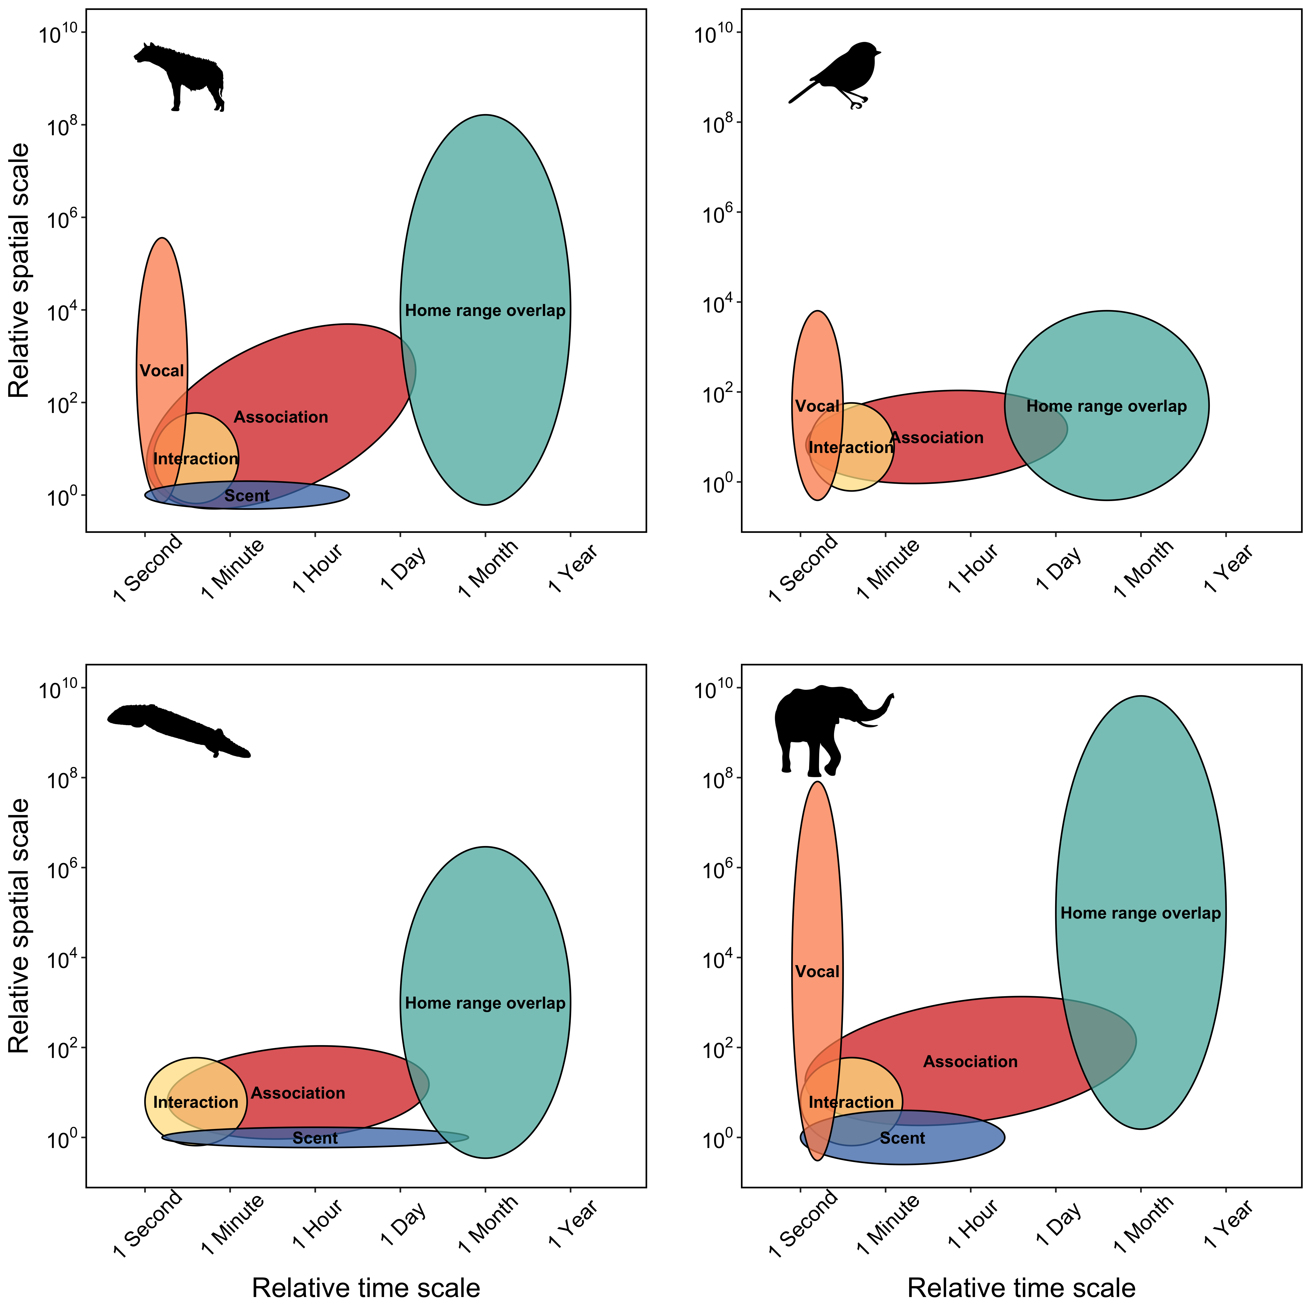

Figure 1: Space-time diagram displaying variation the spatial and temporal extent required for different social processes across a range of taxa.

# Scale in multilayer networks: a case study

## Caribou socioecology

Here, we use caribou as a case study to develop scale-dependent multilayer networks based on social (visual and auditory perception), spatial (habitat type), and temporal (seasonal). Caribou are gregarious ungulates with fission-fusion dynamics (Lesmerises, Johnson, and St-Laurent 2018) that display temporal (Peignier et al. 2019) and spatial (Webber et al. unpublished data) variation in social networks. In winter, caribou dig holes in the snow, termed craters, to access forage (Bergerud 1974). As a result, caribou tend to occupy and re-use craters once they are established and there is considerably less access to forage than when the landscape is snow-free. Importantly, craters exist on the landscape at multiple scales: the crater scale (a single crater), the feeding area scale (multiple craters in close proximity), and the winter range scale (all craters within an individual’s range) (Mayor et al. 2009). The distribution of forage for caribou is therefore seasonally heterogeneous, with greater access in snow-free seasons compared to winter as well as spatially heterogeneous in winter because the distribution of craters on the landscape varies meaning that access to vegetation in winter is highly variable for caribou. We therefore partitioned data into two discrete seasons: summer (3 August - 20 September) and winter (1 January – 17 February) based on caribou socioecology (Peignier et al. 2019).

## Caribou location data

We used GPS location data collected from Fogo Island caribou in 2017 and 2018. Adult female caribou were immobilized and fitted with global positioning system (GPS) collars (Lotek Wireless Inc., Newmarket, ON, Canada, GPS4400M collars, 1,250 g) as described by Schaefer and Mahoney (2013). Collars were programmed to collect location fixes every 2 hours. Prior to analyses, we subset GPS fixes into a discrete removed all erroneous and outlier GPS fixes following Bjørneraas et al. (2010). We did not collar all female caribou in the herd; however, we assumed that our sample of collared animals was random.

## Landscape data and habitat classification

Landcover data were provided by the Newfoundland and Labrador Wildlife Division. Available landcover classification included nine habitat types at 10m resolution. We reclassified the landcover types into three categories: foraging habitat, open habitat, and forest habitat using the R package raster (Hijmans 2019). Foraging habitat consisted of lichen habitat, open habitat consisted of wetland, rocky barrens, and anthropogenic habitat types, while forest habitat consisted of coniferous forest, conifer scrub, broadleaf forest, and mixed-wood forest habitat types. Water habitat was excluded from all subsequent analyses.

## Caribou multilayer social networks

### Network types and construction (defining layers for the multilayer network)

We generated a multilayer social network consisting 16 individual nodes and two aspects (season and landcover). Two season elementary-layers (winter and summer) and three landcover elementary-layers (open, forest and lichen) combined for a total of six layers. Layers were composed of individuals represented as nodes and social associations represented as edges, for each season and landcover combination. Proximity-based social network layers were generated using the R package spatsoc (Robitaille, Webber, and Wal 2019) in R version 3.6.1 (2019-07-05) (R Core Team 2019).

Within each layer, we assumed individuals were associating if simultaneous GPS fixes (i.e., recorded within 5 minutes of each other) were within a given spatial distance of one another. Typically for ungulates and other gregarious mammals, the ‘chain rule’ is applied for group assignment. For GPS data, the chain rule is applied if discrete spatiotemporal GPS fixes buffered by a given distance formed a contiguous buffer for two or more individuals, even if some individuals within the buffer were not within the given distance of one another (Robitaille, Webber, and Wal 2019). Group assignment based on the chain rule has previously been applied to caribou at a distance of 50m (Peignier et al. 2019; Lesmerises, Johnson, and St-Laurent 2018). In all networks, nodes represented individuals, intralayer edges represented associations between individuals in a given habitat type and season, and interlayer edges represented connections between the same individuals across contexts.

We weighted edges of social networks by the strength of association between caribou using the simple ratio index (SRI, Cairns and Schwaeger 1987):

$$SRI=\frac{x}{x+y_{AB}+y_{A}+y_{B}}$$

where x is the number of fixes where individuals A and B were within a given distance of each other, is the number of fixes from individual A when individual B did not have a simultaneous fix, is the number of fixes from individual B when individual A did not have a simultaneous fix, and is the number of simultaneous fixes from individuals A and B that were separated by more than the given distance (Farine and Whitehead 2015). Social groups were designated if two or more individuals occurred within a given distance of one another at any given time point.

### Network metrics

We used a series of metrics to characterize the multilayer networks, focusing on the the role of individuals, relevance of individual layers and the similarity of different layers. To measure the role of individuals, we calculated the graph strength, degree weighted by the values of the edge, for each individual for each layer-specific season and landcover context . Degree centrality, the number of direct connections an individual has to other individuals in the network, is the basis of many calculations (Kivela et al. 2014). We calculated multidegree, the sum of degree centrality across layers, and neighbourhood, the sum of unique neighbours to each individual (Berlingerio et al. 2012; Kivela et al. 2014). Comparing the multidegree and neighbourhood, we measured the connective redundancy, the proportion of neighbours repeated in multiple layers, and the layer relevance, the proportion of neighbours present in each layer compared to the neighbourhood for each individual (Berlingerio et al. 2012). Finally, we calculated the similarity of layers between seasons, across landcover classes (e.g.: winter open compared to summer open) using the Pearson correlation coefficient (Br’odka et al. 2018).

## Varying scale in multilayer networks

### Social scale

We altered the social scale based on visual (short distance) and auditory (long distance) sensory modalities of caribou. Specifically, we modified the spatial distance threshold required for group assignment using spatsoc (Robitaille, Webber, and Wal 2019) (see above) and re-assigned groups at incremental distances between 5-500m. For example, at the finest social scale, only individuals within 5m of one another were considered in the same group, whereas at the coarsest social scale, individuals within 500m of one another were considered in the same group.

### Spatial scale

To assess the influence of spatial scale on multilayer networks, we aggregated our landcover raster at varying scales relevant to caribou ecology. We aggregated the 10m landcover raster using the R package grainchanger (L. Graham 2019) at five scales: 100m, 250m, 500m, and 1000m. Aggregation occurred using a modal moving window method using a circular window corresponding to the above scales (L. J. Graham et al. 2019). 10m and 100m represents fine-scale decision making for caribou during foraging (Webber et al. unpublished data), while re-sampling at 500m and 1000m represents the scale at which caribou tend to select and avoid habitat (Bastille-Rousseau et al. 2017).

### Temporal scale

We altered the temporal scale of multilayer networks by varying the length and position of the time window used to define seasons. The length of the time window varied from 40-100 days using a fixed start day for winter (starting at 1 January) and summer (starting at 3 August). The position of the time window was shifted by 1-48 days, using a fixed time window length of 48 days. These new time windows were iteratively used to partition data into two discrete seasons (winter, summer) and generate multilayer networks.

Studies of social network analysis vary in the number and frequency of observations as well as the data collection technique used to generate networks (Davis et al. 2018; Webber and Vander Wal 2019). In addition to altering the temporal scale by adjusting the time window, we investigated the influence of the number of observations on resulting multilayer networks. We randomly selected 500 timesteps and iteratively included 25 additional observations, regenerating the multilayer network and calculating associations of individuals. Subsequent iterations included the previous set of observations to mimic observational data.

# Scale in multilayer networks in practice: case study results and discussion

In general, individuals in multilayer networks became more connected as social scale increased; however, this relationship varied by habitat type and season. As social scale increased, connective redundancy increased rapidly when groups were formed up to approximately 100m threshold, followed by a plateau and slight decrease at higher thresholds, presumably due to an increase in summer forest degree at ~500m (Figure 2d). Regardless of social scale, layer relevance did not change for any habitat types or seasons, which suggests habitat-by-season layers captured most, if not all, of the potential connections an individual would have across all networks (Figure 2b). Finally, somewhat predictably, graph strength for winter networks increased up to ~100-200m thresholds, followed by a plateau, while graph strength for summer networks did not change as the social threshold increased (Figure 2a). Taken together, these results suggest the optimal social scale at which groups should be assigned is likely somewhere between ~20-100m based on the rate at which network metrics stabilized. For ungulates, groups are often assigned based on 50m threshold (Lingle 2003; Lesmeries et al. 2018; Peignier et al. 2019), suggesting that given similar quantities of data, ~50m is likely an ideal social scale for generating social networks in caribou and similar species.

Increasing the scale of landcover resolution resulted in decreased proportion of rare and patchy habitats and low connectivity of individuals in these habitats. In winter, layer relevance was stable for open and forest habitats but decreased for forage habitats (Figure 3b). Connective redundancy decreased with increasing landcover resolution due the decrease in connectivity of individuals in winter forage habitats, resulting in a multilayer network where neighbours were less frequently repeated in multiple layers (Figure3d). Layer similarity was generally stable for forest and open habitats except for a contrasting increase in similarity for forest and decrease in similarity for open habitats at 250m landcover resolution (Figure 3c). Layer similarity was not possible to calculate between winter and summer forage because, at all landcover resolutions greater than 10m there were no individuals connected in the network layers. These results indicate the importance of matching landcover resolution to scale of selection as well as ensuring the landcover product used has a resolution fine enough to detect relevant landscape features and habitats.

As the number of observations used to generate multilayer networks increased, individuals became more connected and metrics generally appeared to stabilize. Like coarse landcover resolution (above), low numbers of observations were not sufficient for capturing individuals in all contexts and layer similarity could not be calculated below approximately 75 observations for forest, approximately 210 observations for open and approximately 300 observations for forage (Figure 4c). Once sufficient observations were obtained, layer similarity stabilized for all three landcover classes at approximately 200 observations for forest and approximately 300 observations for open and forage landcover types. Connective redundancy increased with increasing number of observations as individuals became more connected to neighbours in multiple layers (Figure 4d). Given the overall trend of these multilayer metrics stabilizing after a certain number of observations are included, the results suggest this sensitivity method could be useful for determining the number of observations necessary for sufficiently describing the social dynamics across contexts.

Contrasting winter and summer seasons became more similar with increasing window length. Layer similarity between seasons increased consistently across landcover class (Figure 5b). Individual graph strength and layer relevance increased for all summer layers as individuals became more connected with increasing window lengths (Figure 5a, Figure 5b). These results suggest that an increasing window length, especially for the summer season, may be resulting in less precisely defined seasons that are not clearly capturing periods of aggregation and dissaggregation according to resource availability and presence of conspecifics.

**Missing: discussion of window position..**

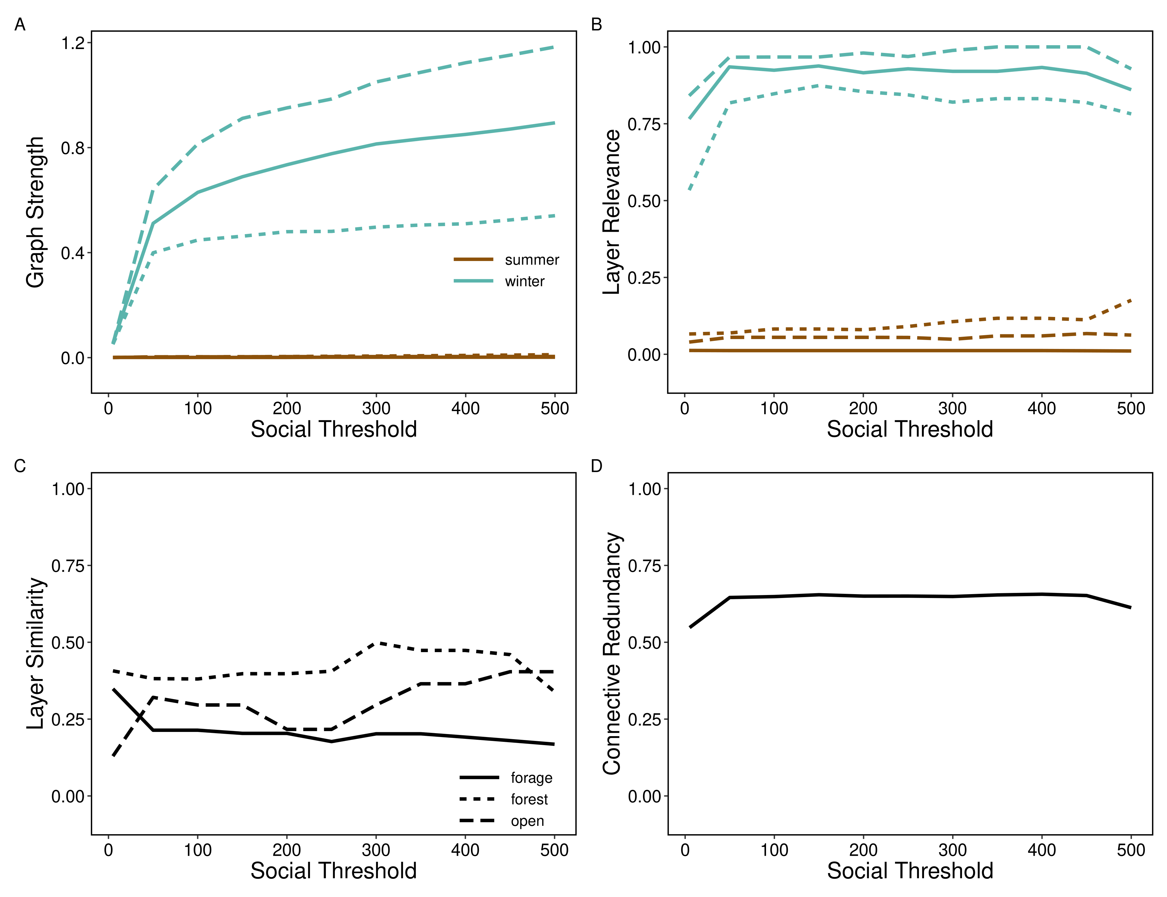

Figure 2: Varying scale in social threshold. For each social threshold (5m, 50m, 100m, 150m, 200m, 250m, 300m, 350m, 400m, 450m, 500m), multilayer networks were constructed for each landcover class (forest, lichen and open) across two seasons (summer and winter) and four network metrics calculated. A) Mean graph strength across individuals showed an increase for winter network layers at 50m through 500m while summer network layers had consistently weak connections. B) Mean layer relevance was relatively stable across social thresholds for each season and landcover layer. C) Similarity of landcover network layers between seasons (e.g.: open summer compared to open winter) showed different responses to changing landcover scale with an overall increase in similarity for open layers and decrease in similarity for lichen layers. D) Mean connective redundancy across individuals increased rapidly between 5m and 50m reaching a plateau of about 0.65 at approximately a 50m social threshold before decreasing between 400m and 500m.

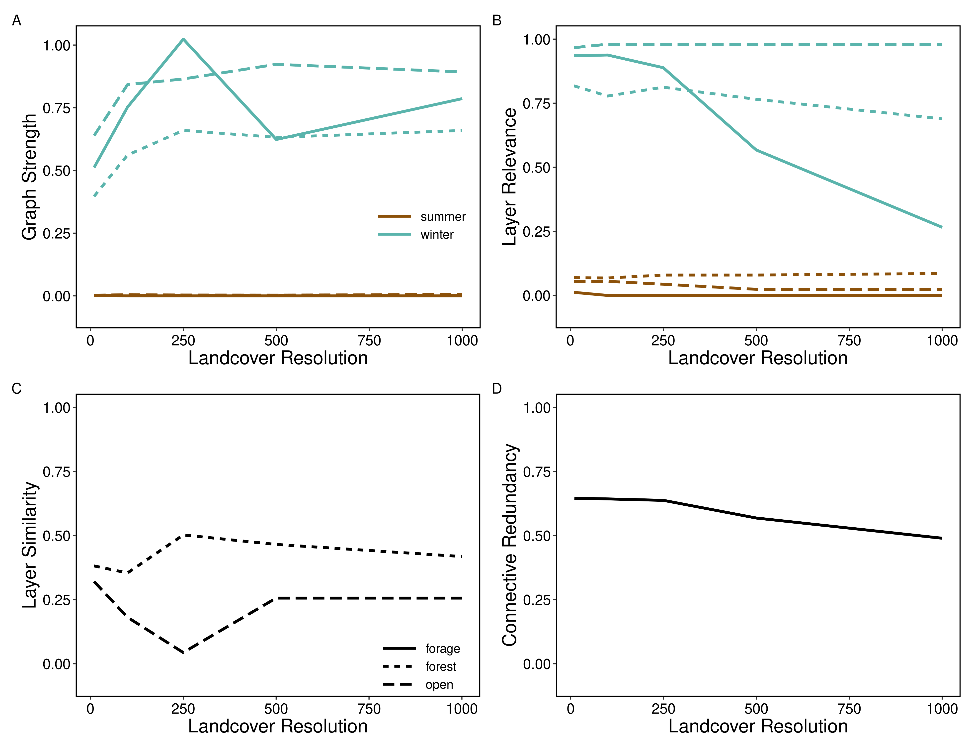

Figure 3: Variation in multilayer network metrics as a function of changes in landcover resolution, a metric which we interpret as spatial scale. For each landcover resolution (10m, 100m, 250m, 500m and 1000m), multilayer networks were constructed for each landcover class (forest, lichen and open) across two seasons (summer and winter), and four network metrics were calculated and we examined how network metrics changed as a function of changes in spatial scale. A) Mean graph strength of individuals was weaker during the summer compared to the winter months. B) Mean layer relevance showed sparse connectivity in summer compared to winter networks and a decrease in winter lichen layer relevance at higher landcover resolutions. C) Similarity of landcover network layers between seasons (e.g.: open summer compared to open winter) showed different responses to changing landcover scale with an increase in similarity for forest layers at 250m and decrease in similarity for open layers at 250m. Note that lichen layer similarity is not shown because individuals did not interact in lichen habitats greater greater than 10m landcover resolution. D) Mean connective redundancy across individuals showed a decreasing trend with increasing landcover resolution.

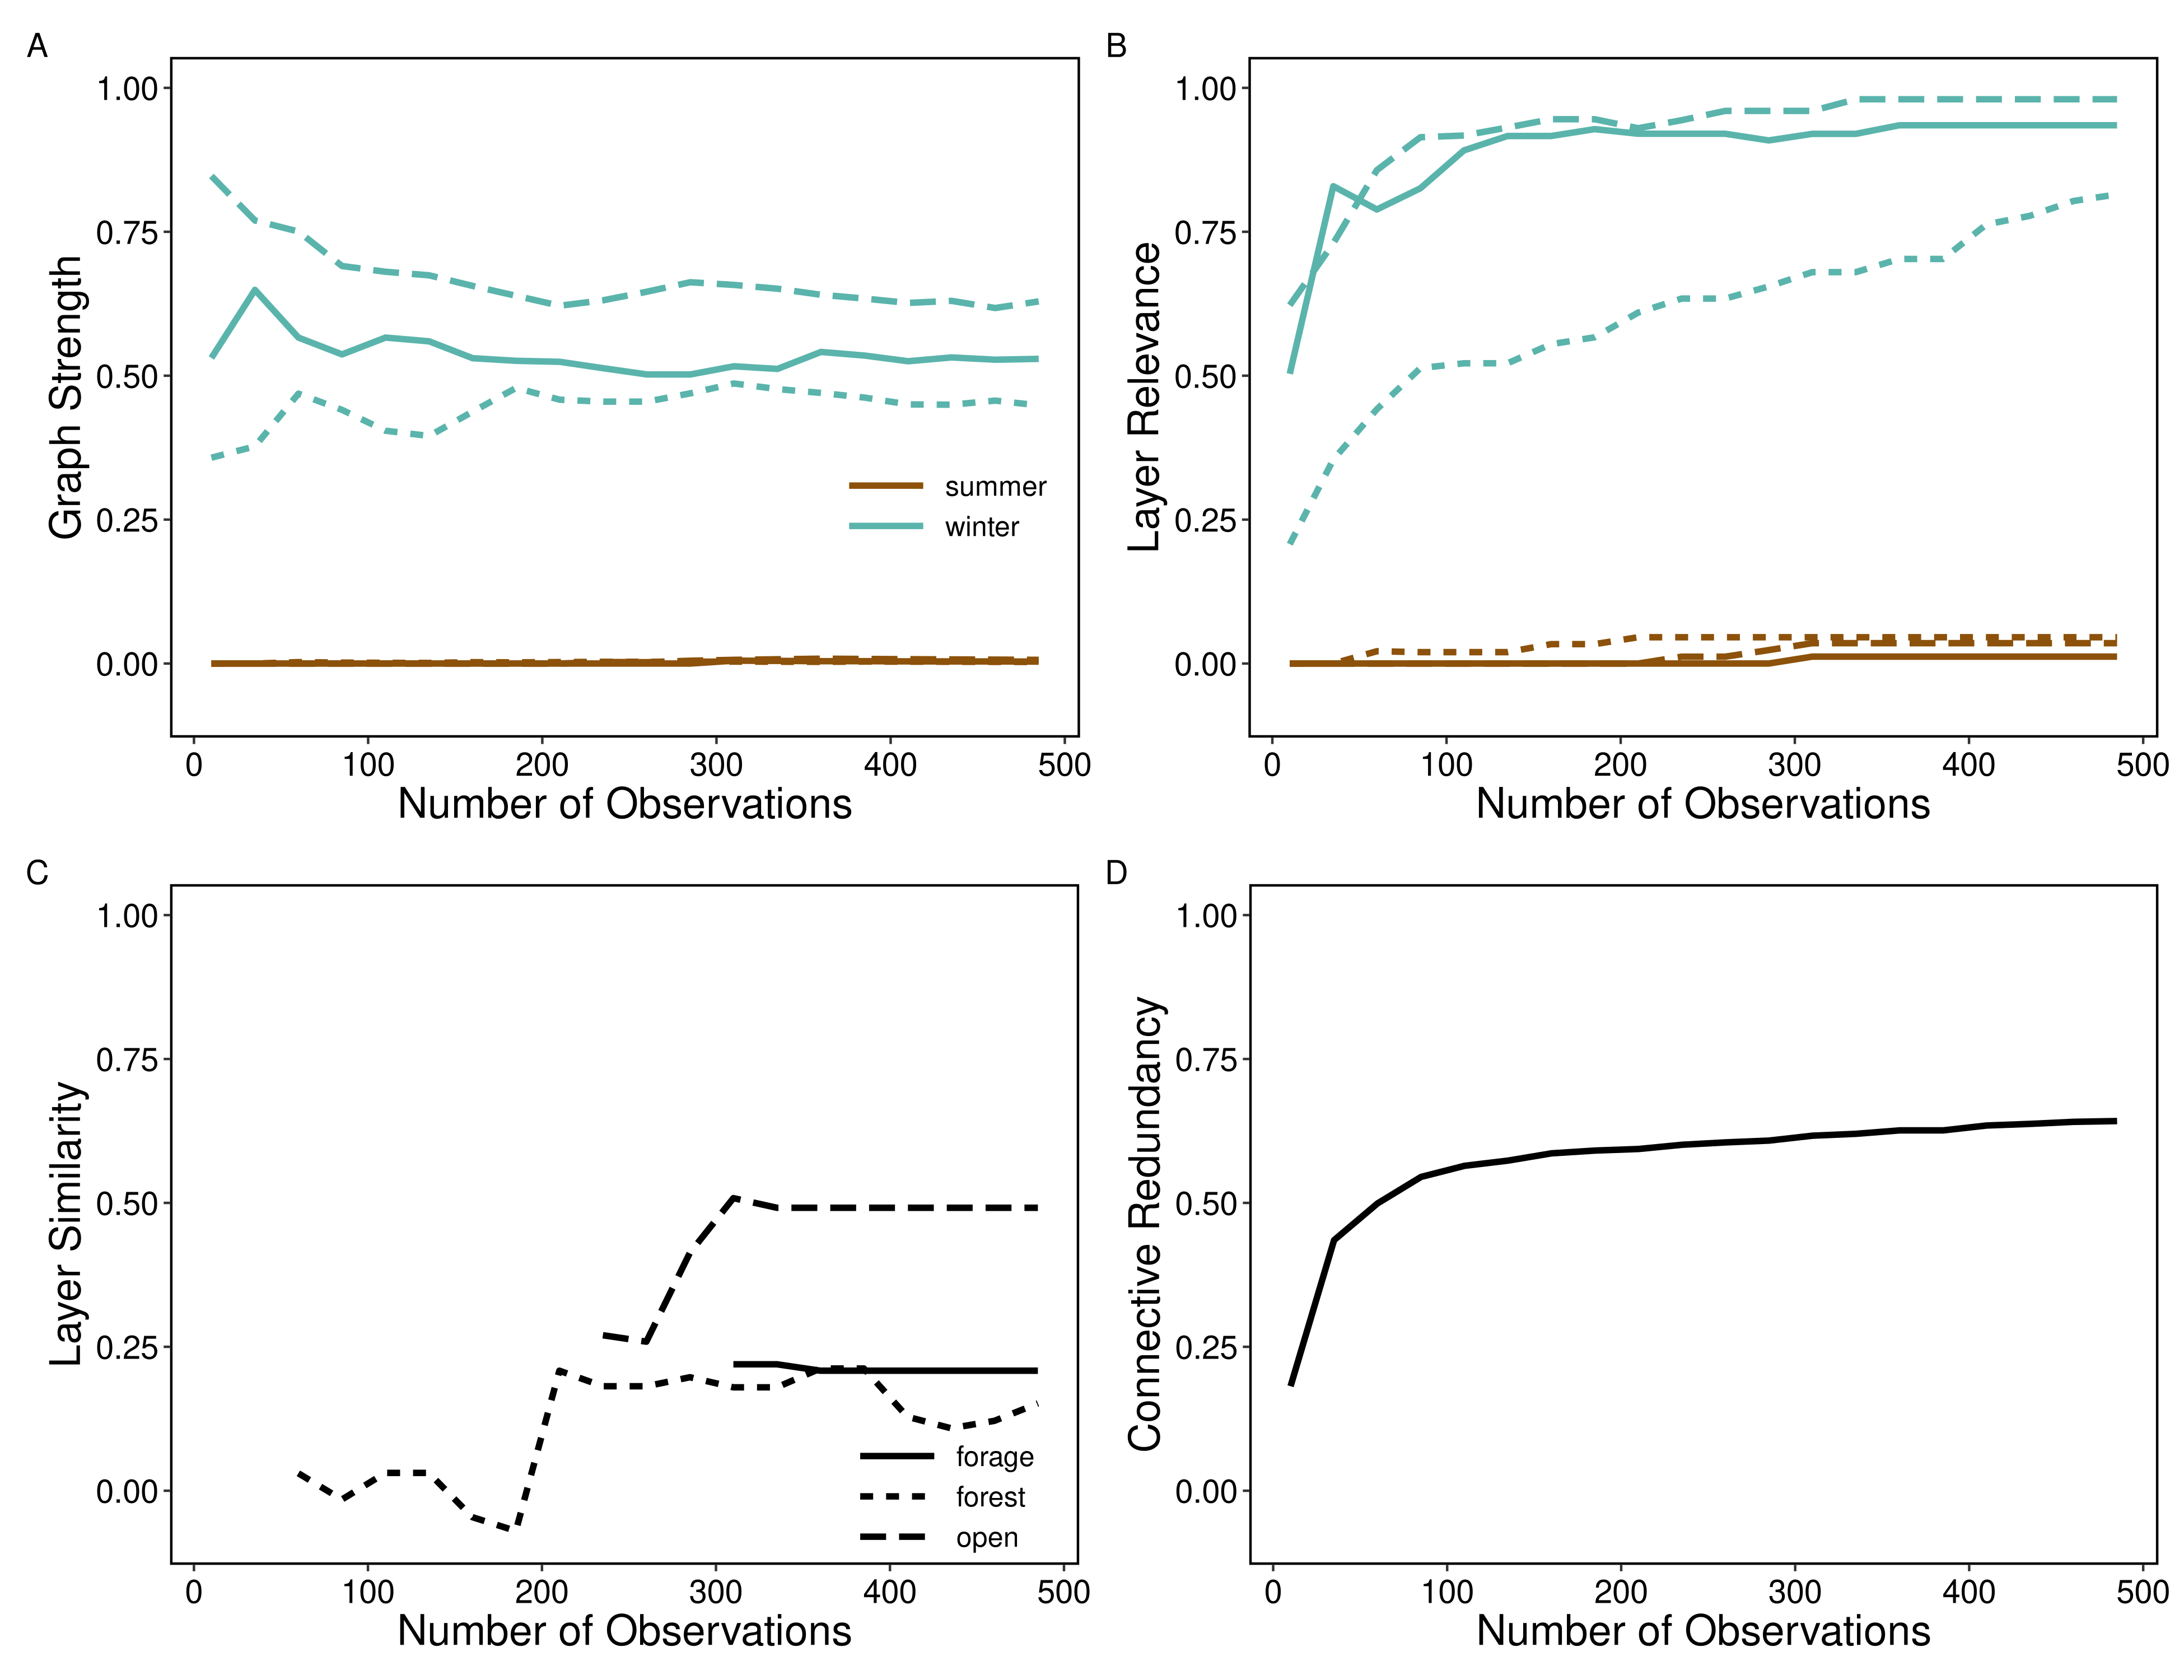

Figure 4: Varying scale in number of observations. For each iteration, a number of observations (10-485 observations in steps of 25) were selected from the complete data set to construct multilayer networks with layers defined by each landcover class (forest, lichen and open) across two seasons (summer and winter) and four network metrics calculated. A) Mean graph strength across individuals varied for winter layers becoming relatively stable at 200 observations and remained weak throughout for summer layers. B) Mean layer relevance across individuals increased for winter layers and slightly increased for summer layers. C) Similarity of landcover network layers between seasons (e.g.: open summer compared to open winter) showed a stabilizing layer similarity at 200 observations for forest and 300 observations for lichen and open. D) Mean connective redundancy across individuals increased with increasing number of observations, which begins to plateau around 100 observations.

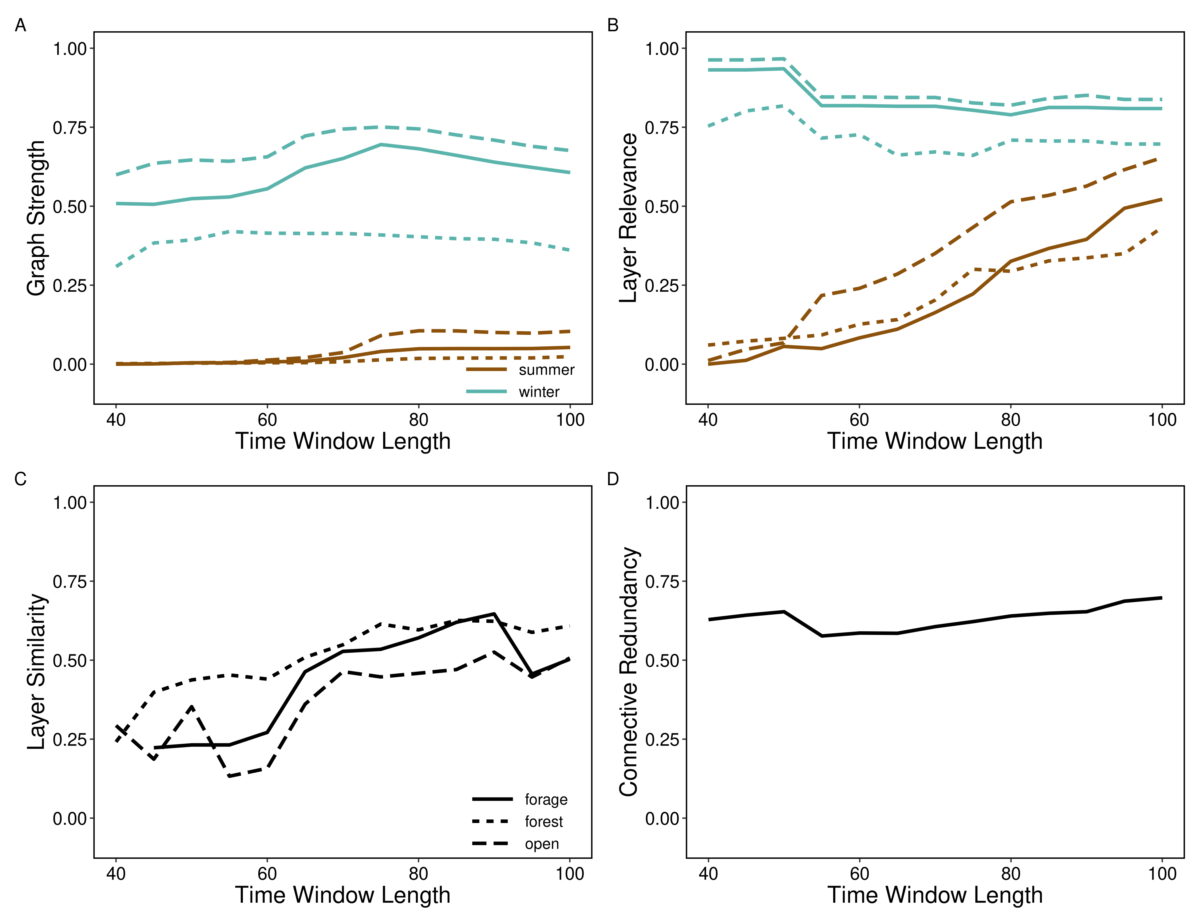

Figure 5: Varying scale in time window length. For each time window length (40 to 100 days in length increasing by 5 days in sequence), multilayer networks were constructed for each landcover class (forest, lichen and open) across two seasons (summer and winter) and four network metrics calculated. A) Mean graph strength across individuals was relatively stable over increasing time window lengths, though there was more variation in strength between landcover types as window length increased. B) Mean layer relevance generally increased during the summer months but was relatively stable across time window lengths for each landcover layer. C) Similarity of landcover network layers between seasons (e.g.: open summer compared to open winter) showed increasing similarity consistent across landcover layers with increasing window length. D) Mean connective redundancy across individuals varied dramatically depending on the length of the time window

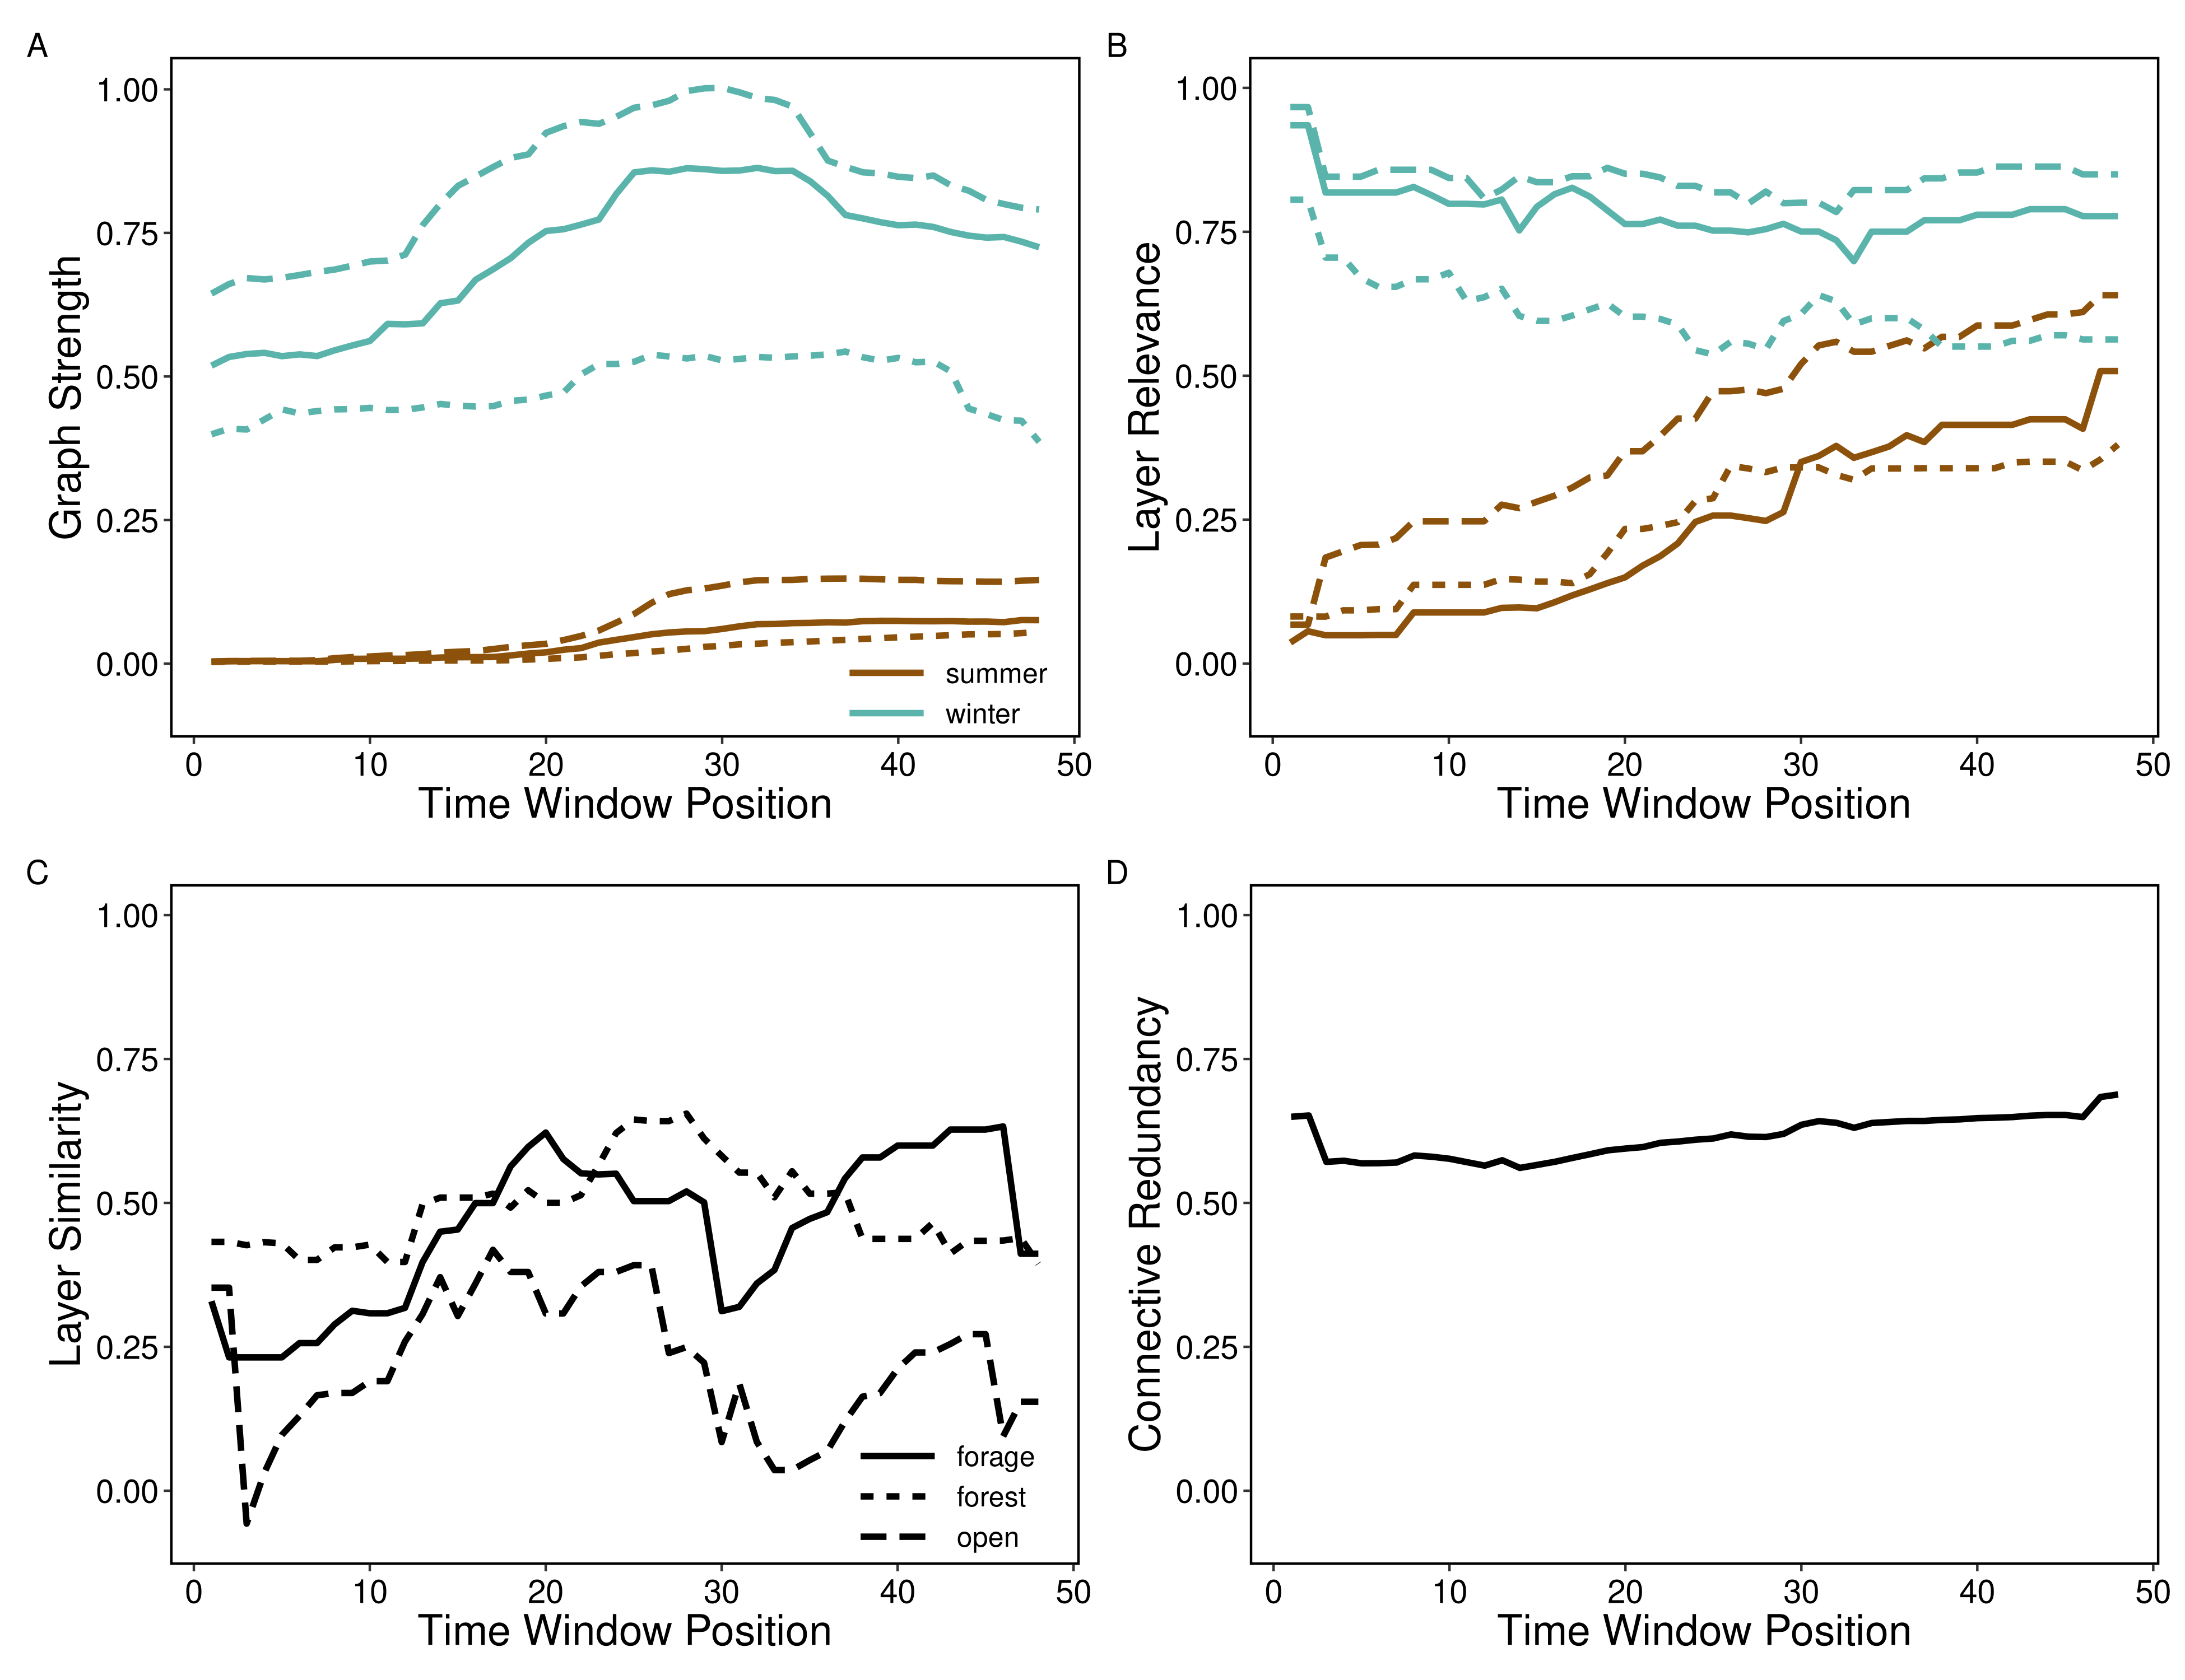

Figure 6: Varying scale in time window position. For each time window position (shifting the start date of the time window used to define seasons 1 to 48 days from the original), multilayer networks were constructed for each landcover class (forest, lichen and ope) across two seasons (summer and winter) and four network metrics calculated. A) Mean graph strength across individuals increased in summer network layers at window position 25 and increased between window position 20 and 40 for winter network layers. B) Mean layer relevance slightly decreased for winter layers and increased for summer layers, showing decreasing connectivity in shifted winter time windows and greater connectivity in summer layers at later window positions. C) Similarity of landcover network layers between seasons (e.g.: open summer compared to open winter) showed fluctuations in layer similarity across landcover types with shifted time windows. D) Mean connective redundancy across individuals increased between window position 12 through 48 due to increased connectivity in the summer network layers.

# Perspectives to advance multilayer networks

The integration of behavioural and ecological theory has shown the value of considering the importance of scale to better understand and predict animal social networks, including demography (Shizuka and Johnson 2019), evolutionary and quantitative genetics (Fisher and McAdam 2017), disease ecology (Silk et al. 2017), and animal personality (Sih et al. 2017). While the number of studies integrating social network theory into a broader array of behavioural and ecological sub-disciplines is impressive, only recently has the role of animal space use been considered in describing the causes and consequences of the social environment in the context of (1) individual fitness and phenotypes (Webber & Vander Wal 2018), (2) movement ecology and collective movement (Bode et al. 2011), and (3) habitat selection and space use (He et al. 2019). Here, we explore how mutlilayer networks may apply to these emerging fields to contribute to the development of social network theory and application.

## Individual fitness and phenotypes

Social network positions are frequently used to represent the social environment that an individual experiences or their social phenotype. Social phenotypes are increasingly linked to important fitness for individuals of various species, including primates (e.g. Brent, Ruiz-Lambides, & Platt, 2017; Thompson, 2019), dolphins (e.g. Stanton & Mann, 2012; Stanton, Gibson, & Mann, 2011), and birds (e.g. McDonald, 2007; Royle, Pike, Heeb, Richner, & Kolliker, 2012). Both temporal, seasons and stages of life, and social scales, types of interactions, have emerged as important for understanding fitness consequences in the context of social network positions (Almeling, Hammerschmidt, Sennhenn-Reulen, Freund, & Fischer, 2016; Berger, Lemaître, Allainé, Gaillard, & Cohas, 2015; Brent, Ruiz-Lambides, & Platt, 2017; Holekamp, Smith, Strelioff, Van Horn, & Watts, 2012). Multilayer networks provide a way to bridge these different scales so that we can examine social phenotypes in more holistic ways rather than looking at each scale separately as has traditionally been done.

For instance, social scale is major consideration for social network analysis, especially in the context of different types of relationships, such as grooming and association, that are typically examined separately while answering a single question (Carter, Lee, & Marshall, 2015; Castles et al., 2014; Farine, 2015). Furthermore, it is a common trope that individuals must be associating to interact, and many studies therefore assume that proximity is proxy for interacting (Farine, 2015). For instance, baboons need to be in proximity in order to groom each other. However, animals have certain interactions that do not require proximity such as long-distance vocalization and olfactory signals (Carter et al., 2015). With the advancement of biologging technology, we have the ability to record social interactions that do not require proximity, particularly long-distance communication networks with devices like microphone arrays (Snijders & Naguib, 2017). These varying social scales can have different fitness repercussions for individuals. Rhesus macaques (*Macaca mulatta*) had higher survivorship when they had fewer but stronger, more stable social associates and grooming partners rather than simply more associates (Ellis, Snyder-Mackler, Ruiz-Lambides, Platt, & Brent, 2019). This finding highlights that different qualities of social scales have lasting consequences.

Temporal scale is also important for understanding the repercussions of social phenotypes. For instance, social phenotypes can change over ontogeny in ways that can affect fitness (Berger et al., 2015; Brent et al., 2017). Thus, it is critical to carefully consider the temporal scale that is meaningful for the proposed hypotheses. Further complicating the issue of selecting suitable time scales across ontogeny, individuals progress through development at different rates (Tarka, Guenther, Niemelä, Nakagawa, & Noble, 2018). This variation can make defining appropriate temporal scales for testing the fitness implications of an individual’s social phenotype over different stages of ontogeny even more difficult when they vary by individual. However, considering fine temporal scales provide insight across developmental stages that may otherwise be missed (Turner, Bills, & Holekamp, 2018).

Multilayer networks provide unique opportunities and challenges, linking these various scales, for understanding the social phenotypes and environments of individuals and their fitness outcomes. The multilayer network framework enables researchers to examine these different social scales simultaneously rather than individually, which is what has been done under most circumstances, but is not very realistic. Metrics from multilayer networks provide an opportunity to simplify statistical models. Interactions that happen side-by-side, proximity associations, and long-distance interactions can be encapsulated in a single multilayer network, and a single metric can be used to describe the various social scales of an individual’s network position. This multilevel network metric could be used to assess the relationship between an individual’s social phenotype and fitness. It would also be a meaningful simplification of many network metrics that could help simplify statistical analyses and deal with the frequent correlations between social network metrics in different types of networks (Castles et al., 2014). Furthermore, multilayer networks provide a framework to test hypotheses linking social phenotypes and fitness across temporal scales. Because of the non-independent nature of social interactions and associations, especially over time, it is hard to test hypotheses about social dynamics with a suitable null control (Farine, 2017; Proskurnikov & Tempo, 2017). Using the framework of multilayer networks, making layers of different temporal periods provides a way to make appropriate null models to test questions about the dynamics of an individual’s social network position over multiple aggregated time periods.

On the other hand, picking the proper temporal scale is important but a challenge because all layers in the multilayer network should reflect the same time period, and the period should be long enough for each layer to have enough data for robust networks (Farine, 2017). These considerations may be limiting factors when answering questions that require timeframes that are relevant to different individuals, for instance. In both mono- and multilayer networks, the effect of scale on the relationship between an individual’s social network position and fitness need to be considered based on the hypotheses being tested and logistical constraints.

## Movement ecology and collective movement

Animal movement undoubtedly affects an individual’s social environment (**???**). Movement is a dynamic process that is related to the resources an individual consumes within their home range and the space that they use (Van Moorter et al. 2016). Collective movement can reduce group-level predation via detection-dilution trade-offs and improve information transfer about the quality or location of resources to other group members (Jolles et al. 2019). Social processes, movement decisions, and space use are inextricably linked and multilayer networks represent a potential analytical framework for linking these processes (e.g. Mourier et al. 2019).

Although multilayer animal social networks are relatively novel (Silk et al. 2018), movement behaviour within multilayer networks has already been considered in a couple studies. In vulturine gunieafowl (*Acryllium vulturinum*), GPS movement data were used to generate *monolayer* association networks within a multilayer network (Papageorgiou et al. 2019). In addition, *spatial networks* are physical locations (nodes) which are connected in a network when individuals move between said locations (edges). For example, spatial networks were applied to monitor movement of sharks (*Carcharhinus amblyrhynchos* and *Carcharhinus melanopterus*) between fixed location autonomous arrays. In this example, nodes represent locations within the array, *intralayer edges* represent individual movement frequency, and *interlayer edges* represent contact probability among individuals at a given node (Mourier et al. 2019). While both studies integrate movement in some capacity, neither generate networks based on continuous measures of dyadic or collective movement (Long et al. 2014).

In contrast to spatial networks, where nodes represent spatial locations that are fixed in space, movement networks can represent continuous and simultaneous movement trajectories of multiple animals. Continuous collection of animal relocation data using GPS technology can be used to measure how groups of animals make collective movement decisions in the context of their local environment (Strandburg-Peshkin et al. 2015, 2017) and across scales. A collective movement layer could constitute similarity in movement for dyads (Long et al. 2014) or groups (Bode et al. 2011). This movement layer could be made at a fine (i.e. minute-to-minute: Cleasby et al. 2019) or coarse scale (global migration: Flack et al. 2018). Another potential application would be to generate social networks during times when animals are engaged in different behaviours, including traveling, interacting, or foraging (e.g. Muller et al. 2018; Finn et al. 2019) and construct a multilayer network based on behaviour-specific monolayer networks (e.g. Smith-Aguilar et al. 2019). Importantly, the key to incorporating movement in multilayer networks across scales is the technological advancements available to overcome previous limitations (see Hughey et al. 2018).

Given the existing framework for constructing multilayer networks from behavioural layers (e.g. Smith-Aguilar et al. 2019), movement layers could be integrated with interaction or association layers. Integrating movement layers with habitat-specific social association layers could further shed light on the role of movement as a driver of the social and spatial environments an individual experiences (Webber and Vander Wal 2018). In our case study, we generated multilayer networks based on habitat-specific monolayers. Coordinated movement of dyads, or groups, could vary based on habitat, and the approach we outline could be used to explore mechanisms linking the social and spatial environments. For example, social processes may be an emergent property of the landscape because animals aggregate at resources, such as waterholes (Chamaillé-Jammes et al. 2008). Movement to, from, or within habitat patches or territories can also contribute to the formation of the social environment (Spiegel et al. 2016). For example, in sleepy lizards (*Tiliqua rugosa*) males interacted primarily at home range edges, presumably driving territorial behaviour (Spiegel et al. 2018). Incorporating movement ecology within a multilayer network framework is a logical next step for a burgeoning field. In particular, when association networks are habitat-specific, we suggest the integration of movement and space use in multilayer networks provides novel insights into the effects of habitat configuration on the formation of the social environment (He et al. 2019).

## Habitat selection and space use

Social structure is influenced by large scale processes such as resource availability and seasonality (**???**), configuration (**???**) and fragmentation (**???**). Habitat selection is the “disproportionate use of available” (Mayor et al. 2009) landscape resources or features by animals. Johnson (1980) identified four orders of habitat selection: (1) the geographical range of a species, (2) the home range of an individual, (3) the habitat patches within the home range and (4) specific resources within a habitat patch. Combined, habitat selection and social structure are intimately linked as individuals must share space to interact (Farine and Whitehead 2015) and resource availability and quality influence home range size and overlap. Multilayer networks represent a novel framework for considering the influence of habitat selection and space use on sociality across scales.

Despite not in a multilayer network context, the link between habitat and sociality has been previously investigated. Fortin et al. (2009) evaluated habitat selection and group formation and division in bison. They observed contrasting group sizes in meadows and forests as well as identified predation risk avoidance as a main factor in their habitat selection (**???**). A review of the influence of habitat fragmentation on sociality noted decreased group size in small patches compared to large, continuous landscapes (**???**). Finally, McLoughlin (2000) showed variable responses in brown bears (*Ursus arctos*) to seasonality, a proxy in this case for habitat quality, showing high home range overlap in areas of low and high seasonality and low home range overlap in areas of moderate seasonality. Despite these, *missing multilayer approach*.

Scale in habitat selection… Mayor (2019)

How to combine moving forward: habitat selection, space use, multiple scales, multilayer networks Sociality across scales eg home range overlap and interactions Layers defined by habitat/landcover

# Conclusions

Silk et al. (2018) presented some key multilayer questions in animal behaviour research. While these questions represent an important starting point for multilayer networks, we present an additional set of questions relevant to the promise and problem of scale in mutlilayer networks:

1. How do social phenotypes across scales differently influence fitness? Are some temporal or social scales better predictors for different fitness metrics?
2. Why do individuals associate more strongly with certain conspecifics in some habitats? What, if any, is the role of movement in the context of habitat networks?
3. How, and why, does the spatial scale of perception influence, e.g. auditory, visual, or chemotaxis, influence the social environment across scales? What is the role of memory, and by extension social and spatial cognition, as animals navigate their environment and make decisions about where to move next?

# Acknowledgements

We thank all members of the Wildlife Evolutionary Ecology Lab, including J. Hendrix, K. Kingdon, S. Boyle, C. Prokopenko, I. Richmond, J. Hogg, and L. Newediuk for their comments on previous versions of this manuscript as well as D. C. Schneider for inspiration and helpful discussions about scale. Funding for this study was provided by a Vanier Canada Graduate Scholarship to QMRW and a NSERC Discovery Grant to EVW.

# References

Allen, Timothy F. H., and Thomas W. Hoekstra. 2015. *Toward a Unified Ecology*. Columbia University Press. <https://doi.org/10.7312/alle06918>.

Berlingerio, Michele, Michele Coscia, Fosca Giannotti, Anna Monreale, and Dino Pedreschi. 2012. “Multidimensional Networks: Foundations of Structural Analysis.” *World Wide Web* 16 (5-6): 567–93. <https://doi.org/10.1007/s11280-012-0190-4>.

Br’odka, Piotr, Anna Chmiel, Matteo Magnani, and Giancarlo Ragozini. 2018. “Quantifying Layer Similarity in Multiplex Networks: A Systematic Study.” *Royal Society Open Science* 5 (8): 171747. <https://doi.org/10.1098/rsos.171747>.

Chave, J’erôme. 2013. “The Problem of Pattern and Scale in Ecology: What Have We Learned in 20 Years?” Edited by Jordi Bascompte. *Ecology Letters* 16 (January): 4–16. <https://doi.org/10.1111/ele.12048>.

Elith, Jane, and John R. Leathwick. 2009. “Species Distribution Models: Ecological Explanation and Prediction Across Space and Time.” *Annual Review of Ecology, Evolution, and Systematics* 40 (1): 677–97. <https://doi.org/10.1146/annurev.ecolsys.110308.120159>.

Farine, Damien R., and Hal Whitehead. 2015. “Constructing, Conducting and Interpreting Animal Social Network Analysis.” Edited by Sonia Altizer. *Journal of Animal Ecology* 84 (5): 1144–63. <https://doi.org/10.1111/1365-2656.12418>.

Field, Richard, Bradford A. Hawkins, Howard V. Cornell, David J. Currie, J. Alexandre F. Diniz-Filho, Jean-François Gu’egan, Dawn M. Kaufman, et al. 2009. “Spatial Species-Richness Gradients Across Scales: A Meta-Analysis.” *Journal of Biogeography* 36 (1): 132–47. <https://doi.org/10.1111/j.1365-2699.2008.01963.x>.

Graham, Laura. 2019. *Grainchanger: Moving-Window and Direct Data Aggregation*. <https://github.com/ropensci/grainchanger>.

Graham, Laura J., Rebecca Spake, Simon Gillings, Kevin Watts, and Felix Eigenbrod. 2019. “Incorporating Fine-Scale Environmental Heterogeneity into Broad-Extent Models.” Edited by Nick Isaac. *Methods in Ecology and Evolution* 10 (6): 767–78. <https://doi.org/10.1111/2041-210x.13177>.

Hijmans, Robert J. 2019. *Raster: Geographic Data Analysis and Modeling*. <https://CRAN.R-project.org/package=raster>.

Kivela, M., A. Arenas, M. Barthelemy, J. P. Gleeson, Y. Moreno, and M. A. Porter. 2014. “Multilayer Networks.” *Journal of Complex Networks* 2 (3): 203–71. <https://doi.org/10.1093/comnet/cnu016>.

Legendre, Pierre. 1993. “Spatial Autocorrelation: Trouble or New Paradigm?” *Ecology* 74 (6): 1659–73. <https://doi.org/10.2307/1939924>.

Lesmerises, Fr’ed’eric, Chris J. Johnson, and Martin-Hugues St-Laurent. 2018. “Landscape Knowledge Is an Important Driver of the Fission Dynamics of an Alpine Ungulate.” *Animal Behaviour* 140 (June): 39–47. <https://doi.org/10.1016/j.anbehav.2018.03.014>.

Levin, Simon A. 1992. “The Problem of Pattern and Scale in Ecology: The Robert H. MacArthur Award Lecture.” *Ecology* 73 (6): 1943–67. <https://doi.org/10.2307/1941447>.

Luther, David. 2009. “The Influence of the Acoustic Community on Songs of Birds in a Neotropical Rain Forest.” *Behavioral Ecology* 20 (4): 864–71. <https://doi.org/10.1093/beheco/arp074>.

Mayor, S. J., J. A. Schaefer, D. C. Schneider, and S. P. Mahoney. 2007. “SPECTRUM OF SELECTION: NEW APPROACHES TO DETECTING THE SCALE-DEPENDENT RESPONSE TO HABITAT.” *Ecology* 88 (7): 1634–40. <https://doi.org/10.1890/06-1672.1>.

Mayor, Stephen J., David C. Schneider, James A. Schaefer, and Shane P. Mahoney. 2009. “Habitat Selection at Multiple Scales.” *Écoscience* 16 (2): 238–47. <https://doi.org/10.2980/16-2-3238>.

Peignier, M’elissa, Quinn M. R. Webber, Erin L. Koen, Michel P. Laforge, Alec L. Robitaille, and Eric Vander Wal. 2019. “Space Use and Social Association in a Gregarious Ungulate: Testing the Conspecific Attraction and Resource Dispersion Hypotheses.” *Ecology and Evolution* 9 (9): 5133–45. <https://doi.org/10.1002/ece3.5071>.

R Core Team. 2019. *R: A Language and Environment for Statistical Computing*. Vienna, Austria: R Foundation for Statistical Computing. <https://www.R-project.org/>.

Robitaille, Alec L., Quinn M. R. Webber, and Eric Vander Wal. 2019. “Conducting Social Network Analysis with Animal Telemetry Data: Applications and Methods Using Spatsoc.” Edited by Nick Golding. *Methods in Ecology and Evolution* 10 (8): 1203–11. <https://doi.org/10.1111/2041-210x.13215>.

Sugihara, G, K Schoenly, and A Trombla. 1989. “Scale Invariance in Food Web Properties.” *Science* 245 (4913): 48–52. <https://doi.org/10.1126/science.2740915>.