spatsoc paper 2
Alec L. Robitaille
Quinn M. R. Webber
Eric Vander Wal
2024-11-22
Abstract
- Beyond social networks, dyadic measures
- Extending social networks derived from GPS using detailed dyadic measures beyond rates of association
- Linking social processes to spatial/geography environment, hint at selection
- Expanding spatsoc to version N by including important and unavailable methods in R

1. Introduction
Many facets of group living need to be measured to better interpret understand animal social systems (King et al 2018). There are additional types of dyadic relationships including genetic, affiliative, agonistic, and cooperative (Farine and Whitehead 2015). There are also interactions between spatial and social phenotypes and environments (Webber et al 2023). Using direct observations, researchers have studied intragroup social dynamics including social foraging (Barnard 1981, Giraldeau 1986, Hirsch 2020), spatial position within groups (Krause 1994, Monus 2008) and the influence of individual traits such as age, sex and dominance (Furuichi 1983, King 2009, Teichroeb 2015). Unfortunately, direct observations can be labor-intensive to collect and susceptible to observer bias (Smith 2021), with low spatial and temporal resolution making them imperfect for studies of collective movement (King 2011).
There are expanded opportunities to understand animal social systems by pairing advances in remote tracking technology with emerging approaches to measuring intragroup social dynamics. The availability and resolution of remote tracking data continues to improve (Kays 2015, Nathan 2022, Kays 2022). There are over two decades of research on measuring the interaction between moving individuals from the study of “moving point objects” in GISciences (Laube 2002, Dodge 2008, Andersson 2008) to group coordination of moving groups (Couzin 2002, Herbert-Read 2011) and leadership and decision making (Nagy 2010, King 2011, Strandburg-Peshkin 2015). Despite this, we suggest the availability of open source tools (Hampton 2015, Wilson 2017, Powers 2019) is the missing piece between the call to integrate technology enhanced research with multidisciplinary approaches to better understand animal social systems. (King 2023, Couzin 2023).
Here we present N (~11) new functions for the R package {spatsoc} (Robitaille et al. 2019) for measuring intragroup dynamics. We conducted a scoping review to identify metrics applicable to spatiotemporal data used in ecological studies focused on dyadic interactions, dominance hierarchies and leadership patterns (Sup A, B). Of the resulting metrics, we selected those with a high number of citations (as a measure of value for the target audience) and unavailability in the R programming language, either through R packages or supplemental materials in the literature. We will demonstrate these new functions through a case study and discuss biological interpretation.

2. Methods

2.1 Selecting metrics
TODO

2.2 Directional correlation delay
The directional correlation delay (Nagy et al. 2010) of individuals i, j is
$$C_{ij}={\left[\vec{v_{i}}\left(t\right)*\vec{j}\left(t+τ\right)\right]}_{t}$$
where
- $\vec{v_{i}}\left(t\right)$ is the normalized velocity of bird i at time t
- $\vec{v_{j}}\left(t+τ\right)$ is the normalized velocity of bird j at time t + $τ$
- Note that $C_{ij}\left(τ\right)$ = $C_{ji}\left(−τ\right)$
- Calculated only where pairs of individuals were less than 100 m apart
The maximum value of the directional correlation function $C_{ij}$ is at $C_{ij}\left(τ_{ij}^{*}\right)$ where $τ_{ij}^{*}$ is the directional correlation delay time. $τ_{ij}^{*}$ values focus on the relationship in pairs of individuals, ignoring hierarchy changes caused by other individuals.
- Note that $τ_{ij}^{*}$ = $−τ_{ji}^{*}$
- Negative values indicate that flight directional changes of bird i fall behind that of bird j and therefore j is leading
Hierarchical networks can be generated using $τ_{ij}^{*}$

2.3 Position within group, rank position within group, time spent leading group, distance and direction to leader
The position within group is the position along the front-to-back axis of the group’s bearing (eg. (Quera_2023?; Harel_2021?)). The rank position within group is the ordinal rank along the front-to-back axis of the group’s bearing (eg. (Burns_2012?)). The time spent leading group is an aggregate metric of the time in the first rank position within group. The distance to leader is the geographic distance to the focal individual’s group leader. The direction to leader is the absolute bearing to the focal individual’s group leader.

2.4 Distance, direction and rank distance to group centroid
The group centroid is the mean of individual locations in a group. The distance to group centroid is the distance between an individual’s location and the group centroid. The direction to group centroid is the absolute bearing from an individual’s location and the group centroid. The rank distance to group centroid is the ordinal rank of individuals’ distances from the group centroid.

2.5 Polarization, directional alignment and interindividual direction
Polarization measures the uniformity of bearings in a group of individuals (Wang_2022?) on a scale of 0-1 where values near 0 indicate that bearings point in different directions and values near 1 indicate that bearings point in similar directions.
# Random bearings (radians)
h <- runif(25, 0, 2 * pi)
library(swaRm)
pol_order(h)
[1] 0.2402522
library(CircStats)
r.test(h)
$r.bar
[1] 0.2402522
$p.value
[1] 0.2381767
# Also interesting
circ.range(h)
range
1 5.290424
Directional alignment measures the pairwise differences in bearing between individuals. Interindividual direction measures the pairwise bearings between individual locations.

2.6 Behavioural zones
The behavioural zones metric metric assigns neighbours to three non-overlapping behavioural zones [Couzin_2002]. The “zone of repulsion” is the minimum distance around an individual within which neighbours are expected to move away to avoid collisions. The “zone of orientation” is the next zone around an individual beyond the “zone of repulsion” within which neighbours are expected to orient themselves to the movement of their neighbours. The “zone of attraction” is the last zone around an individual within which neighbours are expected to be attracted to the position of the focal individual. Notably, there is a possibly “blind volume” behind the individual representing the limits of their perception.
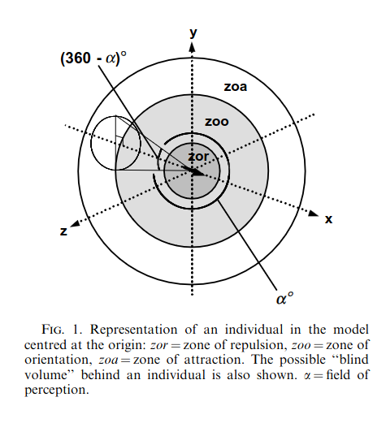
Figure from Couzin et al 2002

2.7 Fission fusion
Given the variability in defining fission fusion dynamics in the literature (Supplement B), we developed a flexible function that allows users to both use their system specific definitions and at the same time easily compare to results to other definitions.
Arguments:
- Minimum run length indicating the number of successive fixes that are required to establish a fusion event
- Maximum missed observations indicating the number of allowable missed observations for either individual in a dyad within a fission event
- Threshold distance to define a fusion event

3. Case study
Functionality previously available in {spatsoc} includes spatiotemporal grouping, edge list generation and data-stream permutations (Robitaille et al. 2019). These functions have allowed users to detect interactions between individuals, measure coocurrence within and across species, and generate social networks from telemetry data. (TODO: cite examples citing spatsoc)
Spatiotemporal grouping can be performed given a telemetry dataset, temporal and spatial thresholds, and one of three grouping functions: group_pts, group_lines or group_polys. Each return a unique identifier for each spatiotemporal group, defined using point based distances, linear trajectory overlap or home range overlap, respectively.
For example, the suggested group_pts workflow with example data from the package:
# Load packages
library(data.table)
library(spatsoc)
# Read example data
DT <- fread(system.file("extdata", "DT.csv", package = "spatsoc"))
# Cast the character column to POSIXct
DT[, datetime := as.POSIXct(datetime, tz = 'UTC')]
# Set variables
temporal_threshold <- '20 minutes'
spatial_threshold <- 50
id <- 'ID'
coords <- c('X', 'Y')
# Temporal grouping
group_times(DT, datetime = 'datetime', threshold = temporal_threshold)
# Spatial grouping with timegroup
group_pts(DT, threshold = spatial_threshold, id = id,
coords = coords, timegroup = 'timegroup')
ID | X | Y | datetime | population | minutes | timegroup | group
A | 715851.4 | 5505340 | 2016-11-01 00:00:54 | 1 | 0 | 1 | 1
B | 699640.2 | 5509638 | 2016-11-01 00:01:02 | 1 | 0 | 1 | 2
C | 710205.4 | 5505888 | 2016-11-01 00:00:44 | 1 | 0 | 1 | 3
D | 700875.0 | 5490954 | 2016-11-01 00:00:47 | 1 | 0 | 1 | 4
E | 701671.9 | 5504286 | 2016-11-01 00:00:48 | 1 | 0 | 1 | 5
Users can also measure dyadic interindividual distance using the edge_dist function and identify nearest neighbors using the edge_nn function. For example:
interindividual_dist <- edge_dist(
DT,
threshold = spatial_threshold,
id = id,
coords = coords,
timegroup = 'timegroup',
returnDist = TRUE,
fillNA = TRUE
)
timegroup | ID1 | ID2 | distance
1 | A | NA | NA
1 | B | G | 5.782904
1 | C | NA | NA
1 | D | NA | NA
1 | E | NA | NA
nearest_neighbours <- edge_nn(
DT,
id = id,
coords = coords,
timegroup = 'timegroup',
returnDist = TRUE
)
timegroup | ID | NN | distance
1 | A | I | 4921.397041
1 | B | G | 5.782904
1 | C | I | 972.464226
1 | D | J | 11581.941376
1 | E | H | 65.061671
Building on these functions, {spatsoc}’s new functionality provides a finer understanding of an individual’s behaviour with respect to conspecifics. We aim to provide users with accessible, flexible functions that will help them identify leader follower patterns, fission fusion dynamics and potentially dominance behaviours in their own animal telemetry data.

3.1 Position within groups
Extending {spatsoc}’s abilities to identify spatiotemporal groups, a new set of functions are now available to measure individuals position relative within spatiotemporal groups.
After identifying spatiotemporal groups with eg. group_pts, we can measure the group centroid. The group centroid is defined as the the mean of individual locations in a group.
group_centroid(DT, coords = coords)
ID | X | Y | datetime | timegroup | group | group_mean_X | group_mean_Y
A | 715851.4 | 5505340 | 2016-11-01 00:00:54 | 1 | 1 | 715851.4 | 5505340
B | 699640.2 | 5509638 | 2016-11-01 00:01:02 | 1 | 2 | 699637.9 | 5509637
C | 710205.4 | 5505888 | 2016-11-01 00:00:44 | 1 | 3 | 710205.4 | 5505888
D | 700875.0 | 5490954 | 2016-11-01 00:00:47 | 1 | 4 | 700875.0 | 5490954
E | 701671.9 | 5504286 | 2016-11-01 00:00:48 | 1 | 5 | 701671.9 | 5504286
Then we can measure each individual’s direction and distance to the group centroid. The distance to group centroid is the distance between from the focal individual to the group centroid. The direction to group centroid is the absolute azimuth from the focal individual to the group centroid. The rank distance to group centroid is the ordinal rank of individuals’ distances to the group centroid.
distance_to_group_centroid(DT, coords, return_rank = TRUE)
bearing_to_group_centroid(DT, coords)
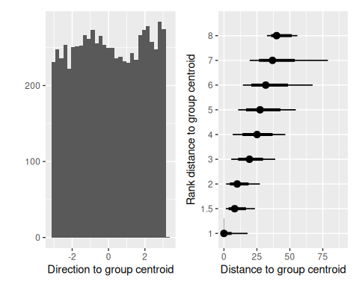
After considering how individuals are positioned relative to the group centroid, we can also measure how individuals are positioned relative to the mean group direction. To do so, we rotate the coordinate system around the group centroid by the mean bearing of all individuals in the group. Then we take the distance along this new axis to the measure of front-back position within the group.
The position within group is the position along the front-to-back axis of the group’s bearing (eg. (Quera_2023?; Harel_2021?)). The rank position within group is the ordinal rank along the front-to-back axis of the group’s bearing (eg. (Burns_2012?)). The time spent leading group is an aggregate metric of the time in the first rank position within group. The distance to leader is the geographic distance from the focal individual to the group’s leader. The direction to leader is the absolute azimuth from the focal individual to the group’s leader.
projection <- 32636
az(DT, id = id, coords = coords, projection = projection)
position_within_group(DT, coords = coords, return_rank = TRUE)
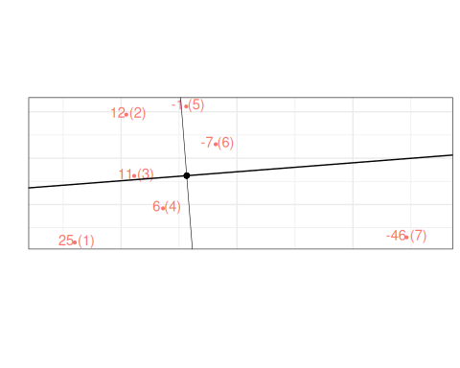
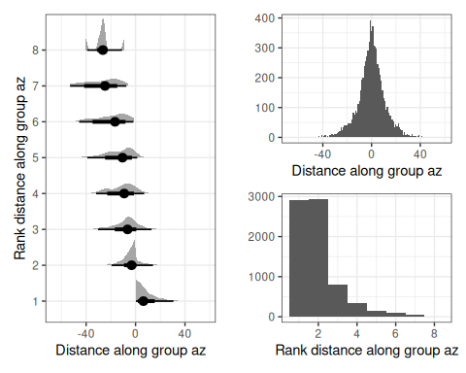

3.2 Position relative to leader
Taking a simple, dynamic definition of leadership, we can identify the distance and direction of each individual to the leader of each spatiotemporal group.
distance_to_leader(DT, coords = coords)
bearing_to_leader(DT, coords = coords)
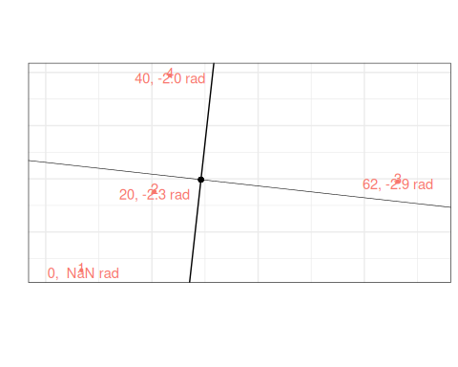
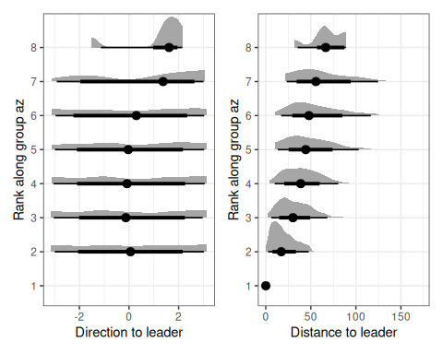

3.3 Fission fusion
Given the variability in defining fission fusion dynamics in the literature, we developed a flexible function that allows users to both use their system specific definitions and at the same time easily compare to results to other definitions.
Function arguments: - threshold: spatial distance threshold to establish a fusion event - n_min_length: the minimum number of successive fixes that are required to establish a fusion event - n_max_missing: the maximum number of allowable missed observations for either individual in a dyad within a fusion event - allow_split: if fusion events allow a temporary spatial splitting for one observation without resulting in a fission event
# Fission fusion events using interinvidiual distance calculated with edge_dist
dyad_id(interindividual_dist, 'ID1', 'ID2')
fusion_events <- fusion_id(
interindividual_dist,
threshold = spatial_threshold,
n_min_length = 0,
n_max_missing = 0,
allow_split = FALSE
)
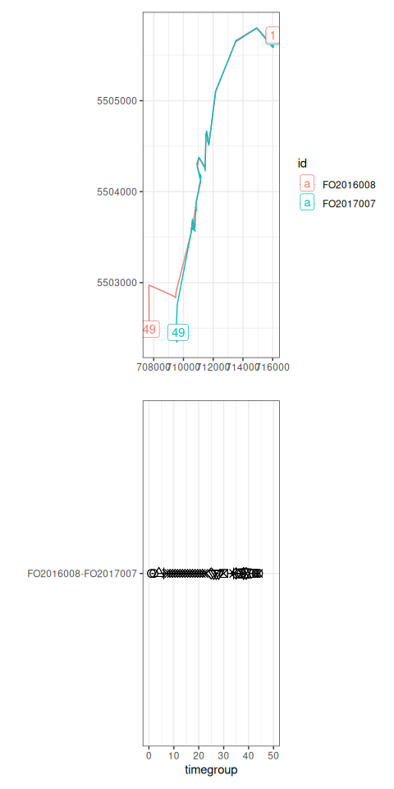

3.4 Bearings
Next, we can use individuals’ bearings to explore interindividual direction, directional alignment and group polarization.
Polarization measures the uniformity of absolute azimuth in a group of individuals (Wang_2022?) on a scale of 0-1 where values near 0 indicate that azimuths point in different directions and values near 1 indicate that azimuths point in similar directions.
# Calculate polarization using azimuth from az_sequential()
bearing_polarization(DT)
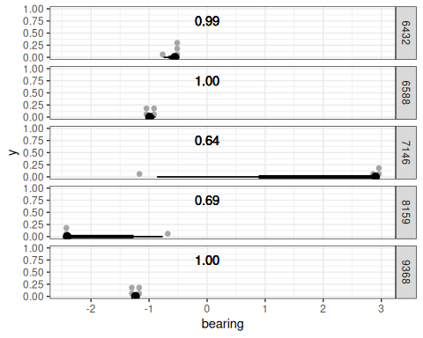
Directional alignment is the relative difference between two individuals’ azimuths. Given the similarity to edge_dist, this functionality is provided under a similar name: edge_az.
directional_align <- edge_az(
DT,
threshold = NULL,
id = id,
timegroup = 'timegroup',
coords = coords,
returnDist = TRUE,
fillNA = TRUE
)
Interindividual direction measures the absolute azimuth between individuals.
(TODO)

3.5 Lagged differences in bearing
The directional correlation delay (Nagy et al. 2010) of individuals i, j is given by
$$C_{ij}={\left[\vec{v_{i}}\left(t\right)*\vec{j}\left(t+τ\right)\right]}_{t}$$
where
- $\vec{v_{i}}\left(t\right)$ is the normalized velocity of individual i at time t
- $\vec{v_{j}}\left(t+τ\right)$ is the normalized velocity of individual j at time t + $τ$
- Note that $C_{ij}\left(τ\right)$ = $C_{ji}\left(−τ\right)$
- Calculated only where pairs of individuals were less than 100 m apart
The maximum value of the directional correlation function $C_{ij}$ is at $C_{ij}\left(τ_{ij}^{*}\right)$ where $τ_{ij}^{*}$ is the directional correlation delay time. $τ_{ij}^{*}$ values focus on the relationship in pairs of individuals, ignoring hierarchy changes caused by other individuals.
- Note that $τ_{ij}^{*}$ = $−τ_{ji}^{*}$
- Negative values indicate that flight directional changes of individual i falls behind that of individual j and therefore j is leading
Hierarchical networks can be generated using $τ_{ij}^{*}$.
# Cast the character column to POSIXct
DT[, datetime := as.POSIXct(datetime, tz = 'UTC')]
# Temporal grouping
DT <- group_times(DT, datetime = 'datetime', threshold = temporal_threshold)
# Interindividual distance with maximum distance threshold set at 50 m
interindividual_dist <- edge_dist(
DT,
threshold = 100,
id = id,
coords = coords,
timegroup = 'timegroup',
returnDist = TRUE,
fillNA = TRUE
)
fusion_events <- fusion_id(
interindividual_dist,
threshold = spatial_threshold,
n_min_length = 0,
n_max_missing = 0,
allow_split = FALSE
)
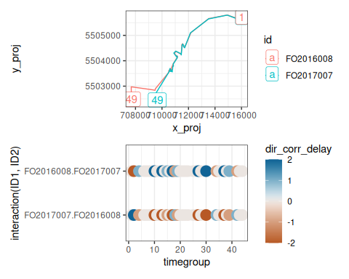

3.6 Behavioural zones
The behavioural zones metric assigns neighbours to three non-overlapping behavioural zones [Couzin_2002]. The “zone of repulsion” is the minimum distance around an individual within which neighbours are expected to move away to avoid collisions. The “zone of orientation” is the next zone around an individual beyond the “zone of repulsion” within which neighbours are expected to orient themselves to the movement of their neighbours. The “zone of attraction” is the farthest zone around an individual within which neighbours are expected to be attracted to the position of the focal individual. Notably, there is a possibly “blind volume” behind the individual representing the limits of their perception.

Figure from Couzin et al 2002
(TODO)

4. Discussion
- social networks, history of spatsoc
- high number of studies in review with IID, NND
Animal social dynamics have broad implications in ecology including resource availability, disease transmission and collective behaviour. Social network analysis can measure the structure of social systems, the consequences of an individual’s position in a network, the spread of disease or information across networks, and the influence of the environment (Farine and Whitehead 2015). Open source tools have been developed to derive social networks from animal telemetry data (Robitaille et al 2019) using aggregated association rates or home range overlap. The methods have been used to measure contact rates to measure social cohesion (Bracken 2021), human-wildlife conflict (Boudreau 2021), socioecology and resource availability (Peignier2019), community structure (Sunga 2021), influence of stress of social proximity (Keshavarzi 2023), social patterns in non-social species (Heeres 2024).

5. Conclusion

Box 1
Producer-scrounger dynamics describe two strategies of social foragers: “producers” are those who discover patches and “scroungers” are those who join patches discovered by others. This concept can be applied to animal telemetry data by evaluating the position of individuals within groups, the individual’s arrival timing to forage patches and characteristics of forage patches. Individuals balance predation risk and foraging success by adjusting their spatial position within groups (Teichroeb 2015, Hirsch 2019), and the foraging strategy selected by an individual can be influenced by the size of forage patches (Hansen 2016).
Leader-follower patterns in groups of moving animals can be studied both to determine factors that causally influence leadership, and for the influence of leader-follower strategies on foraging success and downstream fitness. Applied to animal telemetry, leadership can be defined simply by identifying the individual at the foremost position along the front-to-back axis of the group’s bearing (Quera 2023, Harel 2021). Alternatively, leadership can be identified by calculating the directional correlation delay (Nagy 2010), the temporal delay of shared directional movements between individuals. Leadership in a group of moving animals can inform animal decision making, group coordination, and migratory patterns (Flack 2018, Weesner 2023, Quera 2023, Kano 2021).
Individual traits can influence behaviors related to intragroup dynamics. Dominance is related to foraging success (Caraco 1989, Teichroeb 2015) and choice of foraging strategy (King 2009, Aplin and Morand-Ferron 2017, Lee 2016). Dominant, aggressive, grooming and other interindividual behaviors are typically measured using focal observations. However, some metrics have been developed for remotely estimating dominance behaviors. The directional correlation delay can be used to derive hierarchies of leadership which can be a proxy for dominance relationships in certain species (Flack 2013, Akos 2014). Movement patterns that estimate dominance relationships can be identified from animal telemetry including movement initiations (Amornbunchornvej 2018), approach-avoidance behaviours (Strandburg-Peshkin 2015) and displacement events (Evans 2018).

References
Nagy, Máté, Zsuzsa Ákos, Dora Biro, and Tamás Vicsek. 2010. “Hierarchical Group Dynamics in Pigeon Flocks.” Nature 464 (7290): 890–93. https://doi.org/10.1038/nature08891.
Papageorgiou, Danai, and Damien R. Farine. 2020. “Shared Decision-Making Allows Subordinates to Lead When Dominants Monopolize Resources.” Science Advances 6 (48): eaba5881. https://doi.org/10.1126/sciadv.aba5881.

Supplement A: Scoping Review Methods
We conducted a scoping review to identify metrics used in ecology studies focusing on dyadic interactions, dominance hierarchies and leadership patterns. We focused on metrics applicable to spatiotemporal data such as GPS telemetry. We used two databases of academic literature: Web of Science and Scopus. We established a test list of nine benchmark papers (Supplement A: Table 1) that were relevant to our objectives and verified that each paper was indexed in our selected databases. We used an iterative search method to fine-tune search terms measuring the total number of papers returned and sensitivity of the search. Sensitivity is defined as the proportion of potentially relevant papers returned from the search estimated using the number benchmark papers returned from the test list (Env Evidence 4.2.7). Search terms were established in four categories: topic, population, method and exclusion (Supplement A: Table 2). Topic included terms associated with dyadic interactions, dominance hierarchies and leadership patterns. Population included terms associated with animals, wildlife and ecology. Method included terms associated with data collection and data types. Finally, a list of exclusion terms were used to remove clearly irrelevant papers. Each category of terms were combined with OR operators and all three categories of terms were combined with AND operators. The set of papers used in further steps was the combination of the last iteration of search terms applied to both of the Web of Science (using the “TS” field) and Scopus (using the “TITLE-ABS-KEY” field) databases. Only articles between 1980-2023 were included using the PY (Web of Science) or PUBYEAR (Scopus) fields. The resulting set of references were imported into Covidence (Covidence systematic review software) for deduplication, title and abstract screening, full text screening, and data extraction.
Before screening, articles were marked as duplicates using Covidence and manual screening. Covidence detected N duplicates based on title, year, volume, and authors, and manual screening identified an additional N duplicates.
Articles were screened out based on the following criteria:
- Study does not describe dyadic or group metric related to leadership or dominance (eg. (Papageorgiou and Farine 2020))
- Study describes metric that is not applicable to spatiotemporal data (eg. focal observations (Ballesta_2021?))
- Study does not describe metric beyond static interaction (eg. home range or spatial overlap Carter_2013)
- Study does not describe metric beyond group size (eg. (Delgado_2021?))
- Study full text is not available in English (eg. (Bernard_2002?))
- Study is not a thesis
- Study is not a book chapter (eg. (Bernstein_2019?))
Despite a focus on animal ecology, some studies were discussed movement data more generically or, alternatively, specifically focused on human or robotic movement data (EXAMPLE). These studies were retained when the metrics described were deemed applicable to animal spatiotemporal movement data. Studies using mathematical models or simulations were largely beyond the scope of this review but studies were retained when the parameters used as inputs could be applied to spatial temporal data (eg. (Long_2015?)). Review studies were retained for building the scope of introduction and discussion but not included in data extraction (eg. (Herbert-Read_2016?)).
The goals of data extraction were to record the breadth of dyadic social and dominance metrics applicable to spatiotemporal data, and the degree of code availability. General information about each study was recorded including the type of study (empirical, simulation, algorithm, model, or review), study species and study region. Dyadic social metrics for each study were listed including citations and interpretation for each metric used and data input required. Dominance metrics derived from spatiotemporal data were listed including citations and interpretation. Code availability was described including location of code (eg. Zenodo, or GitHub), programming languages and software packages used.
Metrics identified were aggregated using a manual process to identify synonymous terms. This aggregation process was required due to variability in defining metrics during data extraction, as well as differences between authors in describing metrics (eg. distance to group “center”, “centroid”, or “center of mass”). Each study was geocoded using the {tidygeocoder} package (Cambon_2021?) and species were parsed using the {rgnparser} package (CITE) which provides the GNparser (CITE) functionality in R. We calculated frequency of data extracted for each categorical field including programming language, software package, analysis code availability, geographic region, study species and metric used. For many fields, authors did not provide sufficient to determine how metrics were calculated, eg. not including the programming language or software package used. In all cases, counts are presented both as an overall frequency including papers with missing fields and subset frequency including only papers that provided sufficient information are retained.

Form
Covidence #
Study ID
Title
Reviewer Name
Study information
- Type of study
  - Empirical
  - Simulation
  - Algorithm
  - Model
  - Review
  - Other
- Species
- Region
Dyadic social metric
- Metric used or described
- Software package(s) used
- Citation for metric if not introduced in this current paper
- Interpretation
- Data input required
- Definitions of “leader”, “initiator”, etc
Dominance
- Dominance metric
- Interpretation
- Citation for dominance metric if not introduced in this paper
Code availability
- Analysis code availability
- Programming language
- Analysis code link
- Analysis code availability location
- Other comments about code availability
Discussion points, etc

Table A.1
Citation | Indexed in WoS
Nagy, Máté, Zsuzsa Ákos, Dora Biro, and Tamás Vicsek. 2010. “Hierarchical Group Dynamics in Pigeon Flocks.” Nature 464 (7290): 890–93. https://doi.org/10.1038/nature08891. | TRUE
Strandburg-Peshkin, Ariana, Damien R. Farine, Iain D. Couzin, and Margaret C. Crofoot. 2015. “Shared Decision-Making Drives Collective Movement in Wild Baboons.” Science 348 (6241): 1358–61. | TRUE
Merkle, J.A., M. Sigaud, and D. Fortin. 2015. “To Follow or Not? How Animals in Fusion–Fission Societies Handle Conflicting Information during Group Decision-Making.” Ecology Letters 18 (8): 799–806. | TRUE
Andersson, Mattias, Joachim Gudmundsson, Patrick Laube, and Thomas Wolle. 2007. “Reporting Leadership Patterns among Trajectories.” In Proceedings of the 2007 ACM Symposium on Applied Computing, 3–7. SAC ’07. New York, NY, USA: Association for Computing Machinery. https://doi.org/10.1145/1244002.1244004. | TRUE
Flack, Andrea, Máté Nagy, Wolfgang Fiedler, Iain D. Couzin, and Martin Wikelski. 2018. “From Local Collective Behavior to Global Migratory Patterns in White Storks.” Science 360 (6391): 911–14. | TRUE
Bracken, A.M., C. Christensen, M.J. O’Riain, I. Fürtbauer, and A.J. King. 2022. “Flexible Group Cohesion and Coordination, but Robust Leader-Follower Roles, in a Wild Social Primate Using Urban Space.” Proc. R. Soc. B Biol. Sci. 289 (1967). https://doi.org/10.1098/rspb.2021.2141. | TRUE
Long, Jed A., Trisalyn A. Nelson, Stephen L. Webb, and Kenneth L. Gee. 2014. “A Critical Examination of Indices of Dynamic Interaction for Wildlife Telemetry Studies.” Journal of Animal Ecology 83 (5): 1216–33. https://doi.org/10.1111/1365-2656.12198. | TRUE
Dodge, Somayeh, Robert Weibel, and Anna-Katharina Lautenschütz. 2008. “Towards a Taxonomy of Movement Patterns.” Information Visualization 7 (3–4): 240–52. https://doi.org/10.1057/PALGRAVE.IVS.9500182. | TRUE
Laube, Patrick, Stephan Imfeld, and Robert Weibel. 2005. “Discovering Relative Motion Patterns in Groups of Moving Point Objects.” International Journal of Geographical Information Science 19 (6): 639–68. https://doi.org/10.1080/13658810500105572. | TRUE

Table A.2
Source | String
Web of Science | TS=(“dominance hierarch” OR ”leadership” OR ”dominance” OR ”collective move” OR “fusion-fission” OR “fission-fusion” OR (“fission” AND ”fusion”) OR (“producer” AND ”scrounger”) OR ”producer-scrounger” OR ”leader-follower” OR ”leader follower” OR (”leader” AND “follower”) OR (”finder” AND “joiner”) OR ”group cohesion” OR ”dynamic interaction” OR ”leadership pattern” OR “collective behav” OR ”spatiotemporal group” OR “relative motion” OR “group dynamics”) AND TS=(“ecolog” OR ”animal” OR “wildlife”) AND TS=((“spatial” AND ”network”) OR “track” OR ”gps” OR ”telemetry” OR ”PIT” OR ”video” OR ”RFID” OR ”biotelem” OR “spatiotemporal” OR “spatio-temporal” OR “GPS” OR “movement pattern”) NOT TS=(”human group” OR “robot” OR ”genetic algorithm” OR ”cell movement” OR ”cellular” OR ”sport” OR “team sport” OR ”task force” OR ”food web” OR “host plant*” OR “fossil” OR “urbanism” OR “psychiatry” OR “bile”) AND PY=(1980-2023)
Scopus | TITLE-ABS-KEY (“dominance hierarch” OR ”leadership” OR ”dominance” OR ”collective move” OR “fusion-fission” OR “fission-fusion” OR (“fission” AND ”fusion”) OR (“producer” AND ”scrounger”) OR ”producer-scrounger” OR ”leader-follower” OR ”leader follower” OR (”leader” AND “follower”) OR (”finder” AND “joiner”) OR ”group cohesion” OR ”dynamic interaction” OR ”leadership pattern” OR “collective behav” OR ”spatiotemporal group” OR “relative motion” OR “group dynamics”) AND TITLE-ABS-KEY (“ecolog” OR ”animal” OR “wildlife”) AND TITLE-ABS-KEY ((“spatial” AND ”network”) OR “track” OR ”gps” OR ”telemetry” OR ”PIT” OR ”video” OR ”RFID” OR ”biotelem” OR “spatiotemporal” OR “spatio-temporal” OR “GPS” OR “movement pattern”) AND NOT TITLE-ABS-KEY (”human group” OR “robot” OR ”genetic algorithm” OR ”cell movement” OR ”cellular” OR ”sport” OR “team sport” OR ”task force” OR ”food web” OR “host plant*” OR “fossil” OR “urbanism” OR “psychiatry” OR “bile”) AND PUBYEAR > 1980

Supplement B: Scoping Review Results

Results

PRISMA
3870 references imported for screening as 3870 studies
128 duplicates identified manually
799 duplicates identified by Covidence
2943 studies screened against title and abstract
2527 studies excluded
416 studies assessed for full-text eligibility
262 studies excluded
171 Does not discuss dyadic metric
86 Metric not applicable to spatiotemporal data
2 Book chapter
2 Full text not in English
1 Thesis
0 studies ongoing
0 studies awaiting classification
154 studies included

Code availability
Code availability | N
No | 107 (82%)
Yes | 24 (18%)

Programming language / GUI program
Out of 131 articles, 45 did not list a programming language or GUI program. Of the 86 that did, 20 articles listed more than one programming language or GUI program, therefore the total count below will be greater than the number of articles.
Programming language / GUI software | N
R | 51 (44.35%)
MATLAB | 13 (11.30%)
R | 8 (6.96%)
Python | 4 (3.48%)
CUDA | 4 (3.48%)
NetLogo | 2 (1.74%)
MATLAB | 2 (1.74%)
Ucinet | 2 (1.74%)
C++ | 2 (1.74%)
Python | 2 (1.74%)
Perl | 2 (1.74%)
SchoolTracker | 1 (0.87%)
Bonsai | 1 (0.87%)
Keras | 1 (0.87%)
TensorFlow | 1 (0.87%)
SYSTAT | 1 (0.87%)
Fortran | 1 (0.87%)
Mathematica | 1 (0.87%)
SPSS | 1 (0.87%)
Brodgar | 1 (0.87%)
Ucinet | 1 (0.87%)
Stata | 1 (0.87%)
ArcGIS | 1 (0.87%)
Pascal | 1 (0.87%)
Matlab | 1 (0.87%)
Hawth Tools for ArcGIS | 1 (0.87%)
Wolfram Mathematica | 1 (0.87%)
SPSS | 1 (0.87%)
Ctrax | 1 (0.87%)
StreamPix 5 | 1 (0.87%)
Perl | 1 (0.87%)
MoveMine | 1 (0.87%)
Java | 1 (0.87%)
C++ | 1 (0.87%)

Software packages
Out of 130 articles, 105 did not list a software package. Of the 25 that did, 12 articles listed more than one software package , therefore the total count below will be greater than the number of articles.
Software package | N
wildlifeDI | 6 (12.5%)
wildlifeDI | 3 (6.2%)
adehabitat | 2 (4.2%)
moveVis | 2 (4.2%)
ctmm | 2 (4.2%)
CircStats | 2 (4.2%)
geosphere | 2 (4.2%)
corrMove | 2 (4.2%)
adehabitatHR | 2 (4.2%)
numpy | 2 (4.2%)
h5py | 2 (4.2%)
matplotlib | 2 (4.2%)
pathlib | 2 (4.2%)
swaRm | 1 (2.1%)
forecast (cross correlation) | 1 (2.1%)
move | 1 (2.1%)
moveUD | 1 (2.1%)
boot | 1 (2.1%)
MASS | 1 (2.1%)
BBMM | 1 (2.1%)
momentuHMM | 1 (2.1%)
adehabitatLT | 1 (2.1%)
geosphere | 1 (2.1%)
DescTools | 1 (2.1%)
EloRating | 1 (2.1%)
compete | 1 (2.1%)
changepoint | 1 (2.1%)
igraph | 1 (2.1%)
rethinking | 1 (2.1%)
OpenCV | 1 (2.1%)

Software packages metadata
package | N | description | on_CRAN | archive_date | months_since_updated | metrics
wildlifeDI | 9 | dyadic interaction metrics, contact analysis | TRUE | NA | 3 | Ca; Cr; DI; Don; HAI; IAB; Lixn; Prox
swaRm | 1 | processing individual and collective movement data | TRUE | NA | 3 | angular acceleration; ang speed; centroid; convex hull; dist to centroid; heading; linear acc; speed; dist; NN; NN dist; NSD; dist matrix; polarization order; sphericity; stretch
corrMove | 2 | correlated movements between individuals | FALSE | NA | 84 | diffusive movement correlation; drift movement correlation; overall component movement correlation
adehabitatLT | 1 | analysis of animal movements | TRUE | NA | 10 | NA
adehabitatHR | 2 | home range estimation | TRUE | NA | 10 | NA
adehabitat | 2 | analysis of habitat selection | FALSE | 2018-04-10 | 84 | NA
moveVis | 2 | animating movement trajectories | FALSE | 2023-07-11 | 24 | NA
sf | 0 | spatial data | TRUE | NA | 0 | NA
ctmm | 2 | continuous time movement modeling | TRUE | NA | 0 | NA
geosphere | 2 | spherical trigonometry | TRUE | NA | 6 | NA
CircStats | 2 | circular statistics | TRUE | NA | 72 | NA
forecast | 1 | forecasting functions for time series | TRUE | NA | 6 | NA
move | 1 | access data on movebank.org, visualize and analyze animal movement data | TRUE | NA | 2 | NA
moveUD | 1 | dynamic brownian bridge movement model individual time-step utilization distributions | FALSE | NA | 96 | NA
changepoint | 1 | methods for finding changepoints | TRUE | NA | 24 | change point analysis
boot | 1 | methods for bootstrapping | TRUE | NA | 24 | NA
MASS | 1 | functions from Modern Applied Statistics with S | TRUE | NA | 10 | NA
BBMM | 1 | Brownian bridge movement model | FALSE | 2022-05-23 | 264 | NA
OpenCV | 1 | computer vision | NA | NA | NA | NA
momentuHMM | 1 | hidden markov models | TRUE | NA | 2 | NA
igraph | 1 | networks | TRUE | NA | 0 | NA
rethinking | 1 | bayesian modeling | FALSE | NA | 5 | NA
compete | 1 | competitve interaction data | FALSE | 2019-02-24 | 48 | NA
EloRating | 1 | animal dominance hierarchies | TRUE | NA | 9 | NA

Metrics
Metric | N
interindividual distance | 32 (25.00%)
interindividual distance | 21 (16.41%)
nearest neighbour distance | 14 (10.94%)
speed | 14 (10.94%)
directional correlation delay | 13 (10.16%)
fission fusion | 12 (9.38%)
position within group | 10 (7.81%)
distance to group centroid | 9 (7.03%)
zones | 8 (6.25%)
direction | 7 (5.47%)
Prox | 6 (4.69%)
direction | 6 (4.69%)
Don | 5 (3.91%)
polarization | 5 (3.91%)
rank position within group | 5 (3.91%)
velocity | 5 (3.91%)
voronoi | 5 (3.91%)
nearest neighbour distance | 5 (3.91%)
Lixn | 4 (3.12%)
group velocity | 4 (3.12%)
DI | 4 (3.12%)
directional alignment | 4 (3.12%)
distance to group centroid | 4 (3.12%)
zones | 4 (3.12%)
DI | 3 (2.34%)
DI in displacement | 3 (2.34%)
HAI | 3 (2.34%)
directional alignment | 3 (2.34%)
directional correlation delay | 3 (2.34%)
distance | 3 (2.34%)
group centroid | 3 (2.34%)
group speed | 3 (2.34%)
movement initiations pull and anchor | 3 (2.34%)
time spent leading group | 3 (2.34%)
trend setting | 3 (2.34%)
acceleration | 3 (2.34%)
direction to group centroid | 3 (2.34%)
group centroid | 3 (2.34%)
group direction | 3 (2.34%)
position within group | 3 (2.34%)
DI in direction | 2 (1.56%)
IAB | 2 (1.56%)
constance | 2 (1.56%)
convergence | 2 (1.56%)
direction to group centroid | 2 (1.56%)
divergence | 2 (1.56%)
drift movement correlation | 2 (1.56%)
flock | 2 (1.56%)
group size | 2 (1.56%)
interindividual direction | 2 (1.56%)
overall component movement correlation | 2 (1.56%)
position | 2 (1.56%)
proximity | 2 (1.56%)
relative angle | 2 (1.56%)
temporal correlation delay | 2 (1.56%)
turning angle | 2 (1.56%)
Cs | 2 (1.56%)
attraction | 2 (1.56%)
change point detection | 2 (1.56%)
diffusive movement correlation | 2 (1.56%)
entropy | 2 (1.56%)
polarization | 2 (1.56%)
Cr | 1 (0.78%)
Cs | 1 (0.78%)
Granger causality | 1 (0.78%)
concurrence | 1 (0.78%)
cross correlation | 1 (0.78%)
cross correlation in speed | 1 (0.78%)
difference coefficient | 1 (0.78%)
dispersion | 1 (0.78%)
distance to leader | 1 (0.78%)
elongation | 1 (0.78%)
encounter | 1 (0.78%)
fission fusion | 1 (0.78%)
fleeing event | 1 (0.78%)
following order parameter | 1 (0.78%)
group cohesion | 1 (0.78%)
group concurrence | 1 (0.78%)
group convex hull area | 1 (0.78%)
group direction | 1 (0.78%)
group distance | 1 (0.78%)
group sphericity | 1 (0.78%)
group stretch | 1 (0.78%)
group turn | 1 (0.78%)
herding | 1 (0.78%)
independent | 1 (0.78%)
kappa coefficient | 1 (0.78%)
leadership | 1 (0.78%)
mathematical model | 1 (0.78%)
milling | 1 (0.78%)
motion azimuth | 1 (0.78%)
movement disparity | 1 (0.78%)
movement strength | 1 (0.78%)
nearest neighbour direction | 1 (0.78%)
opposition | 1 (0.78%)
optimal causal entropy | 1 (0.78%)
patch occupancy | 1 (0.78%)
path tortuosity | 1 (0.78%)
persistence index | 1 (0.78%)
persistence velocity | 1 (0.78%)
pointwise mutual information | 1 (0.78%)
potential path area | 1 (0.78%)
propagation | 1 (0.78%)
rank distance to group centroid | 1 (0.78%)
route efficiency | 1 (0.78%)
route selection | 1 (0.78%)
stochastic process model | 1 (0.78%)
synchronicity | 1 (0.78%)
synchronization ratio | 1 (0.78%)
synchronized switch in direction | 1 (0.78%)
tilt | 1 (0.78%)
track | 1 (0.78%)
transfer entropy | 1 (0.78%)
turn | 1 (0.78%)
turn influence | 1 (0.78%)
turning velocity | 1 (0.78%)
withdrawal event | 1 (0.78%)
Ca | 1 (0.78%)
Cr | 1 (0.78%)
DI in direction | 1 (0.78%)
Don | 1 (0.78%)
HMM | 1 (0.78%)
IAB | 1 (0.78%)
ORTEGA | 1 (0.78%)
adjusted order parameter | 1 (0.78%)
approach-avoidance event | 1 (0.78%)
approaching event | 1 (0.78%)
breakup | 1 (0.78%)
closed swarm | 1 (0.78%)
coefficient of sociality | 1 (0.78%)
concurrence | 1 (0.78%)
contact | 1 (0.78%)
convex hull | 1 (0.78%)
cross correlation in speed | 1 (0.78%)
directedness | 1 (0.78%)
direction to leader | 1 (0.78%)
distance | 1 (0.78%)
group velocity | 1 (0.78%)
interindividual direction | 1 (0.78%)
mFLICA | 1 (0.78%)
neural network model | 1 (0.78%)
optimal causal entropy | 1 (0.78%)
pertubation test of dynamic interaction | 1 (0.78%)
speed influence | 1 (0.78%)

Temporal
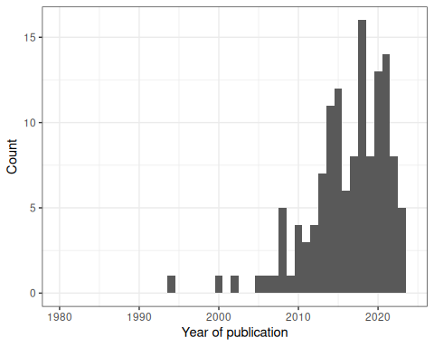

Geographic
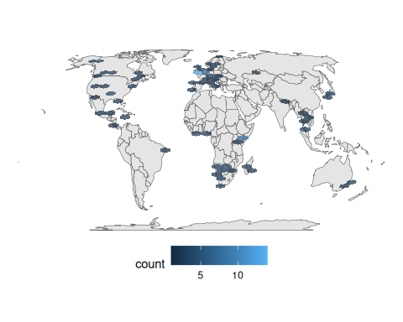

Species
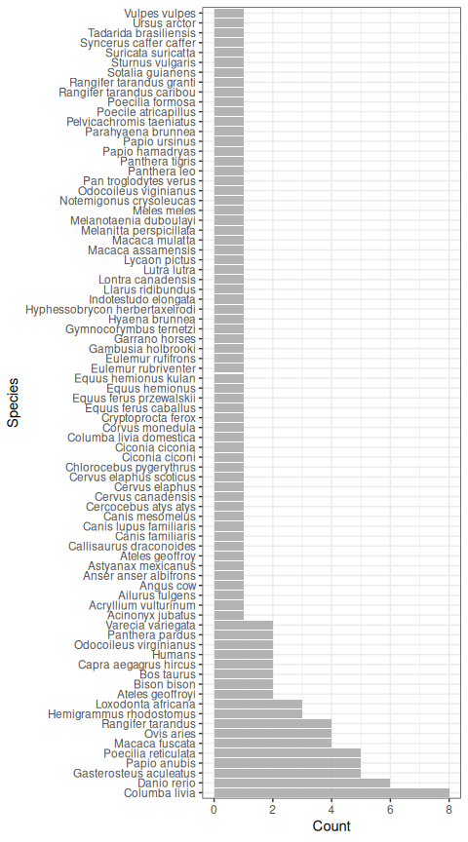

Fission fusion
study_id | definitions_of_leader_initiator_etc
Baden 2016 | NA
Aguilar-Melo 2018 | fission when gte 1 were not observed with a group for 2 consecutive scans; fusion when gte 1 who were previously not observed with group are observed with group for 2 consecutive scans
Barocas 2016 | fission and fusion defined as joining and leaving group in subsequent observations
Haydon 2008 | fusion where solitary to grouped and fission where grouped to solitary
Fortin 2009 | group/fusion when within 100 m; fission when two or more consecutive locations separated by > 100 m
Body 2015 | fusion gte 2 groups merging into one; fission one group splitting into gte 2
DellaLibera 2023 | define a fission and fusion event if one or more individuals left or joined the group, respectively. in the rare cases of missing data, missing individuals are not considered as having changed group membership, and individual ‘disappearances’ and ‘reappearances’ in the dataset are not considered as fission–fusion events
Wielgus 2020 | group where simultaneously within 1 km or >= 1 km for <= 2 hr; fusion where together then different by one time step; fission reverse
Nishikawa 2014 | converged when IID less than 20 m; separated when IID greater than 20 m; converged and separated synonymous with fission fusion
Krueger 2014 | NA
Lesmerises 2018 | grouped/fission fusion if within 50 m for two relocations; to minimize the false fission events, considered dyad valid if together at t0, t2, but apart at t1; if one missing GPS location, dyad valid if before and after missing loc distance was <50 m
Merkle 2015 | group defined as within 100 m within 24 hours

Supplement C: Selected Metrics
- highlighting unavailability of selected metrics despite high use in literature
- detailed justification of not selected metrics

Directional correlation delay
Our review found 13 studies that used the directional correlation delay metric, across 8 study species. Only 1 study had code available using a combination of MATLAB (closed source), CUDA (closed source), and Python (open source). To our knowledge, there are no R packages that provide this metric.

Position within group, rank position within group, time spent leading group, distance and direction to leader
Our review found 4 studies that used the position within group, rank position within group, time spent leading group metrics, distance to leader, or direction to leader metrics across 4 study species. Only 0 study had code available. To our knowledge, there are no R packages that provide these metrics.

Distance, direction and rank distance to group centroid
Our review found 10 studies that used the group centroid, distance to group centroid, direction to group centroid, or rank distance to group centroid metrics, across 8 study species. 0 studies had code available. The {swaRm} package provides functionality to calculate the group centroid and the distance to the group centroid. To our knowledge, there are no R packages that provided the direction and rank distance to group centroid metrics.

Polarization, directional alignment and interindividual direction
Our review found 7 studies that used the polarization, directional alignment or interindividual direction metrics, across 6 study species. 2 studies had code available. The {swaRm} package provides functionality to calculate the polarization order parameter, as well as the {CircStats} package. To our knowledge, there are no R packages that provide the directional alignment or interindividual direction metrics.

Behavioural zones
Our review found 4 studies that used the behavioural zones metric, across 0 study species. 0 studies had code available. To our knowledge, there are no R packages that provided the behavioural zones metric.

Not selected
- wildlifeDI (DI, Don, Prox, Lixn, Cs, DI in direction, DI in displacement, HAI, IAB, Cr, Ca,
- corrMove (diffusive movement correlation, drift movement correlation, overall component movement correlation)
- metrics relating to posture
- static interaction eg. home range overlap
- voronoi
- HMM
- change point detection
- mFLICA
  - available
- FLOCK
- LPD
- Granger causality
- Influence maximization

