Untitled

Table of Contents

# A normal paragraph.

(ref:foo) Define a text reference **here**.

??

(ref:foo)

(ref:bar) A scatterplot of the data cars using **base** R graphics.

plot(cars) # a scatterplot

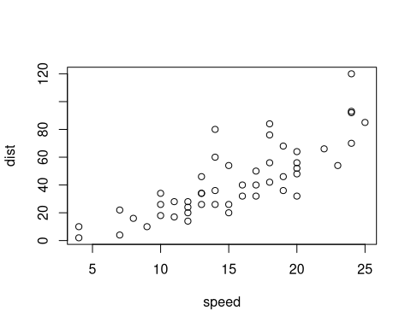

Figure 1: (ref:bar)