**Artificial Intelligence for Software Engineering**

**Assignment#1**

Recommending code tokens via N-gram models

Instructor: Antonio Mastropaolo, PhD

**Data Collection: -**

For this project, we were asked to collect at least 25k Java methods. I used [SEART](https://seart-ghs.si.usi.ch/) to collect the Java methods. I’ve collected overall 2k repositories from that website and I used only 20 repositories to collect the data. The training dataset size was more than 400 MB and for the testing dataset the size was 18 MB.

**Data Pre-processing: -**

Cleaned data is very crucial for the model training. As the data was in the java file, I used some regular expression to extract only the java methods. After pre-processing I saved the data to a text file.

**Model Training Methodology: -**

First of all, I created tokens. The total number of tokens was 380731 and the number of unique tokens was 69141. Then, I build a n-gram model to predict the next word based on inputted word.

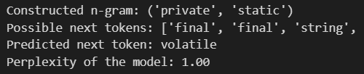

**Code: -**

The code is available in the following address: <https://github.com/robiul-islam-rubel/ngram>