Robiul Alam

Id: 23419382

LAB-4

1. Create database lab4
2. Change database to lab4
3. Create the following tables:

CREATE TABLE customer( customerid INT NOT NULL, customername VARCHAR(255) NOT NULL, agentid INT NOT NULL, PRIMARY KEY(customerid) );

Insert into customer(customerid, customername, agentid) values(1, 'George', 22);

Insert into customer(customerid, customername, agentid) values(2, 'Susan', 11);

Insert into customer(customerid, customername, agentid) values(3, 'Kelsey', 22);

Insert into customer(customerid, customername, agentid) values(5, 'Mike', 13);

Insert into customer(customerid, customername, agentid) values(7, 'Ellen', 38);

Insert into customer(customerid, customername, agentid) values(8, 'Tylor', 40);

CREATE TABLE agent( agentid INT NOT NULL, agentname VARCHAR(255) NOT NULL,phone VARCHAR(15), PRIMARY KEY(agentid) );

Insert into agent(agentid, agentname, phone) values(11, 'Bob', 1111);

Insert into agent(agentid, agentname, phone) values(13, 'Carol', 1313);

Insert into agent(agentid, agentname, phone) values(22, 'Jane', 2222);

Insert into agent(agentid, agentname, phone) values(38, 'Bob', 3838);

Insert into agent(agentid, agentname, phone) values(17, 'Rachel', 1717)

Create table invoice(id int, customer_id int, item_desc varchar(30), price real);

Insert into invoice values(1,10,'book',20.34);

Insert into invoice values(2,24,'chair',10.10);

Insert into invoice values(3,12,'magazine',23);

Insert into invoice values(4,15,'laptop',401.99);

Insert into invoice values(5,10,'headphones',30);

Insert into invoice values(6,10,'CD',13.10);

Insert into invoice values(7,12,'book',22.5);

Insert into invoice values(8,15,'candle',14.99);

create table t1(id INT, name Varchar(10));

insert into t1 values(1, 'A');

insert into t1 values(2, 'B');

insert into t1 values(3, 'C');

insert into t1 values(4, 'D');

insert into t1 values(5, 'E');

create table t2(number INT, letter Varchar(10));

insert into t2 values(3, 'B');

insert into t2 values(4, 'D');

insert into t2 values(5, 'E');

insert into t2 values(6, 'E');

1. Find all agent ids and number of customers for each agent in customer table.

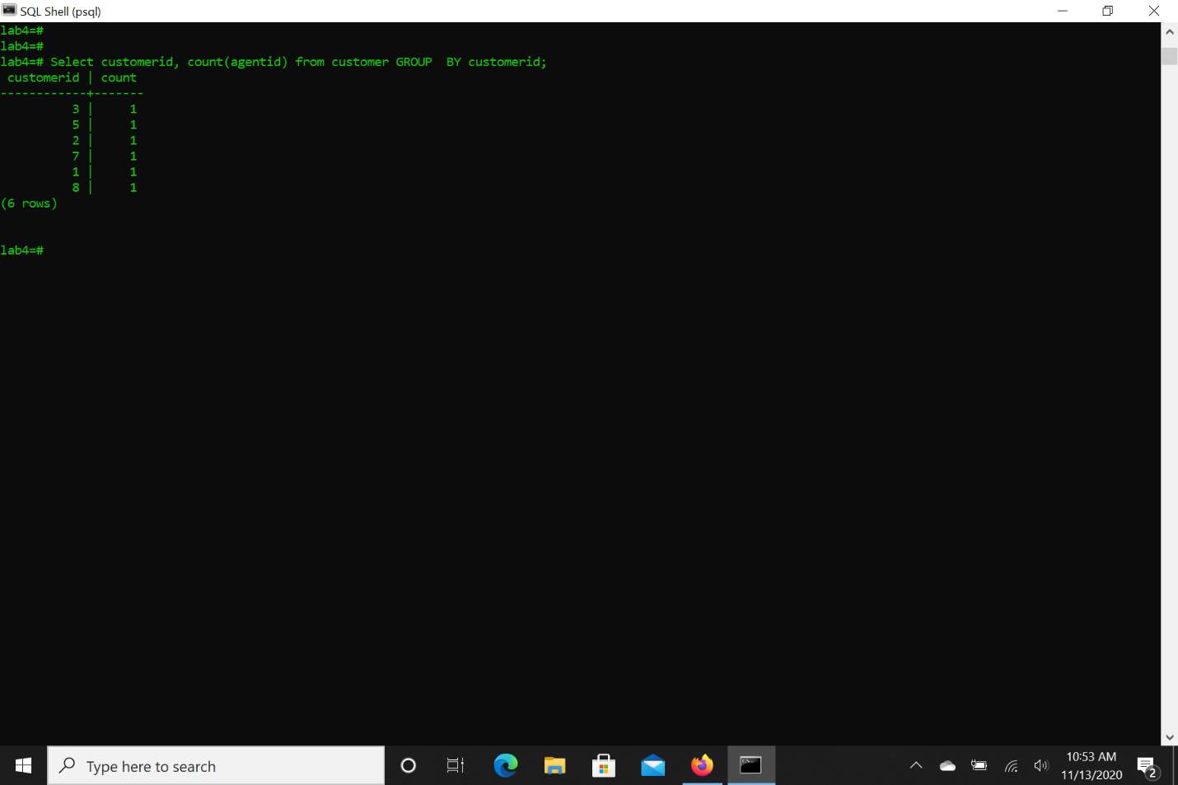

1. Find all agent ids and number of customers for each agent who has more than 1 customer in customer table

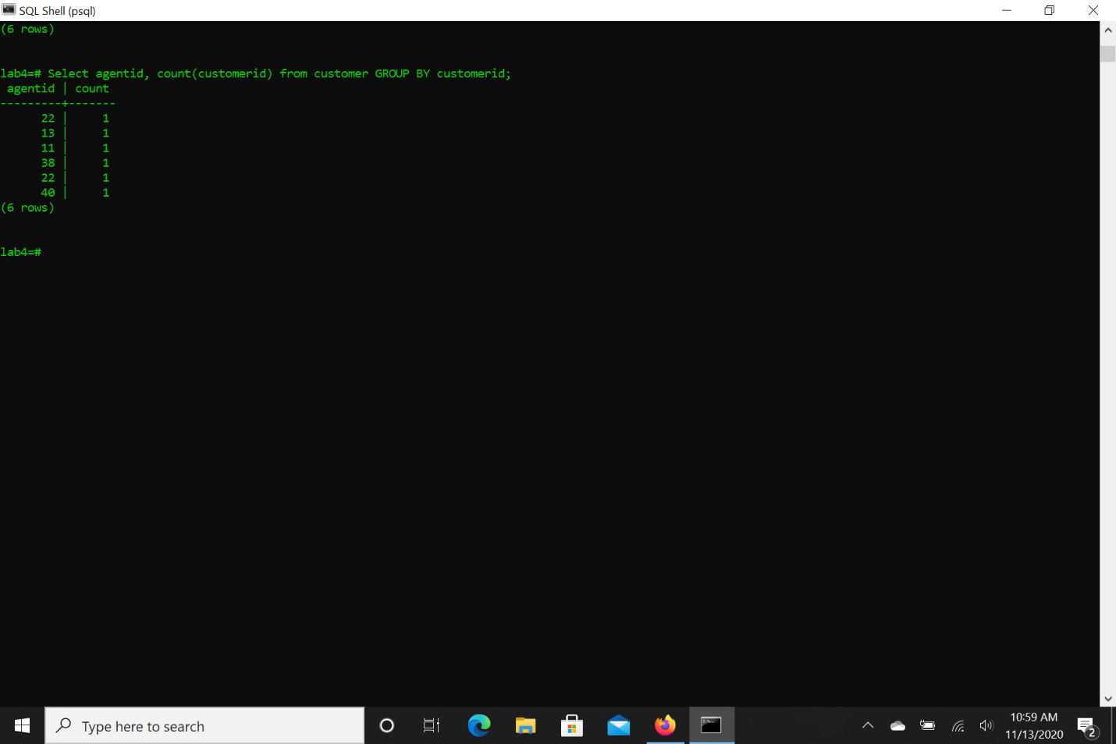

1. Find all agent ids and number of customers for each agent who has exactly 1 customer in customer table

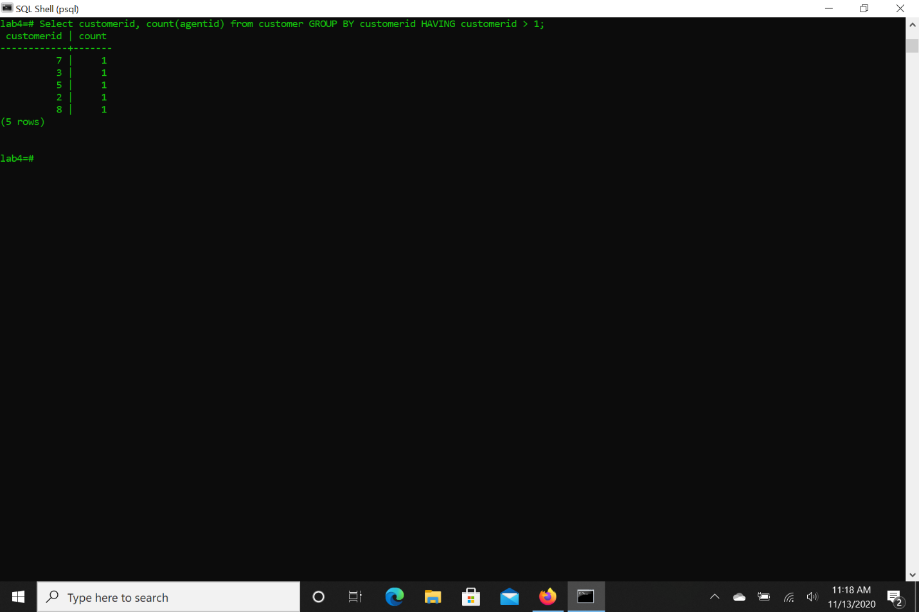

1. Find all agent ids and number of customers for each agent who has less than 5 customers in customer table and sort the list descending based on the agent ID

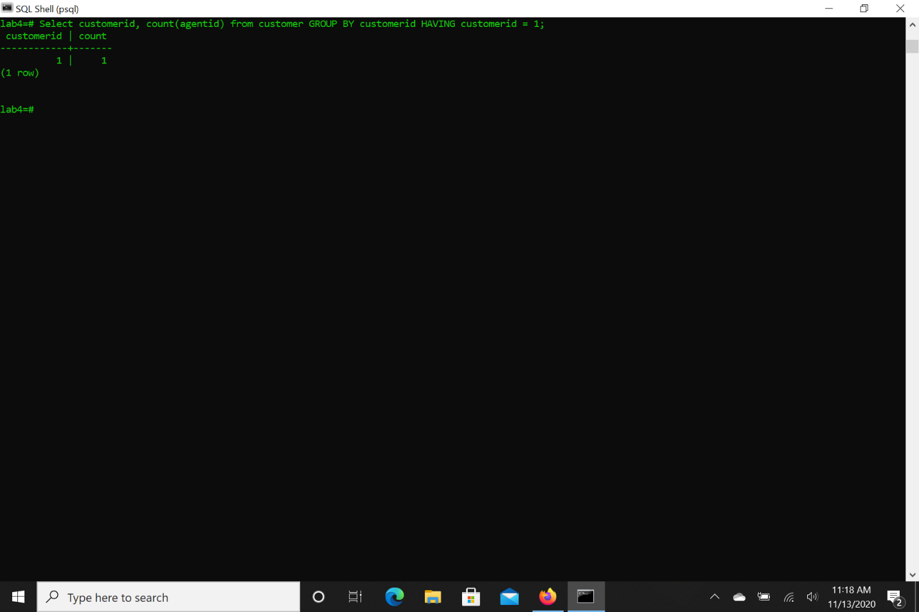

1. Find the max price in the invoice table;

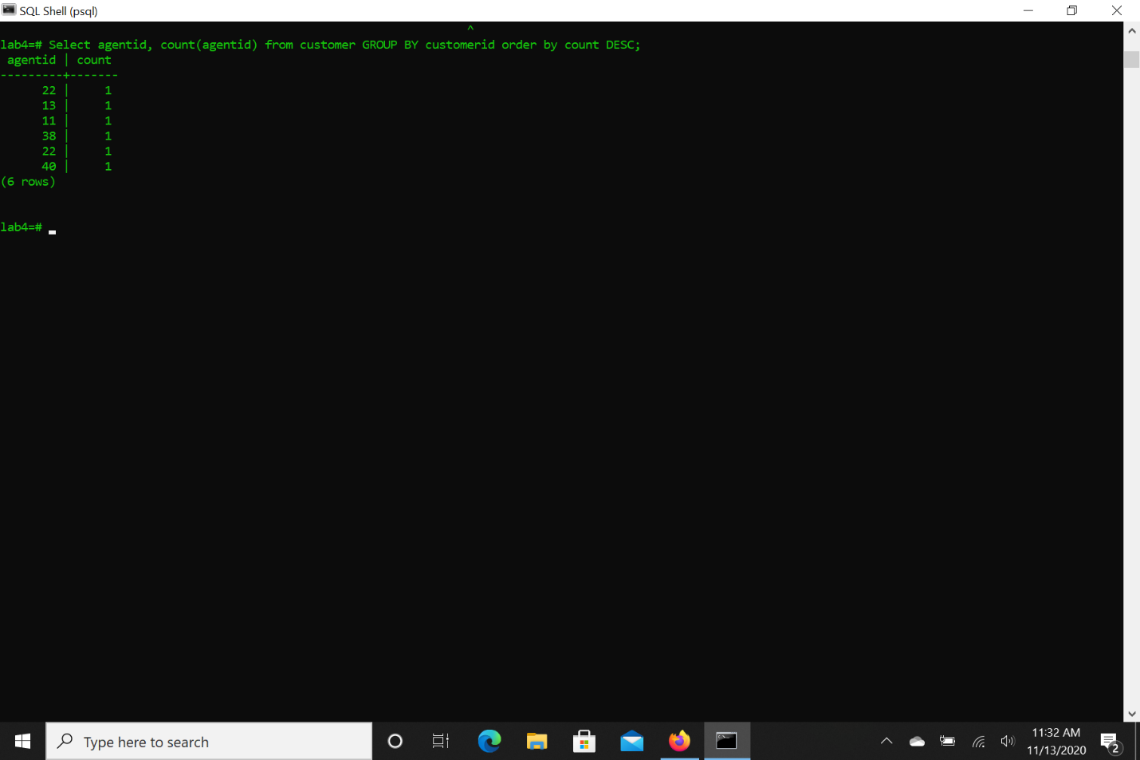

1. Find the min price in the invoice table;

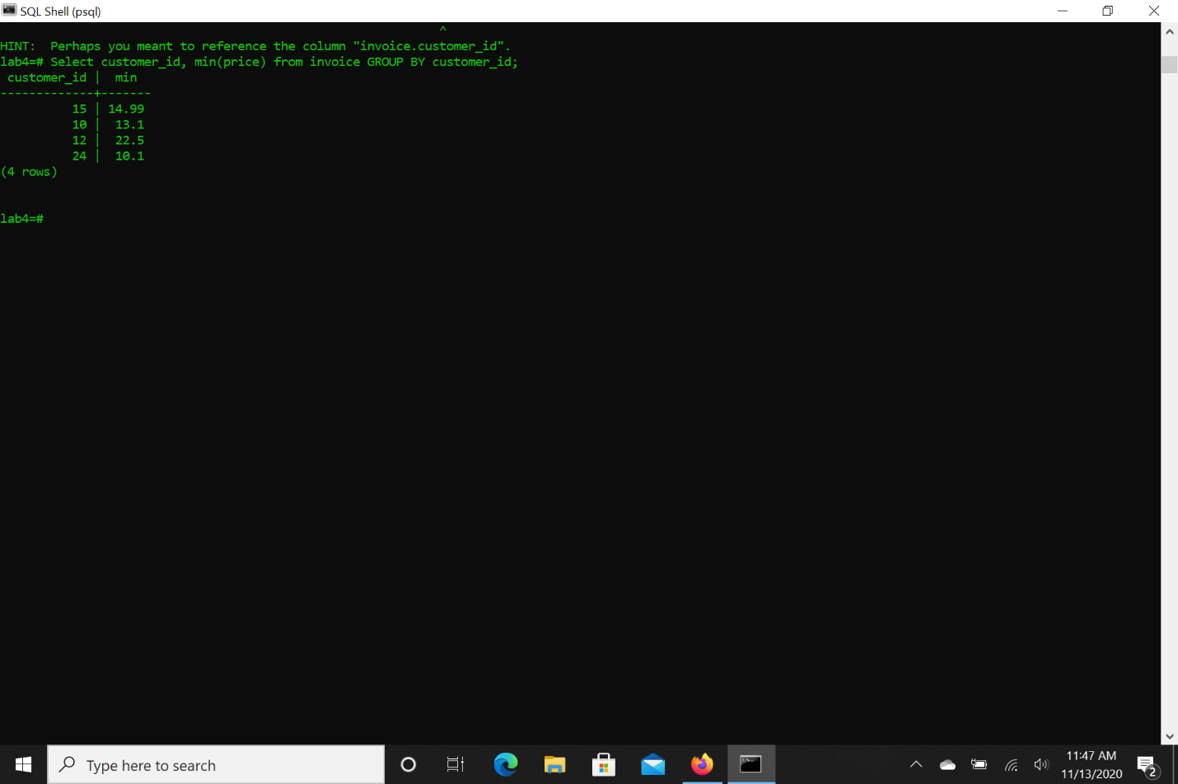

1. Select all item descriptions and prices from invoice table where item price is less than the difference between max and min price in the invoice table

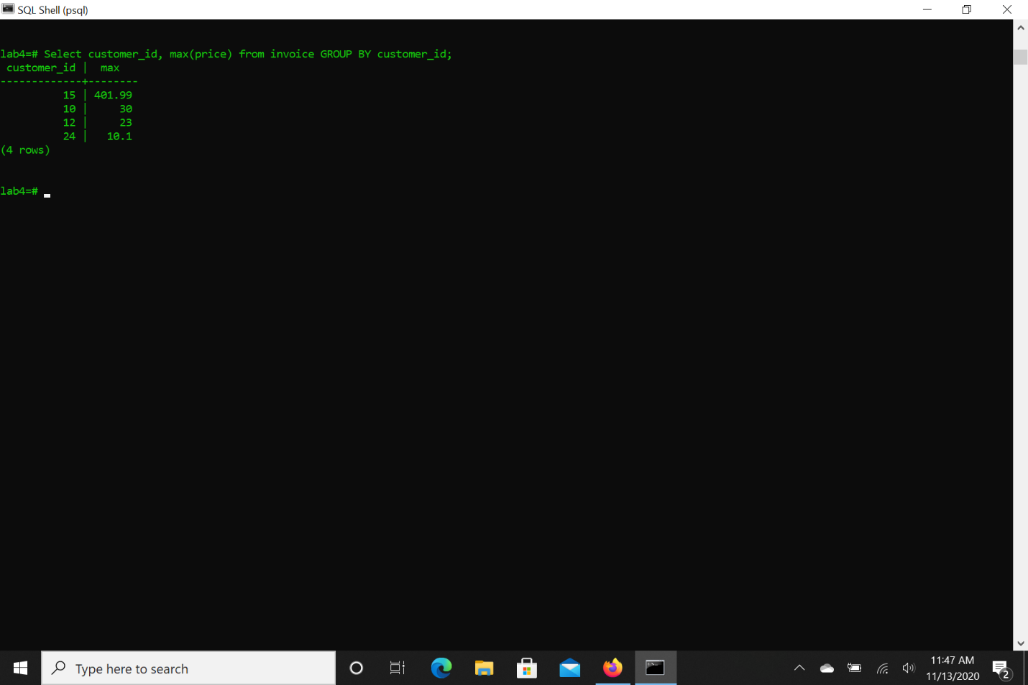

1. Select all item descriptions and prices from invoice table where item price is more than the average between max and min price in the invoice table

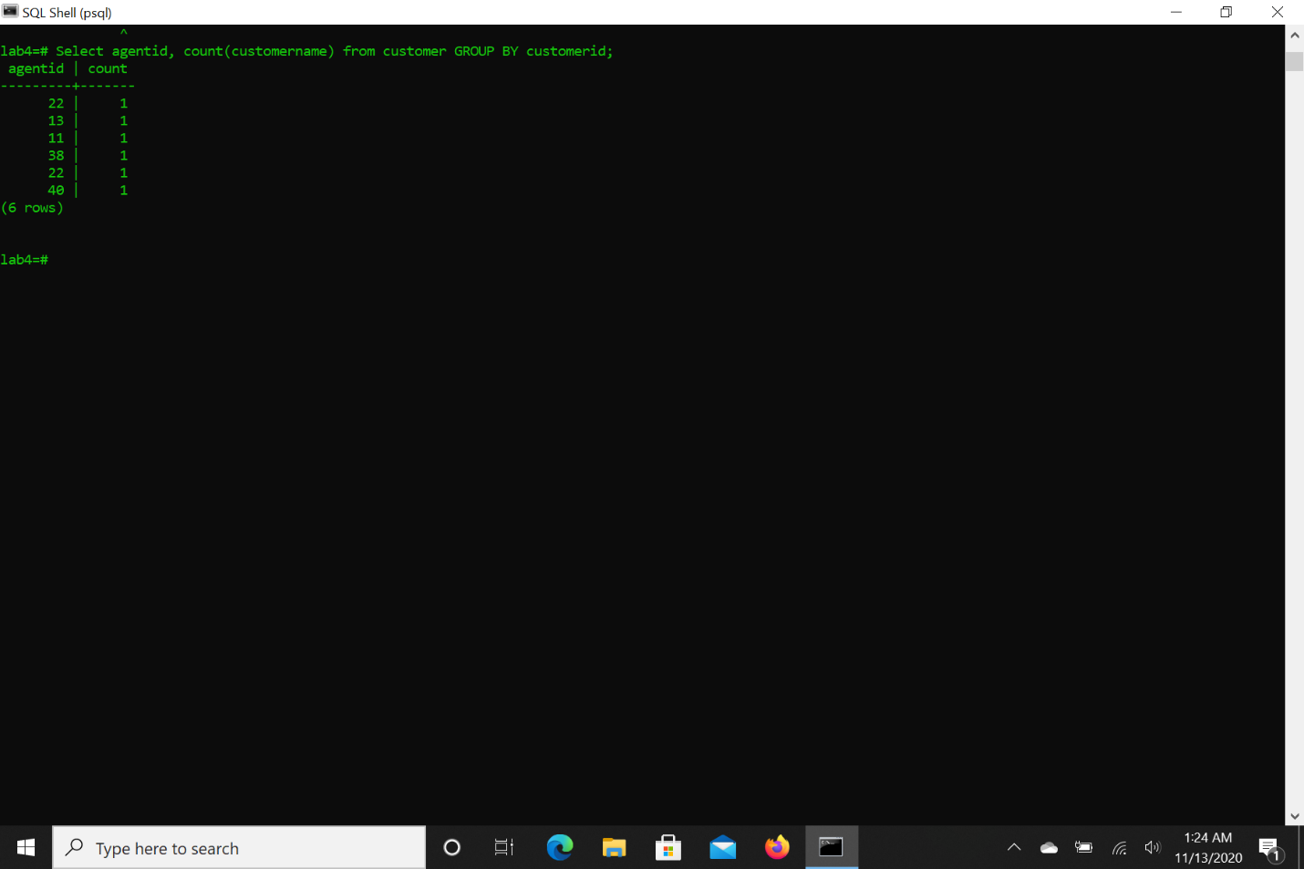

1. List all purchases made by other customers but not by customer 12 only show customer_id, item_desc, price in the results of invoice table
2. Find purchases that are greater than all of customer 12’s purchases in invoice table
3. List customer_id, item_desc,price, max, difference from invoice table. max attribute is going to reflect the max price in the table and difference attribute will be the difference of max price and each item’s price
4. Union t1 and t2 and display the results if their id is less than 5
5. Find the intersect of t1 and t2 and display the results if their id is less than 5