**Lab-2**

Robiul Alam

1) Create database named “lab2”.



2) List all databases



3) Change your database to lab2

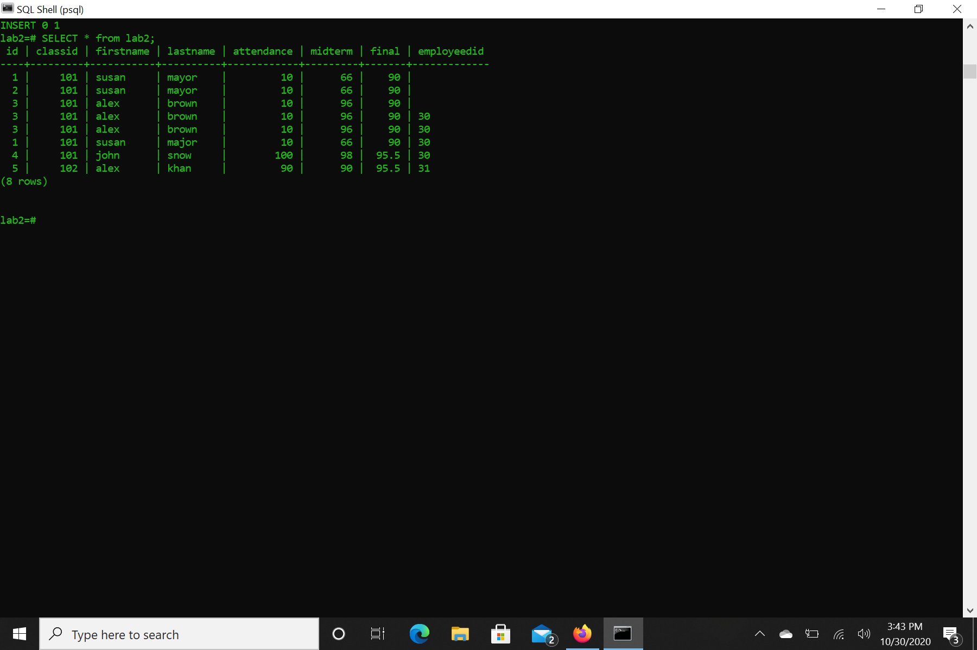

4) Create student table

id, classid, employeeid : INT

firstname, lastname : VARCHAR(30)  
attendance, midterm, final: REAL

Classid : indicated classes taken by the students  
Employeeid: indicates instructors teaching the classes listed under classid



5) Create employee table

employeeid : INT , rest : VARCHAR(30)



6) Apply join based on common employee ID in both tables.

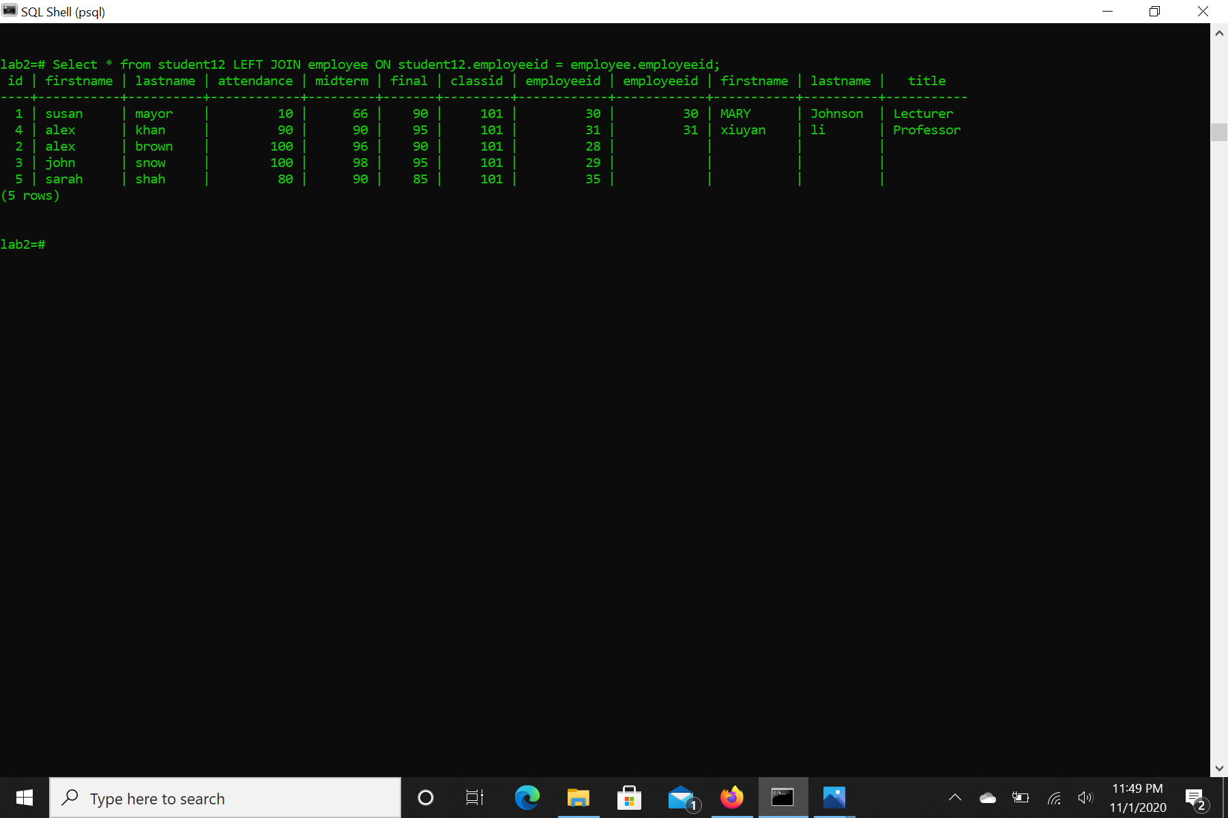

7) List all distinct employee first names who teach using “…JOIN … ON”



8) Insert the following student to student table

Insert into student (id, firstname, lastname, attendance, midterm, final, classid, employeeid) values (5, ‘sarah’, ‘shah’, 80, 90, 85.5, 103, 35);

9) Show all records in student table

10) Show all records in employee table

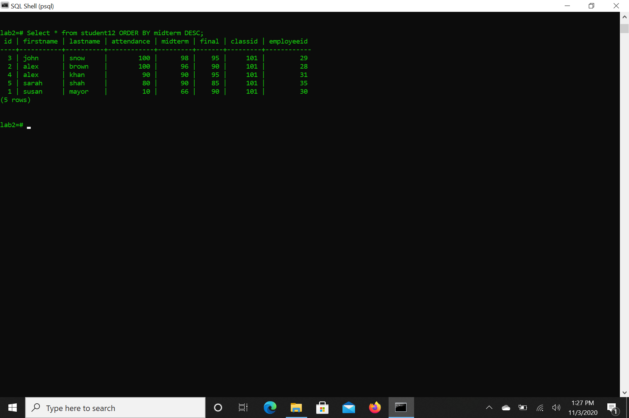

11) List all student and employee attributes even though employee is retired or left(in other words, list instructors who do not exist in employee table).  
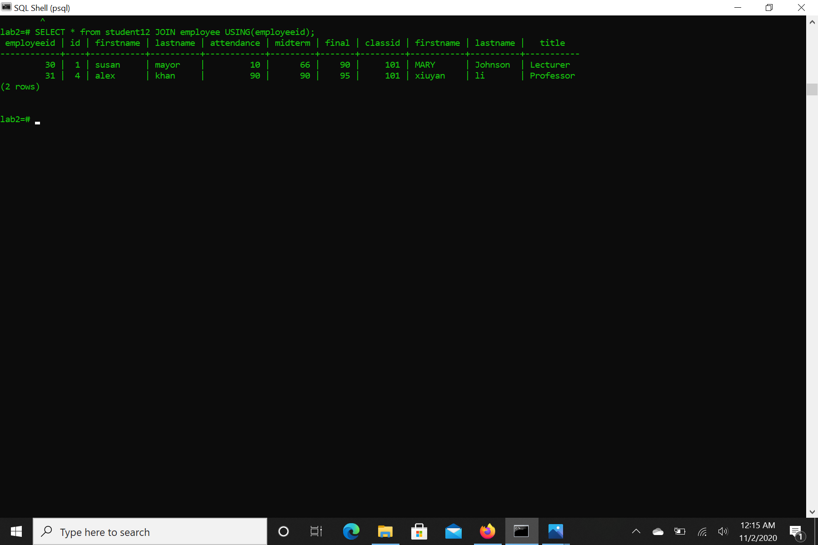

12) List all student and employee attributes even though some employees are not instructional staff.

13) List all student and employee attributes even though some employees are not instructional staff, or some instructors are retired or left.



14) Calculate Overall grade for each student based on the following formula and list student firstname, lastname and overall grade:

overall = %10 attendance + 40% midterm + 50% final

15) List cartesian product of both tables

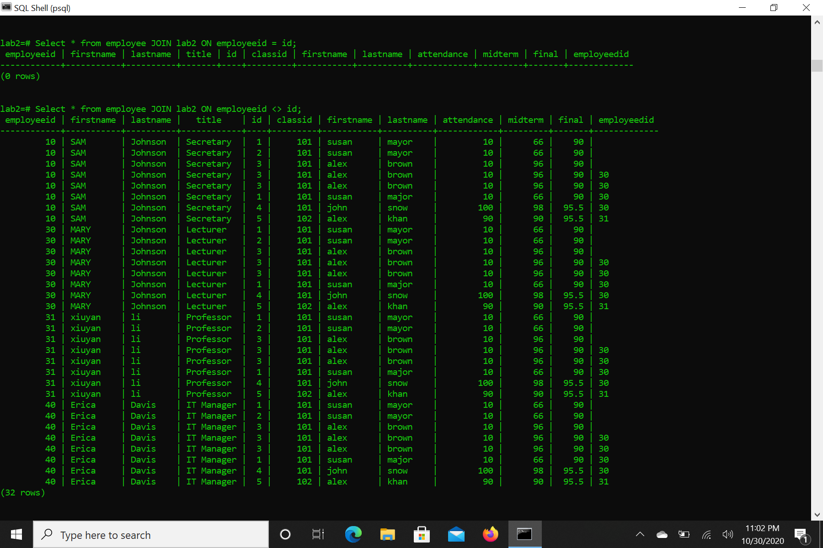

16) Find number of records in student table

17) Write SQL query to find how many students are there who are taking a class from Mary Johnson?

Select * CONT((*))

18) Write SQL query to find name of the students who are taking a class from employees with id number 30 and 31?

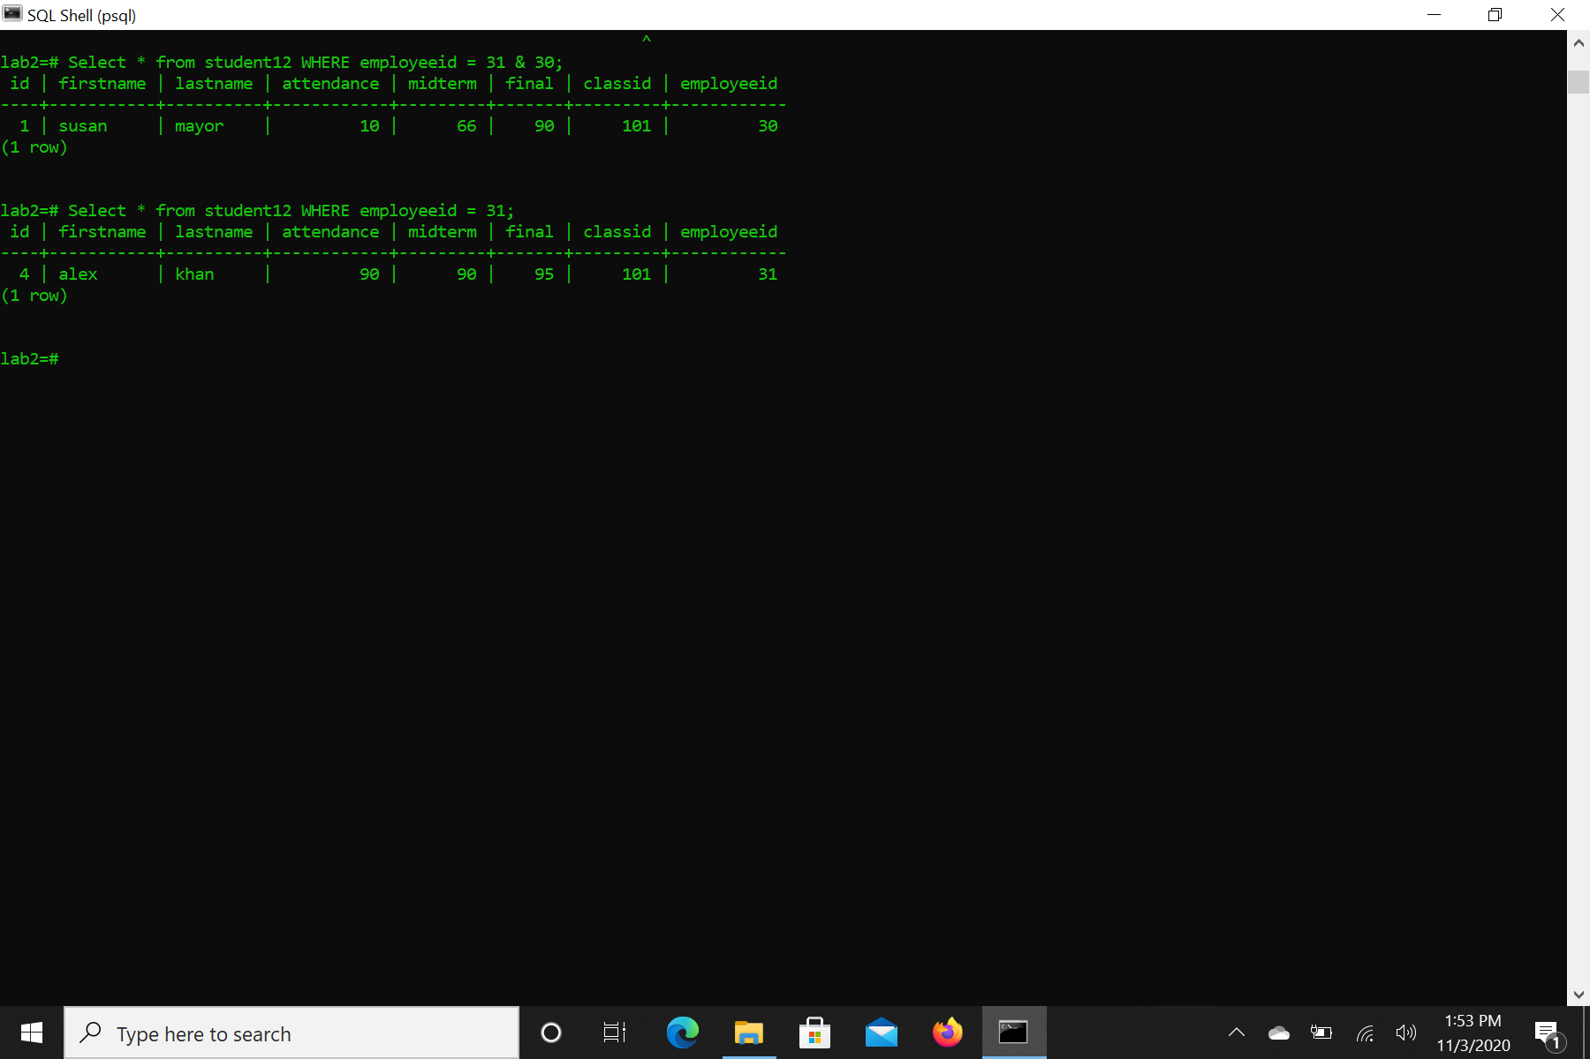

19) Write SQL query to find name of the students who are taking a class from employees with id number 30 or 31?



20) List all student information based on their id numbers in descending order.



21) List all student information based on their first names in descending order, if two or more students share the same first name then sort them based on their id numbers ascending.

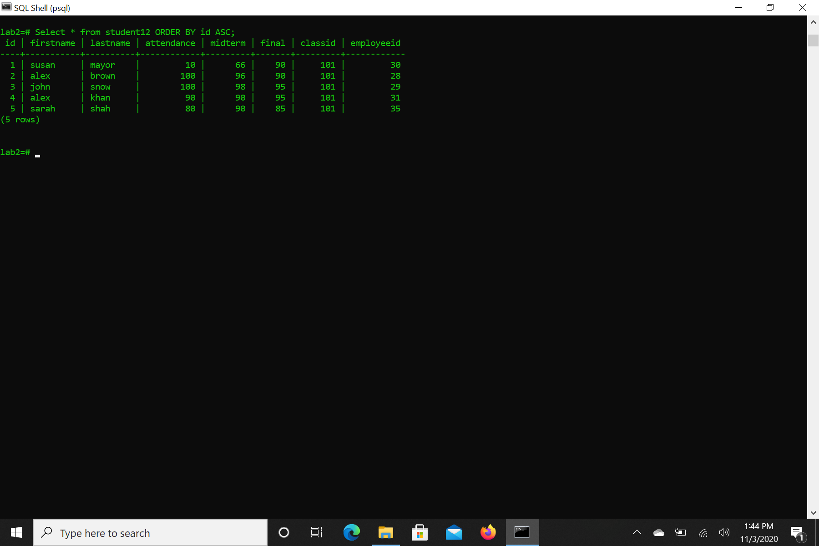

22) List all student information based on their first names in descending order, if two or more students share the same first name then sort them based on their id numbers ascending where student final grades are not 90.

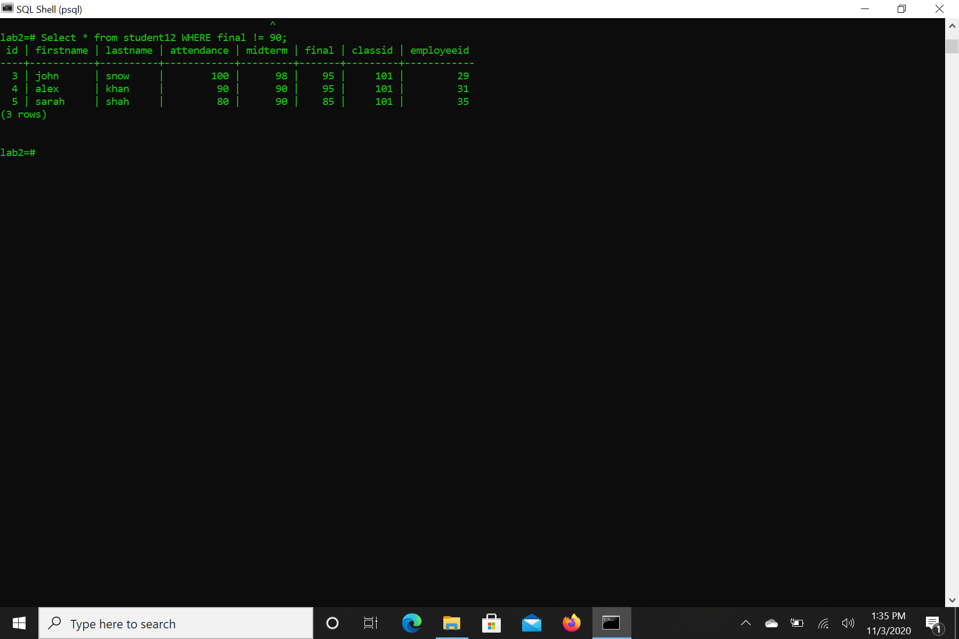

23) List all student information based on their first names in descending order, if two or more students share the same first name then sort them based on their id numbers ascending where student final and midterm grades are not 90.

