Lab-3

1) Create a database called lab3

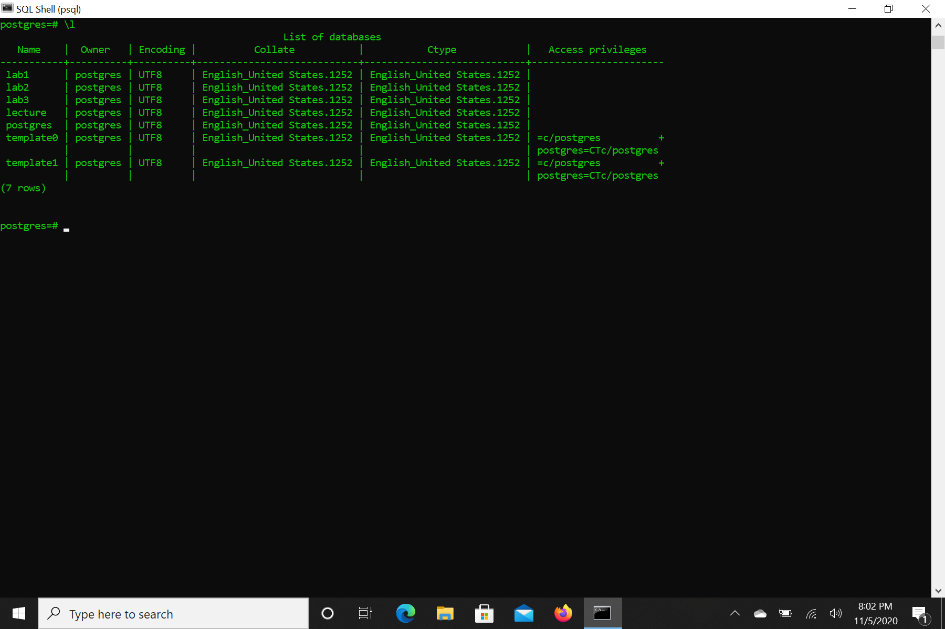

2) Change your database to lab3

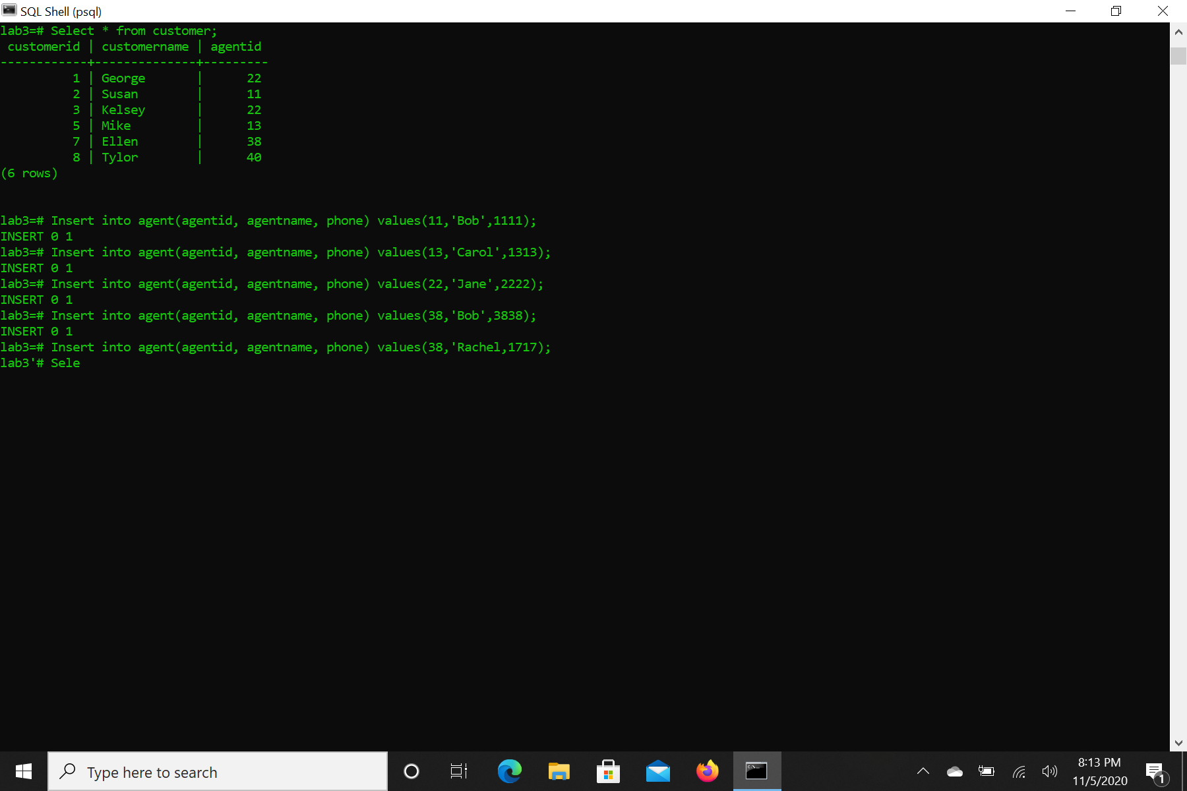

3) Create the following tables

CREATE TABLE customer( customerid INT NOT NULL, customername VARCHAR(255) NOT NULL, agentid INT NOT NULL, PRIMARY KEY(customerid) );

CREATE TABLE agent( agentid INT NOT NULL, agentname VARCHAR(255) NOT NULL,phone VARCHAR(15), PRIMARY KEY(agentid) );

Insert into customer(customerid, customername, agentid) values(1, 'George', 22);

Insert into customer(customerid, customername, agentid) values(2, 'Susan', 11);

Insert into customer(customerid, customername, agentid) values(3, 'Kelsey', 22);

Insert into customer(customerid, customername, agentid) values(5, 'Mike', 13);

Insert into customer(customerid, customername, agentid) values(7, 'Ellen', 38);

Insert into customer(customerid, customername, agentid) values(8, 'Tylor', 40);

Insert into agent(agentid, agentname, phone) values(11, 'Bob', 1111);

Insert into agent(agentid, agentname, phone) values(13, 'Carol', 1313);

Insert into agent(agentid, agentname, phone) values(22, 'Jane', 2222);

Insert into agent(agentid, agentname, phone) values(38, 'Bob', 3838);

Insert into agent(agentid, agentname, phone) values(17, 'Rachel', 1717)



4) Select all customer attributes whose name starts with an S.

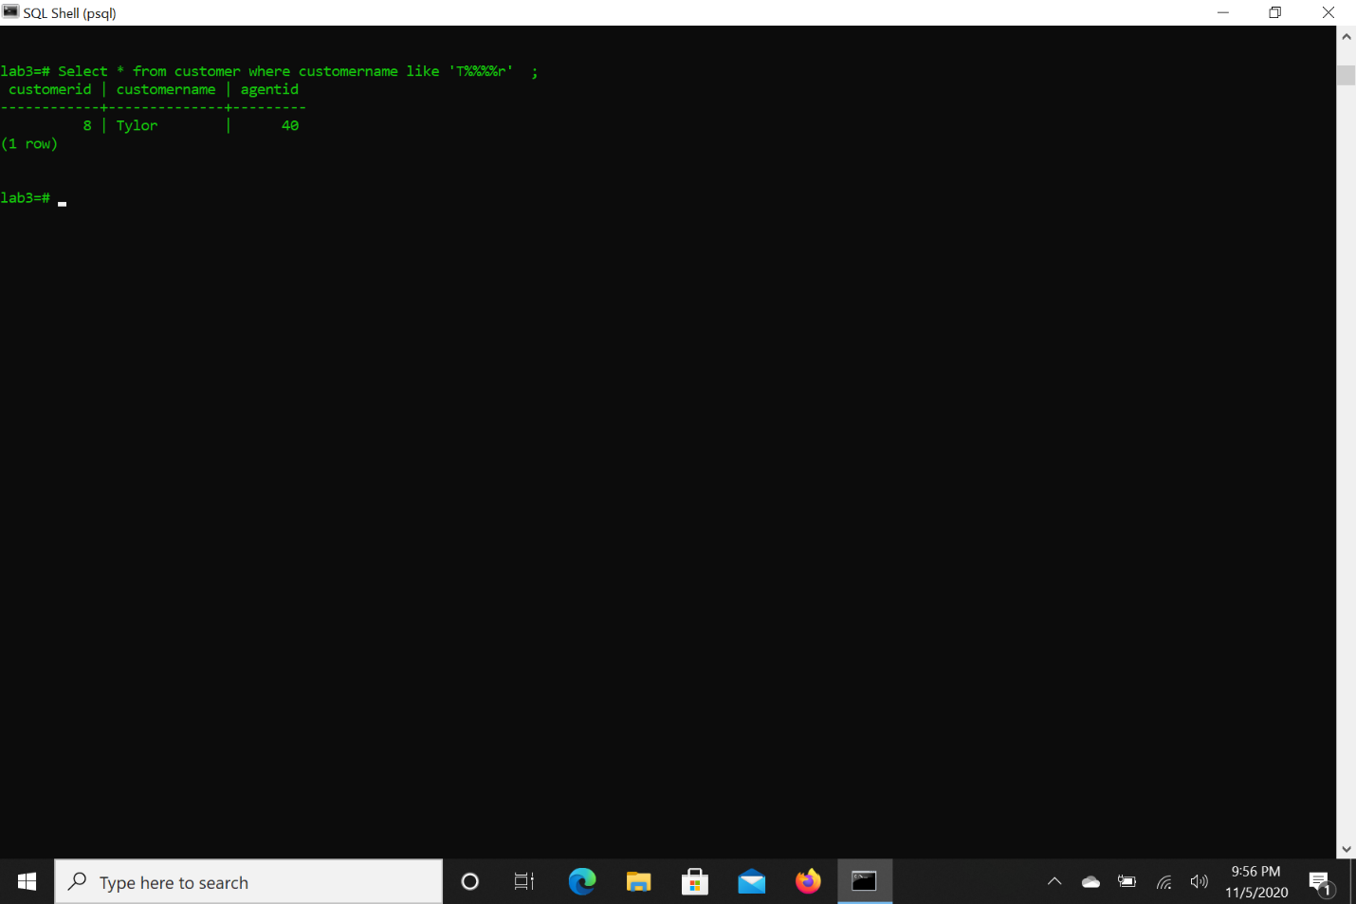

5) Select all customer attributes whose name contains 5 letters and the second letter is an ‘l’.

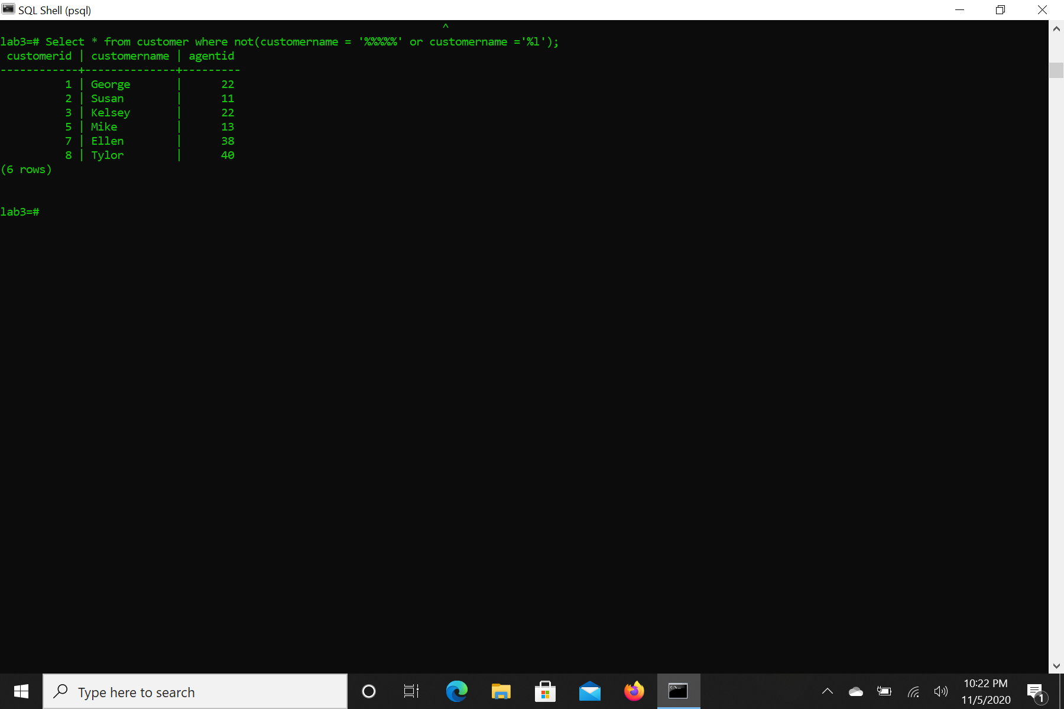

6) Select all customer names starts with a ‘T’ and ends with ‘r’.

7) List all customer names in uppercase.

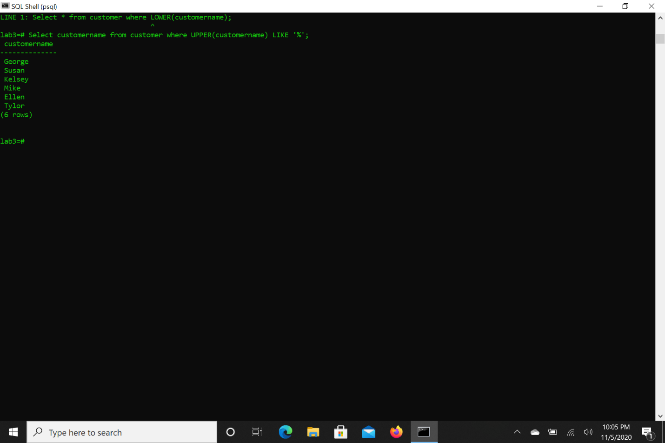

8) List all customer names in lower case and alphabetically decreasing order (Z to A).

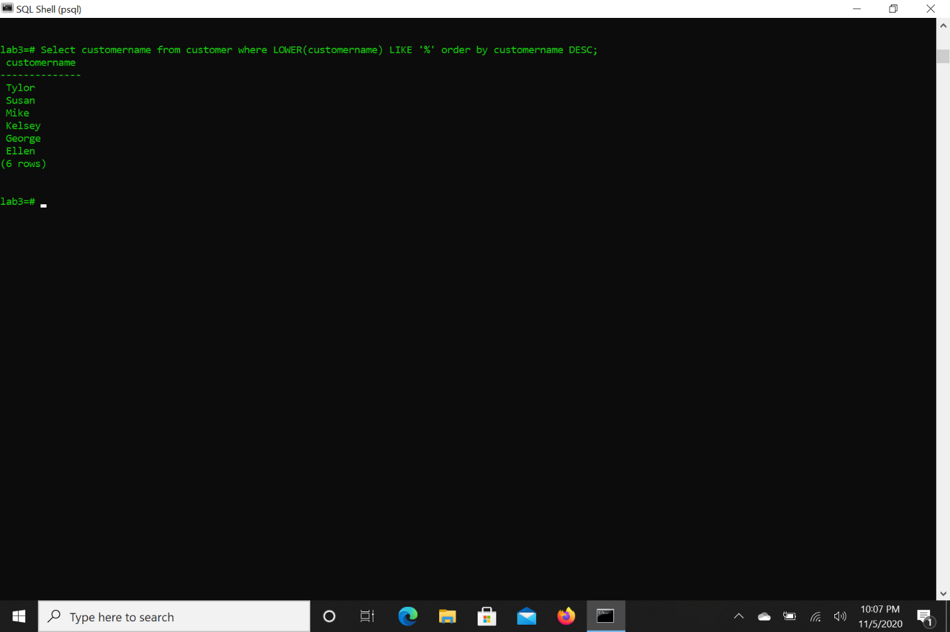

9) List all the customers whose names do not contain 5 letters and second letter is not an ‘l’.



10) Count how many records are there whose customerid is not null in customer table.



11) Find out how many distinct agentid exist in customer table.



12) Find the maximum agentid that exist in customer table.



13) Find the minimum agentid that exist in customer table.



14) Find sum of the agentid that exist in customer table.



16) Find the integer value of average agentid in customer table.

