Robiul Alam

SQL Lab -1

Basak Taylan

October 2020

1. Create Database named “Lab1”.

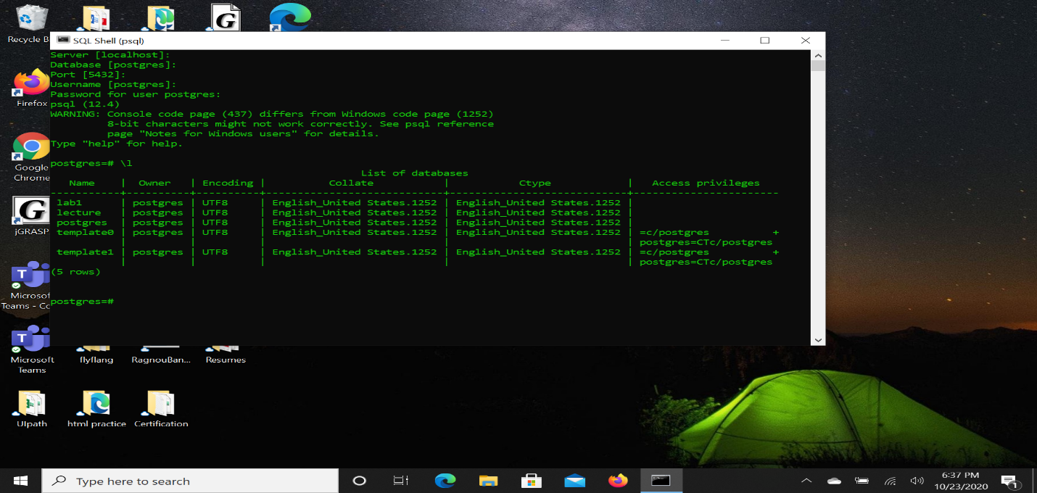

1. List all the databases in your SQL server.

Answer: 

1. Change your current database to Lab1.
2. 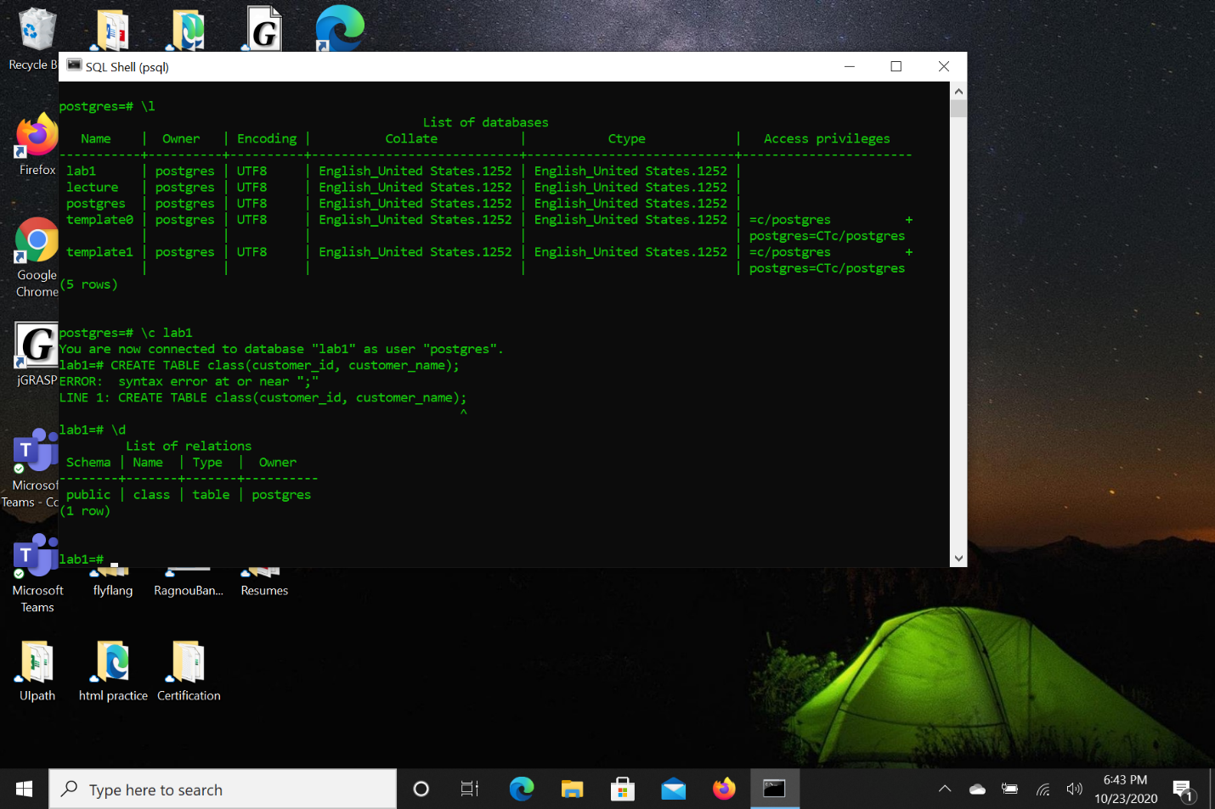

4. List all the tables in Lab1 Database



5.

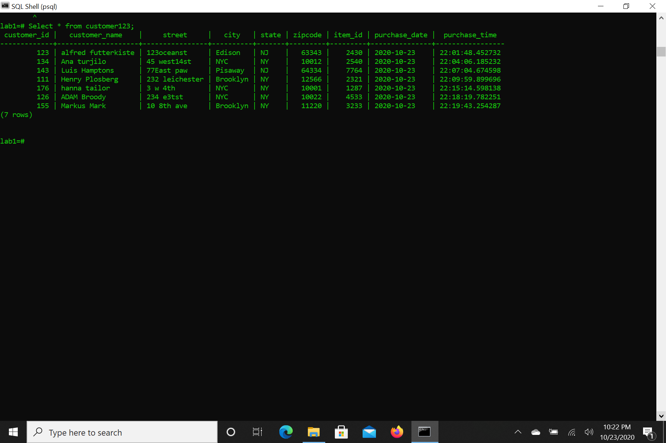

1. List all the customer information for the customers who lives in NY state.

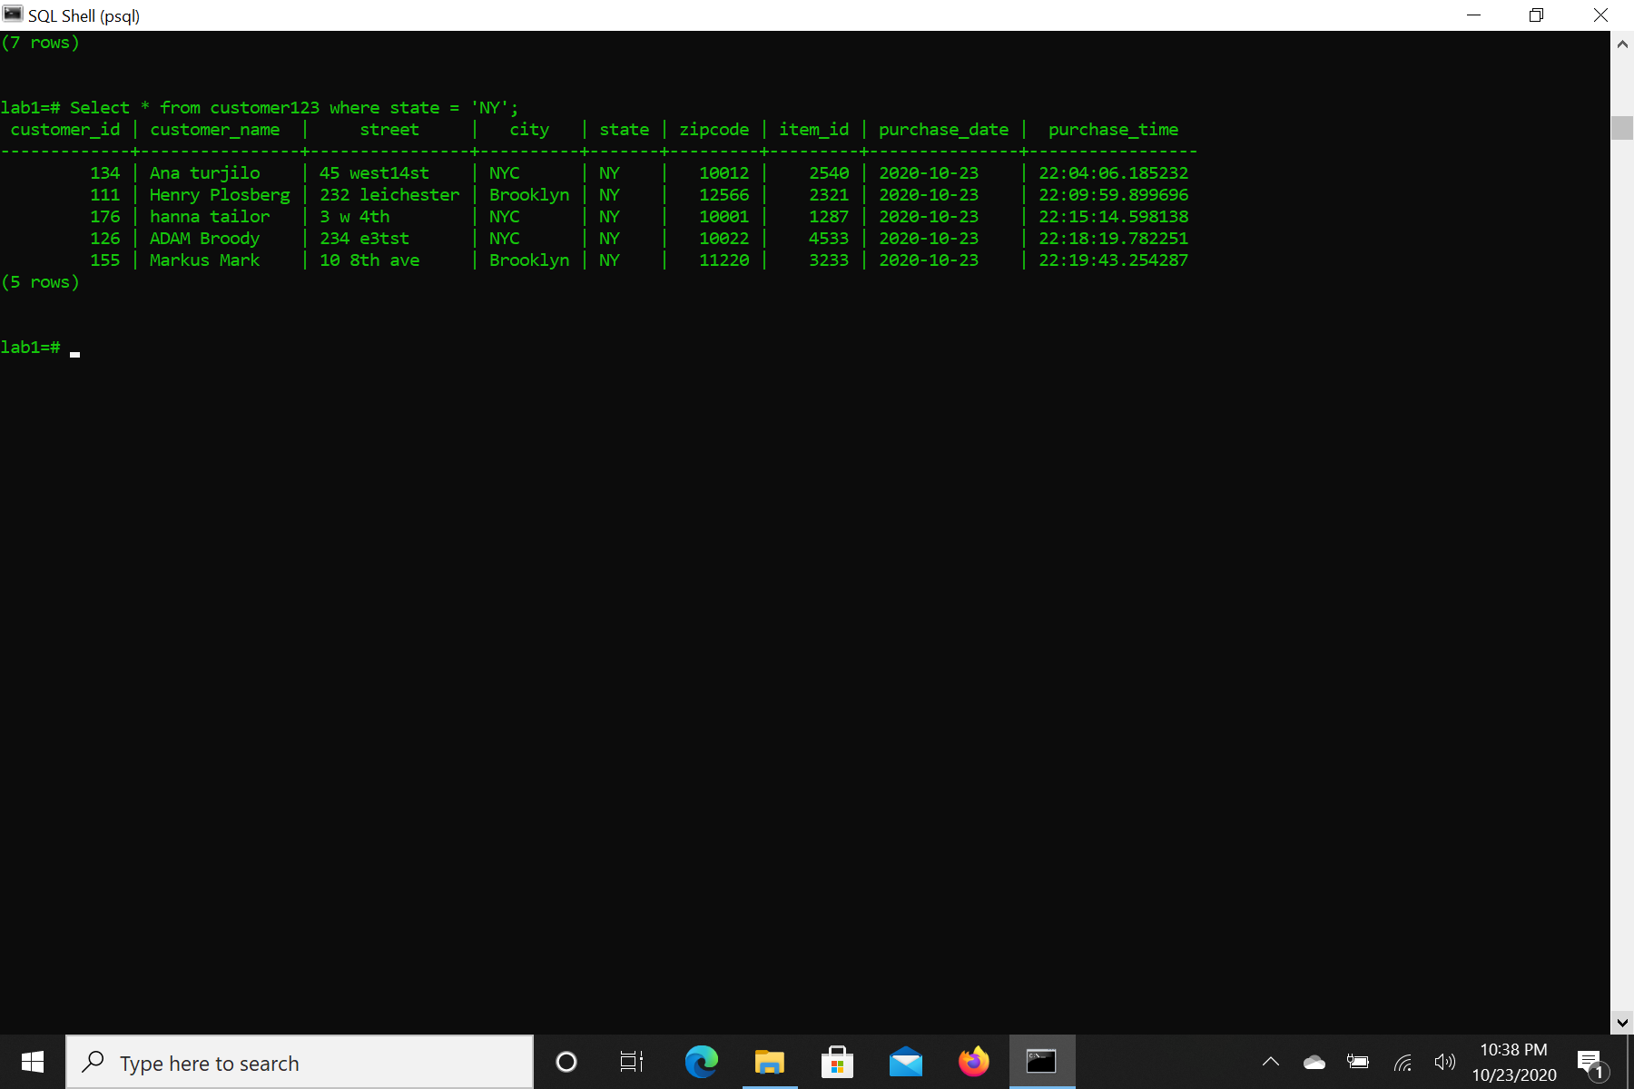

1. List all customer information for the customers who lives in NYC.

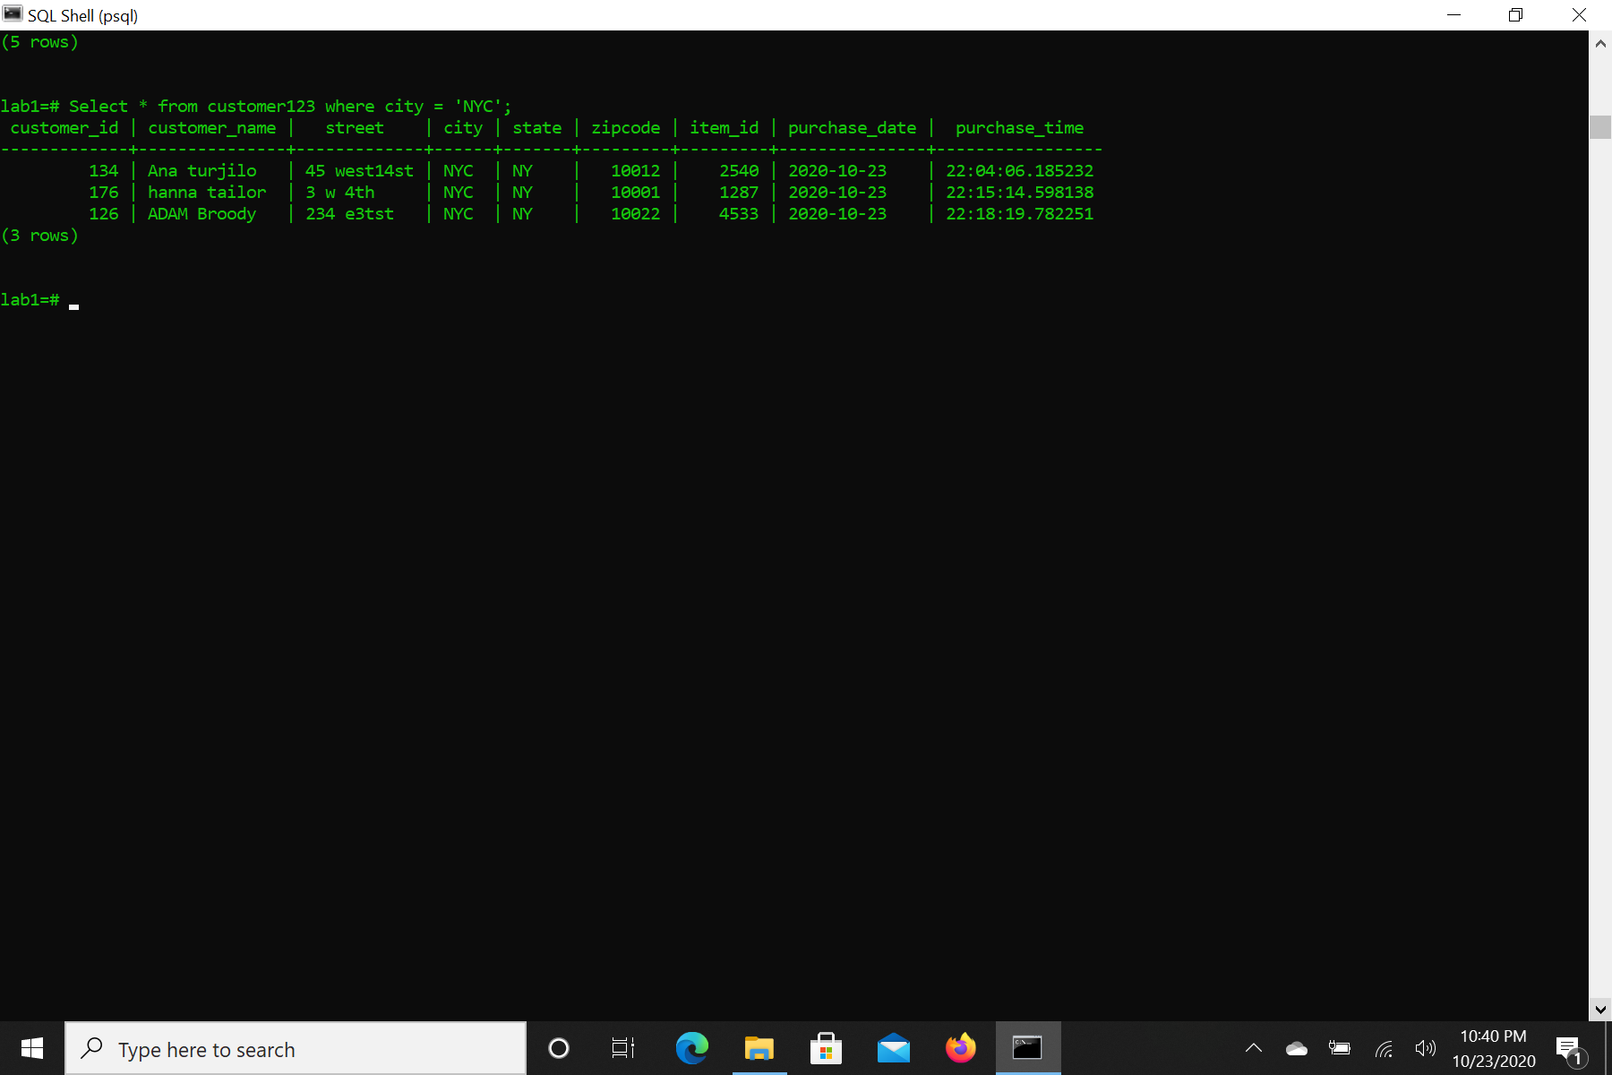

1. List all customer information for the customers with customer number less than 150.

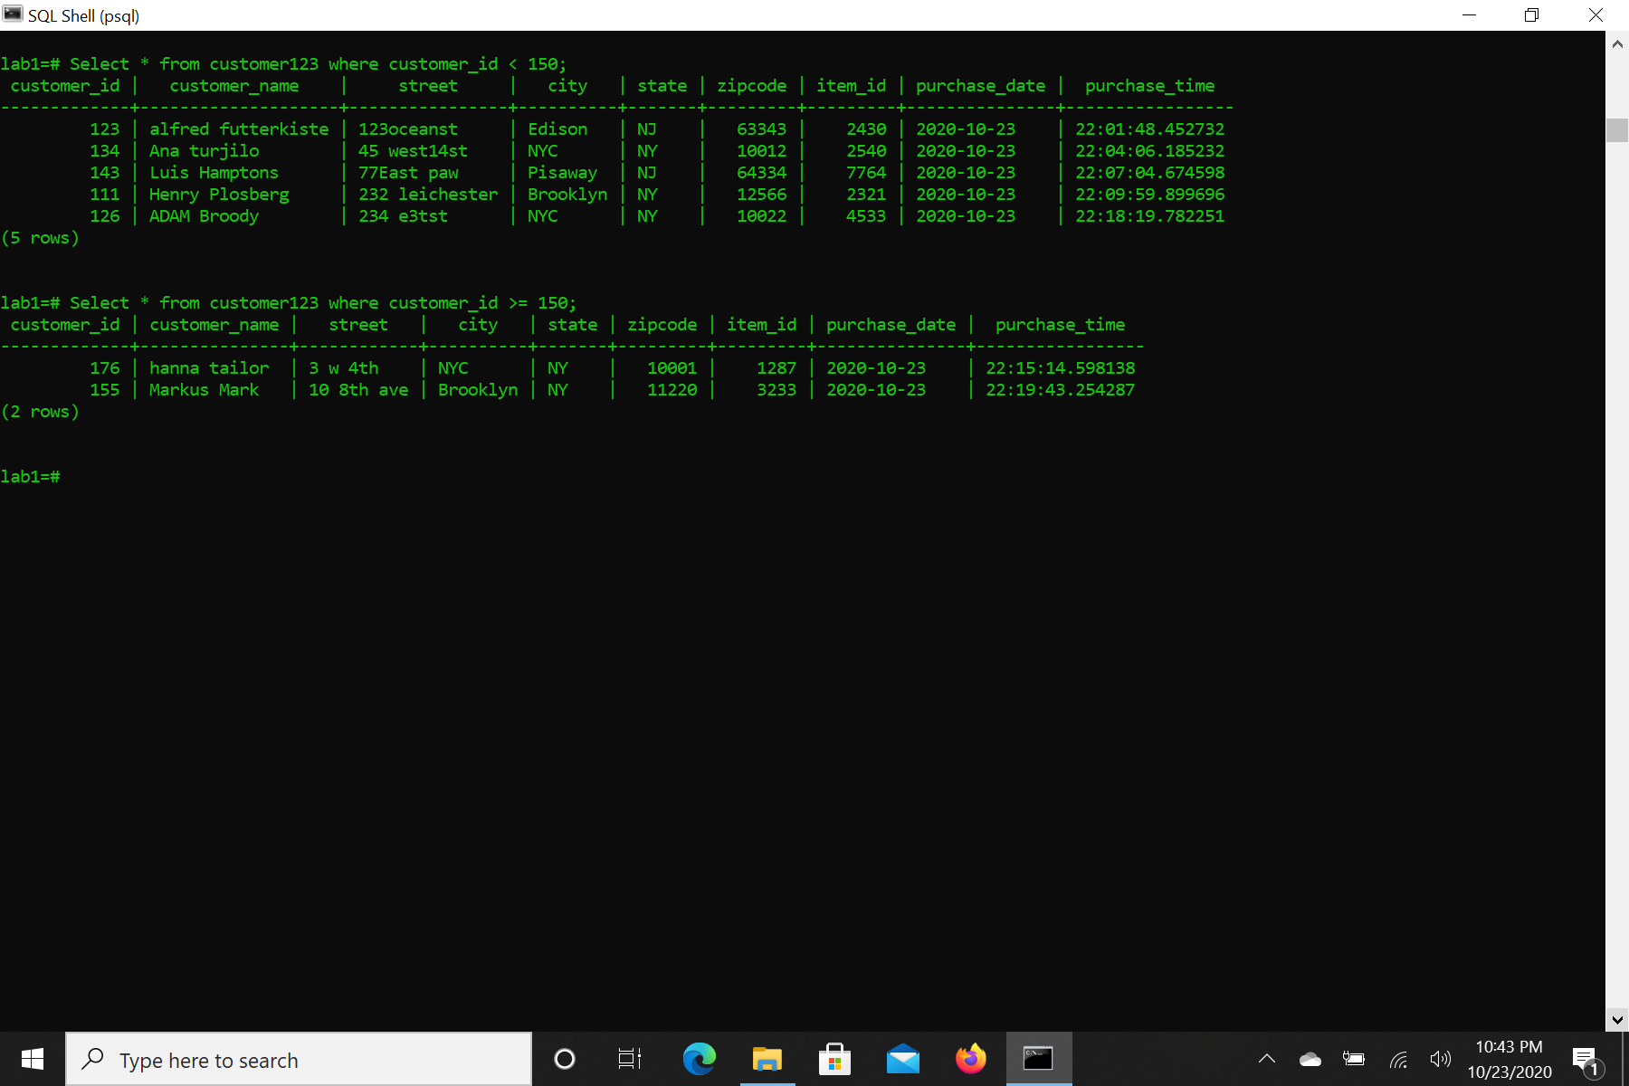

1. List all customer information for the customers with customer number greater than or equal to 150.



1. List all customer information.

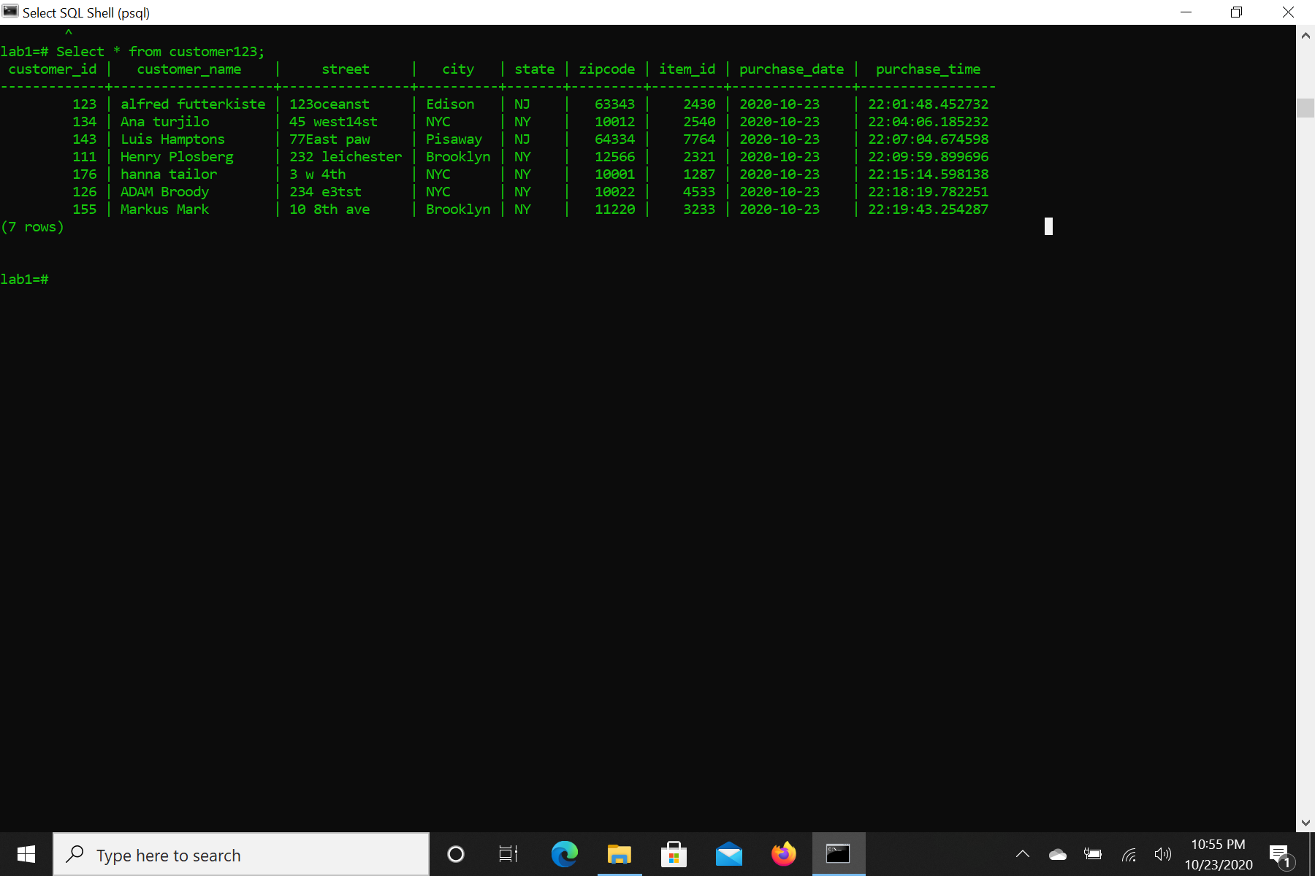

1. List all customer name and address whose name is alphabetically comes after letter ’K.

12. List all customer name and customer id for the customers whose name is alphabetically comes

before ’Kate’

13. List unique customer names.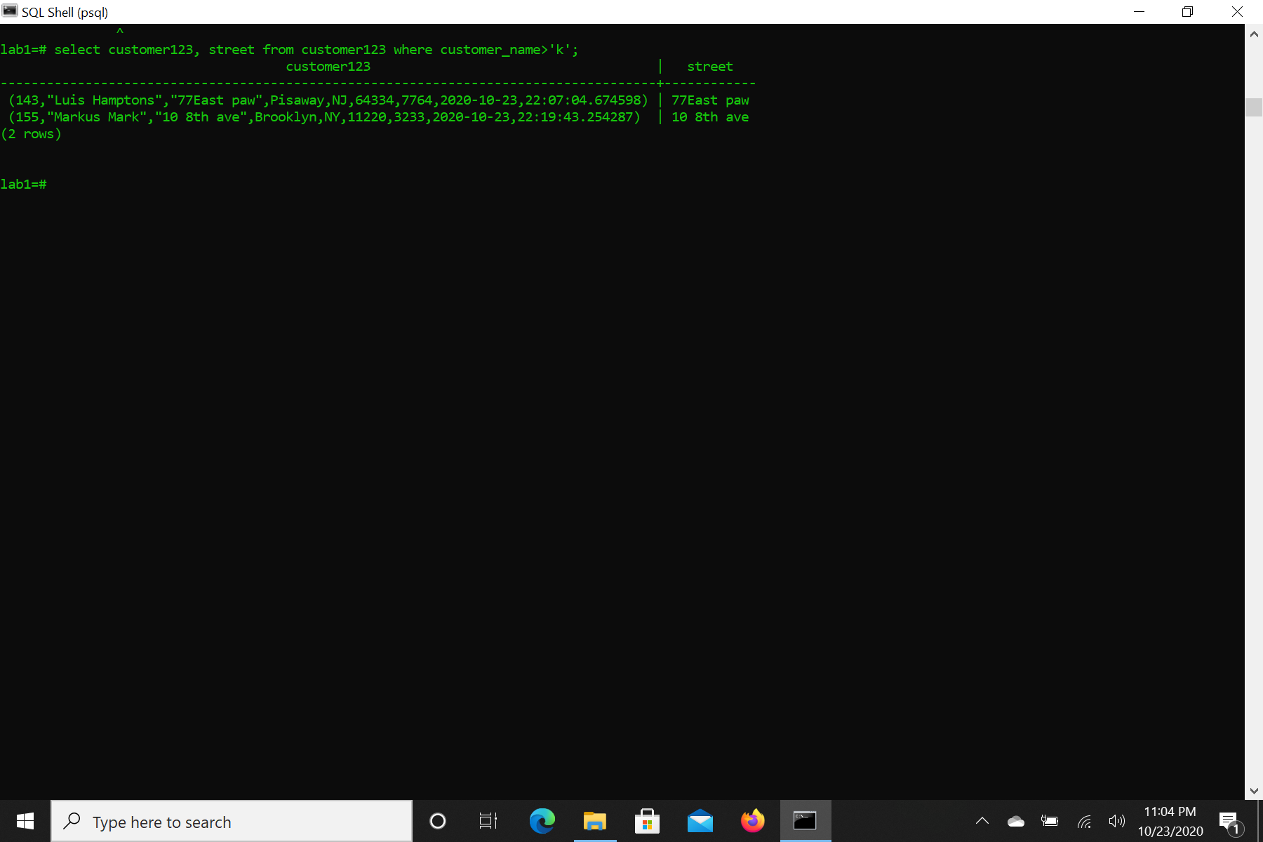

12. List all customer name and customer id for the customers whose name is alphabetically comes

before ’Kate’

1. List unique customer names.

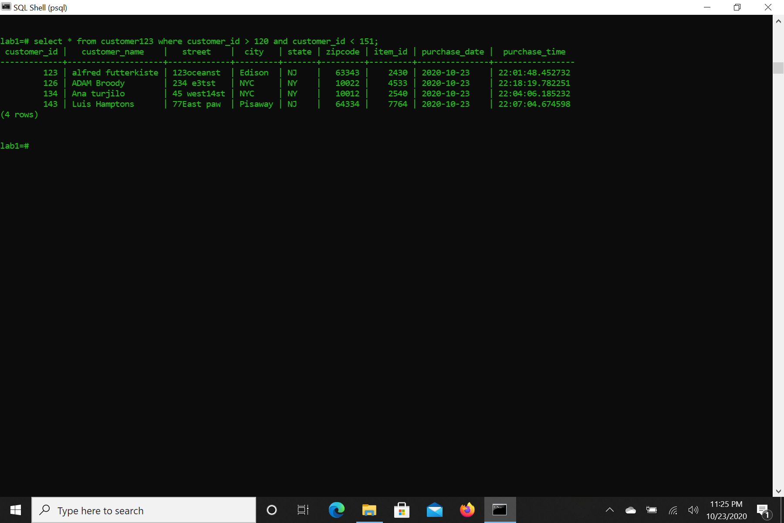

1. 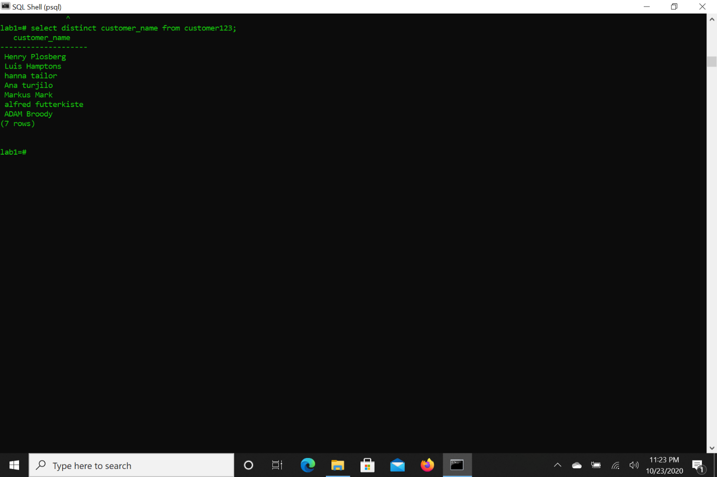

14.

15. 