ALGEBRA 2 | LESSON 3-5 | Day 8
LESSON QUIZ — Zeros of Polynomial Functions
Name: ___________________________________________ Date: _____________
Instructions
• This quiz is silent and individual. Pencil only. No Desmos. No notes.
• Show all work. Partial credit is awarded for correct work even if the final answer is wrong.
• For multiple-choice items, circle one letter AND show supporting work.
• You have 25 minutes.

Question 1a
What are all the zeros of f(x) = x³ + 2x² − 3x?

Work / Answer:
____________________________________________________________
____________________________________________________________
____________________________________________________________
____________________________________________________________

Question 1b
Use the zeros of f(x) = x³ + 2x² − 3x to sketch the graph of f.

Sketch space:
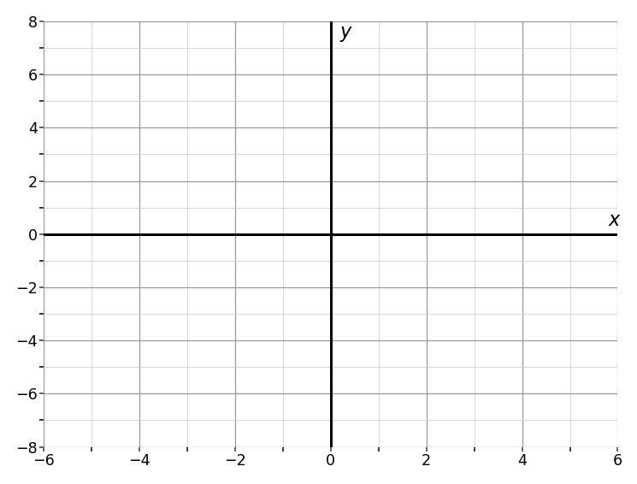

Question 2
What x−values are solutions of x³ + 5x² − x − 7 = x² + 6x + 3? Simplify the polynomial and find the zeros.

Work / Answer:
____________________________________________________________
____________________________________________________________
____________________________________________________________
____________________________________________________________

Question 3
What values of x are solutions of the inequality x³ − 4x > 0?

Work / Answer:
____________________________________________________________
____________________________________________________________
____________________________________________________________
____________________________________________________________

Question 4
What are the zeros and their multiplicities for the function y = x³ + 3x² + x + 3, shown in the graph?
(A) −3, −1, and 1, each multiplicity 1
(B) −3, multiplicity 1
(C) 3, multiplicity 2
(D) −3, multiplicity 3

Work / Answer:
____________________________________________________________
____________________________________________________________
____________________________________________________________
____________________________________________________________

Question 5
Find the zeros of f(x) = −x³ − 2x² + 7x − 4. Then describe the behavior of the graph of f at each zero.
(A) 4, −1; As x → −∞, f → −∞. When −1 < x < 4, f < 0. At x = 4, f is tangent to the x−axis, so when x > 1, f → ∞.
(B) −4, 1; As x → −∞, f → −∞. When −4 < x < 1, f > 0. At x = 1, f is tangent to the x−axis, so when x > 1, f → −∞.
(C) 4, −1; As x → −∞, f → ∞. When −1 < x < 4, f > 0. At x = 4, f is tangent to the x−axis, so when x > 1, f → ∞.
(D) −4, 1; As x → −∞, f → ∞. When −4 < x < 1, f < 0. At x = 1, f is tangent to the x−axis, so when x > 1, f → −∞.

Work / Answer:
____________________________________________________________
____________________________________________________________
____________________________________________________________
____________________________________________________________

