Test Name: LPS_ALG2_Topic3_SY25-26
Test ID: 3783297
Date: 04/20/2026

1. What is the remainder when $f(x)=2x^{4}+x^{3}-8x-1$ is divided by $x-2$?

A. -23

B. 23

C. -3

D. 3

2. Describe the coefficients of a cubic polynomial function $f$ that has one rational zero, $a$, and two zeros, $\sqrt{b}$ and $-\sqrt{b}$, where $b$ is rational.

A. Some are irrational numbers.

B. They are all complex numbers.

C. They are all rational numbers.

D. They are all irrational numbers.

3. Use the Binomial Theorem to expand ${(x-2)}^{6}$.

A. $x^{6}-2x^{5}+4x^{4}-8x^{3}+16x^{2}-32x+64$

B. $x^{6}-12x^{5}+24x^{4}-36x^{3}+48x^{2}-60x+12$

C. $x^{6}-12x^{5}+60x^{4}-160x^{3}+240x^{2}-192x+64$

D. $x^{6}-32x^{5}+16x^{4}-8x^{3}+4x^{2}-2x+64$

4. Simplify $(x^{2}+2x)(x^{2}+x+5)$. Write the simplified polynomial in standard form.
_________ ( Responses: $3x^{3}$, $x^{4}$, $10x$, $7x^{2}$) _________ + _________ ( Responses: $3x^{3}$, $x^{4}$, $10x$, $7x^{2}$) _________ + _________ ( Responses: $3x^{3}$, $x^{4}$, $10x$, $7x^{2}$) _________ + _________ ( Responses: $3x^{3}$, $x^{4}$, $10x$, $7x^{2}$) _________

5. The graph of $f(x)=x^{3}-2x^{2}$ is shown.

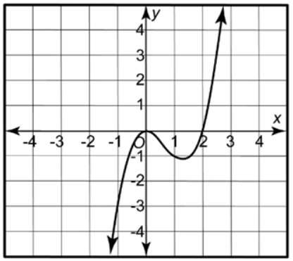

Available Responses:
0 | 1 | decreases | 2 | -2 | remains constant | increases
The zeros of $f$ are _________ and _________ .
As x increases to infinity, $f(x)$ _________ . As x decreases to negative infinity, $f(x)$ _________ .

6. Lucy cuts 4 squares with the side length $x$ in. from the corners of a 6-by-9-in. piece of paper. She folds the paper to make a tray that is $x$ in. high. Complete the function for the tray's volume $V$ in terms of $x$.
$V(x)=$ _________ ( Responses: 6, 4) _________ $x^{3}$ $-$ _________ ( Responses: 9, 30) _________ $x^{2}+$ _________ ( Responses: 30, 54) _________ $x$

7. Use polynomial identities to factor $64+27a^{3}$. Select all factors.

A. $(4-3a)$

B. $(4+3a)$

C. $(16+12a+9a^{2})$

D. $(16-12a+9a^{2})$

E. $(16-12a+3a^{2})$

8. The volume of a cube with length $x$ is $V(x)=x^{3}$. The volume of a sphere with radius $x$ is shown over the graph. Over the interval $[0.5,1]$, which volume is increasing faster?

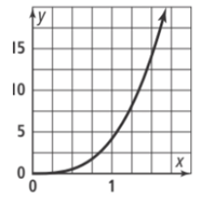

The volume of the _________ ( Responses: sphere, cube) _________ is increasing faster.

9. Use synthetic division to divide $2x^{4}-3x^{3}+2x^{2}-8x-1$ by $x-1$. Complete the quotient.
_________ ( Responses: $-7$, $-x^{2}$, $-\frac{8}{x-1}$, $x$, $2x^{3}$) _________ $+$ _________ ( Responses: $-7$, $-x^{2}$, $-\frac{8}{x-1}$, $x$, $2x^{3}$) _________ $+$ _________ ( Responses: $-7$, $-x^{2}$, $-\frac{8}{x-1}$, $x$, $2x^{3}$) _________ $+$ _________ ( Responses: $-7$, $-x^{2}$, $-\frac{8}{x-1}$, $x$, $2x^{3}$) _________ $+$ _________ ( Responses: $-7$, $-x^{2}$, $-\frac{8}{x-1}$, $x$, $2x^{3}$) _________

10. Identify the zeros of the function $f(x)=x(x-3)(x+1)$.
_________
, _________
, _________

11. How does the graph of the function $f(x)=2x^{4}-3$ differ from the graph of its parent function? Select all transformations.

A. The graphs are the same.

B. Subtracting 3 translates the graph down 3 units.

C. The leading coefficient, 2, stretches the graph vertically.

D. Subtracting 3 translates the graph up 3 units.

E. Subtracting 3 translates the graph right 3 units.


You have reached the end of this section.

