Lesson 4-1: Inverse Variation/Reciprocal Function
Math Objective | Identify and use Inverse Variation. Graph reciprocal functions.
Language Objective | Students will be able to describe why a relation is an inverse variation with the support of sentence frames.
Essential Understanding | The reciprocal function is used to model inverse variation, which is a proportional relationship between 2 variables such that when one increases, the other decreases.

MODEL AND REASON
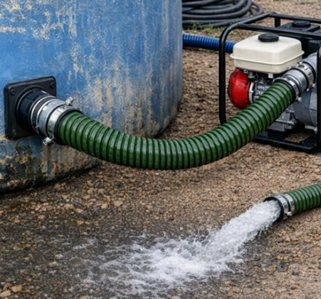
A pump is emptying a water tank. Here are some different pumping rates and the times it takes to empty the tank:
Pump Rate (gal/min) | Time (min)
120 | 40
80 | 60
60 | 80
40 | 120

- What happens to the time when the pump rate increases?

“When the pump rate goes up, the time goes ___.” | “A bigger rate means the time is ___.”
“I notice the time gets ___ when the rate is higher.” | “As the rate increases, the time seems to ___.”
- Try multiplying rate × time for two rows. What do you notice?

“For the second row, the product is ___.” | “The products are ___ and ___, so they are ___.”
“I notice the product stays ___.” | “The product does/does not change because ___.”
- What would happen with a pump rate of 200 gal/min? Explain your thinking.

“If the rate is 200 gal/min, I think the time would be ___ because ___.” | “A faster pump means the time should be ___.”
“At 200 gal/min, the time might be around ___ minutes.” | “I predict the time will be ___ since the pattern shows ___.”
- Pick 2 new pump rates and estimate how long it would take to empty the tank

QUICK GUIDE — Inverse Variation

Definition
Two variables show inverse variation if their product is constant:
$$xy=k$$
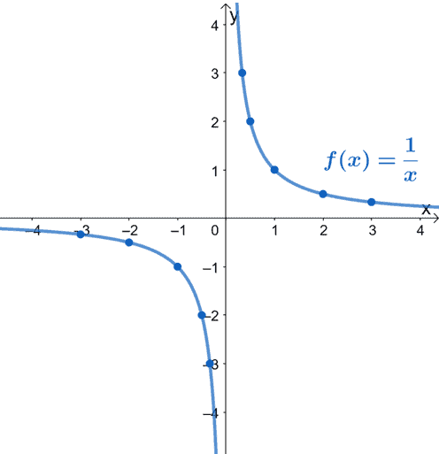
This can also be written as:
$$y=\frac{k}{x}$$
Key Features
- As one variable increases, the other decreases
- The product $xy$ stays constant
- The graph looks like a reciprocal curve

EXAMPLE 1 — Identify Inverse Variation
Does the table represent an inverse variation?
x | 1 | 2 | 3 | 4 | 6
y | 12 | 6 | 4 | 3 | 2
xy | ___ | ___ | ___ | ___ | ___
Compute the products…

Yes. The product is constant → inverse variation.

TRY IT 1
Determine whether each table represents an inverse variation.
x | 1 | 2 | 3 | 5 | 6 | 15
y | 25.5 | 12.75 | 8.50 | 5.10 | 4.25 | 1.70
xy

x | 6.6 | 5.5 | 4.4 | 3.3 | 2.2 | 1.1
y | 3 | 5 | 7 | 9 | 11 | 13
xy

EXAMPLE 2 — Write an Inverse Variation Equation
In an inverse variation, $x=10$ when $y=3$. Write the equation and find $y$ when $x=-6$.

Step 1: Find the constant $k$.
$$10⋅3=30$$
Step 2: Write the equation.
$$y=\frac{30}{x}$$
Step 3: Substitute $x=-6$.
$$y=-5$$
TRY IT 2
If $x=6$ when $y=16$:

a. Find k b. Write the equation. c. Find $y$when $x=15$.

EXAMPLE 3 — Use an Inverse Variation Model

The number of downloaded games $n$ that can be stored on a video game system varies inversely with the average game size $s$ in gigabytes (GB).

A certain system can store 160 games when the average game size is 2.0 GB.

A. Write an inverse equation that relates $n$ and $s$.
$$n=\frac{k}{s}$$

$$160=\frac{k}{2.0}⇒k=320$$

$$n=\frac{320}{s}$$


B. Use the inverse relationship to complete the table.

Game Size (GB), $s$ | 1.0 | 2.5 | 3.0 | 4.0
Number of Games, $n$
ns | 320 | 320 | 320 | 320

C. Sketch a graph of this inverse relationship where n > 0.

TRY IT 3 — Ice Cube Melting

The time $t$ it takes for an ice cube to melt varies inversely with the air temperature $T$ in °C. At 20°C, the ice melts in 20 minutes. Write an inverse equation and find out how long it will take to melt at 30°. Sketch a graph of this relationship

THE RECIPROCAL FUNCTION — Key Features
The reciprocal function is:
$$f(x)=\frac{1}{x}$$
Important Characteristics
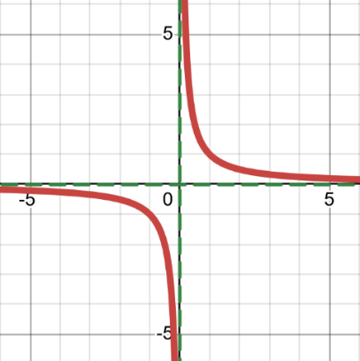
- Vertical asymptote: $x=0$
- Horizontal asymptote: $y=0$
- Domain: all real numbers except 0
- Range: all real numbers except 0
- As $x→0^{+}$, $f(x)→+∞$
- As $x→0^{-}$, $f(x)→-∞$
- As $x→±∞$, $f(x)→0$

EXAMPLE 4 — Transformations of the Reciprocal Function
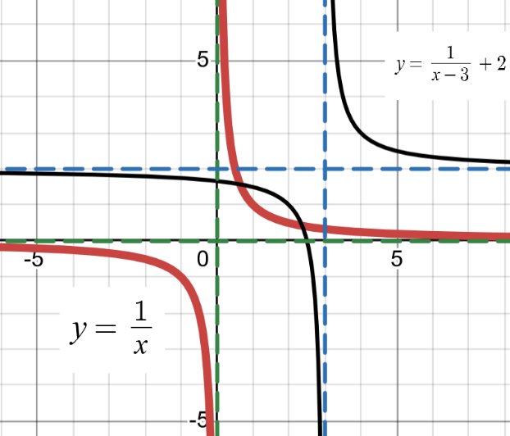
Graph:
$$g(x)=\frac{1}{x-3}+2$$
Transformations
- Shift right 3 + Shift up 2
Asymptotes
- Vertical: $x=3$ + Horizontal: $y=2$
Domain & Range
- Domain: $x≠3$ Range: $y≠2$


TRY IT 4
Graph:
$$g(x)=\frac{1}{x+2}-4$$
Identify:
- Vertical asymptote
- Horizontal asymptote
- Domain
- Range

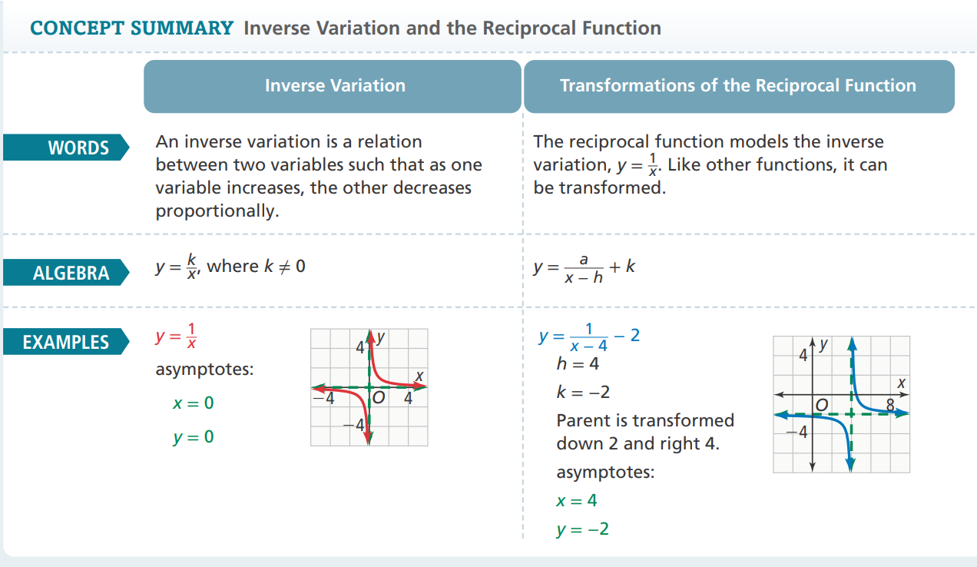

Select Exercises
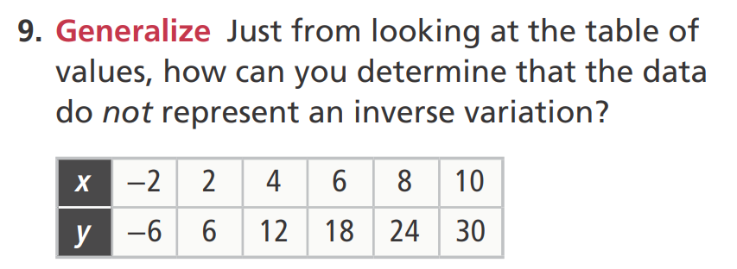
DOK 1
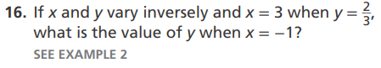
DOK 1
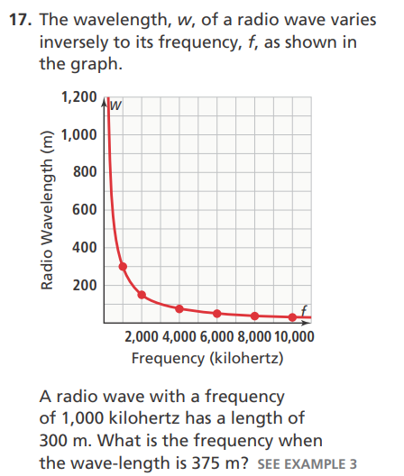
DOK 2
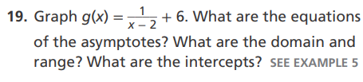 DOK 2 | 
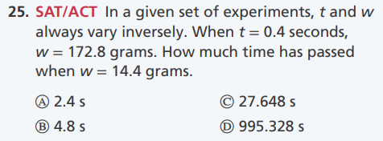 DOK 3

