Lesson 3.5: Zeros of Polynomial Functions
Math Objectives | - Identify the zeros of a function using factoring or synthetic division.  - Use zeros to graph a polynomial function.  - Interpret features of polynomial functions in the context of a real world problem.
Language Objective | Students will explain solutions to problems involving polynomial functions, verbally and in writing, with the support of structured student talk-time, models, and real-time scaffolding/questioning.
Essential Question | How are the zeros of a polynomial function related to an equation and graph of the function?
Do Now
Without the use of a graphing calculator, determine which of the following functions is the graph of
$f\left(x\right)=x^{3}+x^{2}-4x$. Explain why you made that choice.
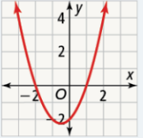 | 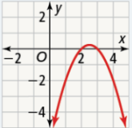
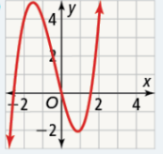 | 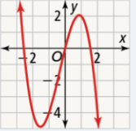

________________________________________________________________________________________________
________________________________________________________________________________________________
________________________________________________________________________________________________
________________________________________________________________________________________________


Apply – Make Sense and Persevere
A firework is launched vertically into the thin air. Its height in meters is given by the function shown, where t is measured in seconds.
- What is a reasonable domain of the function?

- What are the zeros of the function? Explain what they represent in this situation.

- Use technology to find the vertex. What does it represent in this situation?

Performance Task

Venetta opened several deli sandwich franchises in the year 2000. Her profit $P$, in hundreds of dollars, after $t$ years can be modeled by the function:
$$P(t)=t(t+3)(t-2)$$

A. Sketch a graph of the function (and confirm with DESMOS)

B. During what years did Venetta not make a profit? Explain how you know.

- If the model is appropriate, predict the amount of profit Venetta will earn in 2020. Show your thinking. (t = 0 is the year 2000)

Name ___________________________________________________
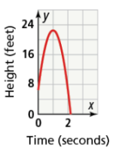
Exit Ticket
- The height of a baseball thrown in the air can be modeled by the function $h\left(t\right)=-16t^{2}+32t+6.5$, where $h\left(t\right)$ represents the height in feet of the baseball after $t$ seconds. Explain why the graph of this function only shows one zero.

______________________________________________________________________
______________________________________________________________________
______________________________________________________________________

- What is something you learned today?
_________________________________________________________________________________________________
_________________________________________________________________________________________________
_________________________________________________________________________________________________
- What is something you liked about this lesson?
_________________________________________________________________________________________________
_________________________________________________________________________________________________
_________________________________________________________________________________________________

