3-5 Lesson Quiz
Zeros of Polynomial Functions

- Part A
What are all the zeros of
f(x) = x³ + 2x² − 3x ?
Zeros: , ,
Part B
Use the zeroes to sketch the graph
of f.
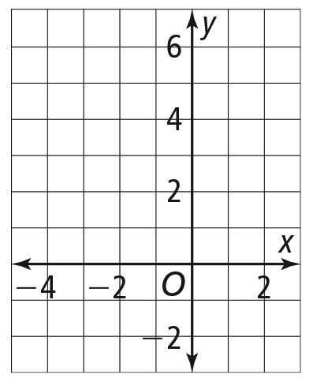

- What x-values are solutions of
x³ + 5x² − x − 7 = x² + 6x + 3?
Simplify the polynomial and find
the zeros. Complete the sentence.
The zeros are at x = ,
x = , and x = .

- What values of x are solutions of
the inequality x³ − 4x > 0?
The inequality is true for
and
0 < x < 2.
x > 0.
x > 2.
x > 4.
0 < x < 2
−2 < x < 0
x < −2
x < 2

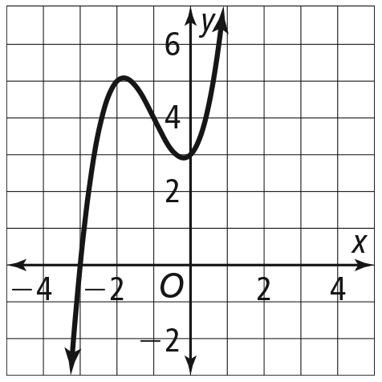
4. What are the zeros and their
multiplicities for the function
y = x³ + 3x² + x + 3, shown in
the graph?
- −3, −1, and 1, each multiplicity 1
- −3, multiplicity 1
- 3, multiplicity 2
- −3, multiplicity 3

5. Find the zeros of f(x) = −x³ − 2x² +
7x − 4. Then describe the behavior
of the graph of f at each zero.
- 4, −1; As x → −∞, f → −∞. When
−1 < x < 4, f < 0. At x = 4, f is
tangent to the x-axis, so when
x > 1, f → ∞.
- −4, 1; As x → −∞, f → −∞.
When −4 < x < 1, f > 0.
At x = 1, f is tangent to the x-axis,
so when x > 1, f → −∞.
- 4, −1; As x → −∞, f → ∞. When
−1 < x < 4, f > 0. At x = 4, f
is tangent to the x-axis, so
when x > 1, → ∞.
- −4, 1; As x → −∞, f → ∞. When
−4 < x < 1, f < 0. At x = 1, f is
tangent to the x-axis, so when
x > 1, f → −∞.

