
Lesson 1.3: Piecewise-Defined Functions
Math Objectives | - Create and graph piecewise-defined functions, including absolute value functions and step functions.  - Create and use a piecewise-defined function from real-world data.  - Write a piecewise-defined rule from a graph.  HSF.IF.C.7.B, HSF.IF.B.5
Language Objective | Students will verbally explain solutions to piecewise-defined functions, provided pre-taught vocabulary, the three-reads strategy, and structured student-talk time.
Essential Question | How do you model a situation in which different functions describe specific intervals of its domain?
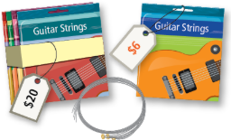
A music teacher needs to buy guitar strings for her class. At Store A, she can buy a single pack of strings. At Store B, she can buy a bundle of 4 packs of strings.

- Make graphs that show the income each store receives if the teacher needs 1-20 packs of guitar strings.

- Describe the shape of the graph for store A. Describe the shape of the graph for store B. Why are the graphs different?

- Communicate Precisely Compare the graphs for stores A and B. For what numbers of guitar strings is it cheaper to buy from store B? Explain how you know.

Alani has a summer job as a lifeguard. She makes $12/hour for up to 40 hours each week. If she works more than 40 hours, she makes 1.5 times her hourly pay, or $18/hour, for each hour over 40 hours. How could you make a graph and write a function that shows Alani’s weekly earnings based on the number of hours she worked?

Step 1 Make a table of values and a graph.
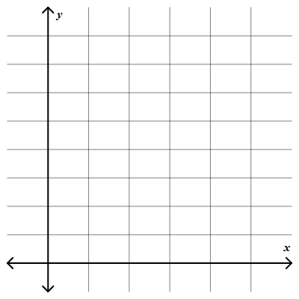
Hours Worked | Pay
20
25
30
35
40
45
50
55

Step 2 Notice that the plot contains two linear segments with a slope that changes slightly at x = 40. A function that has different rules for different parts of its domain is called a piecewise-defined function.

Step 3 Write an equation for each piece of the graph.

- How much will Alani earn if she works:
- 37 hours? | - 43 hours?

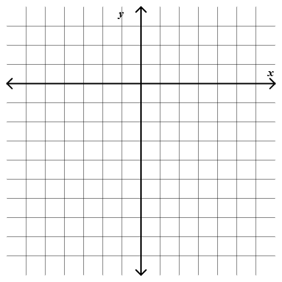
How do you graph a piecewise defined function?

$$f\left(x\right)=\left\{\begin{aligned}4x+11, -10≤x<-2 \\ x^{2}-1, -2≤x≤2 \\ 2x-10, 2<x<10\end{aligned}\right.$$

What are the domain and range? Over what intervals is the function increasing or decreasing?

- Graph the piecewise-defined functions. What are the domain and range? Over what intervals is the function increasing or decreasing?
- $f\left(x\right)=\left\{\begin{aligned}2x+5, -6≤x<-2 \\ {2x}^{2}-7, -2<x<1 \\ -4-x, 1≤x≤3\end{aligned}\right.$  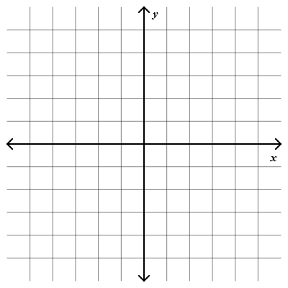 | - $f\left(x\right)=\left\{\begin{aligned}3, -4<x≤-1 \\ -x, 0≤x≤2 \\ 3-x, 2<x<4\end{aligned}\right.$

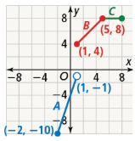
What is the rule that describes the piecewise-defined function shown in the graph?
There are three pieces for this function. For each piece, find the x interval. For each piece, also find each slope and pick a point to find the rule.
Piece A | Piece B | Piece C
Interval: | Interval: | Interval:
point( , ), slope = | point( , ), slope = | point( , ), slope =
y = mx + b | y = mx + b | y = mx + b
f(x) = | f(x) = | f(x) =

The rule for this function is:

- What rule defines the function in each of the following graphs?
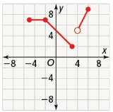 | 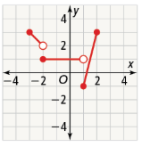

How can you rewrite the function $f\left(x\right)=|6x+18|$ as a piecewise-defined function?

Step 1 Write the function in the form $f\left(x\right)=a\left|x-h\right|+k$ to find the vertex of the function.

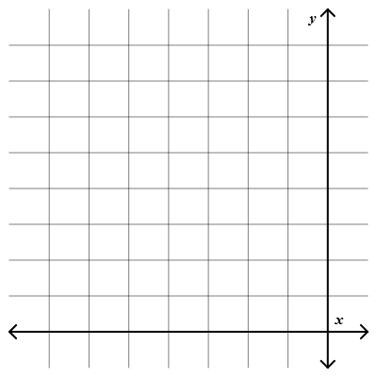
Step 2 Graph the function. Determine the slope and equation of each piece by choosing x-values on either side of -3.

Step 3 Write the piecewise-defined function.

- How can you rewrite each function as a piecewise-defined function?
- $f\left(x\right)=|-5x-10|$ | - $f\left(x\right)=-\left|\frac{1}{2}x\right|+3$

The shipping cost of items purchased from an online store is dependent on the weight of the items. The table represents shipping costs y based on the weight x.  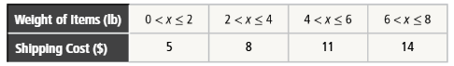  - Graph the function.  - What are the domain and range of the function, and what do they represent?  - What are the maximum and minimum values? |  | Student Responses (in complete sentences) |  | Additional Responses
 |  | First Read – Understanding Context
What is the core of the problem?
- I think the problem is about …
 |  | Second Read – Interpreting the Question
What are you trying to find out?
- The problem is asking …
 |  | Third Read – Identifying Necessary Information
What are the important quantities, relationships, and other relevant information?
- The important information is…
Explore Reasoning – What are three different ways to think about solving this problem?
Solution (show and explain your answer)
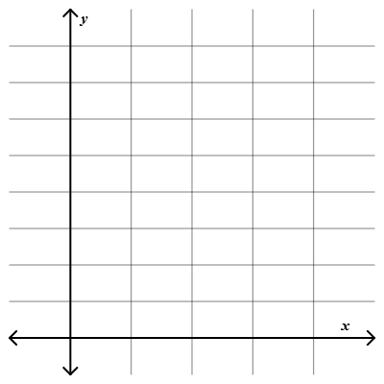
Interpretation of Solution (interpret your solution in your own words)
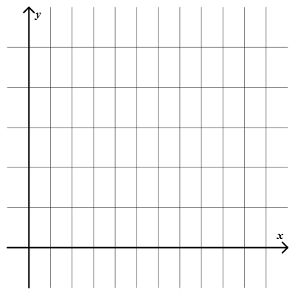
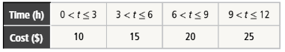
- The table below represents fees for a parking lot. Graph the function. What are the domain and range of the function, and what do the represent? What are the maximum and minimum values?

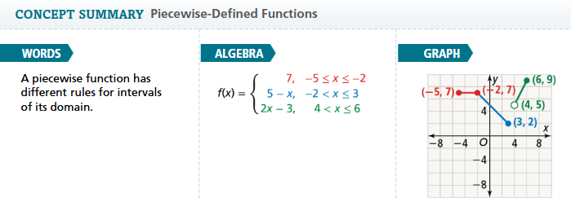
- Essential Question How do you model a situation in which different functions describe specific intervals of its domain?

- Error Analysis Given the function $f\left(x\right)=\left\{\begin{aligned}2x+5, -2<x≤4 \\ -4x-7, 4<x≤9\end{aligned}\right.$
Tomas says there is an open circle at x = 4 for both pieces of the function. Explain his error.

Graph the function.
- $f\left(x\right)=\left\{\begin{aligned}-x+1, -10≤x<-3 \\ x^{2}-9, -3≤x≤3 \\ 2x+1, 3<x<5\end{aligned}\right.$  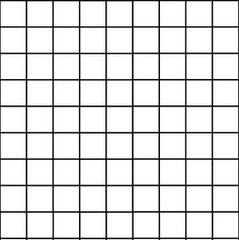 | - $f\left(x\right)=\left\{\begin{aligned}1, 0≤x<2 \\ 3, 2≤x<4 \\ 5, 4≤x<6 \\ 7, 6≤x<8\end{aligned}\right.$

