
Lesson 1.4: Arithmetic Sequences and Series
Math Objectives | - Identify the common difference in an arithmetic sequence.  - Write arithmetic sequences both recursively and with an explicit formula.  - Construct arithmetic sequences, given a graph, a description of a relationship, or two input-output pairs.  HSF.BF.A.2, HSF.BF.A.1.A
Language Objective | Students will explain solutions to problems involving arithmetic sequences and series, provided pre-taught vocabulary, the three-reads strategy, and structured student-talk time.
Essential Question | What is an arithmetic sequence, and how do you represent and find its terms and their sums?
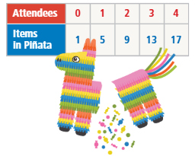
Yumiko and Hugo are looking at the table of data about the number of families attending a party and how many items are needed to fill piñatas.

Yumiko writes the following:
$$f\left(1\right)=1+4=5 \\ f\left(2\right)=f\left(1\right)+4=5+4=9 \\ f\left(3\right)=f\left(2\right)+4=9+4=13 \\ f\left(4\right)=f\left(3\right)+4=13+4=17$$

Huo writes: $g\left(x\right)=1+4x$

- Describe the pattern Yumiko found for finding items needed for the piñatas.

- Describe the pattern Hugo found for finding items needed for the piñatas.

- Use Structure Compare the two methods. Which method would be more useful in finding the items needed when 100 family members attend? Why?

- Is the sequence arithmetic? If so, what is the common difference? What is the next term in the sequence?

3, 8, 13, 18, 23, …

A sequence is a function whose domain is the natural numbers.

Create a table that shows the term number, or domain, and the term, or range.

Term Numbers | Term
1 | $$f\left(1\right)=3$$
2 | $f\left(2\right)=$
3
4
5
6

An arithmetic sequence is a sequence with a constant difference between consecutive terms. This difference is known as the common difference, or d.

- Is the sequence 4, 7, 10, 13, 16, … arithmetic? If so, what is the next term in the sequence?

- Are the following sequences arithmetic? If so, what is the next term in the sequence?

- 25, 20, 15, 10, … | - 2, 4, 7, 12, 13, …

How could you write a formula for the terms of the sequence 3, 8, 13, 18, 23, … based on the previous terms?

Represent each term by f(n) where n represents the number of the term.

So, for n = 1, $f(1) = 3$.

$$f\left(2\right)=f\left(1\right)+$$
$$f\left(3\right)=$$
$$f\left(n\right)=$$

You can write a formula for an arithmetic sequence with a common difference d as a piecewise-defined function.

This is the recursive definition for the arithmetic sequence. Each term is defined by operations on the previous term.

Another way to write a sequence is to use subscript notation:

- Write recursive definitions for each arithmetic sequence, using function notation and subscript notation.

- 103, 99, 95, 91, 87, … | - $-6\frac{1}{3},-4\frac{2}{3},-3, -1\frac{1}{3},\frac{1}{3},…$

- Given the recursive definition $a_{n}=\left\{\begin{aligned}3, n=1 \\ a_{n-1}+0.5, n>1\end{aligned}\right.$ what is an explicit definition for the sequence?

An explicit definition allows you to find any term in the sequence without knowing the previous term.

Use the recursive definition to find a pattern.

$$a_{1}=3$$
$$a_{2}=a_{1}+0.5=$$
$$a_{3}=$$

In general, the explicit definition of an arithmetic sequence is:

- Given the explicit definition $a_{n}=16-3(n-1)$, what is the recursive definition for the arithmetic sequence?

  - For the recursive definition $a_{n}=\left\{\begin{aligned}45, n=1 \\ a_{n-1}-2, n>1\end{aligned}\right.$, what is the explicit definition?

  - For the explicit definition $a_{n}=1+7(n-1)$, what is the recursive definition?

A high school auditorium has 18 seats in the first row and 26 seats in the fifth row. The number of seats in each row forms an arithmetic sequence.  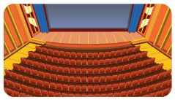  - What is the explicit definition for the sequence?  - How many seats are in the twelfth row? |  | Student Responses (in complete sentences) |  | Additional Responses
 |  | First Read – Understanding Context
What is the core of the problem?
- I think the problem is about …
 |  | Second Read – Interpreting the Question
What are you trying to find out?
- The problem is asking …
 |  | Third Read – Identifying Necessary Information
What are the important quantities, relationships, and other relevant information?
- The important information is…
Explore Reasoning – What are three different ways to think about solving this problem?
Solution (show and explain your answer)
Interpretation of Solution (interpret your solution in your own words)

- Samantha is training for a race. The distances of her training runs form an arithmetic sequence. She runs 1 mi the first day and 2 mi the seventh day.
  - What is the explicit definition for this sequence?

  - How far does she run on day 19?

    - What is the sum of the terms in the arithmetic sequence 1, 4, 7, 10, 13? What is a general formula for an arithmetic sequence?

A finite series is the sum of the terms in a finite sequence.
A finite arithmetic series is the sum of the terms in an arithmetic sequence.
For the sum of n numbers in a sequence, you can use a recursive formula, or simply add the terms.

$$s_{n}=a_{1}+a_{2}+a_{3}+a_{4}+…+a_{n} \\ s_{5}=$$

If the series has many terms, it would be easier to use an explicit definition.
To find the explicit definition for the sum, use the Commutative Property of Addition and reverse the order of the terms in the recursive series.
$$s_{5}=$$

Add the last two expressions for the series. Notice you are adding the first term to the last term.

Write the explicit formula.

    - What is the sum of the following arithmetic sequence?
2, 6, 10, 14, 18, 22, …

n = $a_{1}=$ $a_{n}=$
Use the general formula to find the sum.

The sum of the terms in the sequence is: _______.

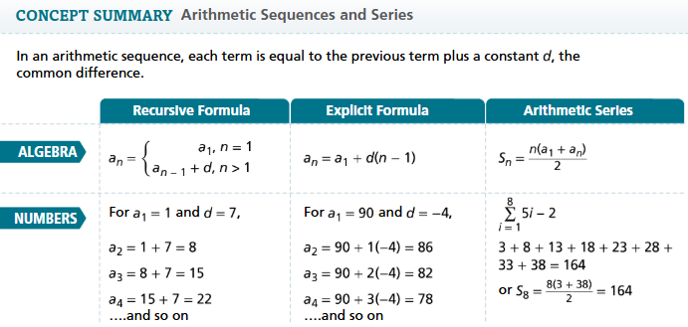
- Essential Question What is an arithmetic sequence, and how do you represent and find its terms and their sums?

Find the common difference and the next three terms of each arithmetic sequence.
- $\frac{1}{4},\frac{1}{2},\frac{3}{4}, 1,\frac{5}{4},…$ | - $6, 1,-4,-9,-14,…$
- $215, 227, 239, 251, …$ | - $-4, -5, -6, -7, …$
- $4.1, 6.3, 8.5, 10.7, …$ | - $-17, -9, -1, 7, 15$

