Lesson 1.5: Solving Equations and Inequalities by Graphing
Math Objectives | - Use graphs, tables, and graphing technology to find or approximate solutions to equations and inequalities.  - Find approximate solutions to equations and inequalities by setting each expression equal to y and graphing.  HSA.CED.A.1
Language Objective | Students will verbally explain solutions to equations and inequalities by graphing, provided pre-taught vocabulary, sentence starters, and structured student-talk time.
Essential Question | How can you solve an equation or inequality by graphing?
A homeowner has 32 feet of fencing to build three sides of a rectangular chicken run.
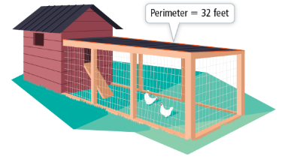
- Make a table of values for the length, width, and area of different rectangular chicken runs that will utilize 32 feet of fencing. Then write a function for the area, in terms of width, of a rectangular run using this much fencing.

- Graph your function. (Use graph pap er or Desmos.)

- Reason Explain what happens where the graph intersects the x-axis.

How can you use a graph to solve an equation?

- Solve $-3x+20=0.2x+4$ by graphing.
To solve an equation by graphing, write two new equations by setting y equal to each expression in the original equation.

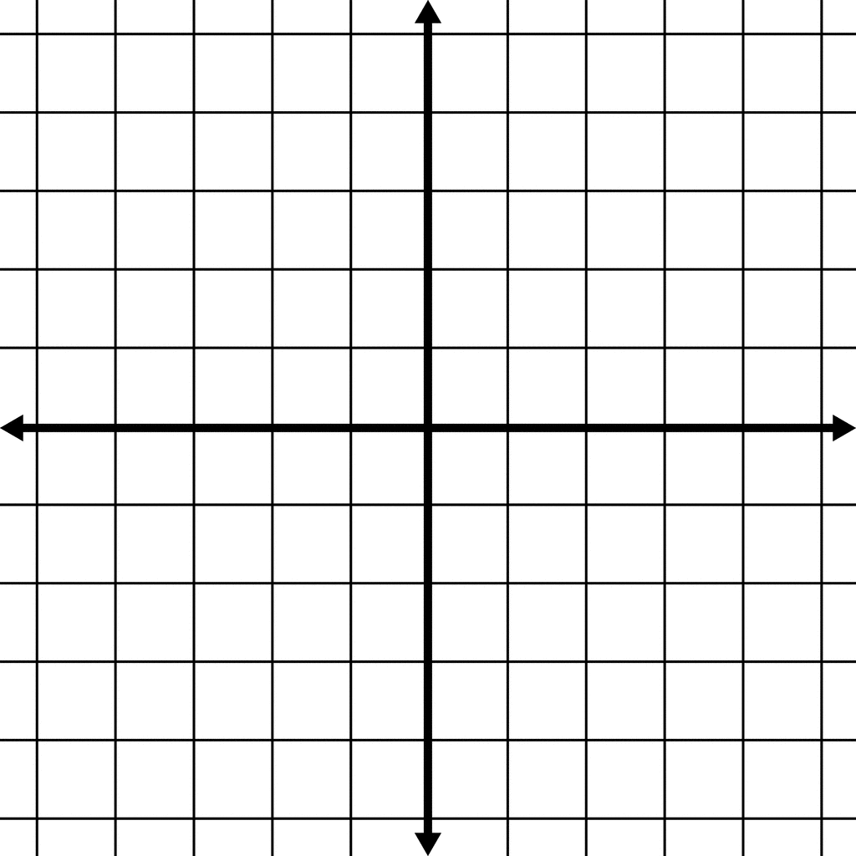

Graph the two equations and identify the points of intersection.

- Solve $\left|x-4\right|=\frac{1}{2}x+1$ by graphing.

- Use a graph to solve the equation.
- $5x-12=3$ | - $-\left|x-2\right|=-\frac{1}{2}x-2$

- Solve $x^{2}-4>0$.
To solve the inequality, identify the values of x that make the value of the expression $x^{2}-4$ greater than 0.

Graph the equation $y=x^{2}-4$ by translating the parent function ${y=x}^{2}$ down 4 units.

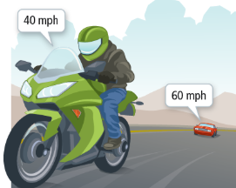
- A motorcycle is 40 mi ahead of a car. When will the car be ahead of the motorcycle?
To solve, we need to determine when the number of miles the car travels exceeds the number of miles the motorcycle travels.



- Use a graph to solve each inequality.
- $x^{2}+6x+5≥0$ | - $x+3>7-3x$

Use a graph and tables to solve the equation $x^{2}-4x+1=x-2$.

Sketch the graphs of $y=x^{2}-4x+1$ and $y=x-2$. Identify the points of intersection to find initial estimate(s) of the solution value(s).

You can use a table to get more accurate estimates for the solutions.
Create tables of values for each of the equations to estimate solutions, either by hand or on Desmos.

- The equation $x^{2}-4x+1=x-2$ has a second solution in the interval $4<x<5$. Use Desmos or a spreadsheet to approximate this solution to the nearest thousandth.

- Use graphing technology to approximate the solutions of the equation
$-x^{2}+8x-13=|x-4|$ to the nearest tenth.

Graph $y=-x^{2}+8x-13$ and $y=|x-4|$

Use the INTERSECT feature to find the approximate solutions.

The equation has solutions at:

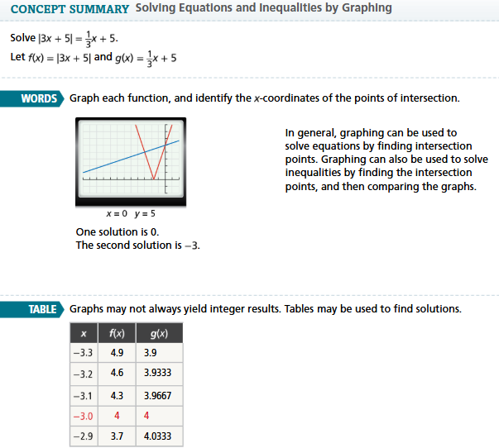
- Essential Question How can you solve an equation or an inequality by graphing?

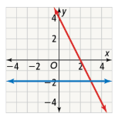
- Using the graph below, what is the solution to $-2x+4=-2$? How can you tell?

