
Lesson 1.6: Linear Systems
Math Objectives | - Solve linear systems graphically and algebraically.  - Identify regions that satisfy systems of inequalities.  HSA.REI.C.6, HSA.CED.A.3
Language Objective | Students will verbally explain solutions to linear systems, provided pre-taught vocabulary, the three-reads strategy, and structured student-talk time.
Essential Question | How can you find and represent solutions of systems of linear equations and inequalities?
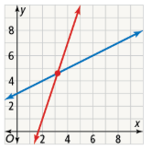
The graph shows two lines that intersect at one point.
- What are the approximate coordinates of the point of intersection?

- How could you verify whether the coordinates you estimated are, in fact, the solution? Is the point the solution to the equations of both lines?

- Make Sense and Persevere Use your result to refine your approximation, and try again. Can you find the point of intersection this way? Is there a more efficient way?

What is the solution of the system of linear equations $\left\{\begin{aligned}x+2y=3 \\ x-2y=4\end{aligned}\right.$?
A system of linear equations is a set of two or more equations using the same variables. The solution of a system of linear equations is the set of all ordered coordinates that simultaneously make all equations in the system true.

Sketch the graph of each equation to estimate the solutions.
Then, solve algebraically.

- Solve each system of equations.
- $\left\{\begin{aligned}2x+y=-1 \\ 5y-6x=7\end{aligned}\right.$ | - $\left\{\begin{aligned}3x+2y=5 \\ 6x+4y=3\end{aligned}\right.$

Malcon earns money doing chores for neighbors. His goal is to earn at least $200 each week, but he can work a maximum of 20 hours per week. Malcom must spend at least 5 hours per week walking his neighbors’ dogs. For how many hours should Malcom work at each job in order to meet his goals?  A system of linear inequalities is a set of two or more inequalities using the same variables.   |  | Student Responses (in complete sentences) |  | Additional Responses
 |  | First Read – Understanding Context
What is the core of the problem?
- I think the problem is about …
 |  | Second Read – Interpreting the Question
What are you trying to find out?
- The problem is asking …
 |  | Third Read – Identifying Necessary Information
What are the important quantities, relationships, and other relevant information?
- The important information is…
Explore Reasoning – What are three different ways to think about solving this problem?
Solution (show and explain your answer)
Interpretation of Solution (interpret your solution in your own words)

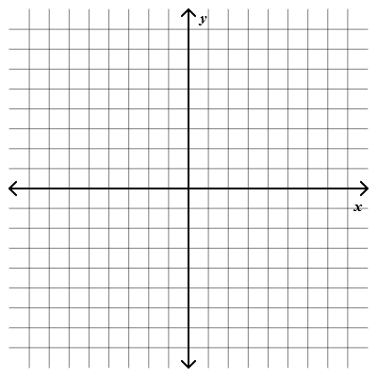
- Sketch the graph of the set of all points that solve this system of linear inequalities.
$$\left\{\begin{aligned}2x+y≤14 \\ x+2y≤10 \\ x≥0 \\ y≥0\end{aligned}\right.$$

How can you solve a system of equations in three variables?
- What is the solution of this system?
$$\left\{\begin{aligned}2x+y-x=-10 \\ -x+2y+z=3 \\ x+2y+3z=13\end{aligned}\right.$$

- What is the solution of this system?
$$\left\{\begin{aligned}2x-y+z=3 \\ x+y+z=5 \\ -4x+2y-2z=0\end{aligned}\right.$$

- Solve the following systems of equations.
- $\left\{\begin{aligned}x+y+z=3 \\ x-y+z=1 \\ x+y-z=2\end{aligned}\right.$ | - $\left\{\begin{aligned}2x+4y-6z=8 \\ -4x+y+12z=-16 \\ x-3z=4\end{aligned}\right.$

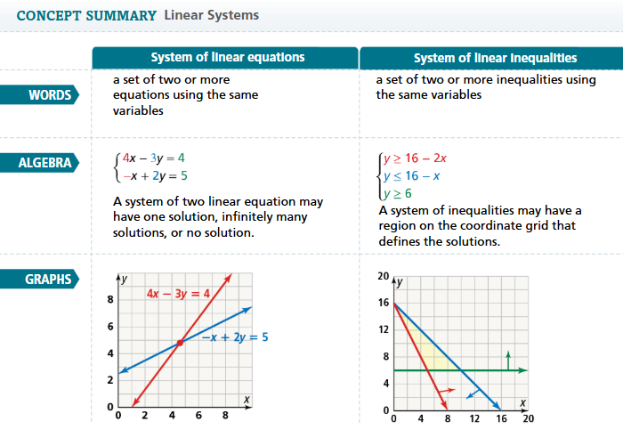
- Essential Question How can you find and represent solutions of systems of linear equations and inequalities?

- Solve the following system of equations.  $$\left\{\begin{aligned}2x+2y=10 \\ x+5y=13\end{aligned}\right.$$ | - Graph the following system of inequalities.  $$\left\{\begin{aligned}-x+2y<1 \\ x≥0 \\ y≥0\end{aligned}\right.$$  