
Lesson 2.1: Vertex Form of a Quadratic Function
Math Objectives | - Create quadratic functions in vertex form to represent relationships between variables as shown in their graphs.  - Graph functions on coordinate axes using their key features.  - Interpret key features of the graph of a quadratic function.  HSA.CED.A.2, HSF.IF.B.4
Language Objective | Students will verbally explain solutions problems involving the vertex form of a quadratic function, provided pre-taught vocabulary, the three-reads strategy, and structured student-talk time.
Essential Question | How are transformations related to the vertex form of a quadratic function?
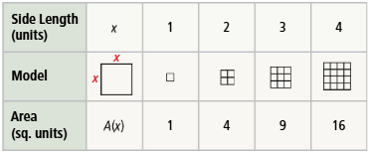
The table represents A(x), the area of a square as a function of side length x units, where x is a positive real number.
- Consider the function where the areas in the table are doubled. Write the equation of a function that represents this.

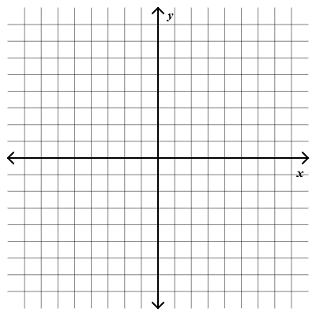
- Look for Relationships Graph the ordered pairs for both A(x) and your new function. How would you describe the differences in the locations of these points?

- Find the equation for a function whose x-values are the same as A(x) but whose y-values are 2 units greater than each y-value in A(x).

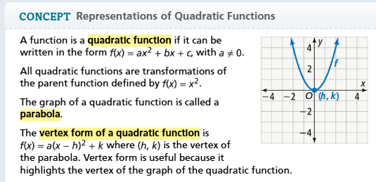
How are transformations of the graph of $f\left(x\right)=x^{2}$ related to its parent function?
The vertex form of the quadratic function contains three values which transform the graph of the function $f\left(x\right)=x^{2}$.
The value of a determines the direction the parabola opens and whether the graph is stretched or compressed.
$$f\left(x\right)=a({x-h)}^{2}+k$$
The value of h determines the vertical translation.
The value of h determines the horizontal translation.

- $g\left(x\right)=-\frac{1}{2}{\left(x+2\right)}^{2}$  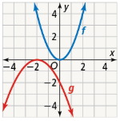  The equation shows that the graph is translated _____ units __________, will open ____________________, and will be ____________________ ______________________. | - $j\left(x\right)=2{\left(x-1\right)}^{2}-3$  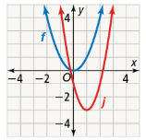  The equation shows that the graph is translated _____ units __________, will open ____________________, and will be ____________________ ______________________.
When a > 0, the parabola opens upward. When a < 0, the parabola opens downward.
When |a| > 1, the graph is stretched. When 0 < |a| < 1, the graph is compressed.
- Describe the transformations of the parent function $f\left(x\right)=x^{2}$. Then graph the function.

- $g\left(x\right)=0.4{\left(x-3\right)}^{2}$ | - $g\left(x\right)=3{\left(x-1\right)}^{2}+2$

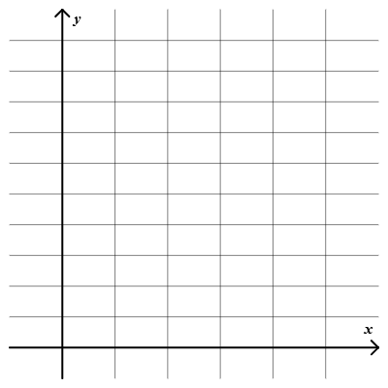
What are the key features of the quadratic function $f\left(x\right)=2{\left(x-3\right)}^{2}+4$?
- Graph the function.
- Determine the following:
  - Vertex:
  - Axis of symmetry:
  - Minimum or maximum:
  - Domain:
  - Range:

- Identify the vertex, axis of symmetry, minimum or maximum, domain, and range of the function $f\left(x\right)=-{\left(x+4\right)}^{2}-5$.

What is the equation of a quadratic function with vertex (-2, 3) and y-intercept -1? Write the equation in vertex form.
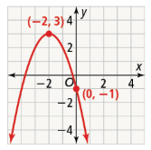
Step 1 Substitute the coordinates of the vertex for h and k in the vertex form of a quadratic function.

$(h, k) =$ $(______, ______)$so $y=a{\left(x-\left(______\right)\right)}^{2}+______$

Step 2 Substitute the values of x and y from the y-intercept, and then solve for a.

$(x, y) =$ $(______, ______)$so

Step 3 Substitute the value of a into the vertex form of a quadratic function.

The equation of the parabola is:

- What is the equation of a parabola with a vertex of (1, -4) which passes through (-2, -1)? Write the equation in vertex form.

The height of a hit ball is a quadratic function of the time it has been in the air. The ball is hit with an initial height of 4 feet and after 1 second reaches its vertex at 20 feet. What is an equation that defines this function? Write the quadratic equation in vertex form and in the form $y=ax^{2}+bx+c$.  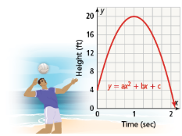 |  | Student Responses (in complete sentences) |  | Additional Responses
 |  | First Read – Understanding Context
What is the core of the problem?
- I think the problem is about …
 |  | Second Read – Interpreting the Question
What are you trying to find out?
- The problem is asking …
 |  | Third Read – Identifying Necessary Information
What are the important quantities, relationships, and other relevant information?
- The important information is…
Explore Reasoning – What are three different ways to think about solving this problem?
Solution (show and explain your answer)
Interpretation of Solution (interpret your solution in your own words)

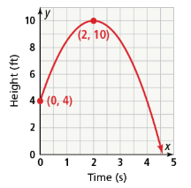
- The graph shows the height of a ball with respect to time. What is the equation of the function? Write the equation in vertex form. Then write the equation in the form $y=ax^{2}+bx+c$.

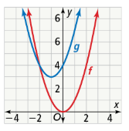
The function g is a translation of the parent function f 1 unit left and 3 units up. What is the equation of g? Write the quadratic equation in vertex form and in the form $y=ax^{2}+bx+c$.

- What is the equation of j? Write the equation in vertex form and in the form $y=ax^{2}+bx+c$.
  - Let j be a quadratic function whose graph is a translation 2 units right and 5 units down of the graph of the parent function f.

  - Let j be a quadratic function whose graph is a reflection of the graph of the parent function f in the x-axis followed by a translation 1 unit down.

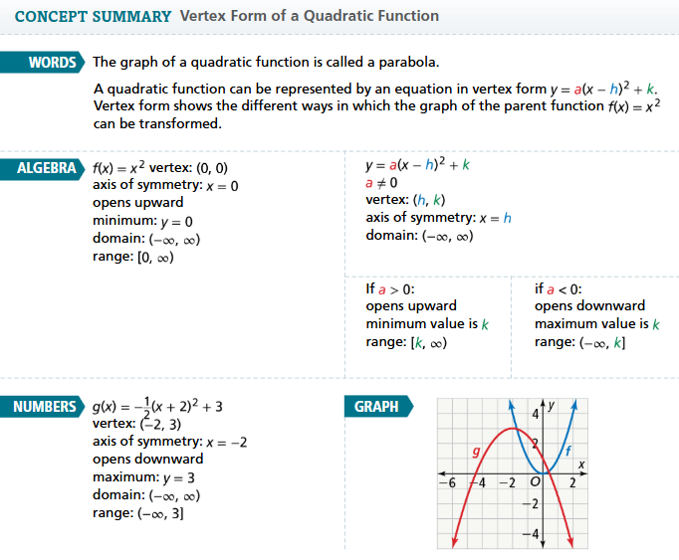
- Essential Question How are transformations related to the vertex form of a quadratic function?

- Error Analysis Given the function $g\left(x\right)={\left(x+3\right)}^{2}$, Martin says the graph of g is the graph of the parent function $f\left(x\right)=x^{2}$ translated 3 units right. Explain his error.

Describe the transformation of the parent function $f\left(x\right)=x^{2}$.
- $g\left(x\right)=-{\left(x+5\right)}^{2}+2$ | - $h\left(x\right)={\left(x+2\right)}^{2}-7$

- Write the equation of the parabola in vertex form.
Vertex: (-3, 7); Point: (-2, -5)

