
Lesson 2.2: Standard Form of a Quadratic Function
Math Objectives | - Create quadratic functions written in standard form.  - Identify key features of quadratic functions and graph a quadratic function written in standard form.  HSA.CED.A.2, HSS.ID.B.6.A
Language Objective | Students will verbally explain solutions problems involving the standard form of a quadratic function, provided pre-taught vocabulary, the three-reads strategy, and structured student-talk time.
Essential Question | What key features can you determine about a quadratic function from an equation in standard form?
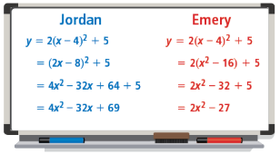
Jordan and Emery are rewriting the vertex form of the quadratic function $y=2{\left(x-4\right)}^{2}+5$ in the form $y=ax^{2}+bx+c$.
- Communicate Precisely Did Jordan rewrite the equation correctly? Did Emery? Explain.

- Without rewriting the equation, how could you prove that Jordan or Emery’s equations are not equivalent to the original?

How can you find the vertex from a quadratic function written in standard form?
- What is the x-coordinate of the vertex $f\left(x\right)=ax^{2}+bx+c$?
The standard form of a quadratic function is $y=ax^{2}+bx+c$ where $a,b,$ and $c$ are real numbers and $a≠0$. Use the vertex form to derive the standard form.

$$y=a{\left(x-h\right)}^{2}+k$$

- What is the vertex of the function $f\left(x\right)=x^{2}-6x+10$?
Step 1 Identify the coefficients a, b, and c.
a = b = and c =
Step 2 Solve for h, the x-coordinate of the vertex.
h = $-\frac{b}{2a}=$

Step 3 Substitute the value of h into the equation for x to find k, the y-coordinate of the vertex.

The vertex of the function is (h, k) = ( , )

- What is the vertex of the graph of the function $f\left(x\right)=x^{2}-8x+5$?

How can you use key features to graph $f\left(x\right)=x^{2}-4x+8$?
For $f\left(x\right)$, identify a, b, and c: a = b = and c =

Step 1 Find the vertex and the axis of symmetry of the quadratic function.

Step 2 Find the y-intercept of the quadratic function.

Step 3 Find a point symmetric to the y-intercept across the axis of symmetry.

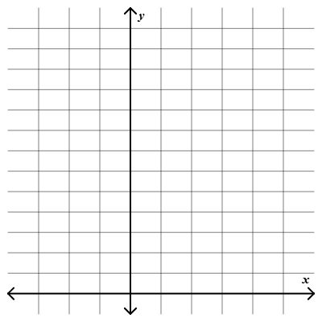
Step 4 Sketch the graph.

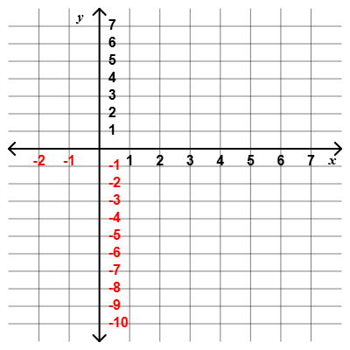
- Use key features to graph the function $f\left(x\right)=x^{2}-6x-1$.

The graph of the function:  $f\left(x\right)=-10x^{2}+700x-6000$    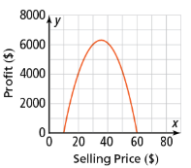  shows the profit a company earns for selling headphones at different prices. What is the maximum profit the company can expect to earn? |  | Student Responses (in complete sentences) |  | Additional Responses
 |  | First Read – Understanding Context
What is the core of the problem?
- I think the problem is about …
 |  | Second Read – Interpreting the Question
What are you trying to find out?
- The problem is asking …
 |  | Third Read – Identifying Necessary Information
What are the important quantities, relationships, and other relevant information?
- The important information is…
Explore Reasoning – What are three different ways to think about solving this problem?
Solution (show and explain your answer)
Interpretation of Solution (interpret your solution in your own words)
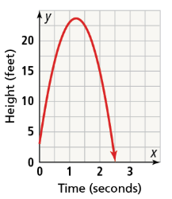
- A water balloon is tossed straight up from the ground. The height of the water balloon over time can be modeled by the function $y=-14x^{2}+34x+3$. What was the maximum height of the water balloon after it was tossed?

What is the equation of a parabola that passes through the points (-2, 32), (1, 5) and (3, 17)?
Step 1 Write three equations by substituting the given x- and y-values into the standard form of a parabola equation, $y=ax^{2}+bx+c$. Then set up a system of three equations with three unknowns.

Step 2 Solve the system.

Step 3 Substitute for a, b, and c in the quadratic equation.

Step 4 Confirm that the graph of the equation passes through the given points with a graphing calculator or Desmos.

- What is the equation of a parabola that passes through the points (2, -12), (-1, -15), and (-4, -90)?

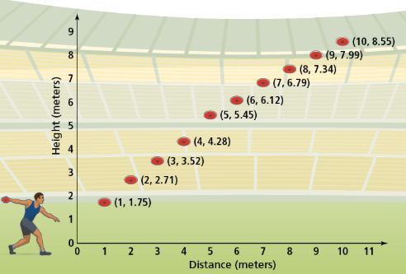
Esteban is training for the discus throw. His coach recorded the horizontal distance and height of one of Esteban’s discus throws. The graph shows the horizontal distance the discus traveled, in meters, and the height of the discus, in meters. What will be the height of the discus when it has traveled 15 meters from Esteban? Validate your model.
Use graphing technology to perform quadratic regression with the data.

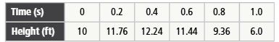
- A fan threw a souvenir football into the air from the top of the bleachers toward the bottom of the bleachers. The table shows the height of the football, in feet, above the ground at various times, in seconds. If the football was not touched by anyone on its way to the ground, about how long did it take the football to reach the ground after it was thrown?

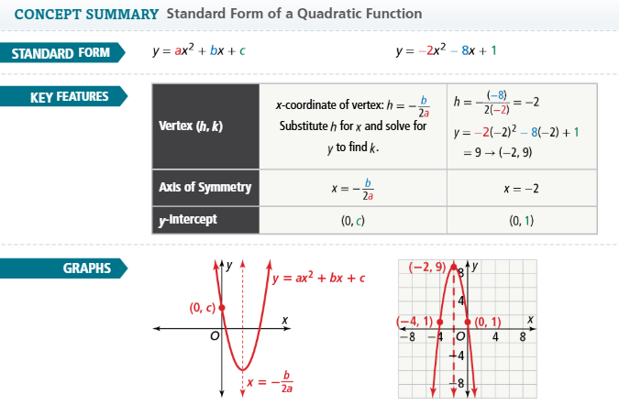

- Essential Question What key features can you determine about a quadratic function from an equation in standard form?

- Error Analysis Amos said that the y-intercept of a quadratic function always tells the maximum value of that function. Explain Amos’ error.

Find the vertex and the y-intercept of the quadratic function.
- $y=3x^{2}-12x+40$ | - $y=-x^{2}+4x+7$

For 5 and 6, find the maximum or minimum of the parabola.
- $y=-2x^{2}-16x+20$ | - $y=x^{2}+12x-15$

Graph the parabola.
- $y=3x^{2}+6x-2$  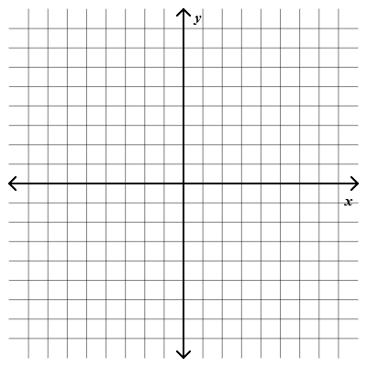 | - $y=-2x^{2}+4x+1$

