
Lesson 2.3: Factored Form of a Quadratic Function
Math Objectives | - Write a quadratic function in factored form and use it to identify zeros of the function it defines.  - Determine the intervals over which a quadratic function is positive or negative.  HSA.APR. B.3, HAS.SSE. B.3.A, HAS.SSE. A.2
Language Objective | Students will verbally explain solutions to problems involving quadratic functions in factored form, provided pre-taught vocabulary, the three-reads strategy, and structured student-talk time.
Essential Question | How is the factored form helpful in solving quadratic equations?
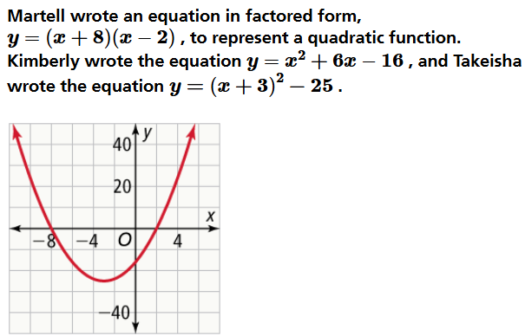

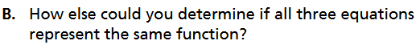

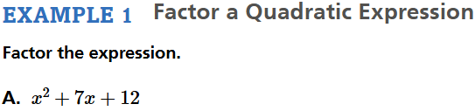

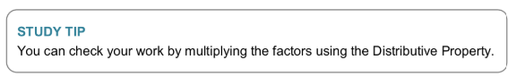


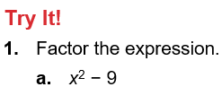

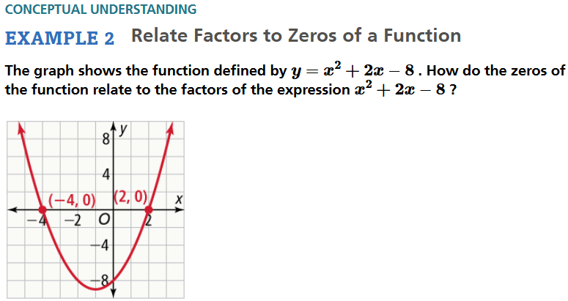

- Recall Zero of a Function

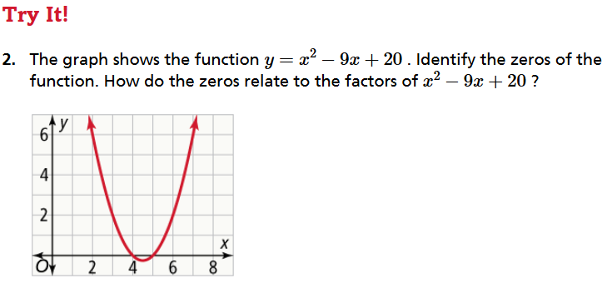

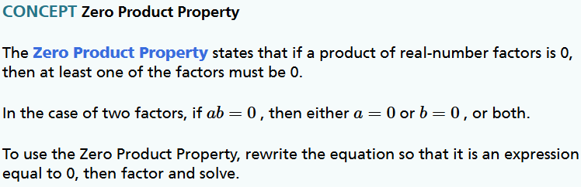

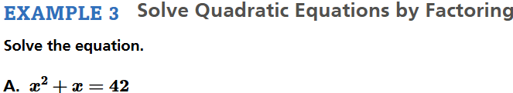

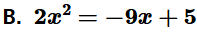

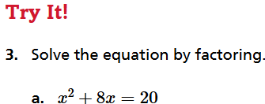

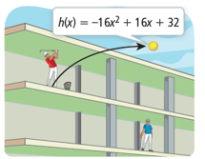  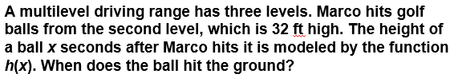 |  | Student Responses (in complete sentences) |  | Additional Responses
 |  | First Read – Understanding Context
What is the core of the problem?
- I think the problem is about …
 |  | Second Read – Interpreting the Question
What are you trying to find out?
- The problem is asking …
 |  | Third Read – Identifying Necessary Information
What are the important quantities, relationships, and other relevant information?
- The important information is…
Explore Reasoning – What are three different ways to think about solving this problem?
Solution (show and explain your answer)
Interpretation of Solution (interpret your solution in your own words)
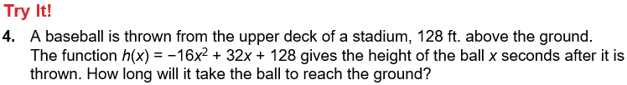

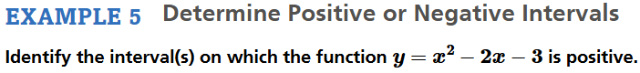

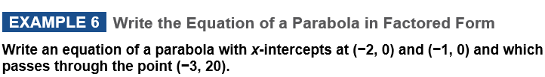

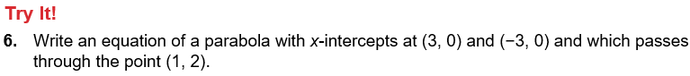

Concept Summary:
