
Lesson 2.4: Complex Numbers and Operations
Math Objectives | - Add, subtract, and multiply complex numbers using the properties of operations and the relation $i^{2}=-1$.  - Use complex numbers to represent numbers that are not on the real number line.  HSN.CN.A.1, HSN.CN.A.2
Language Objective | Students will verbally explain solutions problems involving the standard form of a quadratic function, provided pre-taught vocabulary, the three-reads strategy, and structured student-talk time.
Essential Question | How can you represent and operate on numbers that are not on the real number line?
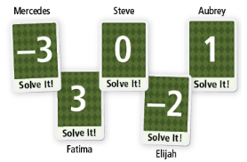
A math class played a game called “Solve It, You’re Out.” At the start of each round, students chose a card from a deck marked with integers from -5 to 5. When an equation is shown, any student whose card states the solution to the equation is eliminated. Five students remain.
- The next equation presented was $x^{2}=9$. Which student(s) was eliminated? Explain.

- Construct Arguments In the next round, the equation presented was $x^{2}=-4$. Is Elijah eliminated? Why or why not?

- What is true about solutions to $x^{2}=a$ when $a$ is a positive number? When $a$ is a negative number? What about when $a=0$?

How can you use square roots to solve each equation?
- $x^{2}=16$ | - $x^{2}=-9$

The solutions of the equation $x^{2}=-9$ are not real numbers but are part of a number system called the complex numbers. The number $\sqrt{-1}$ is called the imaginary unit i. Replacing $\sqrt{-1}$ with i allows you to write the solutions to the equation $x^{2}=-9$ as _____ and _____.

- Use square roots to solve each equation. Write your solutions using the imaginary unit, i.
- $x^{2}=-5$ | - $x^{2}=-72$

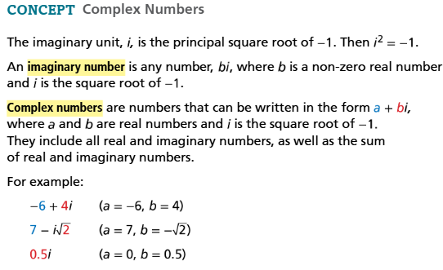
How can you add and subtract complex numbers?
- What is the sum of $(4-7i)$ and $(-11+9i)$?
When adding (or subtracting) two numbers in the form $a+bi$, combine the real parts and then combine the imaginary parts. The sum (or difference) may include both a real and imaginary part and can be written in the form $a+bi$.

- What is the difference of $(6+8i)$ and $(2-5i)$?

- Find the sum or difference.
- $\left(-4+6i\right)+(-2-9i)$ | - $\left(3-2i\right)-(-4+i)$

How can you write each product in the form $a+bi$?
- $-2.5i(8-9i)$ | - $(3-2i)(3+2i)$

- Write each product in the form $a+bi$.
- $\frac{2}{5}i(10-\frac{5}{2}i)$ | - $(\frac{1}{2}+2i)(\frac{1}{2}-2i)$

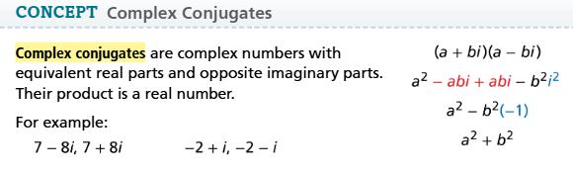
How can you write the quotient expression $\frac{10}{2-i}$ in the form $a+bi$?
When the denominator has an imaginary component, you can create an equivalent fraction with a real denominator by multiplying by its complex conjugate.

- Write each quotient in the form $a+bi$.
- $\frac{80}{2-6i}$ | - $\frac{4-3i}{-1+2i}$

How can you use complex numbers to factor the sum of two squares?
- How can you factor the expression $x^{2}+y^{2}$?
Rewrite $x^{2}+y^{2}$ as a difference of two squares $x^{2}-(-y^{2})$.

- How can you factor the expression $12x^{2}+3$?

How can you solve $x^{2}+4=0$ using factoring?

- Solve each equation.
- $x^{2}+49=0$ | - $9x^{2}+25=0$

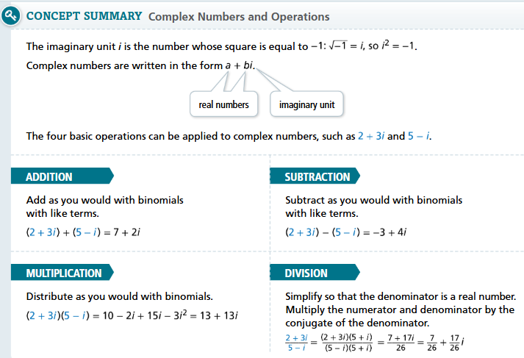
- Essential Question How can you represent and operate on numbers that are not on the real number line?

- Vocabulary How do you form the complex conjugate of a complex number a + bi?

Write each of the following in the form a + bi.
- $\left(2+5i\right)-(-6+i)$ | - $(2i)(6+3i)$

Solve each equation.
- $x^{2}+16=0$ | - $y^{2}=-25$

