Lesson 4-2: Graphing Rational Functions
Math Objectives | - Graph rational functions by identifying asymptotes and end behavior.  - Rewrite simple rational expressions in different form susing long division.
Language objective | Verbally explain the effect of dividing functions with rational expressions using a graphic organizer.
Essential Understanding | - A rational function is any function $R\left(x\right)= \frac{P(x)}{Q(x)}$ where P(x) and Q(x) are polynomial functions.  - The domain of a rational function is all real numbers except any x values where Q(x) equals zero.  - The graph of a rational function has one or more asymptotes, which guide the end behavior of the graph.
EXPLORE & REASON using DESMOS

- Look for Relationships. Graph each function. Determine whether the functions are linear. Find the y intercept of each function, and slope, if appropriate.
Function | Linear? (Yes/No) | y-intercept | Slope
$$f\left(x\right)=x-1$$
$$g\left(x\right)= \frac{x-1}{2}$$

$$h\left(x\right)= \frac{x-1}{x-2}$$

- What is the effect on the graph of f when dividing x-1 by 2?

- What happens to the graph of h as x approaches 2?

- Communicate Precisely. What is the effect on the graph of f(x) when dividing x-1 by x-2. (Hint: Compare it to what you found in part (B)
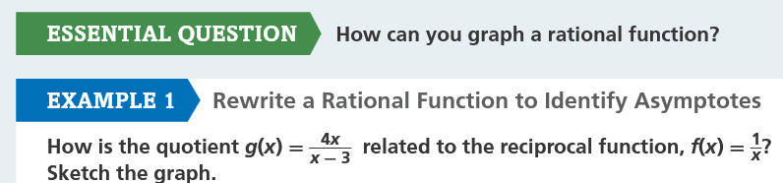

Graph both the parent and your new function Via DESMOS

The graph of the parent function was … (Circle and Fill in the Blank)
Stretched Vertically Horizontally by a factor of ____
Shifted Up Down ___ Units
Translated Left Right ___ Units
Has Asymptote(s) at x =



The graph of the parent function was …  Stretched Vertically Horizontally by a factor of ____  Shifted Up Down ___ Units  Translated Left Right ___ Units  Has Asymptote(s) at x = | The graph of the parent function was …  Stretched Vertically Horizontally by a factor of ____  Shifted Up Down ___ Units  Translated Left Right ___ Units  Has Asymptote(s) at x =

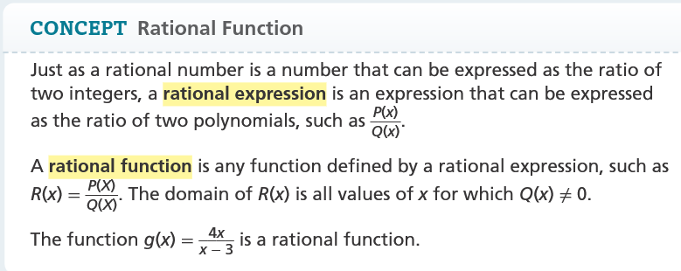

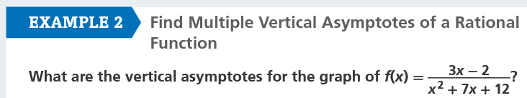

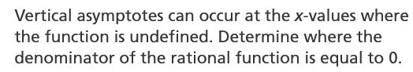 | 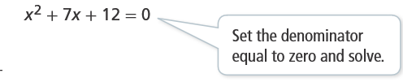

Graph the Function in DESMOS. Verify that there are no values @ x = ____ and x = _____.

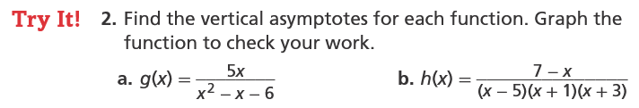

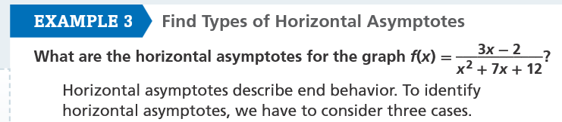
Graph with DESMOS
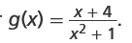 | As | x |→∞ the value of the denominator  gets very large in relation to the numerator.  The value of the function gets closer and  closer to ____

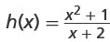 | As | x |→∞ , the value of the  numerator gets very large in relation  to the denominator, so y approaches ___

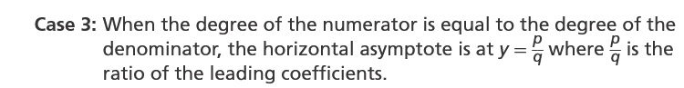
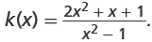 | As | x |→∞ , the value of  the rational expression  approaches 0, so the value of  the function approaches____

 | Replace a with a adult dosage value and write your equation.  Graph with technology. At what a value does the curve reach 60?



