
Lesson 3.1: Graphing Polynomial Functions
Math Objectives | - Students will be able to identify the degree, lead coefficient, number of terms, and classification of a polynomial function.  - Predict end behaviors of graphs using degree and lead coefficient.  - Graph polynomial functions and label key features.  HSF.IF.B.4 HSF.IF.C.7.C HSF.IF.B.6
Language Objective | Students will verbally explain how they classified the different parts of a polynomial function, provided pre-taught vocabulary, the three-reads strategy, and structured student-talk time.
Essential Question | How do the key features of a polynomial function help you sketch its graph?

ESSENTIAL VOCABULARY:
Degree: The largest exponent which appears in a polynomial. Found on a variable.
Lead coefficient: The number factor attached to the degree variable.
Term: A product or quotient of numbers, variables and/or expressions.

Lead Coefficient
Degree

Term 1 Term 2 Term 3 Term 4 Term 5
$$4x^{5}+3x^{3}-2x^{2}-17x+3$$

This would be considered a polynomial of degree 5 with a lead coefficient of 4 and has 5 terms.
The polynomial should be written in STANDARD FORM from largest exponent to the constant at the end.
Classifying Polynomials By Name or Number
VALUE OF… | DEGREE | NUMBER OF TERMS
1 | Linear | Monomial
2 | Quadratic | Binomial
3 | Cubic | Trinomial
4 | Quartic (rarely used) | With # Terms
5+ | Of Degree # | With # Terms

A polynomial is fully classified by using the sentence frame below.
The polynomial is (Degree Name) , with a lead coefficient of , and is a (or has) term name/number of terms.
TRY IT!!!
- $2x^{3}-4x^{2}+3$

- $4x-9$

- $-3x^{2}+6x^{4}-2+3x^{3}$

- $4-3x+11x^{2}$

EXPLORE AND REASON:
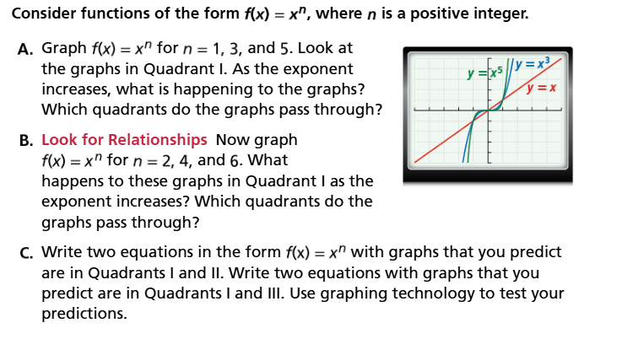
PART A: (What do you see happening to these graphs as the degree increases? Look at the ends of the curves. Do they stay in the same quadrants? Will they if they follow the pattern of the degree? Do you think it might change if something else changes?)

Part B: (What do you see happening to these graphs as the degree increases? Look at the ends of the curves. Do they stay in the same quadrants? Will they if they follow the pattern of the degree? Do you think it might change if something else changes?)

Part C: (Follow directions from problem)

Understanding End Behavior of Functions
End behavior is knowing where to draw the arrows of a function on the graph because we know it will “go on forever” in that direction.
NOTICE and WONDER: 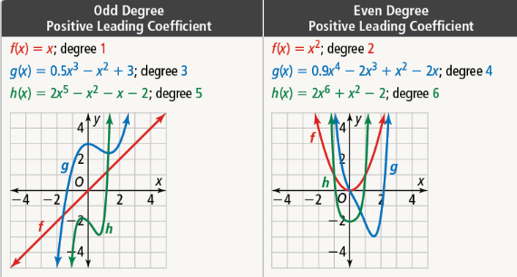
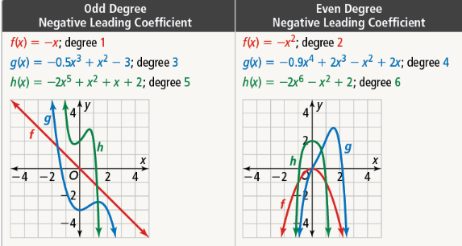
What do I Notice? What do I wonder?

Conclusions:
- If the degree of a polynomial is ____________ and the lead coefficient is _____________ then the ends of the function are in quadrants ____ and ______.

- If the degree of a polynomial is ____________ and the lead coefficient is _____________ then the ends of the function are in quadrants ____ and ______.

- If the degree of a polynomial is ____________ and the lead coefficient is _____________ then the ends of the function are in quadrants ____ and ______.

- If the degree of a polynomial is ____________ and the lead coefficient is _____________ then the ends of the function are in quadrants ____ and ______.

Can you predict the end behavior of the following? Try it!!!

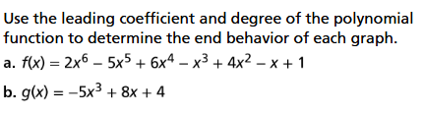

Sketch a Graph of a Polynomial Function:
Use the function $f\left(x\right)= -\frac{1}{2}x^{4}+3x^{2}+2$ and use key features to sketch the graph.
- Predict End Behavior.
- Create a table of values.
- Estimate points from the table.
- Estimate where the graph has its TURNING POINTS (switches directions).
- Sketch.
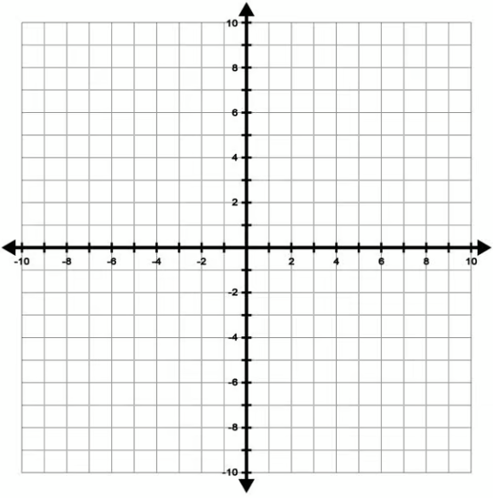
Where do you think the turning points are? Why do you think the turning points are there?
x | f(x) | x | f(x)

Do you remember?
From your graph can you find the rate of change over the interval [-2,0]?
YOU TRY IT NOW!!!
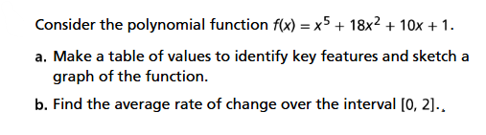

Sketch Graphs from Interval Descriptions, End Behavior, Zeros.
We will construct the first example together.
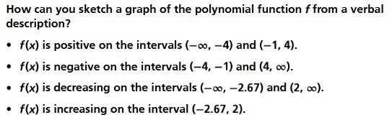
Give a short explanation of why you put key features in places on the graph.

NOW YOU TRY!!!
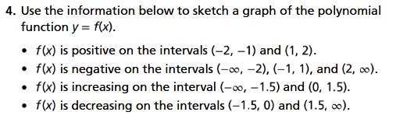

3-READ Graphic Organizer

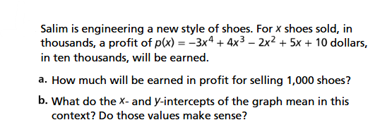  (Use the space below if you need more space for your answers) | Student Responses (in complete sentences)
 | First Read – Understanding Context
What is the core of the problem?
- I think the problem is about …

 | Second Read – Interpreting the Question
What are you trying to find out?
- The problem is asking …

 | Third Read – Identifying Necessary Information
What are the important quantities, relationships, and other relevant information?
- The important information is…

Explore Reasoning – What is your plan to solve this problem?
Solution (show and explain your answer)
Interpretation of Solution (interpret your solution in your own words)

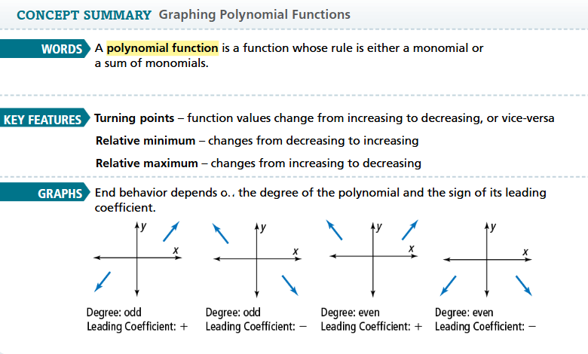
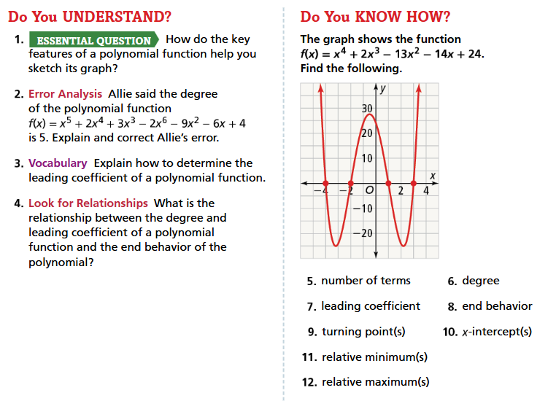

ADDITIONAL PROBLEMS – Teacher will assign if needed.
